UNITED STATES
SECURITIES AND EXCHANGE COMMISSION
Washington, D.C. 20549

FORM 8-K

CURRENT REPORT
Pursuant to Section 13 or 15(d) of the
Securities Exchange Act of 1934

Date of Report (Date of earliest event reported): September 10, 2026

EQUITY LIFESTYLE PROPERTIES, INC.
(Exact name of registrant as specified in its charter)
Maryland |  |  |  |  |  | 1-11718 |  |  |  |  |  |  |  |  | 36-3857664
(State or other jurisdiction of incorporation) |  |  |  |  |  | (Commission File No.) |  |  |  |  |  |  |  |  | (IRS Employer Identification Number)
Two North Riverside Plaza |  |  |  |  |  | Chicago, |  |  | Illinois |  |  |  |  |  | 60606
(Address of Principal Executive Offices) |  |  |  |  |  |  |  |  |  |  |  |  |  |  | (Zip Code)

(312) 279-1400
(Registrant's telephone number, including area code)

Check the appropriate box below if the Form 8-K filing is intended to simultaneously satisfy the filing obligation of the registrant under any of the following provisions (see General Instruction A.2. below):
☐ |  |  | Written communications pursuant to Rule 425 under the Securities Act (17 CFR 230.425)
☐ |  |  | Soliciting material pursuant to Rule 14a-12 under the Exchange Act (17 CFR 240.14a-12)
☐ |  |  | Pre-commencement communications pursuant to Rule 14d-2(b) under the Exchange Act (17 CFR 240.14d-2(b))
☐ |  |  | Pre-commencement communications pursuant to Rule 13e-4(c) under the Exchange Act (17 CFR 240.13e-4(c))
Securities registered pursuant to Section 12(b) of the Act:
Title of each class |  |  | Trading Symbol(s) |  |  | Name of each exchange on which registered
Common Stock, $0.01 Par Value |  |  | ELS |  |  | New York Stock Exchange

Indicate by check mark whether the registrant is an emerging growth company as defined in Rule 405 of the Securities Act of 1933 (§230.405 of this chapter) or Rule 12b-2 of the Securities Exchange Act of 1934 (§240.12b-2 of this chapter).

Emerging growth company ☐

If an emerging growth company, indicate by check mark if the registrant has elected not to use the extended transition period for complying with any new or revised financial accounting standards provided pursuant to Section 13(a) of the Exchange Act. ☐

Item 7.01 Regulation FD Disclosure

Attached hereto as Exhibit 99.1 and incorporated herein by reference in, this report is an investor presentation of Equity LifeStyle Properties, Inc. (referred to herein as “we,” “us,” and “our”) that has been made available to investors beginning September 10, 2026. The presentation has been posted on our website, www.equitylifestyleproperties.com, on September 10, 2026.

In accordance with General Instruction B.2. of Form 8-K, the information included in Item 7.01 of this Current Report on Form 8-K, including Exhibit 99.1, shall not be deemed to be “filed” for purposes of Section 18 of the Securities Exchange Act of 1934, as amended, or otherwise subject to the liabilities of that Section, nor shall such information be deemed incorporated by reference in any registration statement filed by Equity LifeStyle Properties, Inc. under the Securities Act of 1933, as amended.

This report includes certain “forward-looking statements” within the meaning of the Private Securities Litigation Reform Act of 1995. When used, words such as “anticipate,” “expect,” “believe,” “project,” “intend,” “may be” and “will be” and similar words or phrases, or the negative thereof, unless the context requires otherwise, are intended to identify forward-looking statements and may include, without limitation, information regarding our expectations, goals or intentions regarding the future, and the expected effect of our acquisitions. Forward-looking statements, including our guidance concerning Net Income, FFO and Normalized FFO per share data, Dividend per share data, Core Property Operating Revenues, Core Property Operating Expenses, Excluding Property Management, Core Income from Property Operations, Excluding Property Management, by their nature, involve estimates, projections, goals, forecasts and assumptions and are subject to risks and uncertainties that could cause actual results or outcomes to differ materially from those expressed in a forward-looking statement due to a number of factors, which include, but are not limited to the following: (i) the mix of site usage within the portfolio; (ii) yield management on our short-term resort and marina sites; (iii) scheduled or implemented rate increases on community, resort and marina sites; (iv) scheduled or implemented rate increases in annual payments under membership subscriptions; (v) occupancy changes; (vi) our ability to attract and retain membership customers; (vii) change in customer demand regarding travel and outdoor vacation destinations; (viii) our ability to manage expenses in an inflationary environment, including the impact of changes in tariffs, as well as costs associated with supply chain disruptions; (ix) changes in debt service and interest rates; (x) our ability to integrate and operate recent acquisitions in accordance with our estimates; (xi) our ability to execute expansion/development opportunities in the face of changes impacting the supply chain or labor markets; (xii) completion of pending transactions in their entirety and on assumed schedule; (xiii) our ability to attract and retain property employees, particularly seasonal employees; (xiv) ongoing legal matters and related fees; (xv) costs to clean up and restore property operations and potential revenue losses following storms or other unplanned events; and (xvi) the potential impact of material weaknesses, if any, in our internal control over financial reporting.

For further information on these and other factors that could impact us and the statements contained herein, refer to our filings with the Securities and Exchange Commission, including the “Risk Factors” and “Forward-Looking Statements” sections in our most recent Annual Report on Form 10-K and any subsequent Quarterly Reports on Form 10-Q.

These forward-looking statements are based on management’s present expectations and beliefs about future events. As with any projection or forecast, these statements are inherently susceptible to uncertainty and changes in circumstances. We are under no obligation to, and expressly disclaim any obligation to, update or alter our forward-looking statements whether as a result of such changes, new information, subsequent events or otherwise.
We are a fully integrated owner of lifestyle-oriented properties and own or have an interest in 453 properties located predominantly in the United States consisting of 173,559 sites as of June 30, 2026. We are a self-administered, self-managed, real estate investment trust with headquarters in Chicago.
Item 9.01 Financial Statements and Exhibits
(d) Exhibits

The information contained in the attached exhibit is unaudited and should be read in conjunction with the Registrant’s annual and quarterly reports filed with the Securities and Exchange Commission.

99.1 September 2026 Investor Presentation
104 Cover Page Interactive Data File included as Exhibit 101 (embedded within the Inline XBRL document)

SIGNATURE

Pursuant to the requirements of the Securities Exchange Act of 1934, the Registrant has duly caused this Report to be signed on its behalf by the undersigned thereunto duly authorized.
 |  |  |  |  |  | EQUITY LIFESTYLE PROPERTIES, INC.
Date: September 10, 2026 |  |  |  |  |  | By: /s/ Paul Seavey
 |  |  |  |  |  | Paul Seavey
 |  |  |  |  |  | Executive Vice President and Chief Financial Officer

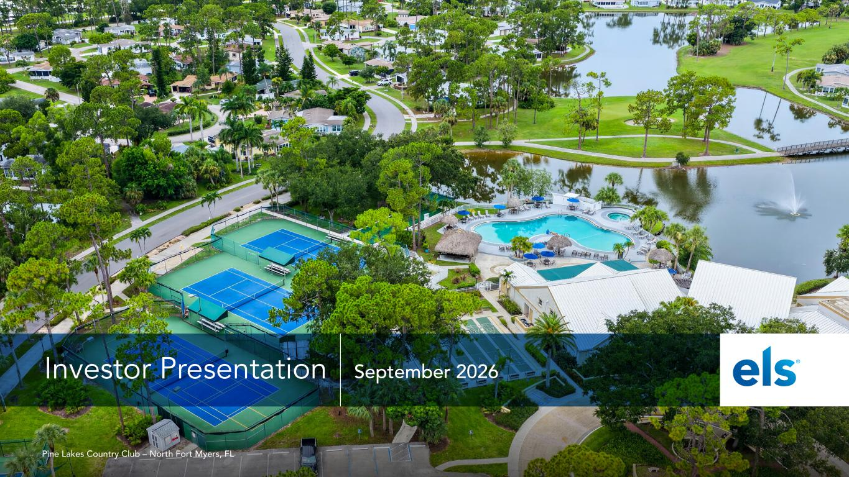

Investor Presentation September 2026 Pine Lakes Country Club – North Fort Myers, FL

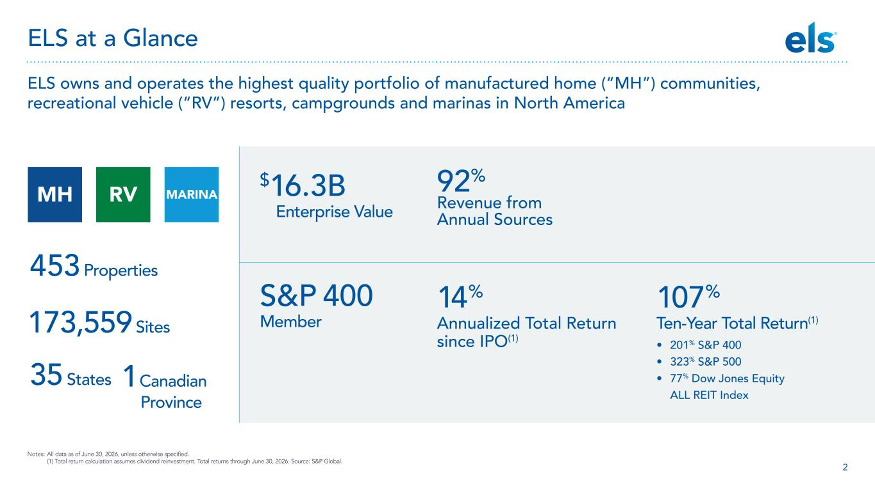
2 ELS at a Glance ELS owns and operates the highest quality portfolio of manufactured home (“MH”) communities, recreational vehicle (“RV”) resorts, campgrounds and marinas in North America S&P 400 Member 92% Revenue from Annual Sources $16.3B Enterprise Value 107% Ten-Year Total Return(1) • 201% S&P 400 • 323% S&P 500 • 77% Dow Jones Equity ALL REIT Index 173,559 Sites 35 States 1 Canadian Province 453 Properties Notes: All data as of June 30, 2026, unless otherwise specified. (1) Total return calculation assumes dividend reinvestment. Total returns through June 30, 2026. Source: S&P Global. 14% Annualized Total Return since IPO(1) MH RV MARINA

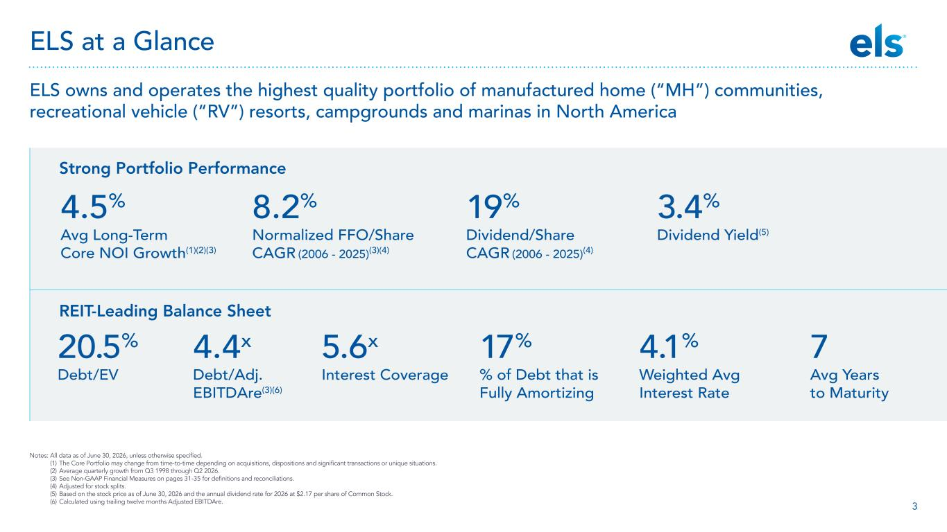
3 ELS owns and operates the highest quality portfolio of manufactured home (“MH”) communities, recreational vehicle (“RV”) resorts, campgrounds and marinas in North America Notes: All data as of June 30, 2026, unless otherwise specified. (1) The Core Portfolio may change from time-to-time depending on acquisitions, dispositions and significant transactions or unique situations. (2) Average quarterly growth from Q3 1998 through Q2 2026. (3) See Non-GAAP Financial Measures on pages 31-35 for definitions and reconciliations. (4) Adjusted for stock splits. (5) Based on the stock price as of June 30, 2026 and the annual dividend rate for 2026 at $2.17 per share of Common Stock. (6) Calculated using trailing twelve months Adjusted EBITDAre. Strong Portfolio Performance REIT-Leading Balance Sheet 8.2% Normalized FFO/Share CAGR (2006 - 2025)(3)(4) 19% Dividend/Share CAGR (2006 - 2025)(4) 4.5% Avg Long-Term Core NOI Growth(1)(2)(3) 3.4% Dividend Yield(5) 17% % of Debt that is Fully Amortizing 4.1% Weighted Avg Interest Rate 7 Avg Years to Maturity 20.5% Debt/EV 4.4x Debt/Adj. EBITDAre(3)(6) 5.6x Interest Coverage ELS at a Glance

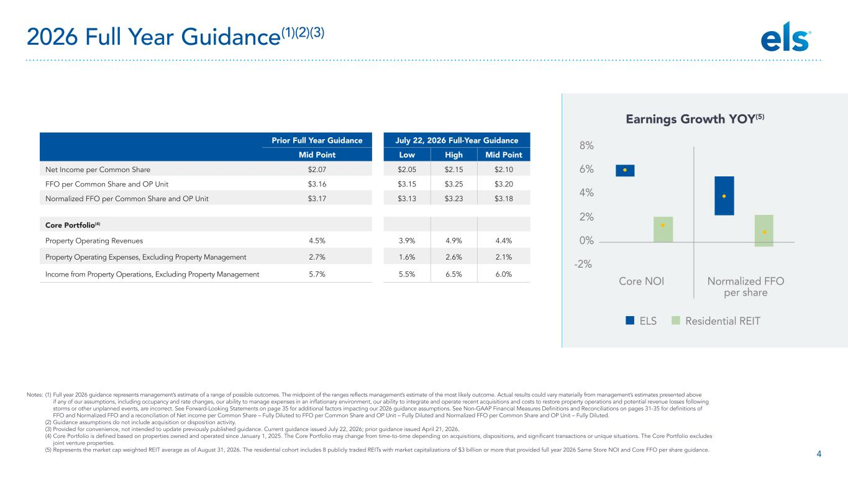
4 Notes: (1) Full year 2026 guidance represents management’s estimate of a range of possible outcomes. The midpoint of the ranges reflects management’s estimate of the most likely outcome. Actual results could vary materially from management’s estimates presented above if any of our assumptions, including occupancy and rate changes, our ability to manage expenses in an inflationary environment, our ability to integrate and operate recent acquisitions and costs to restore property operations and potential revenue losses following storms or other unplanned events, are incorrect. See Forward-Looking Statements on page 35 for additional factors impacting our 2026 guidance assumptions. See Non-GAAP Financial Measures Definitions and Reconciliations on pages 31-35 for definitions of FFO and Normalized FFO and a reconciliation of Net income per Common Share – Fully Diluted to FFO per Common Share and OP Unit – Fully Diluted and Normalized FFO per Common Share and OP Unit – Fully Diluted. (2) Guidance assumptions do not include acquisition or disposition activity. (3) Provided for convenience, not intended to update previously published guidance. Current guidance issued July 22, 2026; prior guidance issued April 21, 2026. (4) Core Portfolio is defined based on properties owned and operated since January 1, 2025. The Core Portfolio may change from time-to-time depending on acquisitions, dispositions, and significant transactions or unique situations. The Core Portfolio excludes joint venture properties. (5) Represents the market cap weighted REIT average as of August 31, 2026. The residential cohort includes 8 publicly traded REITs with market capitalizations of $3 billion or more that provided full year 2026 Same Store NOI and Core FFO per share guidance. 2026 Full Year Guidance(1)(2)(3) -2% 0% 2% 4% 6% 8% Core NOI Normalized FFO per share ELS Residential REIT Earnings Growth YOY(5) Prior Full Year Guidance July 22, 2026 Full-Year Guidance Mid Point Low High Mid Point Net Income per Common Share $2.07 $2.05 $2.15 $2.10 FFO per Common Share and OP Unit $3.16 $3.15 $3.25 $3.20 Normalized FFO per Common Share and OP Unit $3.17 $3.13 $3.23 $3.18 Core Portfolio(4) Property Operating Revenues 4.5% 3.9% 4.9% 4.4% Property Operating Expenses, Excluding Property Management 2.7% 1.6% 2.6% 2.1% Income from Property Operations, Excluding Property Management 5.7% 5.5% 6.5% 6.0%

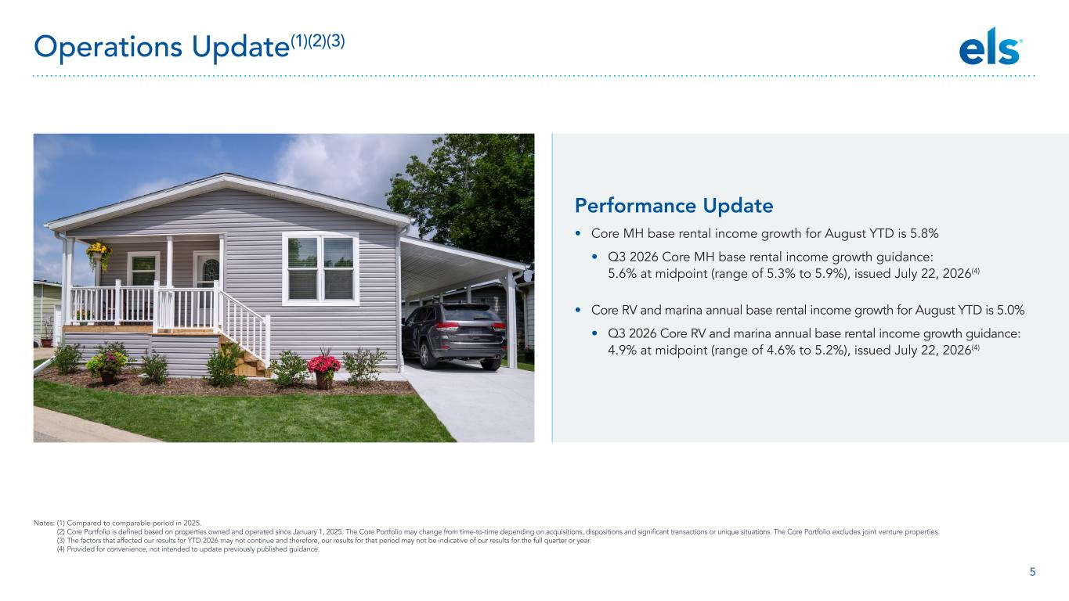
5 Notes: (1) Compared to comparable period in 2025. (2) Core Portfolio is defined based on properties owned and operated since January 1, 2025. The Core Portfolio may change from time-to-time depending on acquisitions, dispositions and significant transactions or unique situations. The Core Portfolio excludes joint venture properties. (3) The factors that affected our results for YTD 2026 may not continue and therefore, our results for that period may not be indicative of our results for the full quarter or year. (4) Provided for convenience, not intended to update previously published guidance. Operations Update(1)(2)(3) Performance Update • Core MH base rental income growth for August YTD is 5.8% • Q3 2026 Core MH base rental income growth guidance: 5.6% at midpoint (range of 5.3% to 5.9%), issued July 22, 2026(4) • Core RV and marina annual base rental income growth for August YTD is 5.0% • Q3 2026 Core RV and marina annual base rental income growth guidance: 4.9% at midpoint (range of 4.6% to 5.2%), issued July 22, 2026(4)

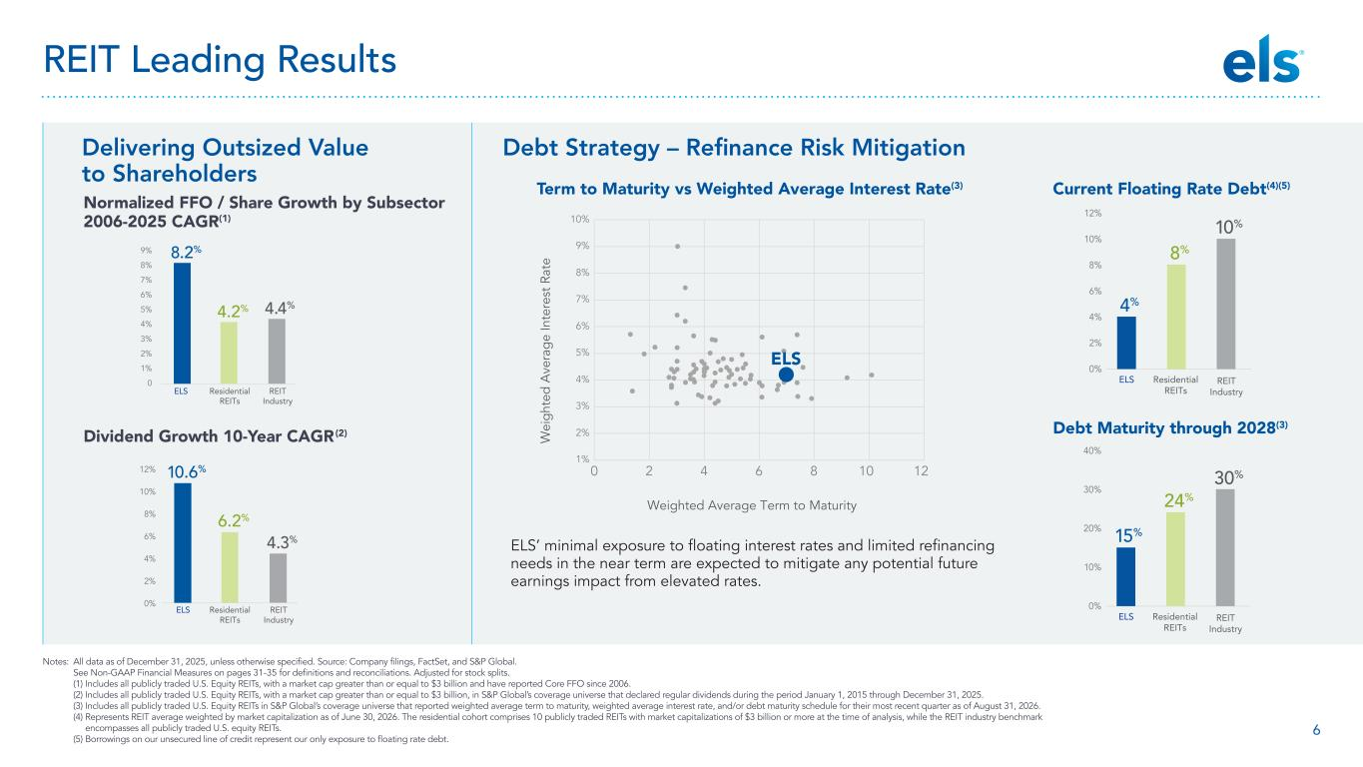
6 Delivering Outsized Value to Shareholders Debt Strategy – Refinance Risk Mitigation Notes: All data as of December 31, 2025, unless otherwise specified. Source: Company filings, FactSet, and S&P Global. See Non-GAAP Financial Measures on pages 31-35 for definitions and reconciliations. Adjusted for stock splits. (1) Includes all publicly traded U.S. Equity REITs, with a market cap greater than or equal to $3 billion and have reported Core FFO since 2006. (2) Includes all publicly traded U.S. Equity REITs, with a market cap greater than or equal to $3 billion, in S&P Global’s coverage universe that declared regular dividends during the period January 1, 2015 through December 31, 2025. (3) Includes all publicly traded U.S. Equity REITs in S&P Global’s coverage universe that reported weighted average term to maturity, weighted average interest rate, and/or debt maturity schedule for their most recent quarter as of August 31, 2026. (4) Represents REIT average weighted by market capitalization as of June 30, 2026. The residential cohort comprises 10 publicly traded REITs with market capitalizations of $3 billion or more at the time of analysis, while the REIT industry benchmark encompasses all publicly traded U.S. equity REITs. (5) Borrowings on our unsecured line of credit represent our only exposure to floating rate debt. ELS Residential REITs REIT Industry 8.2% 0 1% 2% 3% 4% 5% 6% 7% 8% 9% 4.4%4.2% 0% 2% 4% 6% 10% 8% 12% ELS 4% Residential REITs 8% 10% REIT Industry 0% 10% 20% 30% 40% ELS 15% Residential REITs 24% 30% REIT Industry Normalized FFO / Share Growth by Subsector 2006-2025 CAGR(1) Residential REITs REIT Industry 0% 2% 4% 6% 8% 10% 12% 4.3% 6.2% ELS 10.6% Dividend Growth 10-Year CAGR(2) Debt Maturity through 2028(3) 1% 2% 3% 4% 5% 6% 7% 8% 9% 10% 0 2 4 6 8 10 12 W ei gh te d A ve ra ge In te re st R at e Weighted Average Term to Maturity ELS Term to Maturity vs Weighted Average Interest Rate(3) ELS’ minimal exposure to floating interest rates and limited refinancing needs in the near term are expected to mitigate any potential future earnings impact from elevated rates. Current Floating Rate Debt(4)(5) REIT Leading Results

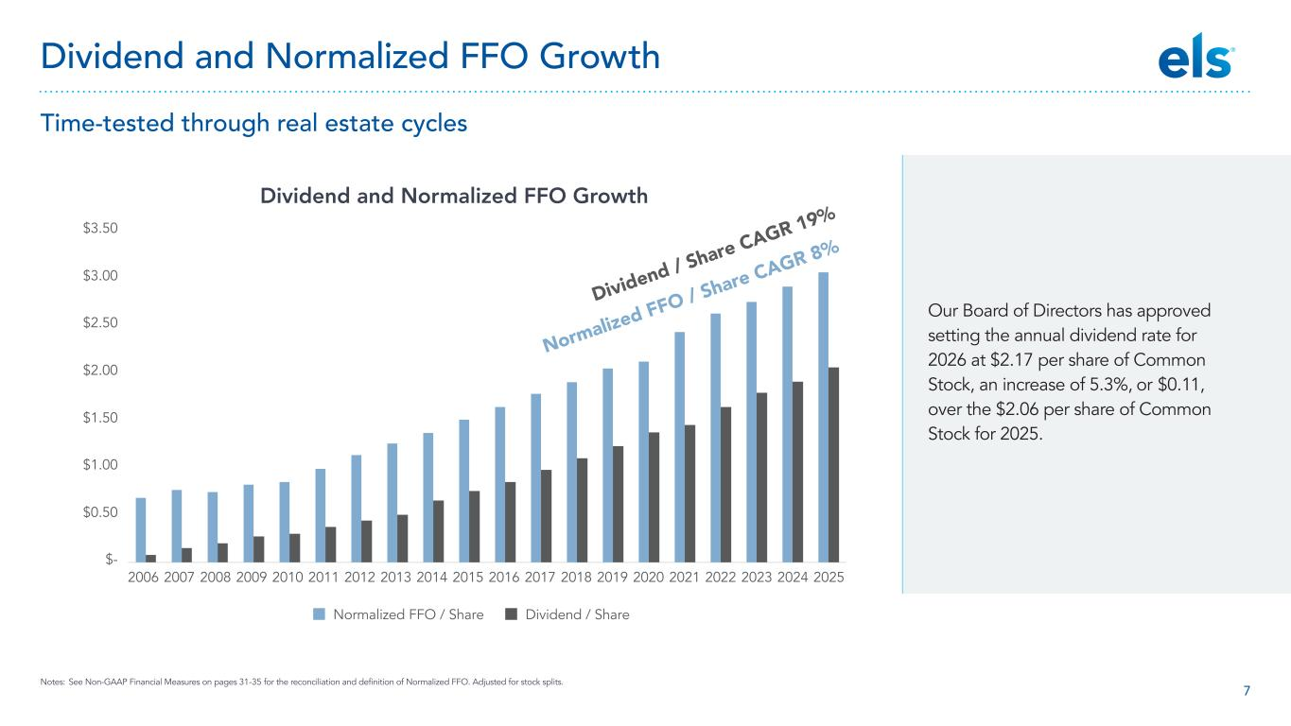
7 $- $0.50 $1.00 $1.50 $2.00 $2.50 $3.00 $3.50 2006 2007 2008 2009 2010 2011 2012 2013 2014 2015 2016 2017 2018 2019 2020 2021 2022 2023 2024 2025 Dividend / ShareNormalized FFO / Share Normalized FFO / Share CAGR 8% Dividend / Share CAGR 19% Dividend and Normalized FFO Growth Our Board of Directors has approved setting the annual dividend rate for 2026 at $2.17 per share of Common Stock, an increase of 5.3%, or $0.11, over the $2.06 per share of Common Stock for 2025. Notes: See Non-GAAP Financial Measures on pages 31-35 for the reconciliation and definition of Normalized FFO. Adjusted for stock splits. Dividend and Normalized FFO Growth Time-tested through real estate cycles

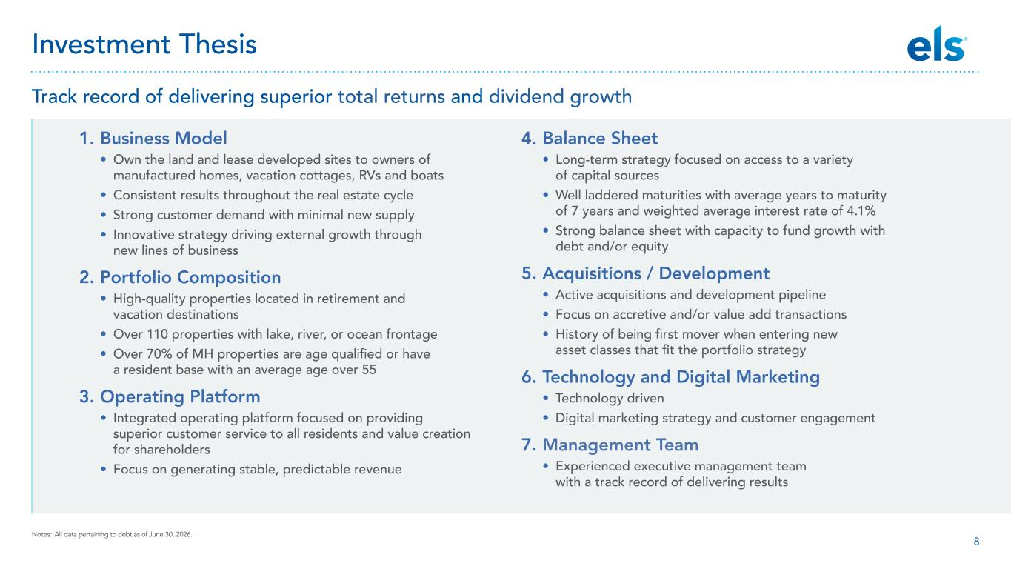
8 1. Business Model • Own the land and lease developed sites to owners of manufactured homes, vacation cottages, RVs and boats • Consistent results throughout the real estate cycle • Strong customer demand with minimal new supply • Innovative strategy driving external growth through new lines of business 2. Portfolio Composition • High-quality properties located in retirement and vacation destinations • Over 110 properties with lake, river, or ocean frontage • Over 70% of MH properties are age qualified or have a resident base with an average age over 55 3. Operating Platform • Integrated operating platform focused on providing superior customer service to all residents and value creation for shareholders • Focus on generating stable, predictable revenue 4. Balance Sheet • Long-term strategy focused on access to a variety of capital sources • Well laddered maturities with average years to maturity of 7 years and weighted average interest rate of 4.1% • Strong balance sheet with capacity to fund growth with debt and/or equity 5. Acquisitions / Development • Active acquisitions and development pipeline • Focus on accretive and/or value add transactions • History of being first mover when entering new asset classes that fit the portfolio strategy 6. Technology and Digital Marketing • Technology driven • Digital marketing strategy and customer engagement 7. Management Team • Experienced executive management team with a track record of delivering results Notes: All data pertaining to debt as of June 30, 2026. Investment Thesis Track record of delivering superior total returns and dividend growth

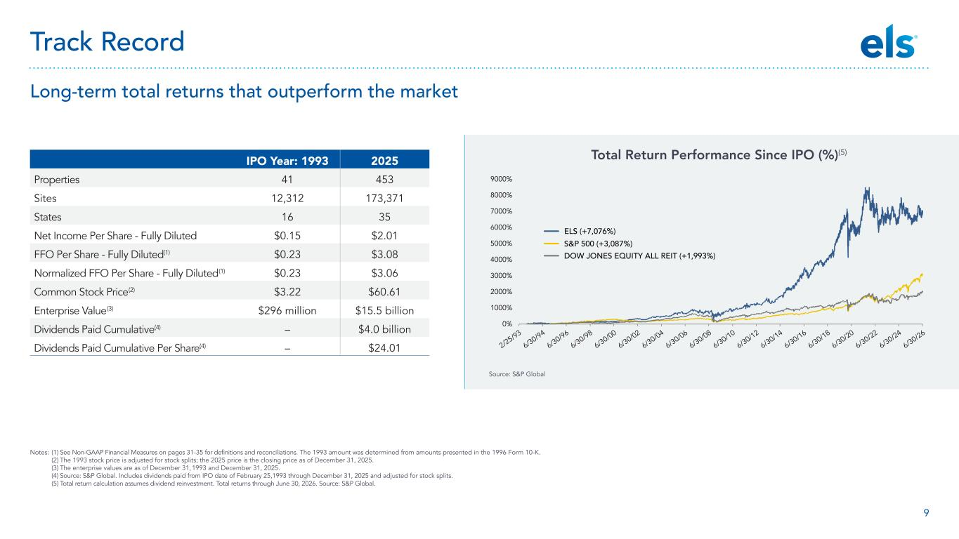
9 0% 1000% 2000% 3000% 4000% 5000% 6000% 7000% 8000% 9000% 2/25/93 6/30/94 6/30/96 6/30/98 6/30/00 6/30/02 6/30/04 6/30/06 6/30/08 6/30/10 6/30/12 6/30/14 6/30/16 6/30/18 6/30/20 6/30/22 6/30/24 6/30/26 ELS (+7,076%) S&P 500 (+3,087%) DOW JONES EQUITY ALL REIT (+1,993%) Notes: (1) See Non-GAAP Financial Measures on pages 31-35 for definitions and reconciliations. The 1993 amount was determined from amounts presented in the 1996 Form 10-K. (2) The 1993 stock price is adjusted for stock splits; the 2025 price is the closing price as of December 31, 2025. (3) The enterprise values are as of December 31, 1993 and December 31, 2025. (4) Source: S&P Global. Includes dividends paid from IPO date of February 25,1993 through December 31, 2025 and adjusted for stock splits. (5) Total return calculation assumes dividend reinvestment. Total returns through June 30, 2026. Source: S&P Global. IPO Year: 1993 2025 Properties 41 453 Sites 12,312 173,371 States 16 35 Net Income Per Share - Fully Diluted $0.15 $2.01 FFO Per Share - Fully Diluted(1) $0.23 $3.08 Normalized FFO Per Share - Fully Diluted(1) $0.23 $3.06 Common Stock Price(2) $3.22 $60.61 Enterprise Value(3) $296 million $15.5 billion Dividends Paid Cumulative(4) – $4.0 billion Dividends Paid Cumulative Per Share(4) – $24.01 Source: S&P Global Total Return Performance Since IPO (%)(5) Track Record Long-term total returns that outperform the market

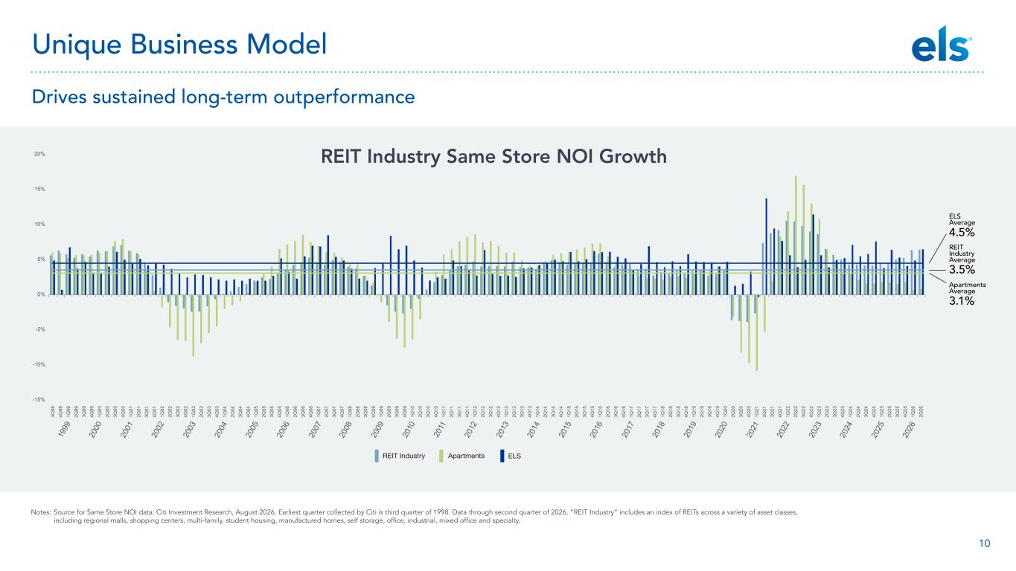
10 Notes: Source for Same Store NOI data: Citi Investment Research, August 2026. Earliest quarter collected by Citi is third quarter of 1998. Data through second quarter of 2026. “REIT Industry” includes an index of REITs across a variety of asset classes, including regional malls, shopping centers, multi-family, student housing, manufactured homes, self storage, office, industrial, mixed office and specialty. Unique Business Model Drives sustained long-term outperformance ELS Average 4.5% Apartments Average 3.1% REIT Industry Average 3.5% -15% -10% -5% 0% 5% 10% 15% 20% 19 99 20 00 20 01 20 02 20 03 20 04 20 05 20 06 20 07 20 08 20 09 20 12 20 13 20 14 20 15 20 16 20 17 20 18 20 19 20 20 20 21 20 22 20 23 20 24 20 25 20 26 20 10 20 11 3Q 98 4Q 98 1Q 99 2Q 99 3Q 99 4Q 99 1Q 00 2Q 00 3Q 00 4Q 00 1Q 01 2Q 01 3Q 01 4Q 01 1Q 02 2Q 02 3Q 02 4Q 02 1Q 03 2Q 03 3Q 03 4Q 03 1Q 04 2Q 04 3Q 04 4Q 04 1Q 05 2Q 05 3Q 05 4Q 05 1Q 06 2Q 06 3Q 06 4Q 06 1Q 07 2Q 07 3Q 07 4Q 07 1Q 08 2Q 08 3Q 08 4Q 08 1Q 09 2Q 09 3Q 09 4Q 09 1Q 10 2Q 10 3Q 10 4Q 10 1Q 11 2Q 11 3Q 11 4Q 11 1Q 12 2Q 12 3Q 12 4Q 12 1Q 13 2Q 13 3Q 13 4Q 13 1Q 14 2Q 14 3Q 14 4Q 14 1Q 15 2Q 15 3Q 15 4Q 15 1Q 16 2Q 16 3Q 16 4Q 16 1Q 17 2Q 17 3Q 17 4Q 17 1Q 18 2Q 18 3Q 18 4Q 18 1Q 19 2Q 19 3Q 19 4Q 19 1Q 20 2Q 20 3Q 20 4Q 20 1Q 21 2Q 21 3Q 21 4Q 21 1Q 22 2Q 22 3Q 22 4Q 22 1Q 23 2Q 23 3Q 23 4Q 23 1Q 24 2Q 24 3Q 24 4Q 24 1Q 25 2Q 25 3Q 25 4Q 25 1Q 26 2Q 26 REIT Industry Same Store NOI Growth

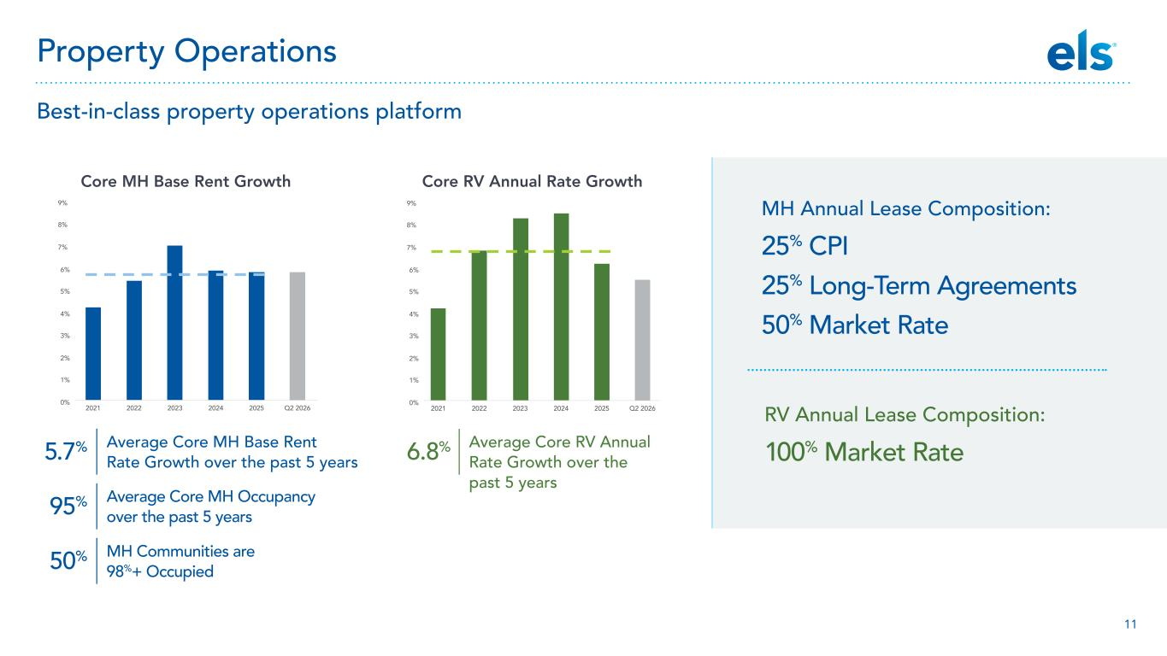
11 Best-in-class property operations platform Property Operations MH Annual Lease Composition: 25% CPI 25% Long-Term Agreements 50% Market Rate 0% 1% 2% 3% 4% 5% 6% 7% 8% 9% 2021 2022 2023 2024 2025 Q2 2026 Core MH Base Rent Growth 0% 1% 2% 3% 4% 5% 6% 7% 8% 9% 2021 2022 2023 2024 2025 Q2 2026 Core RV Annual Rate Growth RV Annual Lease Composition: 100% Market RateAverage Core MH Base Rent Rate Growth over the past 5 years Average Core RV Annual Rate Growth over the past 5 years Average Core MH Occupancy over the past 5 years MH Communities are 98%+ Occupied 5.7% 6.8% 95% 50%

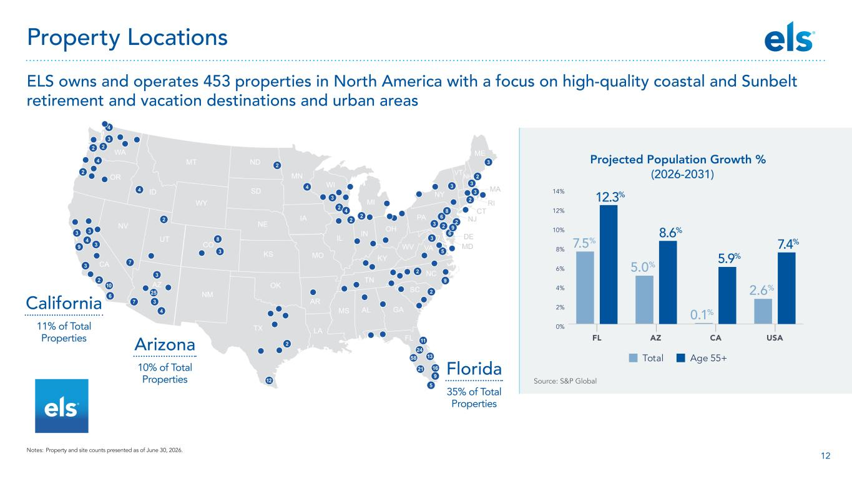
12 Source: S&P Global California 11% of Total Properties Arizona 10% of Total Properties Florida 35% of Total Properties Property Locations ELS owns and operates 453 properties in North America with a focus on high-quality coastal and Sunbelt retirement and vacation destinations and urban areas Total Age 55+ FL AZ CA USA 7.5% 5.0% 0.1% 2.6% 0% 2% 4% 6% 8% 10% 12% 14% 12.3% 8.6% 5.9% 7.4% Projected Population Growth % (2026-2031) Notes: Property and site counts presented as of June 30, 2026.

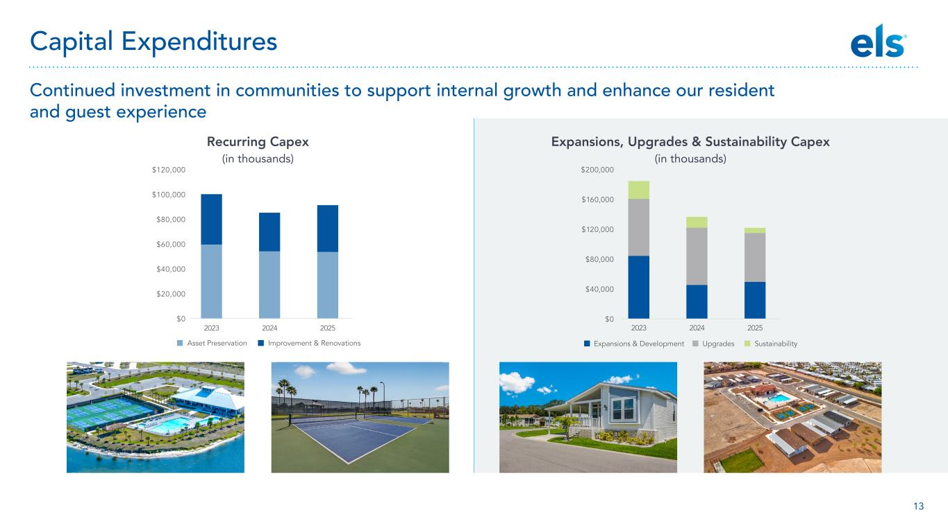
13 Continued investment in communities to support internal growth and enhance our resident and guest experience 202520242023 Expansions & Development Upgrades Sustainability $0 $40,000 $80,000 $120,000 $160,000 $200,000 2023 2024 2025 Asset Preservation Improvement & Renovations $0 $20,000 $40,000 $60,000 $80,000 $100,000 $120,000 Expansions, Upgrades & Sustainability Capex (in thousands) Capital Expenditures Recurring Capex (in thousands)

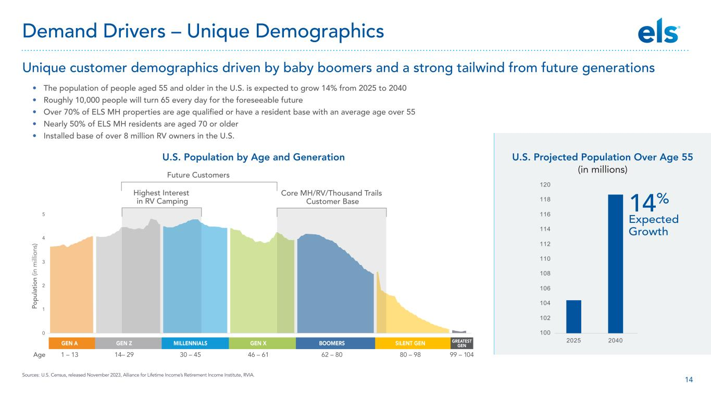
14 • The population of people aged 55 and older in the U.S. is expected to grow 14% from 2025 to 2040 • Roughly 10,000 people will turn 65 every day for the foreseeable future • Over 70% of ELS MH properties are age qualified or have a resident base with an average age over 55 • Nearly 50% of ELS MH residents are aged 70 or older • Installed base of over 8 million RV owners in the U.S. U.S. Projected Population Over Age 55 (in millions) U.S. Population by Age and Generation 0 1 2 3 4 5 Po pu la tio n (in m ill io ns ) Highest Interest in RV Camping Future Customers Core MH/RV/Thousand Trails Customer Base GEN A GEN Z MILLENNIALS GEN X BOOMERS SILENT GEN GREATEST GEN 1 – 13Age 14– 29 30 – 45 46 – 61 62 – 80 80 – 98 99 – 104 100 102 104 106 108 110 112 114 116 118 120 2025 2040 Sources: U.S. Census, released November 2023, Alliance for Lifetime Income’s Retirement Income Institute, RVIA. Unique customer demographics driven by baby boomers and a strong tailwind from future generations Demand Drivers – Unique Demographics 14% Expected Growth

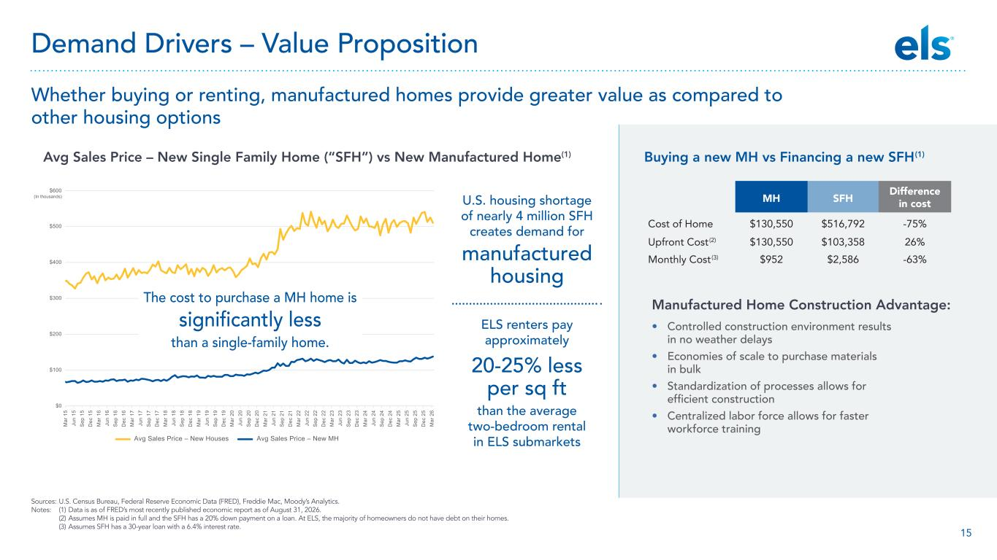
15 U.S. housing shortage of nearly 4 million SFH creates demand for manufactured housing ELS renters pay approximately 20-25% less per sq ft than the average two-bedroom rental in ELS submarkets Whether buying or renting, manufactured homes provide greater value as compared to other housing options Sources: U.S. Census Bureau, Federal Reserve Economic Data (FRED), Freddie Mac, Moody’s Analytics. Notes: (1) Data is as of FRED’s most recently published economic report as of August 31, 2026. (2) Assumes MH is paid in full and the SFH has a 20% down payment on a loan. At ELS, the majority of homeowners do not have debt on their homes. (3) Assumes SFH has a 30-year loan with a 6.4% interest rate. MH SFH Difference in cost Cost of Home $130,550 $516,792 -75% Upfront Cost(2) $130,550 $103,358 26% Monthly Cost(3) $952 $2,586 -63% $0 $100 $200 $300 $400 $500 $600 (In thousands) M ar 1 5 Ju n 15 S ep 1 5 D ec 1 5 M ar 1 6 Ju n 16 S ep 1 6 D ec 1 6 M ar 1 7 Ju n 17 S ep 1 7 D ec 1 7 M ar 1 8 Ju n 18 S ep 1 8 D ec 1 8 M ar 1 9 Ju n 19 S ep 1 9 D ec 1 9 M ar 2 0 Ju n 20 S ep 2 0 D ec 2 0 M ar 2 1 Ju n 21 S ep 2 1 D ec 2 1 M ar 2 2 Ju n 22 S ep 2 2 D ec 2 2 M ar 2 3 Ju n 23 S ep 2 3 D ec 2 3 M ar 2 4 Ju n 24 S ep 2 4 D ec 2 4 M ar 2 5 Ju n 25 S ep 2 5 D ec 2 5 M ar 2 6 Avg Sales Price – New Houses Avg Sales Price – New MH The cost to purchase a MH home is significantly less than a single-family home. Demand Drivers – Value Proposition Avg Sales Price – New Single Family Home (“SFH”) vs New Manufactured Home(1) Buying a new MH vs Financing a new SFH(1) Manufactured Home Construction Advantage: • Controlled construction environment results in no weather delays • Economies of scale to purchase materials in bulk • Standardization of processes allows for efficient construction • Centralized labor force allows for faster workforce training

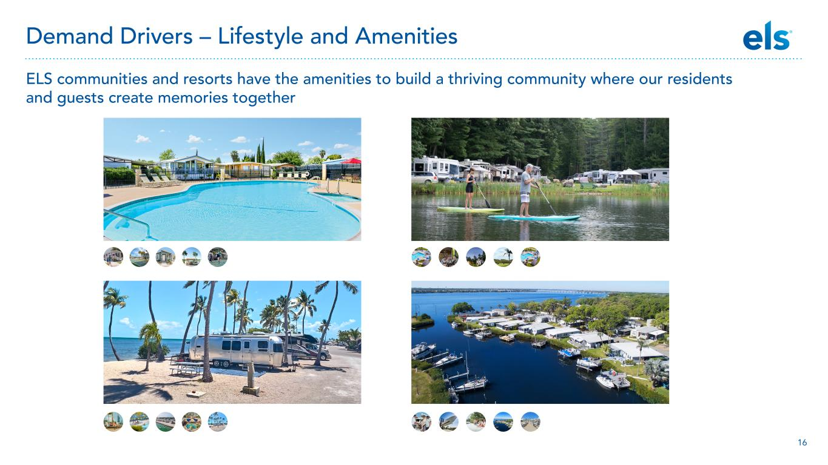
16 ELS communities and resorts have the amenities to build a thriving community where our residents and guests create memories together Demand Drivers – Lifestyle and Amenities

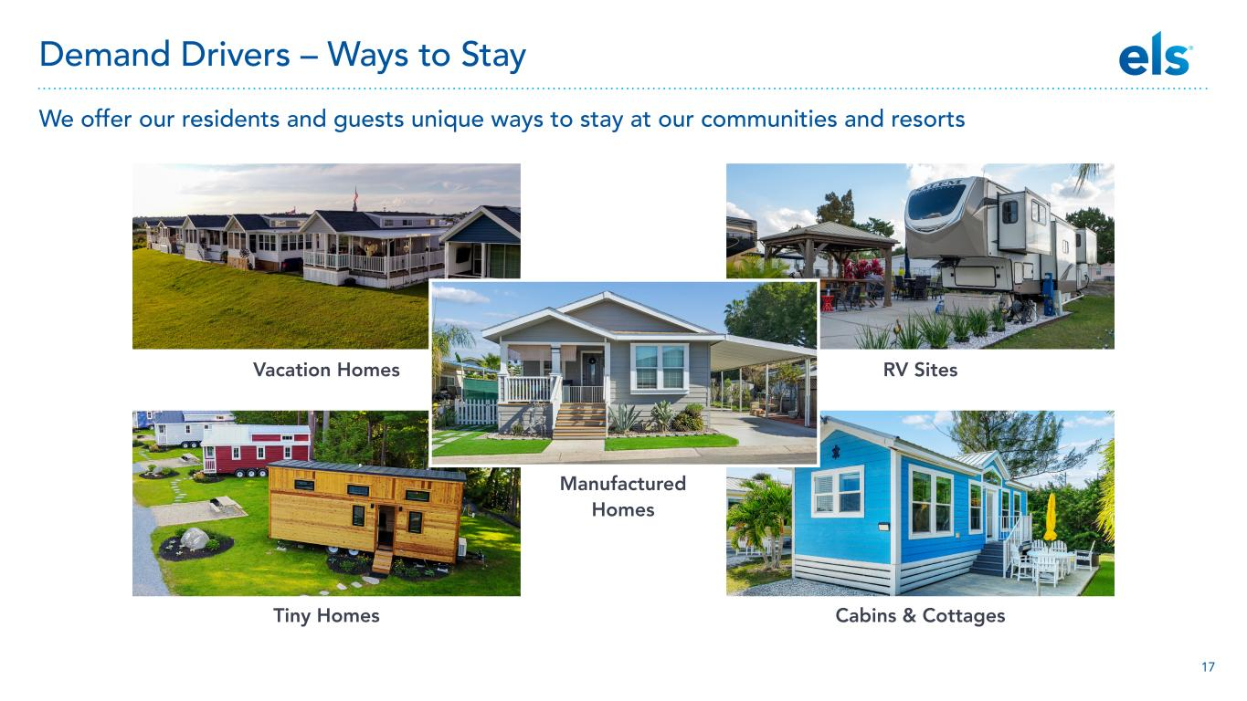
17 We offer our residents and guests unique ways to stay at our communities and resorts Demand Drivers – Ways to Stay Vacation Homes Manufactured Homes RV Sites Tiny Homes Cabins & Cottages

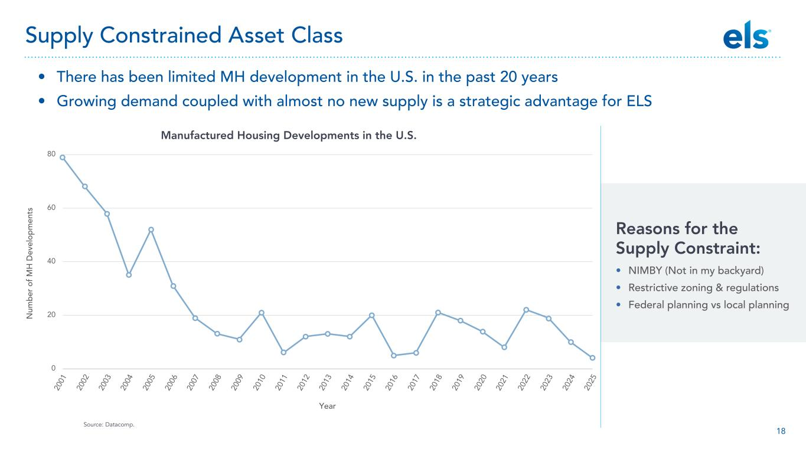
18 20 01 20 02 20 03 20 04 20 05 20 06 20 07 20 08 20 09 20 10 20 11 20 12 20 13 20 14 20 15 20 16 20 17 20 18 20 19 20 20 20 21 20 22 20 23 20 24 20 25 Year 0 20 40 60 80 N um be r o f M H D ev el op m en ts Manufactured Housing Developments in the U.S. Source: Datacomp. • There has been limited MH development in the U.S. in the past 20 years • Growing demand coupled with almost no new supply is a strategic advantage for ELS Supply Constrained Asset Class Reasons for the Supply Constraint: • NIMBY (Not in my backyard) • Restrictive zoning & regulations • Federal planning vs local planning

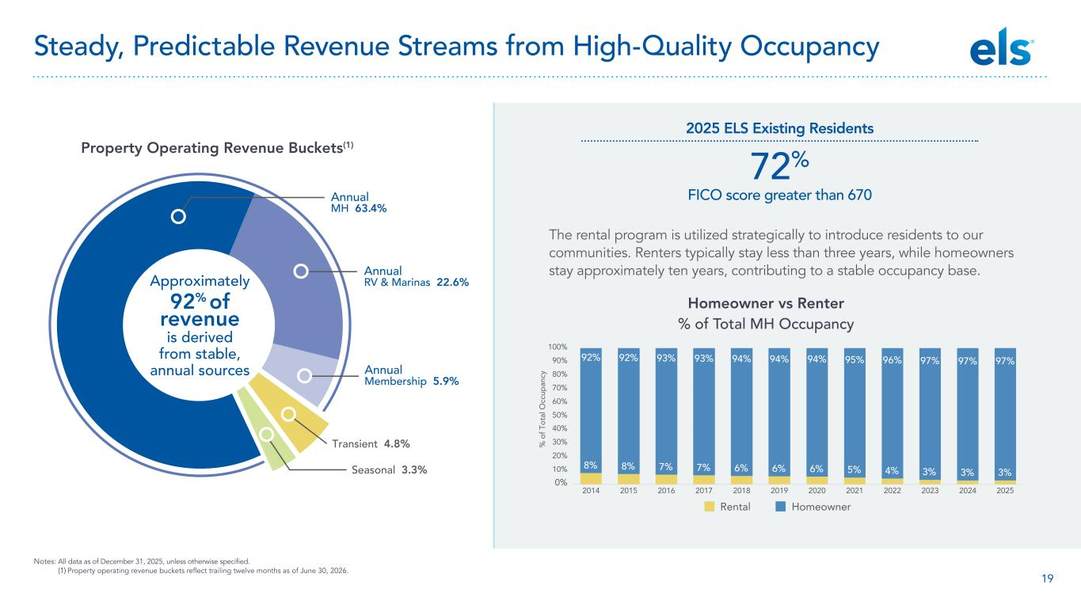
19 Homeowner vs Renter % of Total MH Occupancy 2025 ELS Existing Residents 72% FICO score greater than 670Annual MH 63.4% Annual RV & Marinas 22.6% Annual Membership 5.9% Transient 4.8% Seasonal 3.3% Approximately 92% of revenue is derived from stable, annual sources Property Operating Revenue Buckets(1) Notes: All data as of December 31, 2025, unless otherwise specified. (1) Property operating revenue buckets reflect trailing twelve months as of June 30, 2026. 8% 8% 7% 7% 6% 6% 6% 5% 4% 3% 3% 92% 92% 93% 93% 94% 94% 94% 95% 96% 97% 97% 0% 10% 20% 30% 40% 50% 60% 70% 80% 90% 100% 2014 2015 2016 2017 2018 2019 2020 2021 2022 2023 2024 3% 97% 2025 % o f T ot al O cc up an cy Rental Homeowner Steady, Predictable Revenue Streams from High-Quality Occupancy The rental program is utilized strategically to introduce residents to our communities. Renters typically stay less than three years, while homeowners stay approximately ten years, contributing to a stable occupancy base.

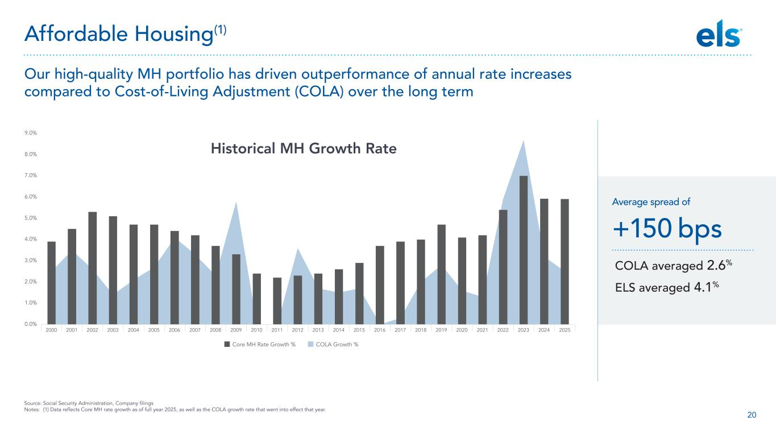
20 0.0% 1.0% 2.0% 3.0% 4.0% 5.0% 6.0% 7.0% 8.0% 9.0% 2000 2001 2002 2003 2004 2005 2006 2007 2008 2009 2010 2011 2012 2013 2014 2015 2016 2017 2018 2019 2020 2021 2022 2023 2024 2025 Core MH Rate Growth % COLA Growth % Historical MH Growth Rate Source: Social Security Administration, Company filings Notes: (1) Data reflects Core MH rate growth as of full year 2025, as well as the COLA growth rate that went into effect that year. Our high-quality MH portfolio has driven outperformance of annual rate increases compared to Cost-of-Living Adjustment (COLA) over the long term Affordable Housing(1) COLA averaged 2.6% ELS averaged 4.1% Average spread of +150 bps

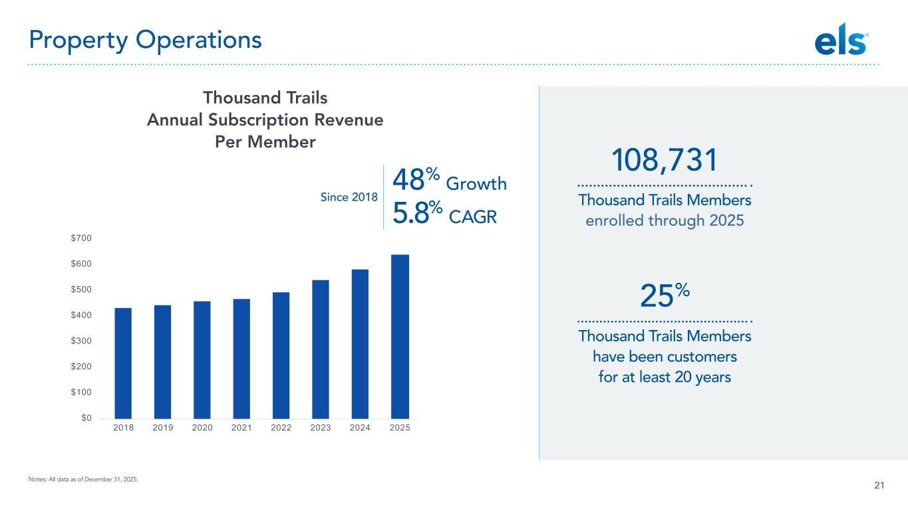
21 25% Thousand Trails Members have been customers for at least 20 years 108,731 Thousand Trails Members enrolled through 2025 Notes: All data as of December 31, 2025. $0 $100 $200 $300 $400 $500 $600 $700 2018 2019 2020 2021 2022 2023 2024 2025 Thousand Trails Annual Subscription Revenue Per Member Property Operations 5.8% CAGR Since 2018 48% Growth

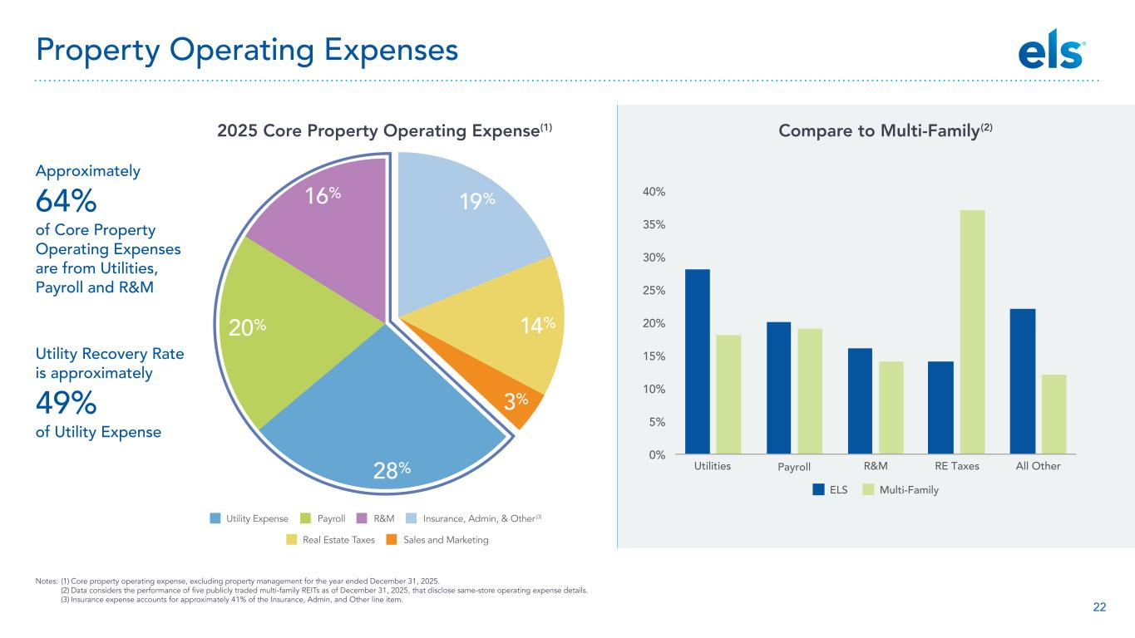
22 2025 Core Property Operating Expense(1) Compare to Multi-Family(2) Notes: (1) Core property operating expense, excluding property management for the year ended December 31, 2025. (2) Data considers the performance of five publicly traded multi-family REITs as of December 31, 2025, that disclose same-store operating expense details. (3) Insurance expense accounts for approximately 41% of the Insurance, Admin, and Other line item. ELS Multi-Family Utilities Payroll R&M RE Taxes All Other 0% 5% 10% 15% 20% 25% 30% 35% 40% 20% 27% 16% 19% 14% 4% Real Estate Taxes Sales and Marketing 19% 14% 3% 28% 20% 16% Utility Expense Payroll R&M Insurance, Admin, & Other(3) Approximately 64% of Core Property Operating Expenses are from Utilities, Payroll and R&M Utility Recovery Rate is approximately 49% of Utility Expense Property Operating Expenses

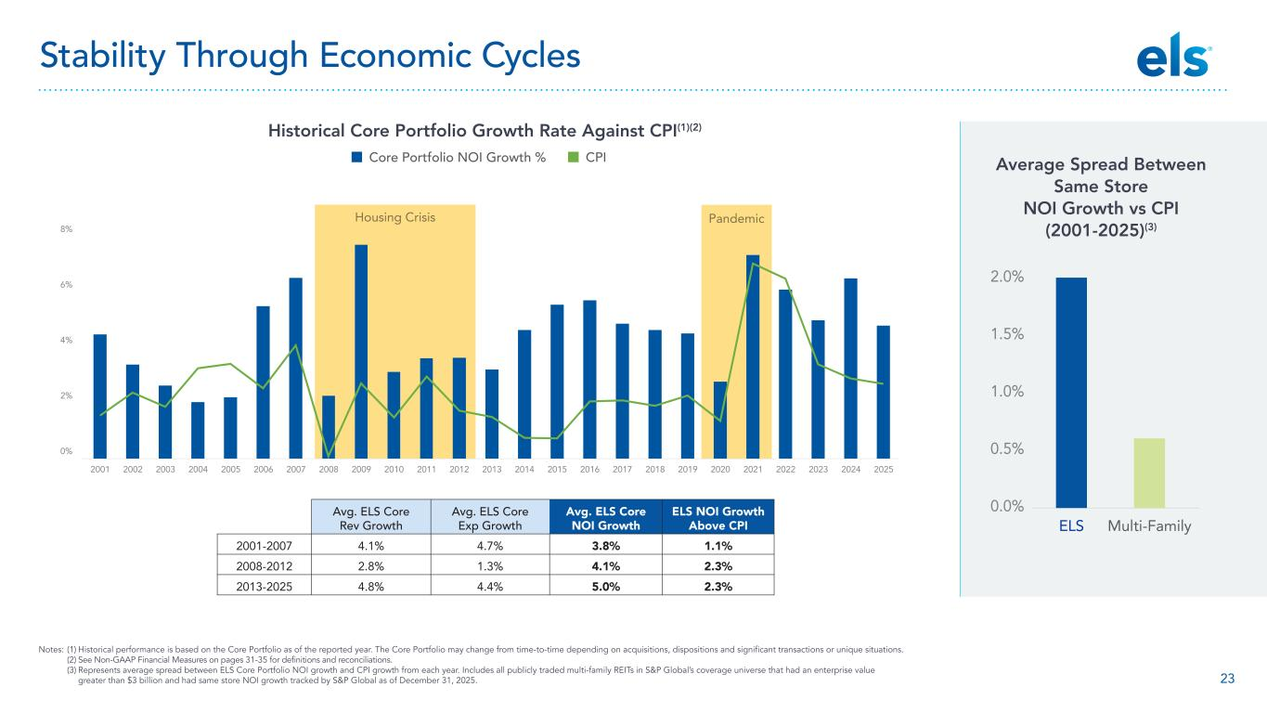
23 Notes: (1) Historical performance is based on the Core Portfolio as of the reported year. The Core Portfolio may change from time-to-time depending on acquisitions, dispositions and significant transactions or unique situations. (2) See Non-GAAP Financial Measures on pages 31-35 for definitions and reconciliations. (3) Represents average spread between ELS Core Portfolio NOI growth and CPI growth from each year. Includes all publicly traded multi-family REITs in S&P Global’s coverage universe that had an enterprise value greater than $3 billion and had same store NOI growth tracked by S&P Global as of December 31, 2025. Housing Crisis Pandemic 2001 2002 2003 2004 2005 2006 2007 2008 2009 2010 2011 2012 2013 2014 2015 2016 2017 2018 2019 2020 2021 2022 2023 2024 2025 0% 2% 4% 6% 8% Avg. ELS Core Rev Growth Avg. ELS Core Exp Growth Avg. ELS Core NOI Growth ELS NOI Growth Above CPI 2001-2007 4.1% 4.7% 3.8% 1.1% 2008-2012 2.8% 1.3% 4.1% 2.3% 2013-2025 4.8% 4.4% 5.0% 2.3% Stability Through Economic Cycles Historical Core Portfolio Growth Rate Against CPI(1)(2) Core Portfolio NOI Growth % CPI Average Spread Between Same Store NOI Growth vs CPI (2001-2025)(3) 0.0% 0.5% 1.0% 1.5% 2.0% ELS Multi-Family

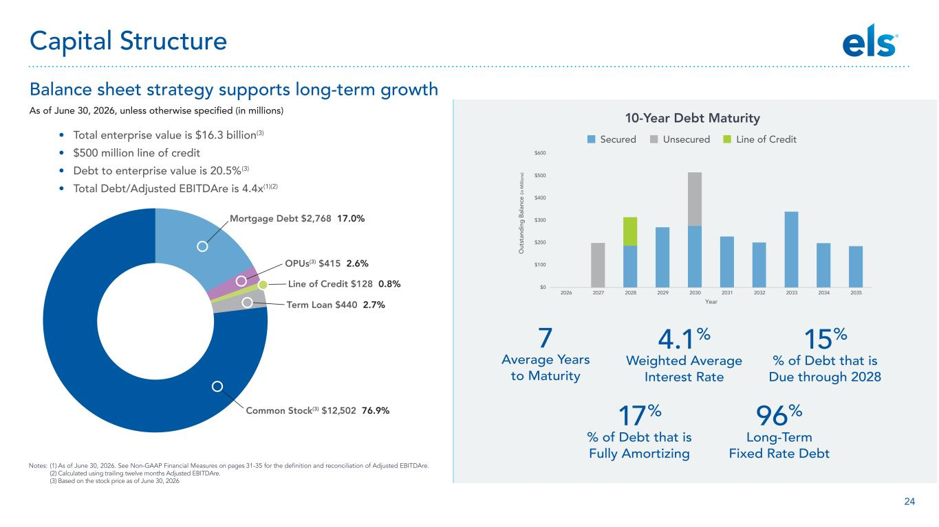
24 Balance sheet strategy supports long-term growth As of June 30, 2026, unless otherwise specified (in millions) Mortgage Debt $2,768 17.0% OPUs(3) $415 2.6% Line of Credit $128 0.8% Term Loan $440 2.7% Common Stock(3) $12,502 76.9% • Total enterprise value is $16.3 billion(3) • $500 million line of credit • Debt to enterprise value is 20.5%(3) • Total Debt/Adjusted EBITDAre is 4.4x(1)(2) Notes: (1) As of June 30, 2026. See Non-GAAP Financial Measures on pages 31-35 for the definition and reconciliation of Adjusted EBITDAre. (2) Calculated using trailing twelve months Adjusted EBITDAre. (3) Based on the stock price as of June 30, 2026 Capital Structure 10-Year Debt Maturity Secured Unsecured Line of Credit 7 Average Years to Maturity 17% % of Debt that is Fully Amortizing 96% Long-Term Fixed Rate Debt 4.1% Weighted Average Interest Rate 15% % of Debt that is Due through 2028 $0 $100 $200 $300 $400 $500 $600 2026 2027 2028 2029 2030 2031 2032 2033 2034 2035 Year O ut st an di ng B al an ce (in M ill io ns )

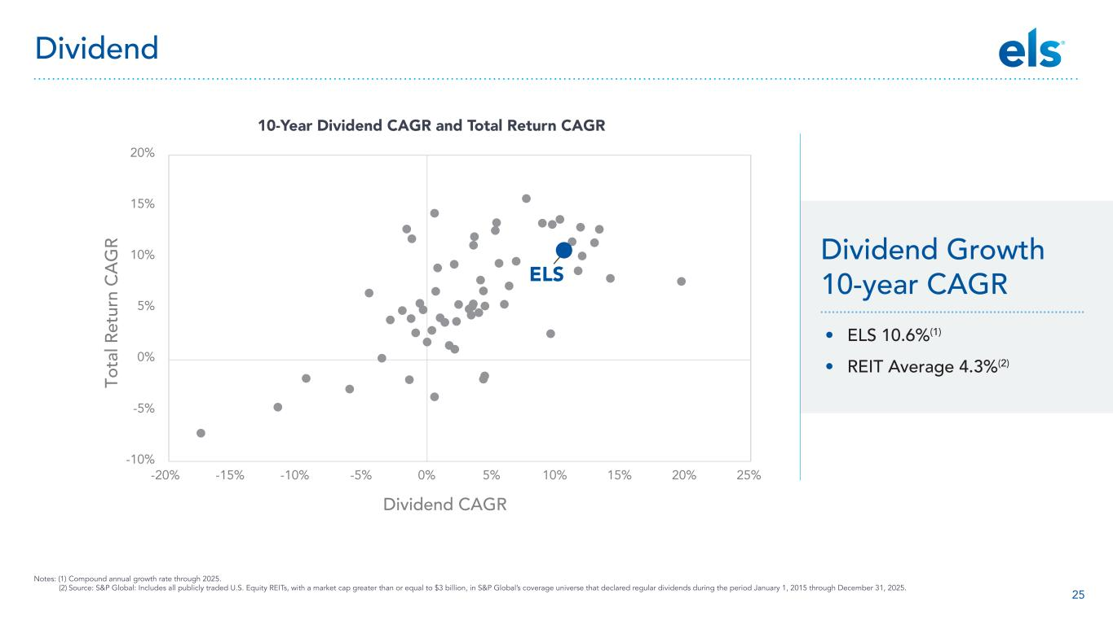
25 -10% -5% 0% 5% 10% 15% 20% -20% To ta l R et ur n CA G R -15% -10% -5% 0% 5% 10% 15% 20% 25% Dividend CAGR ELS Notes: (1) Compound annual growth rate through 2025. (2) Source: S&P Global: Includes all publicly traded U.S. Equity REITs, with a market cap greater than or equal to $3 billion, in S&P Global’s coverage universe that declared regular dividends during the period January 1, 2015 through December 31, 2025. 10-Year Dividend CAGR and Total Return CAGR • ELS 10.6%(1) • REIT Average 4.3%(2) Dividend Growth 10-year CAGR Dividend

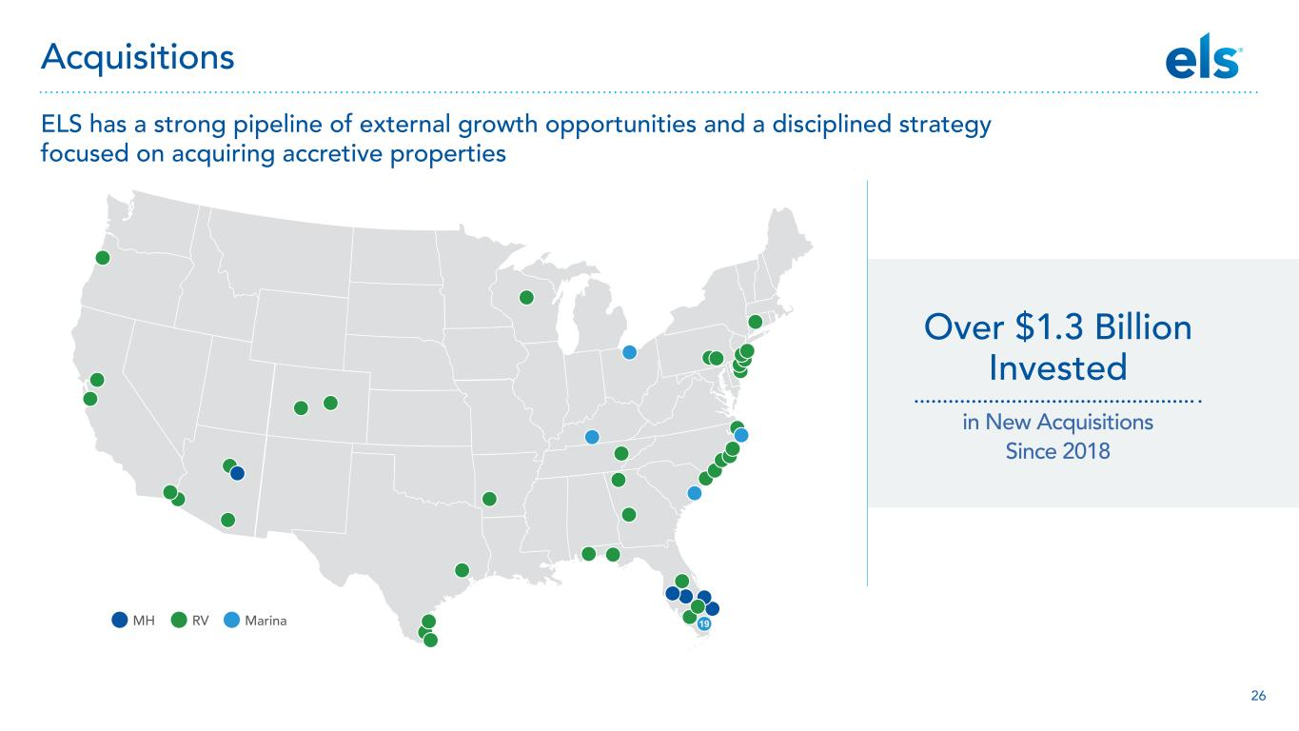
26 ELS has a strong pipeline of external growth opportunities and a disciplined strategy focused on acquiring accretive properties Acquisitions 19MH RV Marina Over $1.3 Billion Invested in New Acquisitions Since 2018

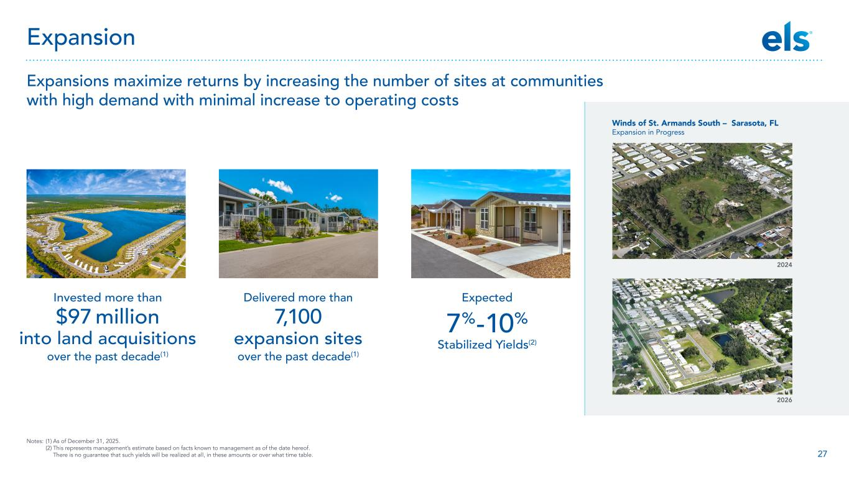
27 Notes: (1) As of December 31, 2025. (2) This represents management’s estimate based on facts known to management as of the date hereof. There is no guarantee that such yields will be realized at all, in these amounts or over what time table. Expansions maximize returns by increasing the number of sites at communities with high demand with minimal increase to operating costs Expansion Invested more than $97 million into land acquisitions over the past decade(1) Delivered more than 7,100 expansion sites over the past decade(1) Expected 7%-10% Stabilized Yields(2) 2024 2026 Winds of St. Armands South – Sarasota, FL Expansion in Progress

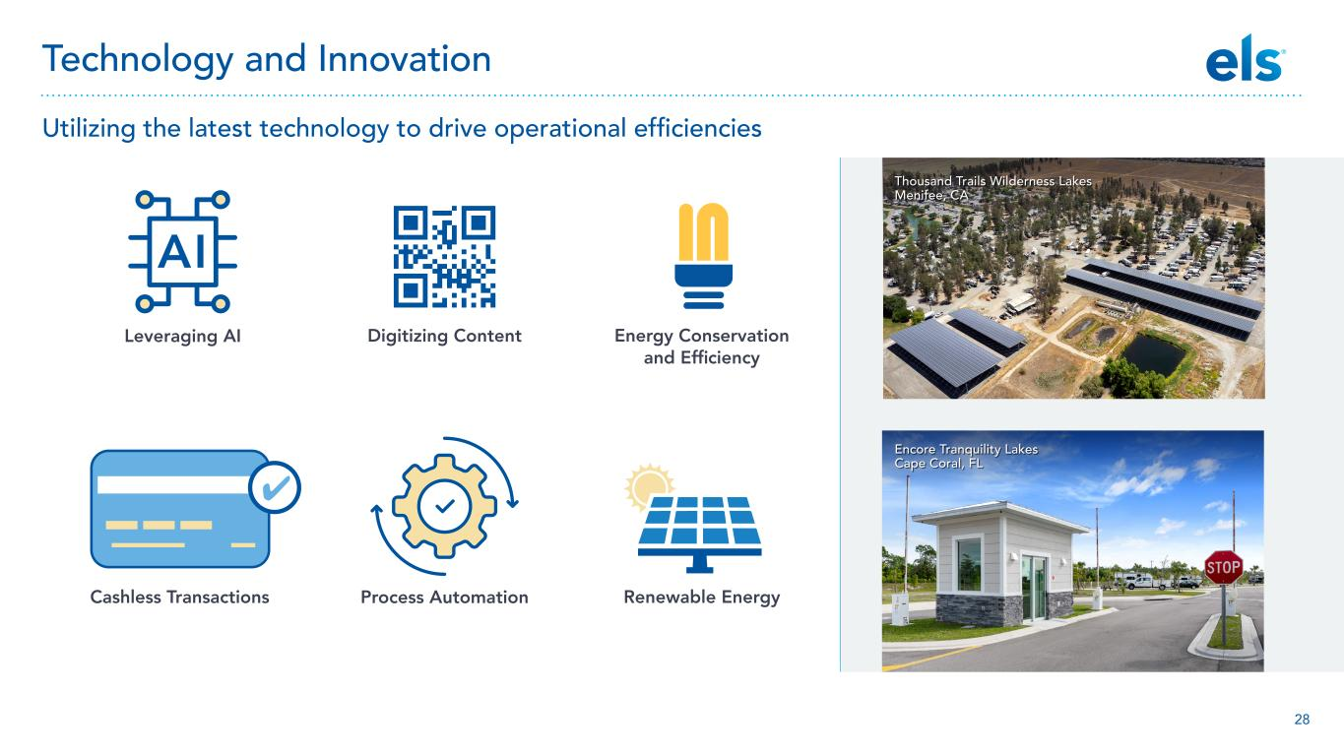
28 Thousand Trails Wilderness Lakes Menifee, CA Encore Tranquility Lakes Cape Coral, FL Leveraging AI Cashless Transactions Digitizing Content Process Automation Renewable Energy Energy Conservation and Efficiency Utilizing the latest technology to drive operational efficiencies Technology and Innovation


29 Over 2.4 Million Total followers across social media channels 6 Properties received award for five consecutive years 23 Travelers’ Choice Awards How our guests connect with us every day Partnering with top travel sites to meet customers where they are Driving digital engagement and building trust

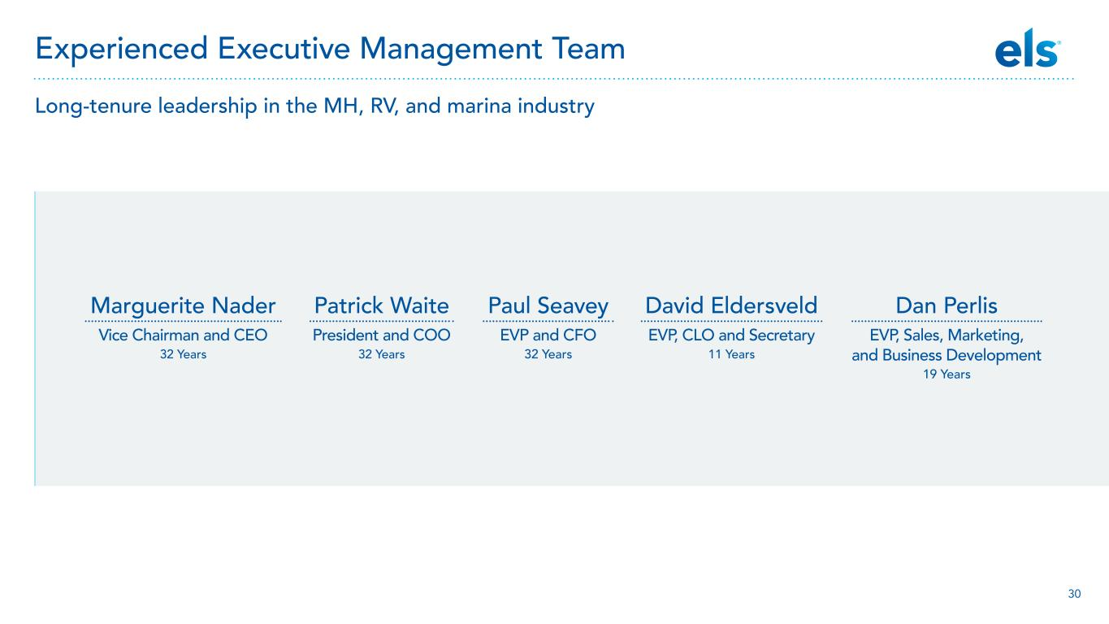
30 Marguerite Nader Vice Chairman and CEO 32 Years Paul Seavey EVP and CFO 32 Years Patrick Waite President and COO 32 Years David Eldersveld EVP, CLO and Secretary 11 Years Dan Perlis EVP, Sales, Marketing, and Business Development 19 Years Long-tenure leadership in the MH, RV, and marina industry Experienced Executive Management Team

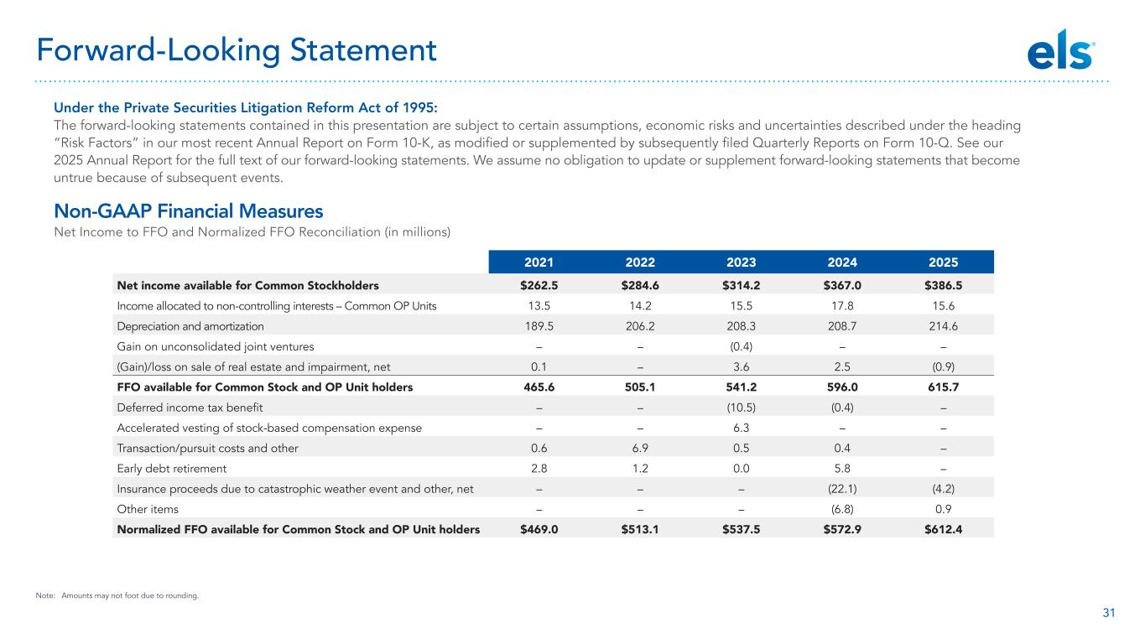
31 Under the Private Securities Litigation Reform Act of 1995: The forward-looking statements contained in this presentation are subject to certain assumptions, economic risks and uncertainties described under the heading “Risk Factors” in our most recent Annual Report on Form 10-K, as modified or supplemented by subsequently filed Quarterly Reports on Form 10-Q. See our 2025 Annual Report for the full text of our forward-looking statements. We assume no obligation to update or supplement forward-looking statements that become untrue because of subsequent events. Non-GAAP Financial Measures Net Income to FFO and Normalized FFO Reconciliation (in millions) 2021 2022 2023 2024 2025 Net income available for Common Stockholders $262.5 $284.6 $314.2 $367.0 $386.5 Income allocated to non-controlling interests – Common OP Units 13.5 14.2 15.5 17.8 15.6 Depreciation and amortization 189.5 206.2 208.3 208.7 214.6 Gain on unconsolidated joint ventures – – (0.4) – – (Gain)/loss on sale of real estate and impairment, net 0.1 – 3.6 2.5 (0.9) FFO available for Common Stock and OP Unit holders 465.6 505.1 541.2 596.0 615.7 Deferred income tax benefit – – (10.5) (0.4) – Accelerated vesting of stock-based compensation expense – – 6.3 – – Transaction/pursuit costs and other 0.6 6.9 0.5 0.4 – Early debt retirement 2.8 1.2 0.0 5.8 – Insurance proceeds due to catastrophic weather event and other, net – – – (22.1) (4.2) Other items – – – (6.8) 0.9 Normalized FFO available for Common Stock and OP Unit holders $469.0 $513.1 $537.5 $572.9 $612.4 Forward-Looking Statement Note: Amounts may not foot due to rounding.

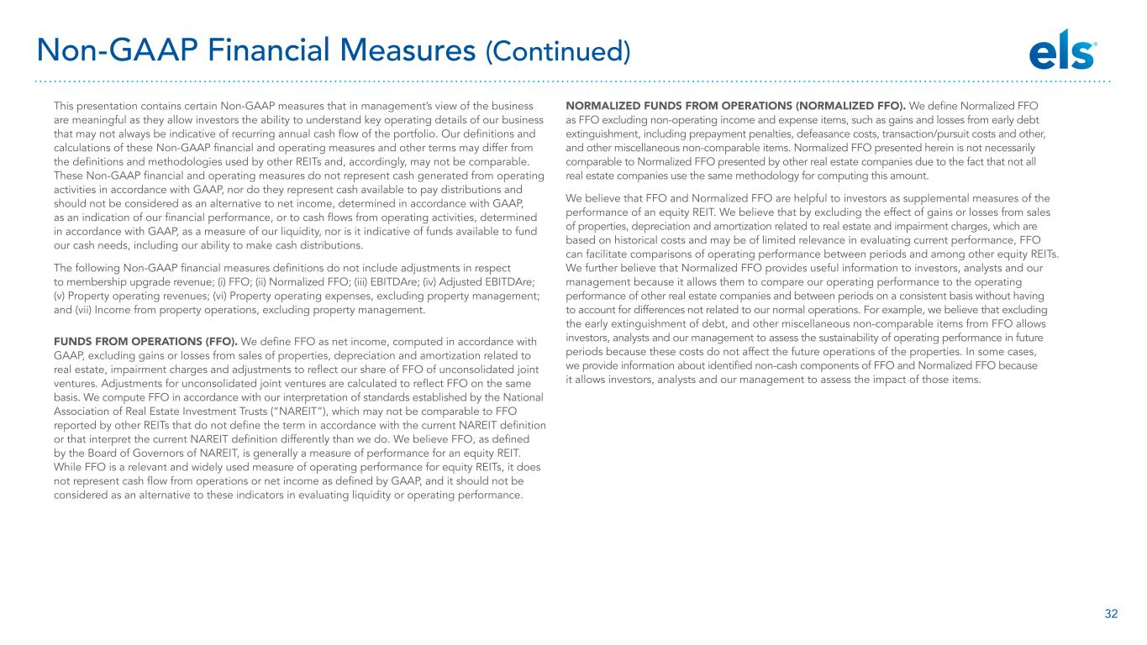
32 This presentation contains certain Non-GAAP measures that in management’s view of the business are meaningful as they allow investors the ability to understand key operating details of our business that may not always be indicative of recurring annual cash flow of the portfolio. Our definitions and calculations of these Non-GAAP financial and operating measures and other terms may differ from the definitions and methodologies used by other REITs and, accordingly, may not be comparable. These Non-GAAP financial and operating measures do not represent cash generated from operating activities in accordance with GAAP, nor do they represent cash available to pay distributions and should not be considered as an alternative to net income, determined in accordance with GAAP, as an indication of our financial performance, or to cash flows from operating activities, determined in accordance with GAAP, as a measure of our liquidity, nor is it indicative of funds available to fund our cash needs, including our ability to make cash distributions. The following Non-GAAP financial measures definitions do not include adjustments in respect to membership upgrade revenue; (i) FFO; (ii) Normalized FFO; (iii) EBITDAre; (iv) Adjusted EBITDAre; (v) Property operating revenues; (vi) Property operating expenses, excluding property management; and (vii) Income from property operations, excluding property management. FUNDS FROM OPERATIONS (FFO). We define FFO as net income, computed in accordance with GAAP, excluding gains or losses from sales of properties, depreciation and amortization related to real estate, impairment charges and adjustments to reflect our share of FFO of unconsolidated joint ventures. Adjustments for unconsolidated joint ventures are calculated to reflect FFO on the same basis. We compute FFO in accordance with our interpretation of standards established by the National Association of Real Estate Investment Trusts (“NAREIT”), which may not be comparable to FFO reported by other REITs that do not define the term in accordance with the current NAREIT definition or that interpret the current NAREIT definition differently than we do. We believe FFO, as defined by the Board of Governors of NAREIT, is generally a measure of performance for an equity REIT. While FFO is a relevant and widely used measure of operating performance for equity REITs, it does not represent cash flow from operations or net income as defined by GAAP, and it should not be considered as an alternative to these indicators in evaluating liquidity or operating performance. NORMALIZED FUNDS FROM OPERATIONS (NORMALIZED FFO). We define Normalized FFO as FFO excluding non-operating income and expense items, such as gains and losses from early debt extinguishment, including prepayment penalties, defeasance costs, transaction/pursuit costs and other, and other miscellaneous non-comparable items. Normalized FFO presented herein is not necessarily comparable to Normalized FFO presented by other real estate companies due to the fact that not all real estate companies use the same methodology for computing this amount. We believe that FFO and Normalized FFO are helpful to investors as supplemental measures of the performance of an equity REIT. We believe that by excluding the effect of gains or losses from sales of properties, depreciation and amortization related to real estate and impairment charges, which are based on historical costs and may be of limited relevance in evaluating current performance, FFO can facilitate comparisons of operating performance between periods and among other equity REITs. We further believe that Normalized FFO provides useful information to investors, analysts and our management because it allows them to compare our operating performance to the operating performance of other real estate companies and between periods on a consistent basis without having to account for differences not related to our normal operations. For example, we believe that excluding the early extinguishment of debt, and other miscellaneous non-comparable items from FFO allows investors, analysts and our management to assess the sustainability of operating performance in future periods because these costs do not affect the future operations of the properties. In some cases, we provide information about identified non-cash components of FFO and Normalized FFO because it allows investors, analysts and our management to assess the impact of those items. Non-GAAP Financial Measures (Continued)

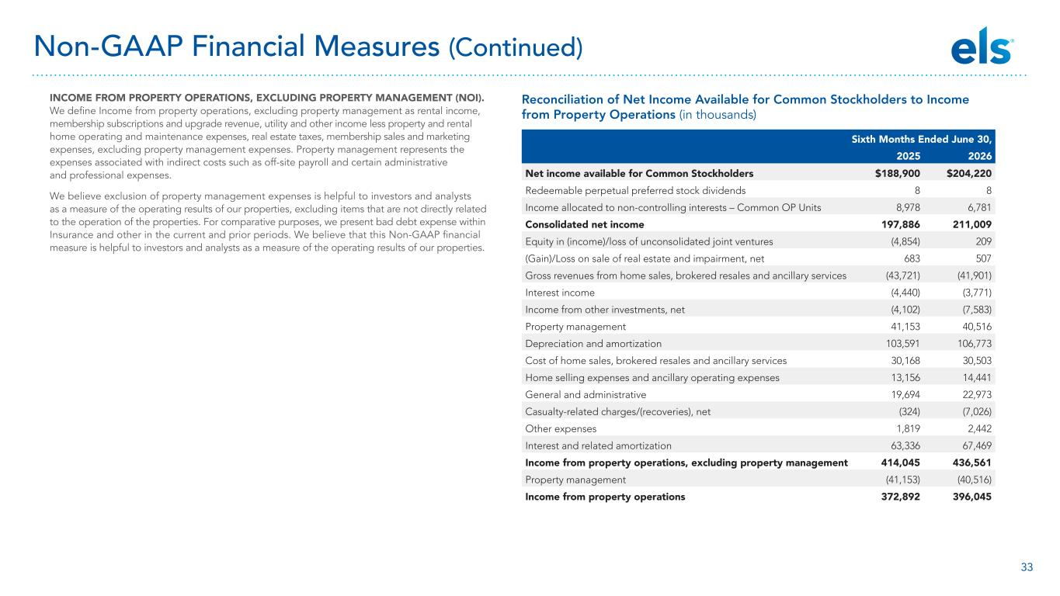
33 Reconciliation of Net Income Available for Common Stockholders to Income from Property Operations (in thousands) INCOME FROM PROPERTY OPERATIONS, EXCLUDING PROPERTY MANAGEMENT (NOI). We define Income from property operations, excluding property management as rental income, membership subscriptions and upgrade revenue, utility and other income less property and rental home operating and maintenance expenses, real estate taxes, membership sales and marketing expenses, excluding property management expenses. Property management represents the expenses associated with indirect costs such as off-site payroll and certain administrative and professional expenses. We believe exclusion of property management expenses is helpful to investors and analysts as a measure of the operating results of our properties, excluding items that are not directly related to the operation of the properties. For comparative purposes, we present bad debt expense within Insurance and other in the current and prior periods. We believe that this Non-GAAP financial measure is helpful to investors and analysts as a measure of the operating results of our properties. Sixth Months Ended June 30, 2025 2026 Net income available for Common Stockholders $188,900 $204,220 Redeemable perpetual preferred stock dividends 8 8 Income allocated to non-controlling interests – Common OP Units 8,978 6,781 Consolidated net income 197,886 211,009 Equity in (income)/loss of unconsolidated joint ventures (4,854) 209 (Gain)/Loss on sale of real estate and impairment, net 683 507 Gross revenues from home sales, brokered resales and ancillary services (43,721) (41,901) Interest income (4,440) (3,771) Income from other investments, net (4,102) (7,583) Property management 41,153 40,516 Depreciation and amortization 103,591 106,773 Cost of home sales, brokered resales and ancillary services 30,168 30,503 Home selling expenses and ancillary operating expenses 13,156 14,441 General and administrative 19,694 22,973 Casualty-related charges/(recoveries), net (324) (7,026) Other expenses 1,819 2,442 Interest and related amortization 63,336 67,469 Income from property operations, excluding property management 414,045 436,561 Property management (41,153) (40,516) Income from property operations 372,892 396,045 Non-GAAP Financial Measures (Continued)

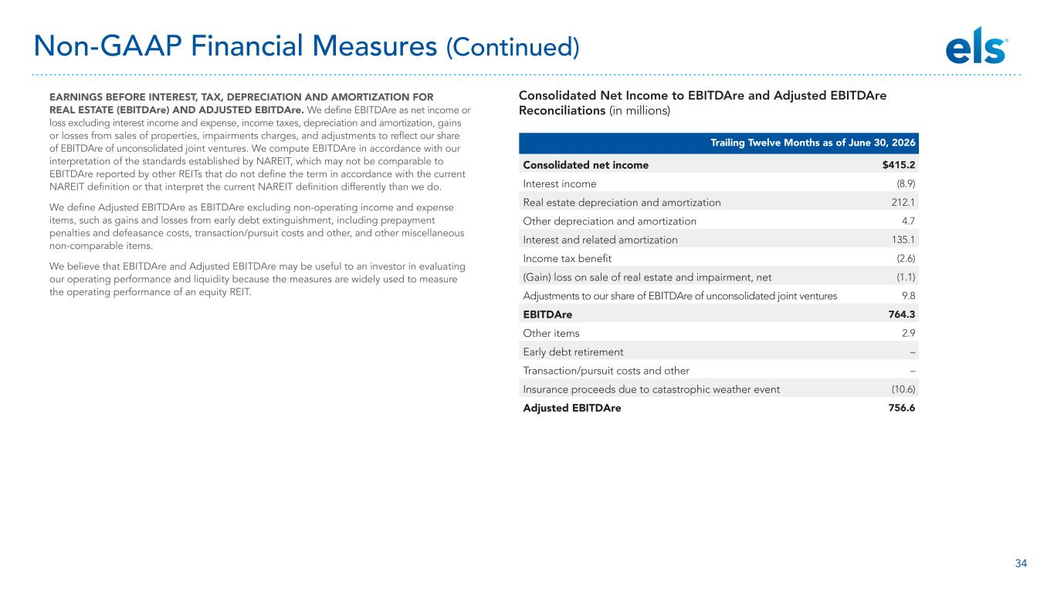
34 Consolidated Net Income to EBITDAre and Adjusted EBITDAre Reconciliations (in millions) EARNINGS BEFORE INTEREST, TAX, DEPRECIATION AND AMORTIZATION FOR REAL ESTATE (EBITDAre) AND ADJUSTED EBITDAre. We define EBITDAre as net income or loss excluding interest income and expense, income taxes, depreciation and amortization, gains or losses from sales of properties, impairments charges, and adjustments to reflect our share of EBITDAre of unconsolidated joint ventures. We compute EBITDAre in accordance with our interpretation of the standards established by NAREIT, which may not be comparable to EBITDAre reported by other REITs that do not define the term in accordance with the current NAREIT definition or that interpret the current NAREIT definition differently than we do. We define Adjusted EBITDAre as EBITDAre excluding non-operating income and expense items, such as gains and losses from early debt extinguishment, including prepayment penalties and defeasance costs, transaction/pursuit costs and other, and other miscellaneous non-comparable items. We believe that EBITDAre and Adjusted EBITDAre may be useful to an investor in evaluating our operating performance and liquidity because the measures are widely used to measure the operating performance of an equity REIT. Non-GAAP Financial Measures (Continued) Trailing Twelve Months as of June 30, 2026 Consolidated net income $415.2 Interest income (8.9) Real estate depreciation and amortization 212.1 Other depreciation and amortization 4.7 Interest and related amortization 135.1 Income tax benefit (2.6) (Gain) loss on sale of real estate and impairment, net (1.1) Adjustments to our share of EBITDAre of unconsolidated joint ventures 9.8 EBITDAre 764.3 Other items 2.9 Early debt retirement – Transaction/pursuit costs and other – Insurance proceeds due to catastrophic weather event (10.6) Adjusted EBITDAre 756.6

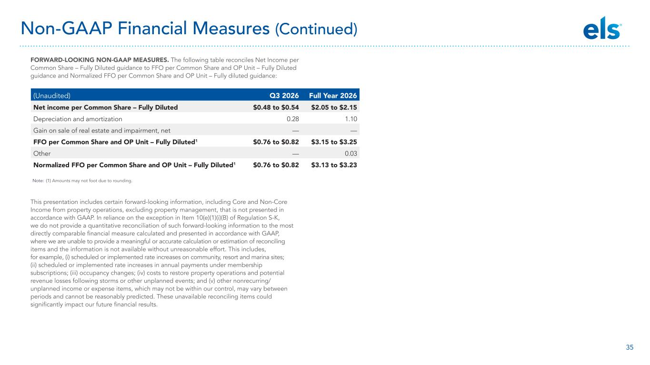
35 FORWARD-LOOKING NON-GAAP MEASURES. The following table reconciles Net Income per Common Share – Fully Diluted guidance to FFO per Common Share and OP Unit – Fully Diluted guidance and Normalized FFO per Common Share and OP Unit – Fully diluted guidance: This presentation includes certain forward-looking information, including Core and Non-Core Income from property operations, excluding property management, that is not presented in accordance with GAAP. In reliance on the exception in Item 10(e)(1)(i)(B) of Regulation S-K, we do not provide a quantitative reconciliation of such forward-looking information to the most directly comparable financial measure calculated and presented in accordance with GAAP, where we are unable to provide a meaningful or accurate calculation or estimation of reconciling items and the information is not available without unreasonable effort. This includes, for example, (i) scheduled or implemented rate increases on community, resort and marina sites; (ii) scheduled or implemented rate increases in annual payments under membership subscriptions; (iii) occupancy changes; (iv) costs to restore property operations and potential revenue losses following storms or other unplanned events; and (v) other nonrecurring/ unplanned income or expense items, which may not be within our control, may vary between periods and cannot be reasonably predicted. These unavailable reconciling items could significantly impact our future financial results. (Unaudited) Q3 2026 Full Year 2026 Net income per Common Share – Fully Diluted $0.48 to $0.54 $2.05 to $2.15 Depreciation and amortization 0.28 1.10 Gain on sale of real estate and impairment, net — — FFO per Common Share and OP Unit – Fully Diluted1 $0.76 to $0.82 $3.15 to $3.25 Other — 0.03 Normalized FFO per Common Share and OP Unit – Fully Diluted1 $0.76 to $0.82 $3.13 to $3.23 Non-GAAP Financial Measures (Continued) Note: (1) Amounts may not foot due to rounding.



