UNITED STATES
SECURITIES AND EXCHANGE COMMISSION WASHINGTON, DC 20549

SCHEDULE 14A
(Rule 14a-101)

INFORMATION REQUIRED IN PROXY STATEMENT SCHEDULE 14A INFORMATION

Proxy Statement Pursuant to Section 14(a) of the Securities Exchange Act of 1934

Filed by the Registrant [X]
Filed by a Party other than the Registrant [ ] Check the appropriate box:
[ ] Preliminary proxy statement

[ ] Confidential, for Use of the Commission Only (as permitted by Rule 14a-6(e)(2))
[X] Definitive proxy statement
[ ] Definitive additional materials
[ ] Soliciting Material pursuant to §14a-12 Name of Registrant as Specified in its Charter:
EQUITY LIFESTYLE PROPERTIES, INC.

Name of Person(s) Filing Proxy Statement if other than the Registrant: N/A
Payment of filing fee (check the appropriate box):

- No fee required.

[ ] Fee computed on table below per Exchange Act Rules 14a-6(i)(1) and 0-11.

  - Title of each class of securities to which transaction applies:
  - Aggregate number of securities to which transaction applies:
  - Per unit price or other underlying value of transaction computed pursuant to Exchange Act Rule 0-11 (set forth the amount on which the filing fee is calculated and state how it was determined):
  - Proposed maximum aggregate value of transaction:
  - Total fee paid:

[ ] Fee paid previously with preliminary materials.

[ ] Check box if any part of the fee is offset as provided by Exchange Act Rule 0-11(a)(2) and identify the filing for which the offsetting fee was paid previously. Identify the previous filing by registration statement number, or the Form or Schedule and the date of its filing.

- Amount previously paid:
- Form, Schedule or Registration Statement No.:
- Filing party:
- Date filed:

NOTICE OF ANNUAL MEETING OF STOCKHOLDERS EQUITY LIFESTYLE PROPERTIES, INC.

To Our Shareholders:
You are cordially invited to attend the 2022 Annual Meeting of Stockholders (the "Annual Meeting") of Equity LifeStyle Properties, Inc. You will be able to attend the virtual Annual Meeting, vote your shares electronically and submit your questions during the live webcast.

 DATE AND TIME
Tuesday, April 26, 2022 9:00 a.m. Central Time

  ACCESS THE ANNUAL MEETING
Stockholders may participate in the virtual Annual Meeting by logging in at www.virtualshareholdermeeting.com/ELS2022.

 RECORD DATE
Stockholders of record at the close of business on February 18, 2022 (the "Record Date") are entitled to attend and vote at the Annual Meeting. On that date, there were 186,014,442 shares of Common Stock of Equity LifeStyle Properties, Inc. outstanding and entitled to vote. On March 17, 2022, these proxy materials and our annual report are being mailed or made available to stockholders.

 ITEMS OF BUSINESS
- Elect 10 Directors to serve until the 2023 Annual Meeting and until his or her successor is duly elected and qualified.

- Ratify the appointment of Ernst & Young, LLP as our independent registered public accounting firm for the fiscal year ending December 31, 2022.

- Conduct a non-binding advisory vote to approve executive compensation.

- To transact any other business properly brought before the Annual Meeting and at any adjournments or postponements thereof.

Every Vote is Important to Equity LifeStyle Properties
Your vote is important to us. Whether or not you plan to attend the Annual Meeting, we urge you to authorize a proxy to vote your shares as soon as possible. Instructions on how to authorize a proxy are contained in this Proxy Statement. Only stockholders of record at the close of business on the Record Date will be entitled to notice of, and to vote at, the Annual Meeting, and at any adjournments or postponements thereof. If you attend the virtual Annual Meeting, you may vote personally if you wish, even if you have previously authorized a proxy to vote your shares. Please note, however, that if your shares of Common Stock are held of record by a broker, bank or other nominee and you wish to vote in person at the Annual Meeting, you must obtain a proxy issued in your name from such broker, bank or other nominee.

  Vote by Mail
If you received a paper copy of the proxy form by mail, you can mark, sign, date and return the proxy form in the enclosed, postage-paid envelope.

 Vote by Internet or Telephone
Voting by internet or by telephone is fast and convenient, and your vote is immediately confirmed and tabulated.
Internet www.proxyvote.com (24/7)
Telephone 1-800-690-6903

IMPORTANT NOTICE REGARDING THE AVAILABILITY OF PROXY MATERIALS FOR THE ANNUAL MEETING TO BE HELD ON April 26, 2022.

The Company's Proxy Statement for the 2022 Annual Meeting and our 2021 Annual Report for the year ended December 31, 2021 are available at https://materials.proxyvote.com/29472R.

By Order of the Board of Directors
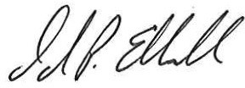

David P. Eldersveld
Executive Vice President, Chief Legal Officer and Corporate Secretary

March 15, 2022

EQUITY LIFESTYLE PROPERTIES, INC. TABLE OF CONTENTS
Page
Proxy Statement Summary 1
Our Nature: Uniting People, Places and Purpose 4
Corporate Governance 6
Governance Policies, Code of Ethics and Committee Charters 6
Board and Committee Self-Evaluation Process 6
Engaging with Our Stakeholders 7
Stockholder Communications with the Board 7
Non-Management Directors' Executive Sessions 7
Board Leadership Structure 8
Management Development and Succession Planning 8
Risk Oversight 8
Cyber Security 9
Securities Hedging Policy 9
Securities Pledging Policy 10
Political Contributions Policy 11
Committees of the Board; Meetings 11
Board Composition, Refreshment and Diversity 13
Executive Officers' Biographical Information 13
Stockholder Right to Amend the Bylaws 13
Proposal No. 1 - Election of Directors 14
Independence of Directors 14
Nominee Information, Qualifications, Skills and Experience 14
Nominees' Biographical Information 16
Director Compensation 20
Proposal No. 2 - Ratification of the Selection of Independent Registered Public Accounting Firm 22
Audit Committee Report 23
Compensation Discussion and Analysis 24
Compensation Committee Report 37
Executive Compensation 38
Summary Compensation Table 38
Grants of Plan-Based Awards 39
Outstanding Equity Awards at Fiscal Year-End 40
Option Exercises and Stock Vested 40
Potential Payments Upon Termination of Employment or Change in Control 41
CEO Pay Ratio 41
Narrative Disclosure of the Company's Compensation Policies and Practices as They Relate to Risk Management 41
Compensation Committee Interlocks and Insider Participation 41
Proposal No. 3 - Non-Binding, Advisory Vote on Executive Compensation 42
Security Ownership of Certain Beneficial Owners 43
Security Ownership of Management and Directors 44
Questions and Answers About the Annual Meeting 45
Additional Information 47
Certain Relationships and Related Transactions 47
Delinquent Section 16(a) Reports 47
Stockholder Proposals for the 2023 Annual Meeting 47
2021 Annual Report 48
Householding of Proxy Materials 48
Other Matters 48
Appendix A 49

PROXY STATEMENT

This Proxy Statement contains information related to the 2022 Annual Meeting of Stockholders (the "Annual Meeting") of Equity LifeStyle Properties, Inc., a Maryland corporation (the "Company", "ELS" or "we", "us", or "our"), which will be held on Tuesday, April 26, 2022, at 9:00 a.m. Central Time. The Annual Meeting will be a virtual meeting held over the Internet. You will be able to attend the Annual Meeting, vote your shares electronically and submit your questions during the live webcast of the meeting by visiting www.virtualshareholdermeeting.com/ ELS2022 and entering your 16-digit control number included in the notice containing instructions on how to access Annual Meeting materials, your proxy card, or the voting instructions that accompanied your proxy materials. On March 17, 2022, these proxy materials and our annual report are being mailed or made available to stockholders.

PROXY STATEMENT SUMMARY
The following pages provide a summary of important information you will find in this Proxy Statement. As it is only a summary, please review the complete Proxy Statement before submitting your vote.

Summary of Matters for Stockholder Voting

Proposal |  | Board's Voting Recommendation
Proposal 1 | Election of Directors | FOR each nominee
Proposal 2 | Ratification of the Appointment of Independent Accountant | FOR
Proposal 3 | Advisory Vote on Executive Compensation | FOR
Stockholders will consider any other business properly brought before the Annual Meeting or any adjournments or postponements thereof.

Unless directions are set forth on the proxy, the representatives holding proxies will vote
as recommended by the Board of Directors, or if no recommendation is given, in their own discretion.

About Equity LifeStyle Properties

Equity LifeStyle Properties is a fully integrated owner of lifestyle-oriented properties consisting of property operations and home sales and rental operations primarily within manufactured home ("MH") and recreational vehicle ("RV") communities and marinas.

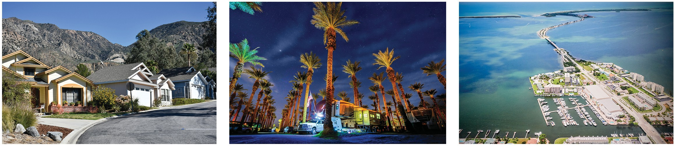

Business Highlights
⁽¹⁾ Total stockholder return ("TSR") is calculated based on the stock price appreciation and dividends paid to show the total return to a stockholder over a period of time. TSR assumes dividends are reinvested in Common Stock on the day the dividend is paid.
⁽²⁾ Adjusted for the two-for-one stock split effected on October 15, 2019. All disclosures in this Proxy Statement with respect to shares or share price information have been adjusted for this stock split.
⁽³⁾ Normalized Funds From Operations ("Normalized FFO") is a non-GAAP measure. See Appendix A to this Proxy Statement for a discussion and reconciliation to the most directly comparable GAAP measure.

- Normalized FFO per common share on a fully diluted basis was $2.53, 17% higher than the year 2020.

2021
Accomplishments ⁽¹⁾
- Core Portfolio generated growth of 9% in income from property operations, excluding deferrals and property management compared to 2020. Our Core Portfolio includes all properties acquired prior to December 31, 2019 that we have owned and operated continuously since January 1, 2020.
- MH occupancy within our Core Portfolio increased by 323 Sites during the year.
- Manufactured homeowners within our Core Portfolio increased by 785 in 2021.
- RV Annual occupancy within our Core RV and Thousand Trails portfolios increased by 1,180 sites during the year.
- RV and MH rental income within our Core Portfolio increased by 12.9% and 4.7%, respectively, compared to 2020.
- Membership sales and expenses, consisting of membership upgrade sales and expenses, as well as commissions on camping and Trails Collection passes, contributed $12.5 million for the year, an increase of $8.1 million, or 184%, compared to 2020.
- New home sales of 1,163 in 2021, which was the highest in Company history.
- Acquired eleven marinas, five RV communities, a parcel of land occupied by a portion of an RV community managed by a tenant pursuant to a ground lease, an 80% equity interest in a joint venture with six RV communities, MH Village/Datacomp and three land parcels adjacent to our properties with an aggregate purchase price of $715.6 million.
- Added 1,037 expansion Sites to our Core Portfolio in 2021.
- Originated secured debt with gross proceeds of $270.0 million with a maturity of 10 years and an interest rate of 2.4%. We used these proceeds to repay $67.0 million of debt due to mature in 2022 at a weighted average rate of 5.1%. The remainder of the proceeds were used to repay a portion of the outstanding balance on the line of credit.
- Closed on an amended revolving line of credit with borrowing capacity of $500.0 million and a
$300.0 million term loan.
- Raised our annual dividend for 2022 to $1.64 per share of Common Stock, an increase of 13.1% or $0.19, over the current $1.45 per share of Common Stock for 2021.
- Sold approximately 1.7 million shares of Common Stock under our ATM equity offering program with a weighted average price of $84.48 per share for net proceeds of $138.4 million.

⁽¹⁾ Capitalized terms not defined herein shall have the meaning ascribed to them in the Company's Annual Report on Form 10-K for the year ended December 31, 2021.

Governance Highlights

- 8 out of 10 Director Nominees are Independent
- Independent Lead Director
- Independent Audit Committee
- Independent Compensation, Nominating & Corporate Governance Committee
- Independent Compensation Consultant to Advise the Compensation, Nominating & Corporate Governance Committee
- Separate Board Chairman and CEO
- Executive Sessions of Non-Management Directors
- Risk Oversight by Board and Committees
- Four New Directors Added Within Last Five Years
- Ongoing Succession Planning
- All Directors Stand for Election Each Year
- Director Resignation Policy
- Annual Board and Committee Evaluation Process
- All Audit Committee Members are Financial Experts
- Frequent Stockholder Engagement Efforts
- No Poison Pill
- Active Shareholder Engagement
- Ability to Amend Bylaws by a Majority Vote by any Stockholder
- Business Ethics and Conduct Policy for Directors, Officers and Employees
- Prohibition Against Hedging Company Shares
- Internal Disclosure Committee for Financial Controls
- No Employment Agreements
- Performance Driven Executive Compensation
- Meaningful Share Ownership Guidelines for Directors and Executives

The Board values diversity in its broadest sense, reflecting, but not limited to, profession, geography, gender, ethnicity, skills and experience, and believes that as a group, the nominees bring a diverse range of thought and perspective to the Board's deliberations.

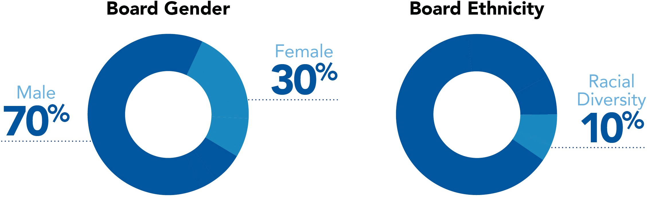

Compensation Highlights

  - No Employment Agreements with NEOs
  - Three-Year Vesting of Restricted Stock Awards
  - Performance Target-Based Restricted Stock Awards
- Stock Ownership Guidelines for Board and NEOs
- Performance-Based Cash Bonus Compensation

OUR NATURE: UNITING PEOPLE, PLACES AND PURPOSE

Environmental, Social and Governance ("ESG") Highlights
At ELS, sustainability is at the core of our nature. Our sustainability strategy is in "Our Nature: Uniting People, Places and Purpose". While rooted in protecting and enhancing the environments where we live, work and play, Our Nature also speaks to our culture of opportunity, inclusivity, caring, transparency and respect. The tagline, "Uniting People, Places & Purpose," embodies the three tenets of Our Nature:

Information on our sustainability practices can be found in our 2020 Sustainability Report, which includes disclosures that reference the Global Reporting Initiative (GRI) standards. Information on our environmental performance and methodology for 2018 - 2020 energy, greenhouse gas emissions and water metrics can be found in our Environmental Performance Report. These reports and other sustainability policies and collaborations are available at www.equitylifestyleproperties.com/sustainability. Such information is not considered part of, nor incorporated by reference into, this Proxy Statement.

ELS’ commitment to sustainability embraces a holistic approach which aims to support our business model, minimize our environmental impact, maintain a safe and healthy workplace and uphold a high standard of business ethics and conduct. We understand the value of continuing to focus on sustainable practices and the highest standard of business ethics and practices, as they are critical to our overall success and building long-term stakeholder value. With a dedicated Sustainability team, we are committed to incorporating ESG principles into our business operations in collaboration with heads of departments.

In 2019, we formed an Environmental, Social and Governance Taskforce (“ESG Taskforce”) to support our on-going commitment to environmental, social, governance and other public policy matters relevant to us (collectively “ESG Matters”). Led by the sustainability team and overseen by our Chief Operating Officer, the ESG Taskforce is comprised of a cross-functional team of employees from asset management, investor relations, compliance, communications, operations, marketing, risk management, financial reporting, legal and human resources that assists Company management and the Board in:

- Setting general strategy and objectives relating to ESG matters;
- Developing, implementing and monitoring initiatives and policies based on that strategy;
- Overseeing communications with employees, investors and stakeholders with respect to ESG matters; and
- Monitoring and assessing risks and opportunities relating to, and improving the Company's understanding of, ESG matters.
On a quarterly basis, the ESG Taskforce reports on ESG Matters to the Compensation, Nominating and Corporate Governance Committee (the "Compensation Committee") of the Board of Directors and senior management. The Compensation Committee is responsible for the review of our ESG strategy, initiatives and policies. Additionally, the Audit Committee is responsible for the discussion and review of policies with respect to risk assessment and risk management, including, but not limited to, human rights and ESG risks. The Strategic Planning Committee further assists the Board in assessing ESG strategies.

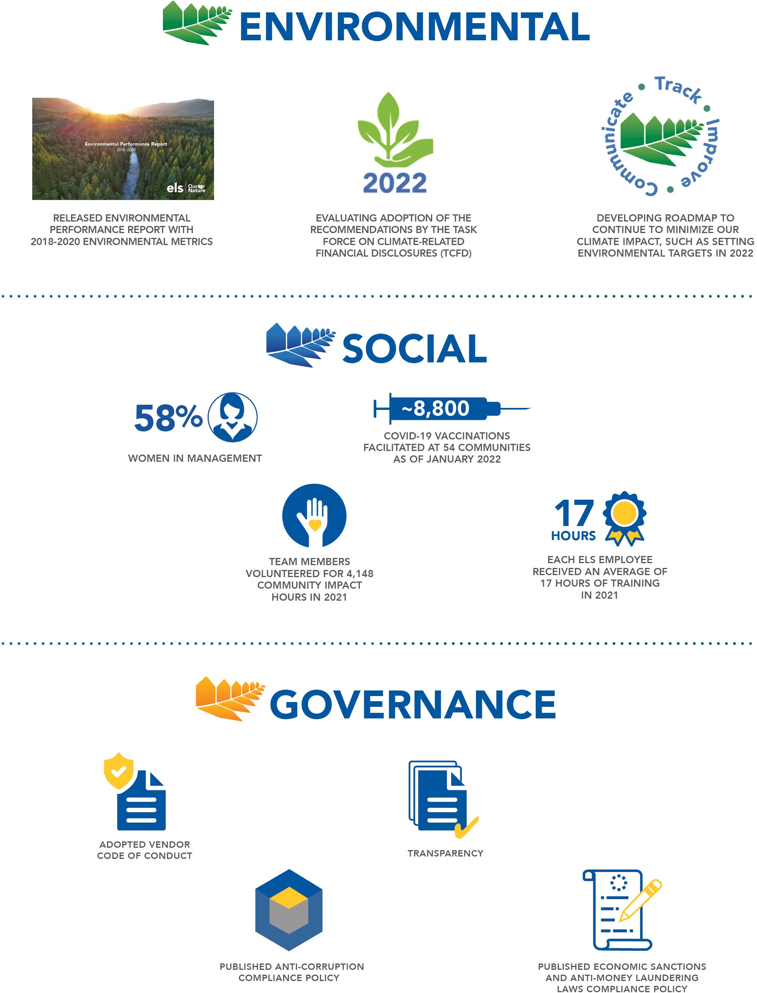

CORPORATE GOVERNANCE

Governance Policies, Code of Ethics and Committee Charters
The Board regularly evaluates the Company's corporate governance policies and benchmarks those policies against the rules and regulations of governmental authorities, the best practices of other public companies and suggestions received from various authorities. The Board has adopted the Company's Guidelines on Corporate Governance, as amended. The Company's Guidelines on Corporate Governance require that a majority of the Directors be independent within the meaning of New York Stock Exchange ("NYSE") standards. The Company’s common stock ("Common Stock") is listed on the NYSE under the ticker symbol "ELS." The Company has also adopted a Business Ethics and Conduct Policy, which applies to all Directors, officers and employees of the Company. We will disclose on our website any amendment to, or waiver of, any provision of the Business Ethics and Conduct Policy applicable to our Directors and executive officers ("Executive Officers" or "NEOs") that would otherwise be required to be disclosed under the rules of the Securities and Exchange Commission ("SEC") or NYSE.

Our Guidelines on Corporate Governance include a Director resignation policy, whereby an incumbent Director who fails to receive a majority of the votes cast in an uncontested election is expected to submit his or her resignation. If an incumbent Director fails to receive such a majority vote and tenders his or her resignation, the Compensation Committee will make a recommendation to the Board as to whether to accept or reject the tendered resignation, or whether other action is recommended, taking into account any information that it considers appropriate and relevant, including the circumstances that led to the failure to receive the vote, if known. The Board will act on the tendered resignation within ninety (90) days following certification of the stockholder vote and will promptly disclose its decision and rationale as to whether to accept the resignation (or the reasons for rejecting the resignation, if applicable) in a press release, filing with the SEC or other public announcement. Our Guidelines on Corporate Governance also provide that the Compensation Committee will have oversight with respect to executive officer succession planning and management development plans.
Key Corporate Governance Documents
Please visit the Company's website at www.equitylifestyleproperties.com in the investor relations section under "Corporate Governance" or "Sustainability" to view the following documents:

  - Company Charter
  - Company Bylaws
  - Guidelines on Corporate Governance
  - Business Ethics and Conduct Policy
  - Audit Committee Charter
  - Compensation, Nominating and Corporate Governance Committee Charter
  - Environmental, Social and Governance Policy
  - Political Contributions Policy
  - Human Rights and Labor Rights Statement
  - Vendor Code of Conduct
  - Anti-Corruption Compliance Policy
  - Economic Sanctions & Anti-Money Laundering Laws Compliance Policy

These documents are also available free of charge by sending a written request to Equity LifeStyle Properties, Inc., Attn: Investor Relations, Two North Riverside Plaza, Suite 800, Chicago, Illinois 60606, or by emailing our Company's Investor Relations Department at investor_relations@equitylifestyle.com. No information contained on the Company's website is part of or incorporated into this Proxy Statement.

Board and Committee Self-Evaluation Process
On an annual basis, a Board evaluation process is completed whereby the Board's Lead Director (the "Lead Director"), Philip Calian, conducts interviews independently with each Director. The evaluation process includes an assessment of the performance of the Board and each Board committee as a whole, and individual Directors, with a focus on areas such as independence and objectivity, meeting attendance, participation and input, knowledge and expertise, insightfulness and forethought, preparation and commitment to improvement. The Lead Director discusses the results of these evaluations with the Directors individually as necessitated and with the Board and each Board committee as a whole.

Engaging with Our Stakeholders
We place great importance on consistent dialogue with all our stakeholders, including stockholders, employees, customers and members of the communities that we serve. We regularly engage in discussions with, and provide comprehensive publicly-available information for, constituents interested in our strategy, performance, governance, citizenship, stewardship and environmental compliance. We are receptive to stakeholder input, and we are committed to transparency and proactive interactions.

We maintain an active dialogue with our investors, which includes meetings with investors and regular participation in investor conferences. Management periodically discusses feedback, including key themes and insights gained from our investor outreach at Board and Board Committee meetings, as appropriate. Additionally, the Compensation Committee takes into consideration the results of the annual advisory vote on the Company's executive compensation. At the 2021 annual meeting of stockholders, 90.4% of all the votes cast approved the compensation program described in the proxy statement for the 2021 annual meeting of stockholders. Although each Director is encouraged to attend each annual meeting of stockholders, the Board has no formal policy with respect to such attendance. Nine of ten Directors in office as of the date of the 2021 annual meeting of stockholders attended that virtual stockholder meeting.
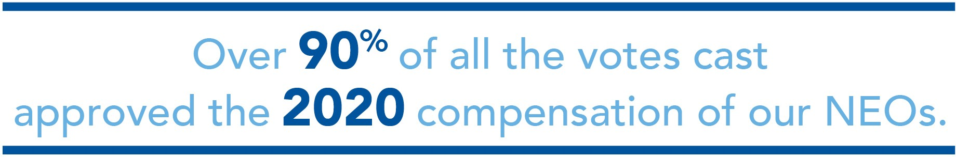

Stockholder Communications with the Board
The Board's Lead Director is Mr. Calian who, as an independent Director, acts in the lead capacity to coordinate the other independent Directors, consults with our Chief Executive Officer on Board agendas, chairs the executive sessions of the non-management Directors and performs such other functions as the Board may direct. Any stockholder or other interested party who has a concern or inquiry regarding the conduct of the Company may communicate directly with the Lead Director, who will receive all such communications on behalf of the Board or the non-management Directors.
Communications may be confidential or anonymous, and may be submitted in writing or by email to: Lead Director, c/o Corporate Secretary
Equity LifeStyle Properties, Inc.
Two North Riverside Plaza, Suite 800 Chicago, Illinois 60606
Email: Investor_Relations@equitylifestyle.com

All communications will be received and processed by our Corporate Secretary, and all substantive communications will be referred to the Lead Director. All such communications will be reviewed and, if necessary, investigated and/ or addressed by the Lead Director and the status of such communications will be reported to the Board or the non- management Directors (as applicable) on a quarterly basis. The Lead Director may direct special treatment, including the retention of outside advisors or counsel, for any such concern or inquiry.

Non-Management Directors' Executive Sessions
Executive sessions of the Company's non-management Directors are scheduled in connection with regularly scheduled meetings of the Board and are held without management present. Executive sessions may also be held at such other times as requested by the non-management Directors. The Lead Director presides at these executive sessions. During the year ended December 31, 2021, the non-management Directors held four executive sessions.

Many regular quarterly Board committee meetings include educational briefings from management regarding a wide variety of strategic initiatives. The Company also provides an orientation program for new Directors, which includes an overview of duties and our corporate governance policies, as well as one-on-one sessions with each member of executive management on the Company's strategy and industry.

Board Leadership Structure
The Company has separated the positions of chairman of the board and chief executive officer since 1996. Samuel Zell currently serves as Chairman of the Board, and Marguerite Nader currently serves as our President and Chief Executive Officer ("CEO") and is a member of the Board. Mr. Zell has served as Chairman of the Board since March 1995, and was previously Co-Chairman of the Board from December 1992 to March 1995, and is uniquely qualified to serve in this capacity. Mr. Zell is an active investor in public and private companies around the world to which he provides strategic direction. He has more than 50 years of experience as a chairman, director and executive of various companies, has managed billions of dollars in global investments and has a strong track record of stewarding companies towards the maximization of their potential. Mr. Zell is recognized as a founder of the modern real estate investment trust industry and is a champion for increased transparency by public companies. As our Chairman, Mr. Zell presides over meetings of the Board, stewards the Company, regularly counsels executive management regarding strategy and provides executive management with a network of resources across the industry. Mr. Calian, an independent Director, serves as the Board's Lead Director as discussed above. The Board has determined that this leadership structure is appropriate as it allows the CEO to focus on our day-to-day business, while allowing the Chairman of the Board to lead the Board in its fundamental role of providing advice to and independent oversight of management.

Management Development and Succession Planning
The Board's goal, through the oversight of the Compensation Committee, is to have an ongoing program for executive leadership development and succession for executive management. As reflected in the Guidelines on Corporate Governance, the Compensation Committee is responsible for overseeing the preparation of executive succession and management development plans tailored to reflect the Company's current business strategy and vision. The Compensation Committee and the CEO review these succession plans for senior management periodically and report to the Board on these plans. The succession plan involves creating profiles of ideal candidates and selecting successors expected to fit the needs of the Company over time. Individuals who are identified as high potential leaders are given exposure and visibility to Board members through formal presentations and informal events.

Risk Oversight
Risk is inherent with every business, and how well a business manages risk can ultimately determine its success. The Company faces a number of risks, including economic, environmental and regulatory risks, and others such as the impact of competition, cyber security and weather conditions. The Company believes one way to manage risk is to maintain balance sheet flexibility and evaluate major capital items, including the dividend policy, debt policy, acquisitions and dispositions, and equity and debt issuances, in light of the potential impact on financial flexibility.
Management is responsible for the day-to-day management of risks the Company faces, while the Board, as a whole and through its committees, has responsibility for the oversight of risk management. In its risk oversight role, the Board has the responsibility to satisfy itself that the risk management processes designed by management are adequate and functioning as designed.

The Board believes that establishing the right "tone at the top" and full and open communications between management and the Board are essential for effective risk management and oversight. Our CEO meets quarterly with Board Committee chairpersons, updating them on a variety of matters, including risk management and related controls. Our CEO also meets monthly with our Lead Director. Our Executive Officers attend each quarterly Board meeting and are available to address any questions or concerns raised by the Board on risk management-related and any other matters. At the quarterly Board meetings, the Board receives presentations from our Executive Officers on strategic matters involving the Company's operations. Our Executive Officers also attend Strategic Planning Committee meetings and Audit Committee meetings and report on relevant topics.

While the Board is ultimately responsible for risk oversight at the Company, our four Board Committees assist the Board in fulfilling its oversight responsibilities in certain areas of risk.

Board of Directors
Oversees the Company's most significant risks and ensures that management responds with appropriate strategic and tactical mitigation plans.
Board Committees
Audit
Compensation
Executive
Strategic Planning

..............................................… Oversees Risk Related to ..................................................

    - Financial Reporting
    - Internal Controls
    - Compliance with Legal & Regulatory Requirements
    - Risk Assessment and Risk Management
    - Insurance Coverage
    - Interest Rates
    - Cyber Security
    - Human Rights
    - ESG
- Compensation Policies & Programs
- Board Organization, Membership & Structure
- Succession Planning
- Corporate Governance
- ESG
- Property Acquisitions
- Property Dispositions
- Financing of Investments
  - Company Strategy
  - Strategic Initiatives
  - Capital Planning and Investment
  - ESG

Cyber Security
The Audit Committee is primarily responsible for oversight of the risk management process related to cyber security. Our Executive Officers and senior management meet with the Audit Committee at least quarterly to discuss the Company's cyber security defense strategy. Topics discussed during these meetings include defense of our business systems and information against cyber attacks and our efforts to comply with data privacy laws such as the California Consumer Privacy Act. During these meetings, the Audit Committee is also informed of recent trends in cyber risks. Certain risks relating to cyber security are also discussed occasionally with our Board of Directors.

The Company addresses potential threats or disclosure of any confidential personally identifiable information it holds by implementing a variety of security measures intended to protect the confidentiality and security of this information. These measures include, but are not limited to: (a) engaging reputable, recognized firms to help us design and maintain our information technology ("IT") and data security systems; (b) conducting periodic testing and verification of information and data security systems, including performing penetration testing of our systems to discover where any vulnerabilities may exist; (c) providing periodic employee awareness training around phishing and other scams, malware and other cyber risks; and (d) timely deletion of personally identifiable information that no longer has a business purpose to be retained. Employees are required to complete the full IT security training curriculum on an annual basis. In addition, the Company conducts monthly phishing tests on all employees, and any employee that fails is enrolled in a phishing refresher course.

The Company has cyber liability insurance which provides coverage for certain risks arising out of data and network breaches and data privacy regulations and has an aggregate limit and a per occurrence retention. Cyber liability insurance generally covers costs associated with the wrongful release, through inadvertent breach or network attack, of personally identifiable information and credit card primary account number information. Our insurance also contains cyber extortion and business interruption coverage. In addition, the Company maintains a disaster recovery plan for our internal IT systems and makes regular updates to our security incident plan.

Securities Hedging Policy
The Company's hedging policy is included in the Company's Policy on Securities Trading and reads as follows: "Directors and officers (and any member of the director's or officer's family sharing the same household) are prohibited from engaging in short sales (including buying puts or selling calls) or any other hedging transactions with

respect to any equity securities of the Company held by them, which includes the purchase of any financial instrument (including, but not limited to, prepaid variable forward contracts, equity swaps, collars, and exchange funds) designed to hedge or offset any decrease in the market value of such equity securities."
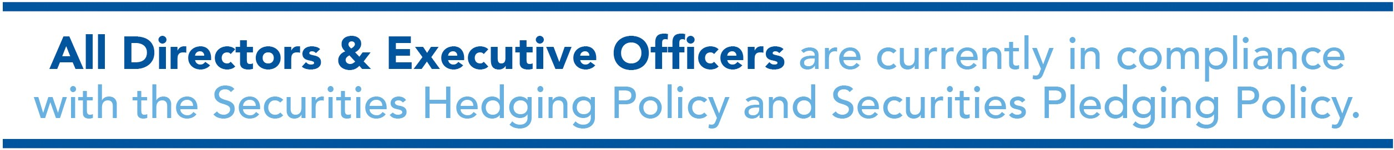

Securities Pledging Policy
Our Board has consistently and closely monitored pledging activity and has examined any potential risks associated with any such pledging by our Directors and Executive Officers. In March 2017, the Board adopted a Securities Pledging Policy with the elements set forth below, which in its business judgment provides appropriate protections of stockholder interests.

- Pledging of our shares of Common Stock and Operating Partnership ("OP Units") by Directors and Executive Officers is not permitted without the prior approval of the Audit Committee.
- For shares of Common Stock held in brokerage accounts, margin loans using our shares of Common Stock as collateral are prohibited.
- When considering whether to permit a proposed pledge, the Audit Committee shall consider factors that it deems relevant, which may include, but are not limited to:
  - the number of shares of Common Stock or OP Units to be pledged and the aggregate market value of the position;

  - the percentage of the Company’s outstanding shares of Common Stock, on an as-converted basis, represented by the equity to be pledged;

  - the value of the equity to be pledged as compared to the net worth of the individual and other factors bearing on the ability of the individual to prevent a forced sale of the pledged position;

  - the number of days required to unwind the proposed pledge;

  - the structural protections in the borrowing arrangement to guard against foreclosure on the pledged position, including whether there are other assets securing the loan; and

  - historical share prices and trends in trading volumes with respect to the Company’s equity.

- For any new loan which includes a proposed pledge of our shares of Common Stock and/or OP Units to be considered by the Audit Committee, the loan must contain the following structural parameters intended to mitigate the risk of a forced sale as a result of a decline in the market price of our Common Stock and OP Units:
  - the loans must be compliant with the requirements of Federal Reserve Regulation U, limiting the amount of any such loan to a maximum 50% of the value of collateral, as measured at the time of borrowing; and

  - the loan and pledge arrangements may not contain provisions requiring automatic or forced sales, prior to notice and a cure period of not less than three business days between when specific loan- to-value thresholds are exceeded and when lenders have the right to exercise remedies under the pledge arrangement.

Political Contributions Policy
The Company has a robust policy governing political expenditures. Under the policy approved by the Board, any political spending by the Company must be legitimately linked to the Company's business purposes and strategic intent, approved by the Chief Executive Officer, and reviewed annually by the Compensation Committee. The policy is available on the Company's website at www.equitylifestyleproperties.com in the investor relations section under "Corporate Governance."

Committees of the Board; Meetings
During the year ended December 31, 2021, the Board held four meetings. Each of the Directors attended 94% or more of the total number of meetings of the Board and the committees on which he or she served. The members of the Board committees are elected by the Board each year at the Board meeting that is held after the annual meeting of stockholders.

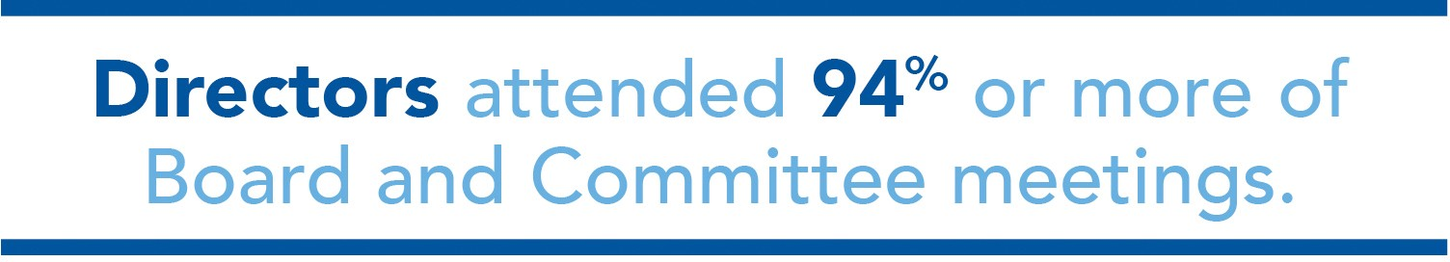

The four standing committees of the Board are: Audit Committee, Compensation, Nominating and Corporate Governance Committee, Executive Committee, and Strategic Planning Committee. The Board has determined that each member of the Audit Committee and Compensation Committee is an "independent" Director within the meaning set forth in the NYSE listing standards and Rule 10A-3 under the Securities Exchange Act of 1934, as amended (the "Exchange Act"). The Audit Committee and Compensation Committee each are governed by a charter which generally states the purpose of the committee and outlines the committee's structure and responsibilities. These charters are available on our website. The current membership information for our Board committees is presented below.

Executive Committee

Members:

Thomas Heneghan (Chair) Samuel Zell
Philip Calian
- Authorizes the acquisition, disposition and financing of investments by the Company (including the issuance of additional limited partnership interests of MHC Operating Limited Partnership), in each case, below certain thresholds set by the Board, without the need for further Board approval.
- Authorizes contracts and agreements, including those related to the borrowing of money by the Company, in each case, below certain thresholds set by the Board, without the need for further Board approval.

Audit Committee

Members:

Philip Calian (Chair) Derrick Burks David Contis
Scott Peppet

Meetings in 2021: 9
- Engages our Independent Accountants.
- Reviews with our Independent Accountants the plans for and results of the audit engagement.
- Approves professional services provided by our Independent Accountants.
- Reviews the independence of our Independent Accountants.
- Reviews the adequacy of the Company’s internal accounting controls and accounting and reporting practices and assesses the quality and integrity of our audited financial statements.
- Establishes procedures for the processing of complaints received from employees regarding internal control, accounting and auditing matters.
- Reviews policies with respect to risk assessment and risk management, including, but not limited to, insurance coverage, interest rate risk management, cyber security, human rights and ESG.
- Reviews compliance with financial, legal, tax and regulatory requirements.
- All members meet the independence, experience and financial literacy requirements of the NYSE and Section 10A of the Exchange Act.
- All members are designated by the Board as "audit committee financial experts" in accordance with SEC regulations.
- The "Audit Committee Report" is included herein.

Compensation, Nominating and Corporate Governance Committee

Members:

David Contis (Chair) Philip Calian Constance Freedman Sheli Rosenberg

Meetings in 2021: 5
- Determines compensation for our NEOs and exercises the powers of the Board in connection with compensation matters, including incentive compensation and benefit plans.
- Receives recommendations regarding executive compensation from our CEO and considers these recommendations in determining appropriate compensation plans.
- Does not delegate its authority in regard to establishing executive compensation.
- Authorizes grants of stock awards under our equity compensation plans, such as the 2014 Equity Incentive Plan.
- All stock award grants to independent Directors are recommended by the Compensation Committee and approved by the Board.
- Develops and recommends to the Board succession plans for the CEO and other senior executive officers.
- Identifies and recommends qualified individuals to become Directors.
- Develops and recommends the Guidelines on Corporate Governance applicable to the Company.
- Reviews ESG strategy, initiatives and policies.
- Recommends to the Board Director nominees for each committee of the Board.
- Directs the Board in an annual review of its performance.
- All members meet the independence requirements of the NYSE.
- The "Compensation Committee Report" is included herein.

Strategic Planning Committee

Members:

Thomas Heneghan (Chair) Andrew Berkenfield Constance Freedman Scott Peppet

Meetings in 2021: 4
- Sets specific broad strategic goals for the executive team that are re- assessed on an annual basis.
- Meets with the executive team to discuss and evaluate the progress with respect to these strategic goals.
- Reviews strategy and progress on initiatives related to:
  - technology and innovation;
  - capital planning, development, acquisitions and investments;
  - utilities and energy;
  - legal proceedings;
  - property and casualty insurance;
  - ESG; and
  - any other matters which may impact the overall strategy of the Company.
- All members meet the independence requirements of the NYSE.

Board Composition, Refreshment and Diversity
Nominees for Director are selected by the Compensation Committee, which will consider nominees recommended by stockholders. If you wish to recommend a person whom you consider qualified to serve on the Board, you must give written notice to our Corporate Secretary in accordance with the requirements described in the "Stockholder Proposals for the 2023 Annual Meeting" section of this Proxy Statement. This notice must contain: (i) as to each nominee, all information that would be required to be disclosed in a proxy statement with respect to the election of Directors pursuant to the Exchange Act, (ii) the name and address of the stockholder giving the notice, (iii) the number of shares of Common Stock owned beneficially and of record by such stockholder, and (iv) the written consent of each nominee to serve as a Director if so elected. The Compensation Committee will consider and evaluate persons recommended by stockholders in the same manner as potential nominees identified by the Board and/or the Compensation Committee. For the upcoming Annual Meeting, the Compensation Committee did not receive any recommendations for nominees from stockholders.

The Compensation Committee identifies nominees for Director from various sources. In assessing potential Director nominees, the Compensation Committee considers the character, background and professional experience of candidates. All nominees should possess good judgment and an inquiring and independent mind. Familiarity with the issues affecting the Company is among the relevant criteria. All Director nominees must possess a reputation for the highest personal and professional ethics, integrity and values. The Compensation Committee will also carefully consider any potential conflicts of interest. Nominees must also be willing and able to devote sufficient time and effort to carrying out the duties and responsibilities of a Director effectively and should be committed to serving on the Board for an extended period of time. The Compensation Committee considers diversity in identifying and evaluating Director nominees. The Compensation Committee strives to nominate Directors with a variety of complementary skills so that, if elected, the Board will contain the appropriate mix of diversity in background and experience to oversee the Company's business.

Executive Officers' Biographical Information
See "Compensation Discussion and Analysis - Executive Officers' Biographical Information" of this Proxy Statement for the biographical information for each of our executive officers.

Stockholder Right to Amend the Bylaws
Stockholders have the power, by the affirmative vote of a majority of all votes entitled to be cast on the matter, to alter or repeal any provision of these Bylaws and to adopt new Bylaws, except that the stockholders shall not have the power to alter or repeal Article XIV or adopt any provision of the Bylaws inconsistent with Article XIV without the approval of the Board.

Independence of Directors

PROPOSAL NO. 1 ELECTION OF DIRECTORS

Pursuant to the Company's Guidelines on Corporate Governance, which require that a majority of our Directors be independent within the meaning of NYSE standards and do not include any additional categorical standards other than those required by the NYSE, the Board undertook a review of the independence of Directors nominated for reelection at the upcoming Annual Meeting. During this review, the Board considered transactions and relationships, if any, during the prior year between each Director or any member of his or her immediate family and the Company, including those reported under the "Certain Relationships and Related Transactions" section of this Proxy statement. As provided in the Guidelines on Corporate Governance, the purpose of this review was to determine whether any such relationships or transactions were inconsistent with a determination that the Director is independent.

As a result of this review, the Board affirmatively determined that all the Directors nominated for election at the Annual Meeting are independent of the Company and its management with the exception of our Chairman, Mr. Zell, and our CEO, Marguerite Nader. The Board determined that none of the independent Directors has or had a material relationship with the Company other than being a Director and/or a stockholder of the Company.

The Board specifically considered Mr. Heneghan's role as former CEO of the Company and determined that this role did not hinder Mr. Heneghan's independence within the meaning of the NYSE listing standards.

Nominee Information, Qualifications, Skills and Experience
You are being asked to vote on the election of ten director nominees listed below. The Company's Charter currently provides for the annual election of all Directors. Directors are elected by a plurality of votes cast. All nominees are presently Directors, and each nominee has consented to be named in this Proxy Statement and to serve if elected.
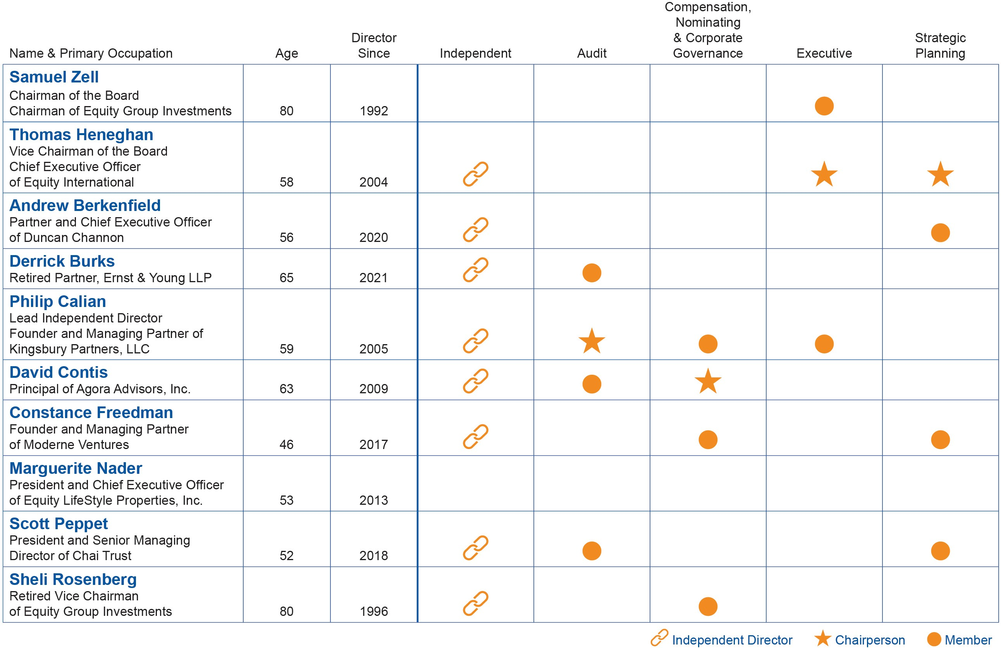

In addition to each Director nominee's qualifications, skills and experience outlined in their biographical data below, the Company's Board looked for certain attributes in each of the Director nominees and based on these attributes, concluded that each Director nominee should serve on the Board. The Board does not require that the Director nominees possess each attribute, but rather the Board is looking for a mix of attributes among the Directors.

The following table shows the attributes of each Director nominee.
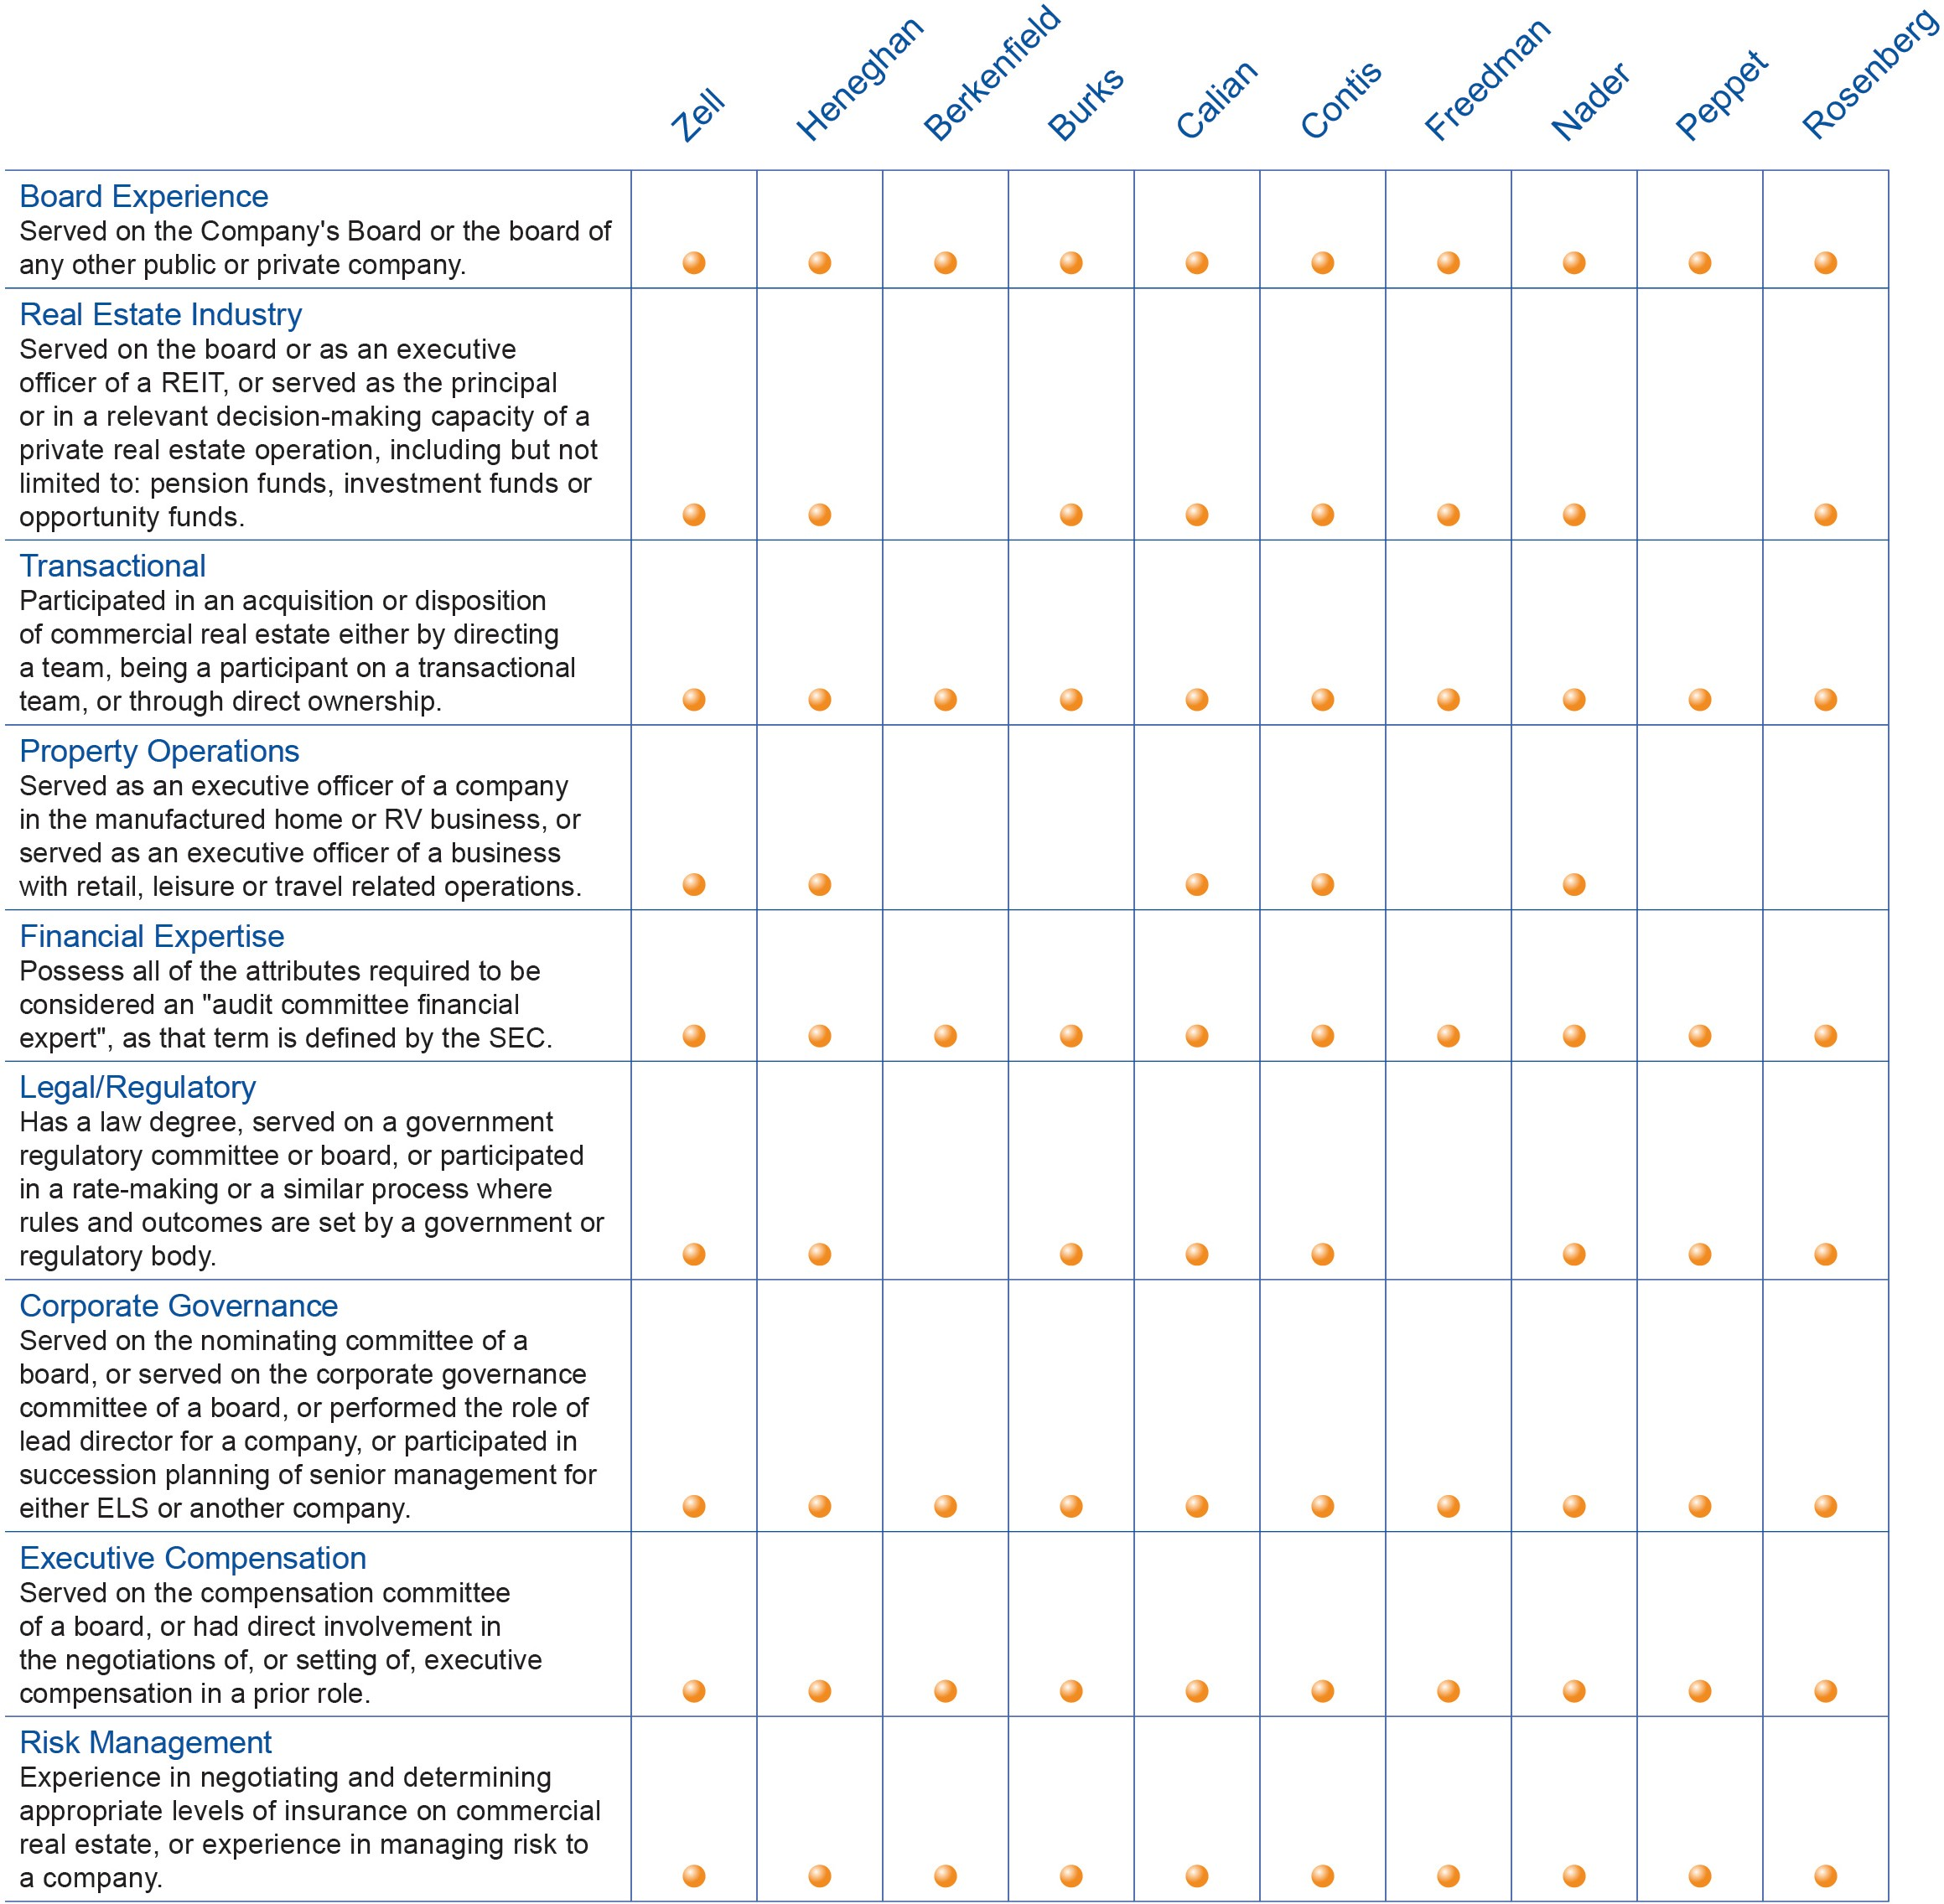

Nominees' Biographical Information
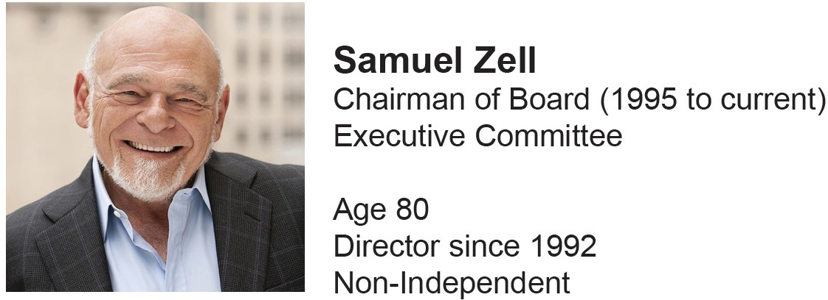

Mr. Zell has been Chairman of the Board of the Company since March 1995 and was CEO from March 1995 to August 1996. Mr. Zell was Co-Chairman of the Board from December 1992 until March 1995. Mr. Zell was a director of Mobile Home Communities, Inc., the former manager of the Company’s manufactured home communities, from 1983 until its dissolution in 1993. Mr. Zell serves as chairman of Equity Group Investments ("EGI"), the private investment firm he founded more than 50 years ago. EGI is a division of Chai Trust Company, LLC ("Chai Trust"). EGI is the private investment firm that manages Sam Zell's and the Zell Family's wealth. Mr. Zell is also the chairman of Equity International, a private investment firm focused on real estate-related companies outside the United States. Mr. Zell has served as chairman of the board of Equity Distribution Acquisition Corp., a publicly traded special purpose acquisition company targeting opportunities to apply technological advancement within the industrial industry, since 2020. Mr. Zell has been chairman of the board of Equity Residential, a publicly traded real estate investment trust ("REIT"), which owns and operates apartment properties, since 1993. Mr. Zell has been chairman of the board of Equity Commonwealth, a publicly traded office REIT, since 2014. Mr. Zell served as chairman of the board of Covanta Holding Corporation from 2005 to 2021, when it was acquired by EQT Infrastructure. Mr. Zell served as chairman of the board of Anixter International, Inc., a publicly traded global supplier of communications and security products from 1984 until its sale in June 2020. Mr. Zell was a trustee and chairman of the board of trustees of Equity Office Properties Trust, a publicly traded REIT primarily focused on office buildings, from October 1996 until its sale in February 2007, and was its chief executive officer from April 2002 to April 2003, and its president from April 2002 to November 2002. Mr. Zell is an active philanthropist with a focus on entrepreneurial education. Through the Zell Family Foundation, he has led the sponsorship of several leading entrepreneurship programs, including: the Zell/Lurie Institute for Entrepreneurial Studies at University of Michigan’s Ross School of Business; the Zell Fellows Program at Northwestern University’s Kellogg School of Management; and the Zell Entrepreneurship Center at the Interdisciplinary Center Herzliya (IDC). The Zell Global Entrepreneur Network (ZGEN) unites the students and alumni of these programs and actively provides them with connections, opportunities, mentorship and support. Mr. Zell also sponsors the Samuel Zell/Robert Lurie Real Estate Center at University of Pennsylvania’s Wharton Real Estate Center. Mr. Zell is the father-in-law of Mr. Scott Peppet, who serves on the Board.

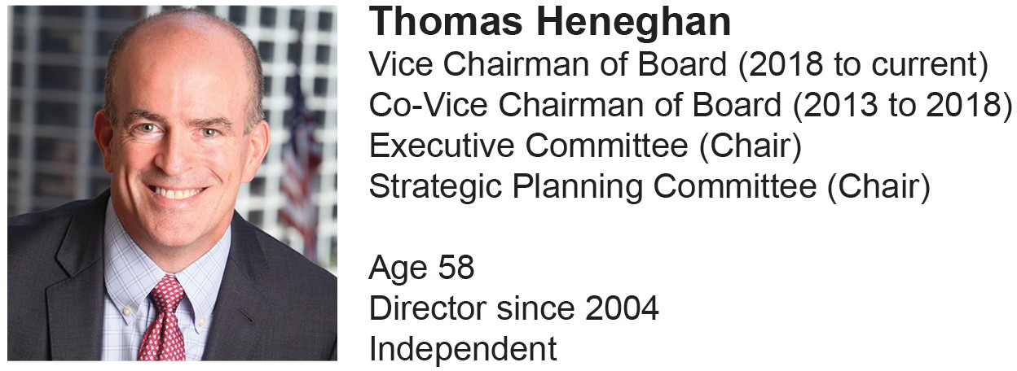

Mr. Heneghan has been Vice Chairman of the Board since May 2018 and was Co-Vice Chairman from 2013 to 2018. Mr. Heneghan has been chief executive officer of Equity International, a private investment firm focused on real estate-related companies, since February 2013. Mr. Heneghan was Chief Executive Officer of the Company from January 2004 to February 2013 and President of the Company from February 2011 to May 2012. He was also President of the Company from January 2004 to January 2008. Mr. Heneghan was President and Chief Operating Officer of the Company from May 2000 to December 2003. He was Executive Vice President, Chief Financial Officer and Treasurer of the Company from April 1997 to May 2000, and Vice President, Chief Financial Officer and Treasurer of the Company from February 1995 to March 1997. Mr. Heneghan has been a director of Farmland Partners Inc., a publicly traded real estate company that owns and seeks to acquire high-quality North American farmland, since December 2020. He is a senior managing director of Chai Trust. He is a member of the Urban Land Institute’s Global Exchange Council.

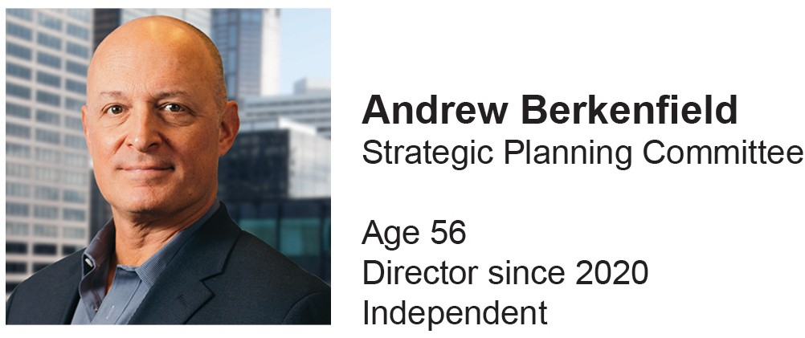

Mr. Berkenfield has been a partner and the chief executive officer of Duncan Channon, a nationally acclaimed, independent advertising agency, since January 2009. Mr. Berkenfield joined Duncan Channon in January 2000 as the agency’s general manager. Prior to 2000, Mr. Berkenfield held senior positions at Foote, Cone & Belding, a global advertising agency, and Lintas: NY, an advertising communications company.
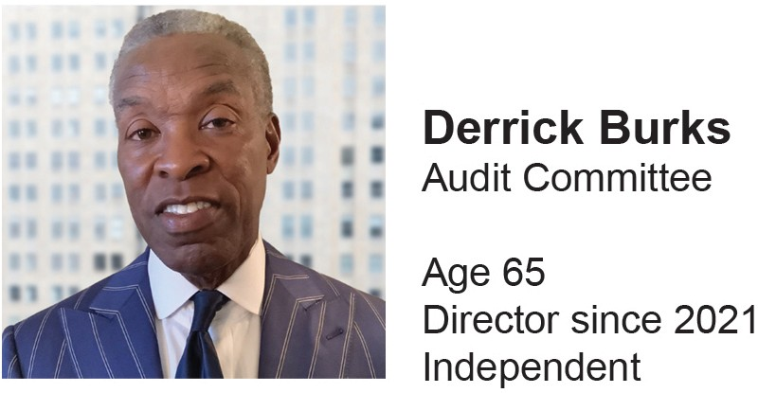

Mr. Burks was a partner at Ernst & Young, LLP, a public accounting firm, from 2002 until his retirement in 2017 and served as the managing partner of the Indianapolis office from 2004 to 2017. Mr. Burks was employed by Arthur Andersen, a public accounting firm, from 1978 to 2002, where he served for three years as the managing partner of the Indianapolis office. Mr. Burks has been a director of Duke Energy, a publicly traded electric power holding company, since March 2022. Mr. Burks has been a director of Kite Realty Group Trust, a publicly traded shopping mall REIT, since 2021. Mr. Burks was a director of Vectren Corporation, a publicly traded regional energy company, from 2017 until the time of its sale in 2019 and was a member of its Audit Committee and Finance Committee. Mr. Burks’ business experience spans small businesses, large international corporations and public companies. He has extensive merger and acquisition, capital markets, enterprise risk and SEC expertise. Throughout his career he has served companies in various industries, including energy, manufacturing, mass merchandising, and logistics with a focus for more than 25 years in real estate (REITs).

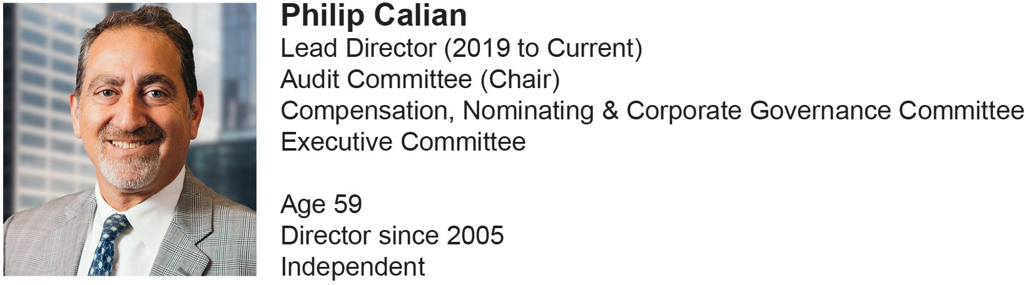

Mr. Calian has been the Board's Lead Director since 2019. Mr. Calian has been founder and managing partner of Kingsbury Partners LLC since January 2002. Kingsbury Partners LLC is a private equity and consulting firm focused on providing capital and ownership skills to middle market distressed businesses. Mr. Calian also served as operating partner of Waveland Investments LLC, a Chicago-based private equity firm with committed equity capital, from July 2003 until December 2019. Prior to founding Kingsbury Partners LLC, Mr. Calian was chief executive officer of American Classic Voyages Co., a publicly traded travel and leisure company, from 1995 until 2002. Mr. Calian is managing member of MCS Investment Group, LLC, a private producer and seller of mineral well brine; Hudson Lock, LLC, a private lock and hardware manufacturer; and Lewis County Press, LLC, a community newspaper publisher. Mr. Calian is a member of the board of directors of CC - Development Group, Inc., a private owner and operator of senior living communities.

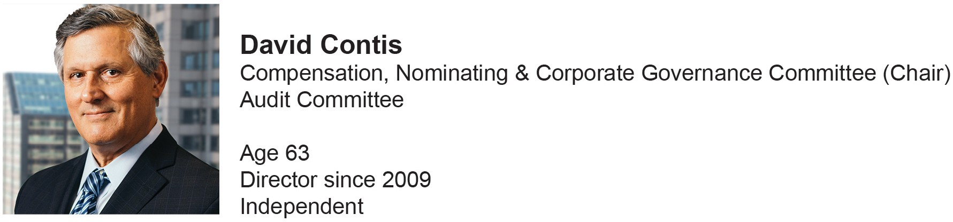

Mr. Contis has been a principal of Agora Advisors, Inc., which provides consulting services to domestic and international real estate and retail companies, since May 2017. Mr. Contis was president - mall platform and senior executive vice president of Simon Properties Group, Inc., a publicly traded retail REIT, from May 2011 to May 2017. Mr. Contis was president of real estate for EGI from November 2006 to May 2011. He was executive vice president and chief operating officer of The Macerich Company, a publicly traded shopping center REIT, from May 1997 to October 2006. Mr. Contis was employed in various capacities by affiliates of EGI from 1980 to 1997, including as vice chairman, executive vice president and chief operating officer of Equity Properties & Development L.P., from 1992 to 1997. Mr. Contis has been a director of CBL Properties, a publicly traded retail REIT since 2021. He served on the board of directors of BRMalls, Brazil’s largest shopping center company from 2008 to 2011. Mr.
Contis was a director and served as a member of the board of directors, compensation committee and audit committee of Dundee Realty Corp., a Canadian-based real estate company, from 1997 to 2003. Mr. Contis is an advisor to Equity International. He is a senior managing director of Chai Trust.

Ms. Freedman is the founder and managing partner of Moderne Ventures, an early stage investment fund she founded in 2015 that is focused on technology companies in and around real estate, finance, insurance and home services. Prior to Moderne Ventures, Ms. Freedman was the vice president of strategic investments for the National Association of Realtors where she launched the investment fund Second Century Ventures in 2008, and founded REach, its technology accelerator, in 2012.

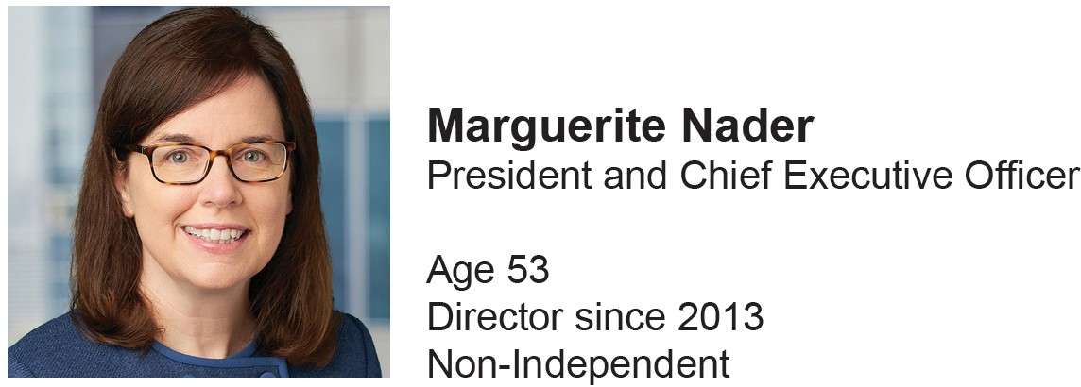

Ms. Nader has been President and CEO of the Company since February 2013. She was President and Chief Financial Officer from May 2012 to October 2012 and Executive Vice President and Chief Financial Officer from December 2011 to May 2012. Ms. Nader was Executive Vice President - New Business Development from February 2011 to December 2011. She was Executive Vice President - Sales and Marketing from February 2009 to February 2011. Ms. Nader was Senior Vice President of New Business Development from January 2007 to February 2009. She was Vice President of New Business Development from January 2001 to January 2007. Ms. Nader was Vice President of Asset Management from January 1998 to January 2001. She has been employed with the Company since 1993. Ms. Nader has been a director of Ventas, a publicly traded healthcare REIT since 2020. Ms. Nader was a trustee of Liberty Property Trust, a publicly traded industrial REIT, from June 2017, until its sale in 2020. Ms. Nader serves as Chair on the National Association of Real Estate Investment Trust ("NAREIT") Executive Board.

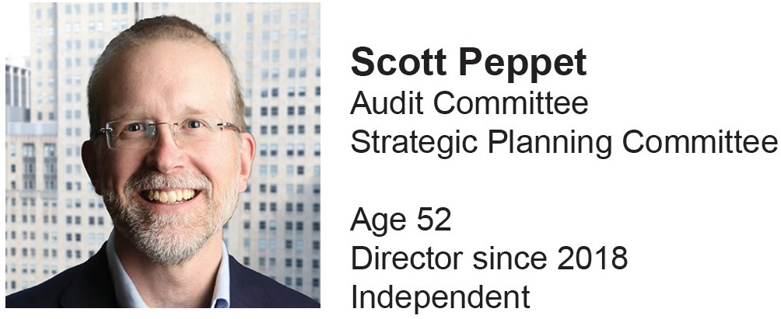

Mr. Peppet is president and senior managing director of the Chai Trust. Mr. Peppet is an advisor to Equity International. Mr. Peppet was a director of Anixter International, Inc., a publicly traded global distributor of network, electronic and utility power solutions, from 2014 until its sale in June 2020. Mr. Peppet brings experience in contracts, negotiations, complex transactions, legal ethics, privacy law and technology to the Board along with an outstanding record of leadership and deep experience in the legal field. Mr. Peppet is the son-in-law of Mr. Samuel Zell, who serves as Chairman of the Board. Mr. Peppet was a Professor of Law at the University of Colorado Law School from 2000 to 2019.
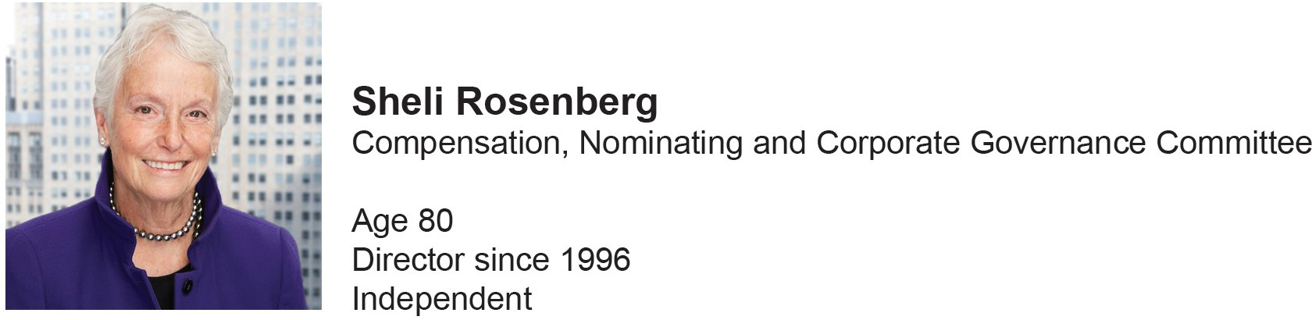

Ms. Rosenberg was the Board's Lead Director from 2002 to 2019. Ms. Rosenberg was a consultant to Skadden, Arps, Slate, Meagher & Flom LLP from January 2014 through 2016 and was Of Counsel at Skadden, Arps, Slate, Meagher & Flom LLP from May 2011 to December 2013. She is the former president, chief executive officer and vice chairman of EGI. Ms. Rosenberg joined EGI in 1980 as the company's general counsel and rose to become chief executive officer from 1990 to 2000 and vice chairman from 2000 to 2003 before retiring in 2003. Ms.
Rosenberg was a principal of the law firm of Rosenberg & Liebentritt from 1980 to 1997. Ms. Rosenberg is an advisor to Equity International. Ms. Rosenberg was the lead director of Strategic Hotels & Resorts, Inc., a publicly traded hotel REIT, until its sale in 2015, and Cellular Dynamics International, a publicly traded producer of stem cells utilized primarily in research, until its sale in 2015. She was a former director of Rush Street Interactive, Inc., Spirit Realty Capital, Inc., General Growth Properties, Inc., CVS Caremark Corporation, Capital Trust, Inc., Avis Budget Group, Inc., Nanosphere, Inc., and Ventas, Inc., and a former trustee of Equity Residential and Equity Office Properties, all of which were publicly traded companies. Ms. Rosenberg was an adjunct professor at Northwestern University's J.L. Kellogg Graduate School of Management from 2003 until 2007. A recognized advocate for women in business, she is a co-founder and former president of the Center for Executive Women at the Kellogg School, where she continues to serve on the Center’s steering committee.

Director Compensation
The following table includes compensation information for the year ended December 31, 2021 for each non- executive Director.

Name
Fees Earned or Paid
in Cash ($) (1)

Stock Awards ($) (2)

Option Awards ($) (2)
Non-Equity Incentive Plan Compensation ($)

All Other Compensation ($) (3)

Total ($)

Andrew Berkenfield | 65,000 | 1,850 | 141,127 | — — | 207,977
Derrick Burks | 65,000 | 112,527 | — | — — | 177,527
Philip Calian | 65,000 | 195,015 | — | — — | 260,015
David Contis | 65,000 | 132,531 | — | — — | 197,531
Constance Freedman | 65,000 | — | 150,917 | — — | 215,917
Thomas Heneghan | 65,000 | 140,023 | — | — — | 205,023
Scott Peppet | 65,000 | 120,020 | — | — — | 185,020
Sheli Rosenberg | 65,000 | 107,509 | — | — — | 172,509
Samuel Zell | 65,000 | 3,192,492 | — | — — | 3,257,492
- For 2021, the Company paid each of its non-executive Directors an annual fee of $65,000.
- These amounts reflect the grant date fair value, as calculated in accordance with FASB ASC Topic 718 "Stock Compensation" ("FASB ASC 718"), related to grants of restricted stock and options to purchase shares of Common Stock made in 2021.
Refer to Note 2, "Summary of Significant Accounting Policies" and Note 13, "Equity Incentive Awards," in the Notes to the Consolidated Financial Statements included in the Company's 2021 Form 10-K filed on February 22, 2022 for the relevant assumptions used to determine the valuation of our restricted stock and stock option awards.
The Board historically has approved an annual award of Restricted Common Stock to non-executive Board members in conjunction with their reelection at the annual meeting of stockholders. On April 27, 2021, upon recommendation of the Compensation Committee, the Board approved the following awards of Restricted Common Stock to non-executive Directors then in office. Each recipient was allowed to take these shares as Stock Options equal to five times the number of shares of Restricted Common Stock that would have been awarded. All shares were granted at a per share price of $68.74, the NYSE closing price of the Company’s Common Stock on April 27, 2021. The number of shares of Restricted Common Stock awarded was determined by dividing the dollar value of the award by the closing price of the Company's Common Stock on the grant date or $68.74.
  - The following Directors: (i) the Chairman of the Board, (ii) the Audit Committee Chairperson and Lead Director, (iii) the Compensation Committee Chairperson, and (iv) the Executive Committee Chairperson and Strategic Planning Committee Chairperson each received an award of Restricted Common Stock for their services rendered in such capacity in 2021. Each recipient elected to take their award as Restricted Common Stock.
Mr. Zell was awarded shares of Restricted Common Stock valued at $3,085,000 for services rendered as Chairman of the Board for 2021. Accordingly, Mr. Zell was awarded 44,879 shares of Restricted Common Stock. The Compensation Committee determined that Mr. Zell’s compensation in consideration for his employment as Chairman of the Board is appropriate and in the best interests of our Company and our stockholders given his ongoing extraordinary contributions to the Company. Mr. Zell's financial acumen, extensive investment and management experience, business and strategic expertise and network of resources across the real estate industry provide significant benefits and unique opportunities to the Company and the Board. Mr. Zell brings a well- recognized brand value to the Company from his more than fifty years of experience in the real estate business and his unparalleled role in the evolution of the REIT industry. Mr. Zell has regular interactions with the Company's executive management team, including with respect to operational strategy, acquisition opportunities and balance sheet management. In addition, Mr. Zell has a distinguished track record and reputation for successfully leading companies with a focus on corporate governance and proper alignment of management and stockholder interests.
Mr. Calian, Mr. Heneghan and Mr. Contis were each awarded shares of Restricted Common Stock for services rendered as Committee Chairpersons valued at $40,000, $40,000 and $20,000, respectively. In addition, Mr. Calian was awarded shares of Restricted Common Stock valued at $40,000 for services rendered as Lead Director. Accordingly, Mr. Calian, Mr. Heneghan and Mr. Contis were each awarded 1,164, 582 and 291 shares of Restricted Common Stock, respectively.
One-third of these shares of Restricted Common Stock will vest on April 27, 2022, one-third will vest on April 27, 2023, and one-third will vest on April 26, 2024.
  - With the exception of the Committee Chairpersons, each member of the Audit Committee received an award of 182 shares of Restricted Common Stock valued at $12,500 and each member of the Compensation Committee, the Executive Committee and the Strategic Planning Committee received an award of 109 shares of Restricted Common Stock valued at $7,500 for their services on their respective Committees in 2021. Mr. Berkenfield and Ms. Freedman elected to take these shares as Stock Options and each received an award of 545 and 1,090 Stock Options, respectively. These shares of Restricted Common Stock and Stock Options will vest 100% on April 27, 2022.
  - Each non-executive Director received an award of Restricted Common Stock for their services rendered as a Director during 2021. With the exception of Mr. Berkenfield and Ms. Freedman, each recipient elected to take this award as Restricted Common Stock.
Mr. Burks, Mr. Calian, Mr. Contis, Mr. Heneghan, Mr. Peppet, Ms. Rosenberg and Mr. Zell each received an award of 1,455 shares of Restricted Common Stock valued at $100,000. Mr. Berkenfield and Ms. Freedman elected to take these shares as Stock Options

and they each received an award of 7,275 Stock Options. One-third of these shares of Restricted Common Stock and Stock Options vested on October 27, 2021, one-third will vest on April 27, 2022 and one-third will vest on April 27, 2023.
On February 9, 2021, the Board appointed Mr. Berkenfield as a member of the Strategic Planning Committee and approved a pro-rated award of 29 shares of Restricted Common Stock to Mr. Berkenfield for his services in this capacity during 2021. These shares were granted at a per share price of $63.78, the NYSE closing price of the Company’s Common Stock on February 9, 2021 and such shares vested on February 9, 2022.
As of December 31, 2021, each non-executive Director had the following unexercised Stock Options and unvested Restricted Stock awards outstanding:

Name | Number of Securities Underlying Unexercised Options (#)  Exercisable | Number of Securities Underlying Unexercised Options (#) Unexercisable | Number of Shares of Stock That Have Not Vested
Andrew Berkenfield | 7,415 | 7,890 | 29
Derrick Burks | — | — | 1,152
Philip Calian | — | — | 4,111
David Contis | — | — | 2,572
Constance Freedman | 8,535 | 8,435 | —
Thomas Heneghan | — | — | 2,679
Scott Peppet | — | — | 1,760
Sheli Rosenberg | — | — | 1,578
Samuel Zell | — | — | 94,865
- During the year ended December 31, 2021, Directors did not receive any perquisites or other compensation. The Company reimburses the Directors for travel expenses incurred in connection with their activities on behalf of the Company.

Vote Required

A plurality of the votes cast in person or by proxy at the Annual Meeting is required for the election of directors. Although we know of no reason why any nominee would not be able to serve, if any nominee should become unavailable for election, the persons named as proxies will vote your shares of Common Stock to approve the election of any substitute nominee proposed by the Board.

Board Recommendation

The Board unanimously recommends that you vote "FOR" each of the ten nominees for director to serve until the next annual meeting of stockholders and until his or her successor is duly elected and qualifies.

PROPOSAL NO. 2
RATIFICATION OF THE SELECTION OF INDEPENDENT REGISTERED PUBLIC ACCOUNTING FIRM

The Board recommends that the stockholders ratify the selection of Ernst & Young, LLP ("Ernst & Young") as the Company's Independent Accountants for the fiscal year ending December 31, 2022. As a matter of good corporate governance, the selection of Ernst & Young is being submitted to stockholders for ratification. In the event of a negative vote on such ratification, the Audit Committee will reconsider its selection. Even if Ernst & Young is ratified as Independent Accountants by the stockholders, the Audit Committee, at its discretion, may direct the appointment of different Independent Accountants at any time during the year if it determines that such a change would be in the best interests of the Company and its stockholders.

Ernst & Young has advised us that neither it nor any member thereof has any financial interest, direct or indirect, in the Company or any of its subsidiaries in any capacity. There have been no disagreements between the Company and Ernst & Young relating to accounting procedures, financial statement disclosures or related items.
Representatives of Ernst & Young are expected to be available at the Annual Meeting. These representatives will have an opportunity to make a statement if they so desire and will be available to respond to appropriate questions.

The following table provides information relating to the fees billed or expected to be billed to the Company by Ernst & Young for the years ended December 31, 2021 and 2020:

 | 2021 | 2020
Audit Fees⁽¹⁾ | $ 1,371,650 | $ 1,312,850
Audit-Related Fees⁽²⁾ | $ 52,700 | $ 51,100
Tax Fees⁽³⁾ | $ 78,500 | $ 52,000
All Other Fees | $ — | $ —
- Audit fees consist of fees for the audit of the Company's financial statements, for the audit of internal controls relating to Section 404 of the Sarbanes-Oxley Act and for reviews of financial statements included in the Company's Quarterly Reports on Form 10-Q.
- Audit-Related Fees consist primarily of fees for services provided to assist the Company with attestation services related to audits of subsidiaries and benefit plans and other accounting consultations.
- Tax fees consist of professional services rendered for tax compliance, tax advice and tax planning.

Auditor Independence. The Audit Committee has determined that the Independent Accountants' provision of the non-audit services described above is compatible with maintaining the Independent Accountants’ independence.

Policy on Pre-Approval. The Company and the Audit Committee are committed to ensuring the independence of the Company’s Independent Accountants, both in fact and in appearance. In this regard, the Audit Committee has established a pre-approval policy in accordance with the applicable rules of the SEC and the NYSE. The Audit Committee must pre-approve all audit services and permissible non-audit services provided by the Independent Accountants, except for any de minimis non-audit services. The Audit Committee may delegate to one or more of its members who is an independent director the authority to grant pre-approvals. All services provided by Ernst & Young in 2021 were pre-approved by the Audit Committee.

Vote Required

The affirmative vote of a majority of the votes cast by stockholders of record is necessary to ratify the selection of Ernst & Young.

Board Recommendation

The Board unanimously recommends that you vote "FOR" ratification of the selection of Ernst & Young as the Company's Independent Accountants for the year ending December 31, 2022.

AUDIT COMMITTEE REPORT
The Audit Committee of the Board is composed of four Directors, each of whom the Board has determined meets the independence and financial literacy requirements of the NYSE and Rule 10A-3 under the Exchange Act. In addition, the Board has determined that each of these four Directors qualifies as an "audit committee financial expert" as defined by the SEC rules. No member of the Audit Committee is a current or former officer or employee of the Company, and no member serves on more than two other public company audit committees.

The Audit Committee oversees the Company’s financial reporting and enterprise risk processes on behalf of the Board. The Company's management has the primary responsibility for the financial statements, for maintaining effective internal control over financial reporting, and for assessing the effectiveness of internal control over financial reporting. The Audit Committee is governed by a written charter approved by the Board, which is posted on the Company's website. In accordance with this charter, the Audit Committee oversees the accounting, auditing, financial reporting, and risk management practices of the Company. The Audit Committee is responsible for the appointment, retention, compensation, and oversight of the work of the Independent Accountants. The Audit Committee pre-approves the services of the Independent Accountants in accordance with the applicable rules of the SEC and the NYSE. The Audit Committee has also established procedures for processing complaints received from employees regarding internal control, accounting, and auditing matters. The Audit Committee held nine meetings during 2021.

In fulfilling its oversight responsibilities, the Audit Committee reviewed and discussed the audited financial statements in the Company’s Annual Report on Form 10-K for the year ended December 31, 2021 (the "2021 Form 10-K") with the Company's management, including a discussion of the quality, not just the acceptability, of the accounting principles; the reasonableness of significant judgments; and the clarity of disclosures in the financial statements. The Audit Committee also reviewed and discussed management’s report on its assessment of the effectiveness of the Company’s internal control over financial reporting and the Independent Accountant’s report on the Company’s internal control over financial reporting with management, the internal auditors and the Independent Accountants.

The Independent Accountants are responsible for expressing an opinion on the conformity of the Company's audited financial statements with generally accepted accounting principles. The Audit Committee reviewed with the Independent Accountants their judgments as to the quality, not just the acceptability, of the Company's accounting principles and such other matters as are required to be discussed with the Audit Committee by standards of the Public Company Accounting Oversight Board ("PCAOB"), rules of the SEC, and other applicable regulations. In addition, the Audit Committee has discussed independence with the Independent Accountants. These discussions included the Independent Accountant’s independence from the Company’s management and the Company, including the matters in the letter from the Independent Accountants required by the PCAOB regarding the Independent Accountant’s communications with the Audit Committee concerning independence. The Audit Committee also considered the compatibility of non-audit services provided to the Company by the Independent Accountants with the Independent Accountant’s independence.

The Audit Committee discussed with the Independent Accountants the overall scope and plans for their audit. The Audit Committee met with the Independent Accountants, with and without management present, to discuss the results of their examinations; their evaluation of the Company's internal controls, including internal control over financial reporting; and the overall quality of the Company's financial reporting.

In reliance on the reviews and discussions referred to above, the Audit Committee recommended to the Board, and the Board approved, that the audited financial statements and management's assessment of the effectiveness of the Company’s internal control over financial reporting be included in the 2021 Form 10-K for filing with the SEC. The Audit Committee and the Board have recommended that stockholders ratify the selection of Ernst & Young as the Company’s Independent Accountants for the year ending December 31, 2022.

Respectfully submitted,

Philip Calian, Chair Derrick Burks David Contis
Scott Peppet

COMPENSATION DISCUSSION AND ANALYSIS

Executive Officers' Biographical Information
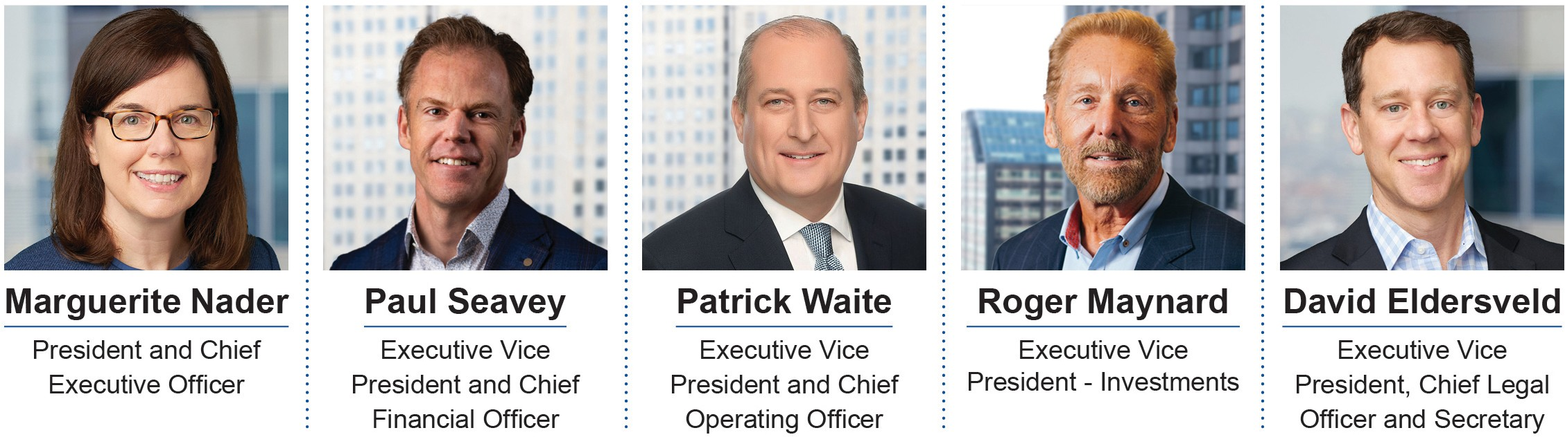

For information with respect to Ms. Nader, please refer to the "Nominees' Biographical Information" section of this Proxy Statement. All of our Executive Officers are named executive officers ("NEOs").

Paul Seavey - Executive Vice President and Chief Financial Officer
Mr. Seavey, 53, has been Executive Vice President and Chief Financial Officer of the Company since February 2020. He was Executive Vice President, Chief Financial Officer and Treasurer from January 2014 to February 2020. Mr. Seavey was Senior Vice President, Chief Financial Officer and Treasurer from October 2012 to January 2014; Senior Vice President of Finance and Treasurer from May 2012 to October 2012; Senior Vice President and Treasurer from December 2011 to May 2012; Vice President of Financial Planning and Treasurer from January 2009 to December 2011; and Vice President of Financial Planning from December 2001 to January 2009. Mr.
Seavey has been employed with the Company since 1994.

Patrick Waite - Executive Vice President and Chief Operating Officer

Mr. Waite, 55, has been Executive Vice President and Chief Operating Officer of the Company since January 2015. He was Executive Vice President - Property Operations from January 2014 to January 2015 and Senior Vice President of Operations from February 2013 to January 2014. Prior to joining the Company, Mr. Waite was senior vice president of asset management at American Residential Communities, a private operator of manufactured housing communities, from January 2010 through January 2013. He was vice president of Riverside Communities, a manufactured home community affiliate of Helix Funds LLC, from August 2004 to January 2010. Mr. Waite co- founded Continental Communities, a private operator of manufactured home communities, and managed its acquisition program from 1997 to 2001. Mr. Waite was the Director of Acquisitions for the Company from 1993 to 1997.

Roger Maynard - Executive Vice President - Investments

Mr. Maynard, 64, has been Executive Vice President - Investments of the Company since March 2016 and will continue in this role through his retirement on March 31, 2022. He was Executive Vice President - Asset Management from February 2009 to March 2016. Mr. Maynard was Executive Vice President and Chief Operating Officer from December 2005 to February 2009; Chief Operating Officer from January 2004 to December 2005; and Senior Vice President for national operations from January 2003 to December 2003. Mr. Maynard was Senior Regional Vice President for the Company’s Eastern division from September 2001 to December 2002, and Senior Regional Vice President for the Company's Southeastern region from January 2000 to September 2001. Mr.
Maynard was Regional Vice President for the Company's Southeastern region from June 1998 to December 1999, and Regional Vice President for the Company's Northeastern region from October 1997 to June 1998.

David Eldersveld - Executive Vice President, Chief Legal Officer and Secretary
Mr. Eldersveld, 48, has been Executive Vice President, Chief Legal Officer and Secretary since February 2021. He was Executive Vice President, General Counsel and Secretary from June 2015 to February 2021. Prior to joining

the Company, Mr. Eldersveld held various senior management positions at Tribune Company where he worked from 2005 through 2013, including serving as executive vice president, general counsel and corporate secretary at Tribune Company from July 2011 to January 2013 and senior vice president, general counsel and corporate secretary from September 2010 to July 2011. From 1999 to 2005, Mr. Eldersveld was an associate at the law firm of Sidley Austin LLP in Chicago, Illinois, where his principal practice areas were mergers and acquisitions, securities and corporate finance and corporate governance.

Executive Summary
The purpose of this Compensation Discussion and Analysis ("CD&A") is to provide stockholders with a description of the Company's executive compensation philosophy, objectives of the Company's compensation program and the material elements of the Company's compensation program for our NEOs.

The Compensation Committee took into account the stockholder advisory vote approving executive compensation at the last annual meeting of stockholders held in April 2021 and incorporated that as one of many factors it considered in connection with the discharge of its responsibilities. 90.4% of all the votes cast at last year's annual meeting of stockholders approved the compensation program described in the proxy statement for the 2021 annual meeting of stockholders. The Compensation Committee believes that this support level demonstrates a strong alignment among our stockholders, the Company's performance, and our executive compensation program and, accordingly, the Compensation Committee did not make any changes to the Company's executive compensation program in response to the 2021 "Say-on-Pay" vote.

96%
95%
94%
88%
91%
90%

80%
2017 2018 2019 2020 2021

Say-on-Pay Results

The core principle of the Company's executive compensation program for 2021 continued to be pay for performance, and the framework of the executive compensation program includes the governance features discussed below:

- The Compensation Committee is comprised solely of independent Directors

What We Do
- Do engage an independent compensation consultant to advise on compensation matters at the request and direction of the Compensation Committee
- Do an annual review of the Company's compensation strategy that includes a review of compensation-related risk management
- Do have a strong pay for performance compensation philosophy with 61% of the NEOs pay tied solely to performance; therefore aligning the long-term interests of our NEOs with our stockholders

- Do enhance executive retention with time-based, multi-year vesting schedules for equity incentive awards, which comprise a large percentage of total compensation
- Do have performance-based cash bonus compensation
- Do have meaningful share ownership guidelines for our executives and directors
- Do have a Hedging Policy that prohibits our directors and officers from engaging in short sales (including buying puts or selling calls) or any other hedging transactions with respect to any equity securities of the Company held by them

- Do have a Securities Pledging Policy that requires Audit Committee approval of any pledging of our shares of Common Stock or OP Units by Directors or NEOs and the satisfaction of certain other conditions

- Do have a Business Ethics and Conduct Policy, which all employees must follow

X No employment agreements

What We Don't Do
X No compensation incentives that encourage excessive risk taking
X No hedging of Company shares allowed
X No excise tax gross-up in any change in control or other agreements
X No excessive perks to our NEOs
X No personal benefits to NEOs that are not otherwise available to all employees

The Compensation Committee takes into consideration the overall performance of the Company when establishing the compensation program and determining final payments to the NEOs. This review of overall Company performance is in addition to specific goals and targets that are set for each NEO. We continued our strong performance in 2021 amidst the COVID-19 pandemic as further described in the "Proxy Statement Summary" section of this Proxy Statement. The impact of the pandemic on the Company's operations, capital allocation and strategic decisions for 2021, and the Company's response to the various state and local restrictions and continued efforts to ensure the health and safety of our employees and customers, were key priorities in 2021.

The following graphs show the Company's Normalized FFO per share of Common Stock, annual dividend per share and related compounded annual growth rates ("CAGR"), historical stock price and Normalized FFO. Normalized FFO is a non-GAAP financial measure. The Company believes that Normalized FFO is generally an appropriate measure of performance of an equity REIT. Appendix A to this Proxy Statement includes the definition of Normalized FFO and a reconciliation of Normalized FFO to net income, the most comparable GAAP measure.

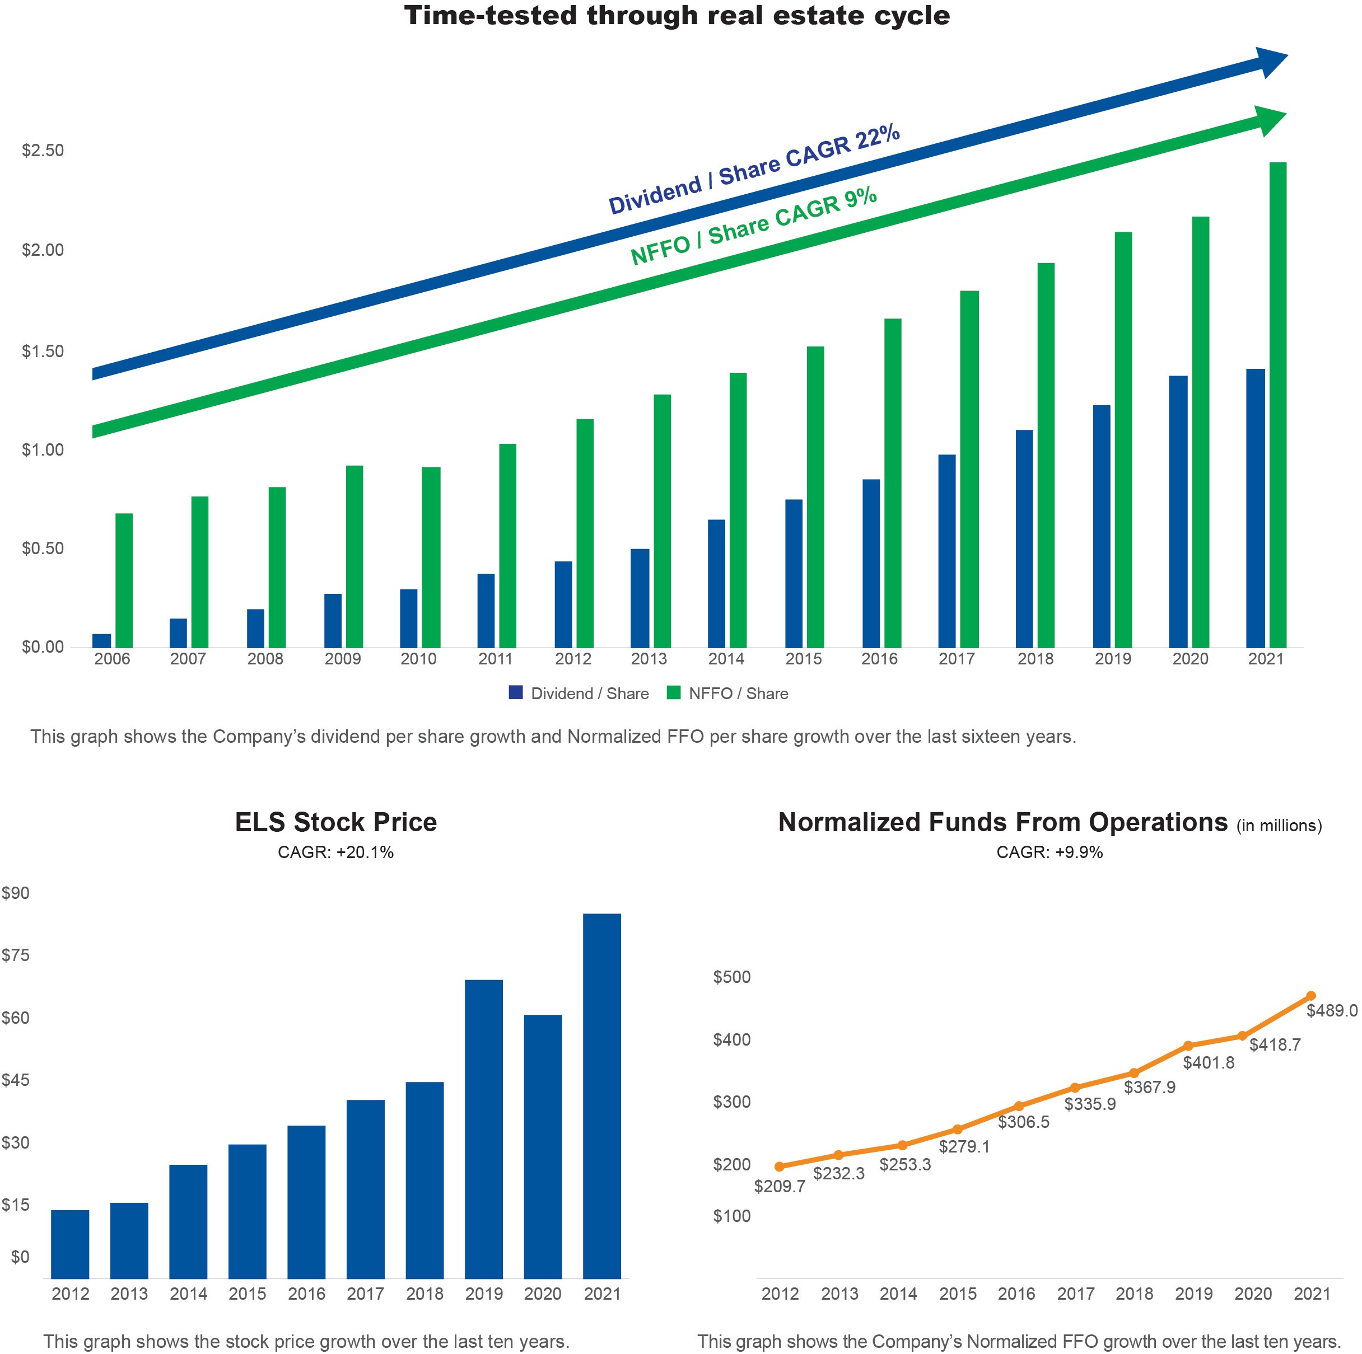

Philosophy
The Compensation Committee determines and approves the compensation of the Company's NEOs and guides the Company's overall philosophy towards the compensation of its employees. The Compensation Committee believes that the compensation of the Company's NEOs should be both competitive and based on individual and Company performance. The Compensation Committee believes that the compensation of the NEOs should reflect their success as a management team in attaining certain operational goals, which leads to the success of the Company and serves the best interests of its stockholders. The Compensation Committee consults with the CEO regarding both NEOs and non-executive employee compensation plans and programs, including administering the Company's equity incentive plan.

In 2017, the Company retained, at the direction of the Compensation Committee, Willis Towers Watson as its independent outside compensation consultant to provide an independent analysis and recommendation concerning the Company's long-term executive compensation plan. The analysis was used in establishing executive compensation for 2018 through 2021. The Compensation Committee has the authority to engage Willis Towers

Watson as its independent outside compensation consultant or hire additional consultants at any time. Willis Towers Watson did not provide any additional services to the Compensation Committee and did not provide any services to the Company other than those it provided to the Compensation Committee described above. The sole role of Willis Towers Watson has been to advise the Compensation Committee with respect to compensation at the request, and at the direction, of the Compensation Committee. The ultimate determination of total compensation and the elements that comprise total compensation for our NEOs is made solely by our Compensation Committee. In addition, the Compensation Committee compared the NEOs total compensation to the NAREIT Compensation Survey and to the salaries of executives at other REITs as obtained from the S&P Global database (formerly known as SNL Financial).

Objectives of the Compensation Program
The primary objective of the Company's compensation program is to attract and retain highly qualified executives by providing competitive Base Salaries and meaningful Cash Bonus and Equity Compensation. In addition, the compensation program is structured to hold the NEOs accountable for the performance of the Company by tying the substantial majority of their annual Cash Bonus and a substantial portion of their Equity Compensation to performance targets. The compensation program is also designed to promote an ownership mentality among the NEOs. The Compensation Committee recognizes that the interests of stockholders are best served by giving our NEOs the opportunity to participate in the appreciation of the Company's Common Stock. The Board has established stock ownership guidelines for each of the NEO positions and Directors. Under these guidelines, all of the NEOs and Directors are required to own a minimum amount of the Company’s Common Stock within four years from their first appointment as an NEO or Director, valued at the time of purchase, and to maintain this minimum amount throughout their tenure as a NEO or Director. Such ownership guidelines are as follows: five times the Base Salary for the CEO; three times the Base Salary for each of the other NEOs; and three times the annual retainer for each Director. Furthermore, any stock pledged by a Director or NEO is excluded from the computation. Hedges by Directors and NEOs are prohibited by our policy. With the exception of Mr. Burks who was appointed to the Board in February 2021, each of the Directors and NEOs currently own shares of Common Stock that exceed the minimum established guidelines.

The following table shows the value of shares of Common Stock of the Company beneficially owned as of February 18, 2022 (the "Record Date") by each of the NEOs as a multiple of their 2021 base salary. The NEOs have not been awarded stock options.

Name
Shares of Common Stock
(1)
Value of Shares Owned
($) ⁽²⁾ Base Salary ($)

Stock Ownership Value/Base Salary ⁽³⁾

Marguerite Nader | 260,330 | 22,820,528 | 600,000 | 38x
Paul Seavey | 153,029 | 13,414,522 | 395,300 | 34x
Patrick Waite | 215,129 | 18,858,208 | 395,300 | 48x
Roger Maynard ⁽⁴⁾ | 269,220 | 23,599,825 | 395,300 | 60x
David Eldersveld | 70,466 | 6,177,050 | 395,300 | 16x
All NEOs as a group | 968,174 | 84,870,133 | 2,181,200 | 39x

  - Shares of Common Stock beneficially owned as of the Record Date. See the "Security Ownership of Management and Directors" section of this Proxy Statement for more information.
  - The value of the total shares beneficially owned as of the Record Date using the Company’s Common Stock closing stock price of
$87.66 on December 31, 2021.
  - The value of total shares beneficially owned as of the Record Date as compared to the NEO's 2021 Base Salary.
  - In conjunction with his retirement on March 31, 2022, Mr. Maynard will forfeit 11,881 shares of unvested restricted Common Stock.

What Our Compensation Program is Designed to Reward
Our compensation program is designed to reward the NEOs for their contributions to the Company and for achieving improvements in the Company's performance during the year. The Compensation Committee deliberately kept Base Salaries at a relatively small percentage of total compensation. This enables the Compensation Committee to reward each NEO’s performance through annual Cash Bonus awards and equity incentives such as Restricted Common Stock awards. The annual Cash Bonus plan for each NEO is established by the Compensation Committee after a review of performance goal recommendations from the CEO, who receives input on such performance goal recommendations from each NEO. Restricted Common Stock awards are designed to provide incentives to the NEOs to ensure the successful implementation of long-term strategic goals of the Company and to

provide for the retention of such NEOs. Awards of Restricted Common Stock are determined and approved by the Compensation Committee with input from the CEO.

Peer Group
The Company's peer group of sixteen companies remained consistent with prior years. When selecting and re- assessing this peer group, the Compensation Committee took into consideration factors including market capitalization, three-year and five-year total returns, dividend yields, compounded annual funds from operations growth rates, and multiples. The following tables show the Company's peer group for 2021 and our one-year, three- year and five-year stockholder returns in comparison to the median and average stockholder returns for the peer group.

Peer Company REIT Type
American Campus Communities, Inc. (ACC) Residential

Apartment Investment and Management Company (AIV) Residential
Camden Property Trust (CPT) Residential

Corporate Office Properties Trust (OFC) Office
CubeSmart (CUBE) Self-Storage

Duke Realty Corporation (DRE) Industrial
Equity Residential (EQR) Residential

Essex Property Trust, Inc. (ESS) Residential
Extra Space Storage, Inc. (EXR) Self-Storage

First Industrial Realty Trust (FR) Industrial
Highwoods Properties, Inc. (HIW) Office

Regency Centers Corporation (REG) Retail
Simon Property Group (SPG) Retail

UDR, Inc. (UDR) Residential
Veris Residential, Inc. (formerly known as Mack-Cali Realty Corporation) (VRE) Diversified

Vornado Realty Trust (VNO) Diversified

Total Stockholder Returns ⁽¹⁾

 | One-Year | Three-Year | Five-Year
ELS ......................................................................................................... | 41.00% | 91.90% | 171.00%
ELS Annualized................................................................................... | 41.00% | 24.30% | 22.10%
Peer Group Median ............................................................................ | 58.90% | 15.60% | 9.90%
Peer Group Average .......................................................................... | 56.60% | 18.20% | 10.30%

⁽¹⁾ Total Stockholder Return is calculated based on the stock price appreciation and dividends paid to show the total return to a stockholder over a period of time. Total Shareholder Return assumes dividends are reinvested in Common Stock on the day the dividend is paid.

Elements of Compensation
During the year ended December 31, 2021, there were three major components of executive compensation: Base Salary, performance-based Non-Equity Incentive Compensation ("Cash Bonus"), and performance and time-based Equity Compensation. In conjunction with the CEO, the Compensation Committee reviews our executive salary structure on an annual basis with the use of a tally sheet. The tally sheet summarizes total compensation for each NEO, including Base Salary, Equity Compensation award values, Cash Bonus performance metrics, and all other compensation for the current and prior years. The Compensation Committee uses the tally sheet to quantify each NEO's total compensation and to compare it to the salaries of executives of the companies in our peer group and at other REITs as obtained from the S&P Global database and to the amounts in the NAREIT Compensation Survey.

The compensation philosophy takes into account a review of executive compensation and performance data on publicly traded REITs obtained from the S&P Global database and the NAREIT Compensation Survey. The

Compensation Committee believes the executive compensation information derived from the S&P Global database for the Company's peer group and the NAREIT Compensation Survey provide relevant salary data for the Company. The Compensation Committee takes into account the relevant compensation data for each NEO position when designing the compensation program. Where salary information is unavailable for a particular position in the S&P Global database, other positions having similar responsibilities are used. Compensation increases are based upon overall Company performance and upon each NEO’s performance, established goals, and contribution to the Company’s performance. In addition, the Compensation Committee considered the CEO Pay Ratio as described more fully under "CEO Pay Ratio" of this Proxy Statement.

Aggregate total compensation for each NEO for 2021 was split among Base Salary, performance-based Cash Bonus, and Equity Compensation, as shown in the following chart. All other compensation was less than 1% of the total compensation. The increase in total executive compensation from 2020 to 2021 for the NEOs in the aggregate reflects a 2.0% increase in base salaries and an increase in the performance-based Cash Bonus.
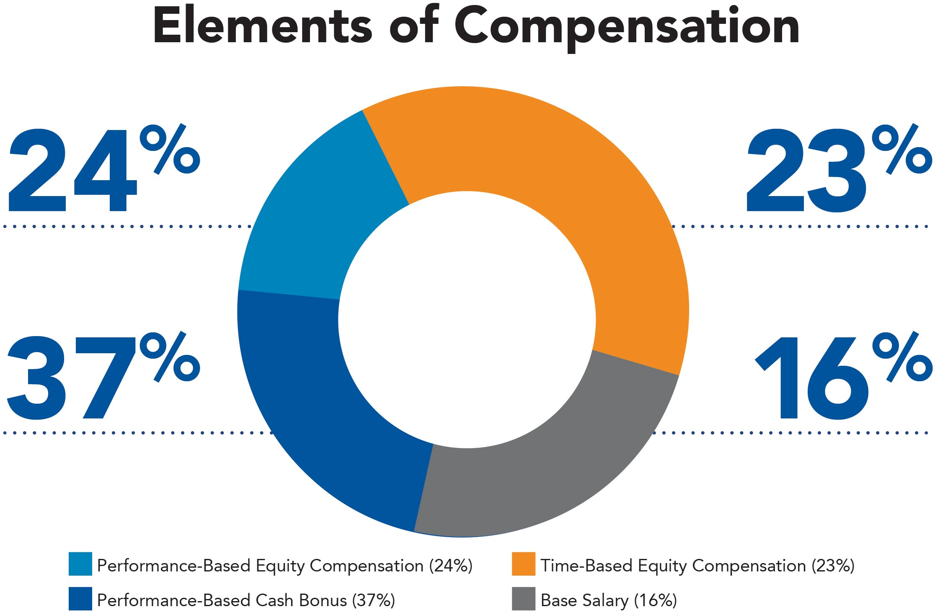

Base Salary
The Compensation Committee deliberately keeps Base Salaries at a relatively small percentage of total compensation. For 2021, the Compensation Committee concluded that Base Salaries of $600,000 for Ms. Nader and $395,300 for each of Mr. Seavey, Mr. Waite, Mr. Maynard and Mr. Eldersveld were appropriate in this regard. These Base Salaries reflect an increase of approximately 2.0% in 2021 from 2020.

Non-Equity Incentive Compensation (Cash Bonus)

The Compensation Committee's practice is to award annual Cash Bonuses based on certain performance targets established by the Compensation Committee for each year after consultation with the CEO. The amount paid to each NEO is subject to the discretion of the Compensation Committee. The Compensation Committee selected short-term annual performance metrics for management's focus that support and ensure the Company's long-term success and profitability. Performance targets were established and communicated to the NEOs when the outcome of the performance targets was substantially uncertain. Performance targets were consistent with earnings guidance expectations publicly disclosed by the Company. The final payout of 2021 Cash Bonuses to the NEOs was in January 2022, after finalization of the Company's year-end earnings results.

The total 2021 maximum Cash Bonus potential for the NEOs set by the Compensation Committee was approximately $5.5 million and was comprised of a $5.5 million bonus potential ("2021 Bonus Potential"), a
$146,122 manufactured home ("MH") revenue stretch goal and a $146,122 resort revenue stretch goal ("2021 Stretch Goals"). The Compensation Committee has discretion to determine an appropriate award for each NEO based on an evaluation of each of the target areas. The Cash Bonus paid to each NEO was based on the pre- established targets approved in February 2021. On a percentage basis, the bonus payments to the Company's employees were generally at or above that of the NEOs.

The following table shows the 2021 Bonus Potential for each NEO and the percentage attributed to each performance target and the discretionary portion. The total Cash Bonus paid to all NEOs was approximately $5.1 million, or 92.5%, as compared to the $5.5 million aggregate potential. The 2021 Stretch Goals required certain increases in the Company’s core MH revenues, which target was met, and certain increases in core resort revenues, which target was met. A total of $292,244 was paid to the NEOs with respect to the 2021 Stretch Goals.
 | 2021 |  | Core
 | Bonus |  | Resort
 | Potential |  | Revenue & | Site and | Core Net | Rentals/
 | (Amount x Base | Core MH Revenue | Dues Revenue | Member Optimization | Operating Income | Working Capital

Name | Salary) | Target ⁽¹⁾ | Target ⁽²⁾ | Target ⁽³⁾ | Target ⁽⁴⁾ | Target ⁽⁵⁾ | Discretionary⁽⁶⁾
Marguerite Nader | 2.9 | 14.0% | 14.0% | 14.0% | 14.0% | 14.0% | 30.0%
Paul Seavey | 2.2 | 14.0% | 14.0% | 14.0% | 14.0% | 14.0% | 30.0%
Patrick Waite | 2.2 | 14.0% | 14.0% | 14.0% | 14.0% | 14.0% | 30.0%
Roger Maynard ⁽⁷⁾ | 2.2 | 14.0% | 14.0% | 14.0% | 14.0% | 14.0% | 30.0%
David Eldersveld | 2.2 | 14.0% | 14.0% | 14.0% | 14.0% | 14.0% | 30.0%

- This target required achieving a 4.5% increase in core MH base rent growth for the year ended December 31, 2021 as compared to the year ended December 31, 2020, which target was met. The total paid for this target was approximately $730,600.
- This target required that the Company’s annual and seasonal core resort revenue increase 2.1% and transient resort revenue and dues revenue increase 9.7% for the year ended December 31, 2021 as compared to December 31, 2020, which target was met. The total paid for this target was approximately $730,600.
- This target was comprised of three equal components related to: (i) the number of paid member sales units; (ii) RV dealer activations; and (iii) completion of expansion sites, which component targets were all met. The total paid to the NEOs for this target was approximately $730,600.
- This target was comprised of two equal components related to: (i) core net operating income, excluding property management expense, to increase 3.8% for the year ended December 31, 2021 as compared to the year ended December 31, 2020, which target was met; and (ii) core expense growth less than 3.4% for the year ended December 31, 2021 as compared to the year ended December 31, 2020, which target was not met. The total paid to the NEOs for this target was approximately $365,300.
- This target was comprised of four equal components related to: (i) reduction of working capital commitment, which portion of the target was met; (ii) an increase in occupancy from homeowners, which portion of the target was met; (iii) reduction of rental expenses, which portion of the target was met at a threshold level; and (iv) management of chattel financing, which portion of the target was met. As a result, the NEOs were paid 93.7% of this target or approximately $684,900.
- At the beginning of 2021, the Compensation Committee, in consultation with Ms. Nader, developed strategic initiatives upon which each NEO would be evaluated and which would be used in determining the discretionary portion of their bonuses. Management focused on key strategic areas for the Company including, but not limited to, revenue management, home and membership sales, expense management, property maintenance and improvements, portfolio assessment, property development, innovation and technology, ESG initiatives and employee relations. Throughout 2021, each NEO met with Ms. Nader to discuss achievement of these strategic initiatives. The Compensation Committee reviewed these evaluations and considered the results of these evaluations in the overall assessment of each NEO’s performance. Payment of the discretionary component is at the discretion of the Compensation Committee based on its assessment of the strategic initiatives established for the executive officer team, as a whole, including the discretion to apportion the aggregate discretionary bonus amount amongst the eligible executives. The strategic initiatives were also reviewed and discussed with the Strategic Planning Committee. As a result, Mr. Seavey, Mr. Waite, Mr. Maynard and Mr. Eldersveld each received 100% of the discretionary bonus potential for 2021.
The Compensation Committee’s evaluation of Ms. Nader’s achievements included a review of the Company’s overall performance, as well as the attainment of the strategic initiative goals by each of the other NEOs. Ms. Nader received 100% of her discretionary bonus potential for 2021.
The total paid to all NEOs for discretionary targets was approximately $1.6 million.
- Effective March 31, 2022, Mr. Maynard will retire from the Company.

Equity-Based Retention and Incentive Compensation (Equity Compensation)
The Company has made Restricted Common Stock grants to provide long-term incentives for the NEOs, align interests with stockholders, and to retain qualified officers. The Company recognizes that the interests of stockholders are best served by giving our NEOs the opportunity to participate in the appreciation of the Company’s Common Stock.

On May 13, 2014, our stockholders approved the Company's 2014 Equity Incentive Plan. The Company has awarded Restricted Common Stock to our NEOs in accordance with and pursuant to the authority set forth in the 2014 Equity Incentive Plan. The Restricted Common Stock awards have each been awarded at the closing price of the Company’s Common Stock on the NYSE on the date of the award (the "Award Date Fair Value"). Upon vesting of these stock awards, at the NEOs option, the Company will buy back a portion of the stock to provide the NEO with the ability to receive the vested stock, net of applicable tax effects.

To further align the interests of our NEOs with our stockholders by linking a larger portion of our NEOs' compensation to their performance and to create stronger retention incentives, in 2018 the Compensation Committee began the practice of awarding Restricted Common Stock to the NEOs on an annual basis with long- term vesting. These annual awards have vesting periods longer than one year and include a time-based vesting component, subject to satisfaction of continuous employment by the NEO through the end of the year prior to the vesting date (the "Explicit Service Period") and a performance-based vesting component, subject to the satisfaction of performance conditions and Explicit Service Period requirements.

Information regarding the annual awards of Restricted Stock for 2018, 2019, 2020 and 2021 (the "2018 Award", the "2019 Award", the "2020 Award" and the "2021 Award"), respectively, and collectively, the "Restricted Stock Awards" along with the status of achievement of the annual performance conditions as to which each of these awards are subject, is set forth below. All Restricted Common Stock Awards were approved by the Compensation Committee prior to the award date. To ensure the Award Date Fair Value of the award of Restricted Common Stock for 2020 and 2021 was aligned with 2019, the number of shares of Restricted Common Stock awarded in 2020 and 2021 was determined by dividing the dollar value of the award by the closing price of the Company's Common Stock on the award date. For each of the Restricted Stock Awards, vesting was subject to the NEO being employed through the Explicit Service Period and vesting of the performance-based portion of the awards was further subject to the satisfaction of performance conditions as further described in the "Performance Conditions" section of this CD&A. The following tables provide information for each of the Restricted Stock Awards.

2018 Award
Approval Date: January 29, 2018
Award Date: February 1, 2018
Award Date Fair Value: $42.33
 | Total Award | Time-Based Vesting^{(a)} | Performance-Based Vesting^{(b)}
Marguerite Nader | 39,000 | 26,000 | 13,000
Paul Seavey | 32,000 | 21,332 | 10,668
Patrick Waite | 32,000 | 21,332 | 10,668
Roger Maynard | 17,500 | 11,666 | 5,834
David Eldersveld | 13,000 | 8,664 | 4,336
^{(a)} 50% vested on December 28, 2018, 25% vested on January 31, 2020 and 25% vested on January 29, 2021.
^{(b)} 50% vested on January 31, 2020 and a portion of the remaining 50% scheduled to vest on January 29, 2021 vested, in each case based on satisfaction of performance conditions as further discussed below.

2019 Award
Approval Date: January 23, 2019
Award Date: February 1, 2019
Award Date Fair Value: $52.84
 | Total Award | Time-Based Vesting^{(a)} | Performance-Based Vesting^{(b)}
Marguerite Nader | 33,000 | 16,500 | 16,500
Paul Seavey | 27,200 | 13,598 | 13,602
Patrick Waite | 27,200 | 13,598 | 13,602
Roger Maynard | 15,000 | 7,500 | 7,500
David Eldersveld | 14,000 | 6,998 | 7,002
^{(a)} One-third vested on January 31, 2020, one-third vested on January 29, 2021 and one-third vested on January 31, 2022.
^{(b)} One-third vested on January 31, 2020, a portion of the one-third scheduled to vest on January 29, 2021 vested, and one-third vested on January 31, 2022, subject to the satisfaction of performance conditions as further discussed below.

2020 Award
Approval Date: February 10, 2020
Award Date: February 11, 2020
Award Date Fair Value: $73.46
 | Total Award | Time-Based Vesting^{(a)} | Performance-Based Vesting^{(b)}
Marguerite Nader | 24,758 | 12,379 | 12,379
Paul Seavey | 19,563 | 9,781 | 9,782
Patrick Waite | 19,563 | 9,781 | 9,782
Roger Maynard | 10,789 | 5,394 | 5,395
David Eldersveld | 11,945 | 5,972 | 5,973
^{(a)} One-third vested on January 29, 2021, one-third vested on January 31, 2022 and one-third vests on January 27, 2023.
^{(b)} A portion of the one-third scheduled to vest on January 29, 2021 vested, one-third vested on January 31, 2022, and one-third vests on January 27, 2023, subject to satisfaction of performance conditions as further discussed below.

2021 Award
Approval Date: February 8, 2021
Award Date: February 9, 2021
Award Date Fair Value: $63.78
 | Total Award | Time-Based Vesting^{(a)} | Performance-Based Vesting^{(b)}
Marguerite Nader | 28,516 | 14,258 | 14,258
Paul Seavey | 22,532 | 11,266 | 11,266
Patrick Waite | 22,532 | 11,266 | 11,266
Roger Maynard | 12,426 | 6,213 | 6,213
David Eldersveld | 13,758 | 6,879 | 6,879
^{(a)} One-third vested on January 31, 2022, one-third vests on January 27, 2023 and one-third vests on January 26, 2024.
^{(b)} One-third vested on January 31, 2022, one-third vests on January 27, 2023 and one-third vests on January 26, 2024, subject to satisfaction of performance conditions as further discussed below.

Performance Conditions
In accordance with FASB ASC 718, the performance-based portion of the Restricted Stock Awards are deemed granted on the date the performance conditions are approved by the Compensation Committee ("Grant Date") and, accordingly, are included in the Summary Compensation Table of this Proxy Statement in the year of approval of the performance conditions. The value of the performance-based portion of these awards is based on the closing price of the Company's stock on the date of approval of the performance conditions ("Grant Date Fair Value") and that amount is shown in the Summary Compensation Table, even if the awards are subsequently forfeited.

2019 Performance Conditions: Effective February 11, 2019, the Compensation Committee established the following performance conditions for the performance-based portion of the 2018 Awards and the 2019 Awards with a performance period January 1, 2019 through December 31, 2019:

"Achieve Normalized FFO per Common Share (fully diluted) for the year ending December 31, 2019 between $2.04 and $2.09."

As such, this portion of the 2018 Awards and 2019 Awards was deemed granted on February 11, 2019 with a Grant Date Fair Value of $54.90 per share. On January 21, 2020, the Compensation Committee determined that such vesting criteria had been met and all of this portion of the 2018 Awards and 2019 Awards vested on January 31, 2020 as follows:

# of Shares Vested - 2019 Performance Period
 | 2018 Award | 2019 Award
Marguerite Nader | 6,500 | 5,500
Paul Seavey | 5,334 | 4,534
Patrick Waite | 5,334 | 4,534
Roger Maynard | 2,917 | 2,500

2020 Performance Conditions: Effective February 11, 2020, the Compensation Committee established the following performance condition for the performance-based portion of the 2018 Awards, the 2019 Awards and 2020 Awards with a performance period January 1, 2020 through December 31, 2020:

"Achieve Normalized FFO per Common Share (fully diluted) for the year ending December 31, 2020 between $2.19 and $2.25."

As such, this portion of the 2018 Awards, 2019 Awards and 2020 Awards was deemed granted on February 11, 2020 with a Grant Date Fair Value of $73.46 per share. We continued our strong performance in 2020 amidst the COVID-19 pandemic. Due to the impact of the pandemic on our business, our Normalized FFO for the year ended December 31, 2020 was $2.17 per Common Share (fully diluted) or $0.02 below the performance target. We achieved 99% of the Normalized FFO per Common Share target. In 2020, the Compensation Committee engaged Willis Towers Watson in order to assist with the Committee’s evaluation of the achievement of the 2020 performance target and to provide a recommendation on the vesting of the 2020 performance-based portion of the Restricted
Stock Awards.

The Committee reviewed the Company’s 2020 performance and taking into account (a) the impact of the COVID-19 pandemic on the Company’s business, (b) management’s diligent efforts to mitigate the impact of the pandemic and
(c) that Normalized FFO for the year ended December 31, 2020 was approximately 1% below the Normalized FFO target range, and the Committee determined that the 2020 performance-based vesting condition had been partially achieved such that a portion of the Restricted Stock Awards scheduled to vest on January 29, 2021 would partially vest as shown in the following table. The remainder of the Restricted Stock Awards subject to the 2020 performance conditions did not vest and were forfeited.

# of Shares Vested - 2020 Performance Period
 | 2018 Award | 2019 Award | 2020 Award
Marguerite Nader | 6,305 | 5,335 | 4,002
Paul Seavey | 5,174 | 4,398 | 3,162
Patrick Waite | 5,174 | 4,398 | 3,162
Roger Maynard | 2,829 | 2,425 | 1,744

2021 Performance Conditions: Effective February 9, 2021, the Compensation Committee established the following performance condition for the performance-based portion of the 2019 Awards, 2020 Awards and 2021 Awards with a performance period January 1, 2021 through December 31, 2021 as follows:

"Achieve Normalized FFO per Common Share (fully diluted) for the year ending December 31, 2021 between $2.26 and $2.36."

As such, this portion of the 2019 Awards, 2020 Awards and 2021 Awards was deemed granted on February 9, 2021 with a Grant Date Fair Value of $63.78 per share. On January 13, 2022, the Compensation Committee determined that such vesting criteria had been met and all of this portion of the 2019 Awards, 2020 Awards and 2021 Awards vested on January 31, 2022 as follows:

# of Shares Vested - 2021 Performance Period
 | 2019 Award | 2020 Award | 2021 Award
Marguerite Nader | 5,500 | 4,126 | 4,752
Paul Seavey | 4,534 | 3,261 | 3,755
Patrick Waite | 4,534 | 3,261 | 3,755
Roger Maynard | 2,500 | 1,798 | 2,071
David Eldersveld | 2,334 | 1,991 | 2,293

2022 and 2023 Performance Conditions: Effective February 8, 2022, the Compensation Committee established the following performance condition for the performance-based portion of the 2020 Awards and 2021 Awards with a performance period January 1, 2022 through December 31, 2022 as follows:

"Achieve Normalized FFO per Common Share (fully diluted) for the year ending December 31, 2022 between $2.64 and $2.74."

The Compensation Committee will establish performance conditions at the beginning of 2023 for the performance period January 1, 2023 through December 31, 2023. If these 2022 and 2023 performance conditions are satisfied as determined by the Compensation Committee in its discretion, the relevant portion of the performance-based portion of the 2020 Awards and 2021 Awards will vest on January 27, 2023 and January 26, 2024, respectively.

CEO Compensation
Ms. Nader’s 2021 compensation consisted of a Base Salary of $600,000 and a performance-based Cash Bonus award of $1,700,415. During the year ended December 31, 2021, Ms. Nader acquired 31,768 shares of Restricted Common Stock upon vesting with a value of $1,953,732. The Compensation Committee established Ms. Nader’s compensation based on the principles previously discussed in this CD&A. Ms. Nader received no compensation or stock grants for her service on the Board.

Accounting and Tax Considerations
The Company accounts for its stock awards in accordance with FASB ASC 718. Internal Revenue Code section 162(m) limits the annual compensation expense deduction available to publicly traded companies to $1 million for certain "covered employees." The definition of compensation includes an amount equal to a publicly held corporation’s distributive share of a partnership’s deduction for the compensation expense attributable to the compensation paid by the partnership after December 18, 2020. Consequently, compensation paid to our NEOs may not be fully deductible.

Severance Benefits
None of the Company’s NEOs have any arrangements that provide for payment of severance benefits.

Non-Qualified Deferred Compensation

The Company does not provide any non-qualified defined contribution or other deferred compensation plans.

Post-Employment Compensation
All of the Company's employees, including its NEOs, are employees-at-will and as such do not have employment contracts with the Company. The Company does not provide post-employment health coverage or other benefits.

Change in Control

None of the Company's NEOs are entitled to any payment upon a change in control of the Company. However, the vesting of Restricted Common Stock grants is subject to acceleration upon a change in control of the Company or in the event of the death or disability of the recipient. As of December 31, 2021, non-vested restricted stock awards for the NEOs were as shown in the "Outstanding Equity Awards at Fiscal Year-End" table of this Proxy Statement.

Perquisites and Other Benefits
The Company's NEOs do not receive benefits that are not otherwise available to all of its employees. All employees who participated in the 401(k) plan received a matching contribution equal to 100% of the first 3%, and 50% of the next 2%, of the participant's eligible earnings that were contributed to the plan, up to a maximum matching contribution of $11,600. Additionally, the Company may make a discretionary contribution annually for each participant in an amount, if any, as determined by the Company, and no such contributions were made in 2021.

The Company has provided each of the NEOs with an indemnification agreement, however, the Company has paid no amounts under such agreements.

The Company has a non-qualified Employee Stock Purchase Plan ("ESPP") in which certain employees and all the Directors may participate. Participants may acquire Common Stock through the ESPP at a 15% discount with up to
$250,000 in contributions per year.

Discounts on such stock purchases are not considered a perquisite and are not included in the Summary Compensation Table as such discount is available to all salaried employees who elect to participate in the ESPP.

2022 Executive Compensation
On February 7, 2022, the Compensation Committee approved the 2022 Base Salaries of $624,000 for Ms. Nader and $411,112 for each of Mr. Seavey, Mr. Waite, and Mr. Eldersveld effective April 1, 2022. On February 7, 2022, the Compensation Committee approved the Executive Bonus Plan for 2022 (the "2022 Plan"). Information regarding the 2022 Plan was filed on Form 8-K with the SEC on February 11, 2022. Under the 2022 Plan, the annual 2022 Cash Bonus potential is based on the achievement of certain performance targets. The total 2022 Cash Bonus potential under the 2022 Plan is as follows:

Name | Title | Bonus Potential
Marguerite Nader | President and Chief Executive Officer | 290% of annual salary
Paul Seavey | Executive Vice President and Chief Financial Officer | 220% of annual salary
Patrick Waite | Executive Vice President and Chief Operating Officer | 220% of annual salary
David Eldersveld | Executive Vice President, Chief Legal Officer and Corporate Secretary | 220% of annual salary
Under the Plan, payment of 70% of the 2022 Cash Bonus potential is contingent upon the achievement of certain operational targets, including goals related to core community base rental income, core resort base rental income and dues revenue, site and member optimization, core net operating income and expense control, and working capital. The Compensation Committee will have discretion at the end of 2022 to determine an appropriate award based on an evaluation of each of the established goals. Payment of the remaining 30% of the 2022 Cash Bonus potential is at the discretion of the Compensation Committee based on its assessment of various strategic initiatives, including, but not limited to, revenue management, home and membership sales, expense management, property maintenance and improvements, portfolio assessment, property development, innovation and technology, ESG initiatives and employee relations, established for the NEOs, as a whole, including the discretion to apportion the aggregate discretionary bonus amount amongst the eligible executives. The amount paid to each NEO is subject to the discretion of the Compensation Committee. In addition, if the NEOs exceed by specified amounts certain operational targets relating to core community base rental income, core resort base rental income, and FFO per share, the total 2022 Cash Bonus potential may be increased by up to an additional $553,284, which would be shared amongst the NEOs. 2022 Cash Bonus payments will be made in cash and will be paid subsequent to the year ending December 31, 2022 after finalization of the Company’s results of operations and upon review and approval by the Compensation Committee.

On February 7, 2022, the Compensation Committee approved the 2022 Restricted Stock Award (the "2022 Award") in accordance with and pursuant to the authority set forth in the 2014 Equity Incentive Plan. On February 8, 2022, the NEOs were awarded 74,907 shares of Restricted Common Stock in accordance with the 2022 Award as shown in the table below. The number of shares of Restricted Common Stock awarded was determined by dividing the dollar value of the award by the closing price of the Company's Common Stock on February 8, 2022, or $76.00 per share.

2022 Award
Approval Date: February 7, 2022
Award Date: February 8, 2022
Award Date Fair Value: $76.00
 | Total Award |  | Time-Based Vesting^{(a)} | Performance-Based Vesting^{(b)}
Marguerite Nader |  | 23,931 | 11,965 | 11,966
Paul Seavey |  | 18,909 | 9,454 | 9,455
Patrick Waite |  | 18,909 | 9,454 | 9,455
David Eldersveld |  | 13,158 | 6,579 | 6,579
^{(a)} One-third vests on January 27, 2023, one-third vests on January 26, 2024 and one-third vests on January 31, 2025.
^{(b)} One-third vests on January 27, 2023, one-third vests on January 26, 2024 and one-third vests on January 31, 2025, subject to satisfaction of performance conditions as further discussed below.

50% of the 2022 Stock Awards are time-based and will vest in equal annual installments on, January 27, 2023, January 26, 2024, and January 31, 2025, subject to satisfaction of continuous employment by the NEO during such explicit service period (the "Service Period Requirement"). The time-based portion of the 2022 Awards have a Grant Date Fair Value of $76.00 per share. The remaining one-half of the 2022 Awards provide for performance- based vesting and will vest in equal annual installments on January 27, 2023, January 26, 2024 and January 31, 2025, subject to the satisfaction of the Service Period Requirement and the performance conditions to be established by the Compensation Committee at the beginning of each performance period in 2022, 2023 and 2024. Effective February 8, 2022, the Compensation Committee established the performance conditions for the 2022 performance period as follows: "Achieve Normalized FFO per Common Share (fully diluted) for the year ending December 31, 2022 between $2.64 and $2.74."

On February 10, 2022, the Company announced the retirement of Mr. Maynard effective March 31, 2022. Mr. Maynard's 2022 Base Salary will remain the same as 2021 through his retirement on March 31, 2022. On February 10, 2022, Mr. Maynard and the Company entered into, effective March 31, 2022, a twelve-month consulting agreement (the "Consulting Agreement"), which may be extended by the mutual agreement of the parties. Pursuant to the Consulting Agreement, Mr. Maynard will provide services at the request of our CEO, primarily related to acquisition and development related projects and initiatives. Under the terms of the Consulting Agreement, the Company will pay Mr. Maynard consulting fees of $83,333 per month and reimbursement of expenses for his services plus an annual bonus opportunity of $200,000. Information regarding Mr. Maynard's retirement and the Consulting Agreement was filed on Form 8-K with the SEC on February 11, 2022.

COMPENSATION COMMITTEE REPORT
The Compensation Committee has reviewed and discussed the foregoing Compensation Discussion and Analysis with management. Based on our review and discussion with management, we have recommended to the Board that the Compensation Discussion and Analysis be included in this Proxy Statement on Schedule 14A and in the Company’s Annual Report on Form 10-K for the year ended December 31, 2021.

Respectfully submitted,

David Contis, Chair Philip Calian Constance Freedman Sheli Rosenberg

EXECUTIVE COMPENSATION

Summary Compensation Table
The following table includes information concerning compensation paid to or earned for the year ended
December 31, 2021 by the Company's Chief Executive Officer, Chief Financial Officer, and those other persons who were, at December 31, 2021, Executive Officers of the Company, which we refer to as the NEOs.

The Company has not entered into any employment agreements with any of the NEOs. When setting total compensation for each of the NEOs, the Compensation Committee reviews all components of compensation, including equity and non-equity based compensation.

In January 2020, 2021 and 2022, the Compensation Committee approved the final short-term incentive plan Cash Bonus payments for each NEO, with the substantial majority of such payments being based on pre-established performance targets. Such annual performance-based Cash Bonus payments are characterized as "Non-Equity Incentive Plan Compensation" in the table. Total compensation amounts include the fair value of the Restricted Stock Awards granted to the NEOs, with such grants being shown in the table in the year of grant, which for the performance-based portion of the Awards is the year in which the performance conditions were approved by the Compensation Committee.

For the years ended December 31, 2021, 2020 and 2019, Base Salary (Salary) accounted for approximately 16%, 16% and 19%, respectively, of total compensation; Equity Compensation (Stock Awards) accounted for approximately 47%, 58% and 51%, respectively, of total compensation; and Cash Bonus (Non-Equity Incentive Plan Compensation) accounted for approximately 37%, 26% and 30%, respectively, of total compensation.

Non-Equity All
Name and Principal |  |  | Stock | Incentive Plan | Other
Position⁽¹⁾ | Year | Salary | Awards⁽²⁾ | Compensation ⁽³⁾ | Compensation⁽⁴⁾ | Total

Marguerite Nader
President and Chief Executive 2020  2019 | $ 586,500  $ 575,000 | $ 2,093,977  $ 1,530,528 | $ 1,165,082  $ 1,125,562 | $ 11,400  $ 11,200 | $ 3,856,959  $ 3,242,290
Paul Seavey 2021 | $ 395,300 | $ 1,455,220 | $ 849,875 | $ 11,600 | $ 2,711,995
Executive Vice President and 2020  2019 | $ 387,600  $ 380,000 | $ 1,682,895  $ 1,260,195 | $ 584,113  $ 565,326 | $ 11,400  $ 11,200 | $ 2,666,008  $ 2,216,721
Patrick Waite 2021 | $ 395,300 | $ 1,455,220 | $ 849,875 | $ 11,600 | $ 2,711,995
Executive Vice President and 2020  2019 | $ 387,600  $ 380,000 | $ 1,682,895  $ 1,260,195 | $ 584,113  $ 565,326 | $ 11,400  $ 11,200 | $ 2,666,008  $ 2,216,721
Roger Maynard ⁽⁵⁾ 2021 | $ 395,300 | $ 802,512 | $ 849,875 | $ 11,600 | $ 2,059,287
Executive Vice President - 2020  2019 | $ 387,600  $ 380,000 | $ 926,257  $ 693,615 | $ 584,113  $ 565,326 | $ 11,400  $ 11,200 | $ 1,909,370  $ 1,650,141
David Eldersveld 2021 | $ 395,300 | $ 860,826 | $ 849,875 | $ 11,600 | $ 2,117,601
Executive Vice President, Chief 2020  2019 | $ —  $ — | $ —  $ — | $ —  $ — | $ —  $ — | $ —  $ —

Officer
2021 $ 600,000 $ 1,826,474 $ 1,700,415 $ 11,600 $ 4,138,489

Chief Financial Officer

Chief Operating Officer

Investments

Legal Officer and Secretary

- Effective February 9, 2021, Mr. David Eldersveld was appointed Executive Vice President, Chief Legal Officer and Corporate Secretary. Mr. Eldersveld was not an NEO for 2020 or 2019, therefore, compensation amounts are not included for those years.
- These amounts reflect the Grant Date Fair Value of restricted stock awards, calculated in accordance with FASB ASC 718 based on the Company's closing stock price on the Grant Date. In accordance with FASB ASC 718, the performance-based portion of the 2018 Awards, 2019 Awards, 2020 Awards and 2021 Awards were deemed granted on the date the performance conditions were approved by the Compensation Committee at the target Grant Date value as the probability of achievement of the performance target at that time was 100%. For the portion of the awards with a performance period of January 1, 2020 to December 31, 2020, Ms. Nader, Mr. Seavey, Mr. Waite and Mr. Maynard forfeited 484 shares, 394 shares, 394 shares and 217 shares of Restricted Common Stock, respectively, that were scheduled

to vest on January 29, 2021. The settlement on the Restricted Stock Awards is further described in the CD&A section of this Proxy Statement. All holders of Restricted Common Stock receive any dividends paid on such shares whether or not vested.
- A substantial majority of the NEOs’ annual short-term incentive plan Cash Bonus payment is based on pre-established performance targets as communicated to the NEOs at the beginning of the year, and therefore, such amounts are classified as non-equity incentive plan compensation in this table.
In February 2021, 2020 and 2019, the Compensation Committee approved the 2021, 2020 and 2019 bonus potential and performance targets, respectively. In January 2022, 2021 and 2020, after assessment of the achievement of such performance targets, the Compensation Committee approved and the NEOs received their annual Cash Bonus for each of the years ended December 31, 2021, 2020 and 2019, respectively. See the "Compensation Discussion & Analysis" section of this Proxy Statement for further discussion of the 2021 performance targets.
On February 7, 2022, the Compensation Committee approved the 2022 Executive Bonus Plan. Information regarding the 2022 Executive Bonus Plan is included in the "Compensation Discussion & Analysis" section of this Proxy Statement and in a Current Report on Form 8-K filed with the SEC on February 11, 2022.
There were no long-term non-equity incentive plan compensation awards granted to the NEOs in 2019, 2020, or 2021.
- Includes employer-matching contributions pursuant to the Equity LifeStyle Properties, Inc. Retirement Savings Plan of $11,600, $11,400 and
$11,200 for the years ended December 31, 2021, 2020 and 2019, respectively.
- On February 10, 2022, the Company announced the retirement of Mr. Maynard effective March 31, 2022 as further described in the "Compensation Discussion and Analysis" section of this Proxy Statement.

Grants of Plan-Based Awards
The following table sets forth certain information with respect to grants of plan-based awards to the Company’s NEOs for the year ended December 31, 2021. All awards were approved on February 8, 2021.

Estimated Future Payouts Under Non-Equity Incentive Plan Awards

Estimated Future Payouts Under Equity Incentive Plan Awards
All Other Stock Awards: Number of Shares of Stock or

Grant Date Fair Value of Stock and Option

Name Grant Date
Marguerite Nader | 02/08/21 ⁽¹⁾
 | 02/09/21
Paul Seavey | 02/08/21 ⁽¹⁾
 | 02/09/21
Patrick Waite | 02/08/21 ⁽¹⁾
 | 02/09/21
Roger Maynard ⁽⁵⁾ | 02/08/21 ⁽¹⁾
 | 02/09/21
David Eldersveld | 02/08/21 ⁽¹⁾
 | 02/09/21

Threshold ($)
Target ($)
Maximum ($)
Threshold (#)
Target (#)(2)
Maximum (#)
Units (#) (3)
Awards ($) (4)

— 1,315,440 1,837,440 — — — — —
— — — — 14,378 — 14,258 1,826,474
— 657,463 918,361 — — — — —
— — — — 11,550 — 11,266 1,455,220
— 657,463 918,361 — — — — —
— — — — 11,550 — 11,266 1,455,220
— 657,463 918,361 — — — — —
— — — — 6,369 — 6,213 802,512
— 657,463 918,361 — — — — —
— — — — 6,618 — 6,879 860,826

- Payment of the 2021 award was based on the following performance targets being achieved: 14.0% related to achieving a benchmark in core MH revenues; 14.0% related to achieving a benchmark in core resort revenues and membership dues revenues; 14.0% related to achieving a benchmark in site and member optimization; 14.0% related to achieving a benchmark in core net operating income;14.0% related to achieving a working capital benchmark and 30.0% was at the discretion of the Compensation Committee after evaluation of each NEO's performance, including an analysis of successes and strategic initiatives during the year. In addition, each NEO was awarded an additional amount upon achievement of the 2021 Stretch Goals. The 2021 maximum amounts represent the total potential bonus award. The 2021 target amounts reflect the non-discretionary portion of the total potential bonus award. Payment of the 2021 award was made in January 2022.
- These amounts reflect the number of shares of Restricted Common Stock granted to each NEO and includes the performance-based portion of the 2019 Awards, 2020 Awards and 2021 Awards with performance conditions that were approved on February 8, 2021.
- These amounts reflect the number of shares of Restricted Common Stock granted to each NEO and includes the time-based portion of the 2021 Awards with a Grant Date of February 9, 2021.
- This amount reflects the grant-date fair value of restricted stock awards calculated in accordance with FASB ASC 718 based on the Company's closing stock price of $63.78 on February 9, 2021, the Grant Date Fair Value for the time-based portion of the 2021 Awards and the Grant Date Fair Value of the performance-based portion of the 2019 Awards, 2020 Awards and 2021 Awards with performance conditions that were approved on February 8, 2021.
- In conjunction with his retirement effective on March 31, 2022, Mr. Maynard will forfeit 4,142 shares of unvested Restricted Common Stock as listed under "All Other Stock Awards".

Outstanding Equity Awards at Fiscal Year-End
The following table includes certain information with respect to the value of all non-vested restricted stock awards previously awarded to the NEOs as of December 31, 2021. The NEOs have not been awarded stock options.
Stock Awards ⁽¹⁾
 |  |  | Equity Incentive
 | Number of Shares | Market | Plan Awards: | Equity Incentive Plan
 | or Units of Stock | Value of Shares or | Number of Unearned | Awards: Market or Payout
 | That Have Not | Units of Stock That | Shares, Units or | Value of Unearned Shares,
 | Vested | Have Not Vested | Other Rights That | Units or Other Rights That
Name | (#) | ($) | Have Not Vested (#) | Have Not Vested ($)
Marguerite Nader | 5,500 ⁽²⁾ | $482,130 | 5,500 ⁽²⁾ | $482,130
 | 8,253 ⁽³⁾ | $723,458 | 8,253 ⁽⁴⁾ | $723,458
 | 14,258 ⁽⁵⁾ | $1,249,856 | 14,258 ⁽⁶⁾ | $1,249,856
Paul Seavey | 4,533 ⁽²⁾ | $397,363 | 4,534 ⁽²⁾ | $397,450
 | 6,521 ⁽³⁾ | $571,631 | 6,522 ⁽⁴⁾ | $571,719
 | 11,266 ⁽⁵⁾ | $987,578 | 11,266 ⁽⁶⁾ | $987,578
Patrick Waite | 4,533 ⁽²⁾ | $397,363 | 4,534 ⁽²⁾ | $397,450
 | 6,521 ⁽³⁾ | $571,631 | 6,522 ⁽⁴⁾ | $571,719
 | 11,266 ⁽⁵⁾ | $987,578 | 11,266 ⁽⁶⁾ | $987,578
Roger Maynard ⁽⁷⁾ | 2,500 ⁽²⁾ | $219,150 | 2,500 ⁽²⁾ | $219,150
 | 3,596 ⁽³⁾ | $315,225 | 3,597 ⁽⁴⁾ | $315,313
 | 6,213 ⁽⁵⁾ | $544,632 | 6,213 ⁽⁶⁾ | $544,632
David Eldersveld | 2,333 ⁽²⁾ | $204,511 | 2,334 ⁽²⁾ | $204,598
 | 3,982 ⁽³⁾ | $349,062 | 3,982 ⁽⁴⁾ | $349,062
 | 6,879 ⁽⁵⁾ | $603,013 | 6,879 ⁽⁶⁾ | $603,013

- The market value of Stock Awards that had not vested as of December 31, 2021 was based on a closing price of the Company’s Common Stock on December 31, 2021, or $87.66. Upon vesting of these stock awards, at the NEO's option, the Company will buy back a portion of the stock to provide the NEO with the ability to receive the vested stock net of applicable tax effects.
- The time-based portion and performance-based portion of these 2019 Awards vested on January 31, 2022.
- The time-based portion of these 2020 Awards vested one-half on January 31, 2022 and will vest one-half on January 27, 2023, subject to the satisfaction of the Explicit Service Period requirement.
- The performance-based portion of these 2020 Awards vested one-half on January 31, 2022 and will vest one-half on January 27, 2023, subject to satisfaction of the Explicit Service Period requirement and performance criteria.
- The time-based portion of these 2021 Awards vested one-third on January 31, 2022, and will vest one-third on January 27, 2023 and one- third on January 26, 2024, subject to the satisfaction of the Explicit Service Period requirement.
- The performance-based portion of these 2021 Awards vested one-third on January 31, 2022, and will vest one-third on January 27, 2023 and one-third on January 26, 2024, subject to satisfaction of the Explicit Service Period requirement and the performance criteria.
- In conjunction with his retirement effective on March 31, 2022, Mr. Maynard will forfeit 11,881 shares of unvested Restricted Common Stock.

Option Exercises and Stock Vested
The following table includes certain information with respect to the stock vested for each of the NEOs for the year ended December 31, 2021.
Option Awards Stock Awards

Name
Number of Shares Acquired on Exercise (#)
Value Realized on Exercise ($)

Number of Shares Acquired on Vesting (#) ⁽¹⁾

Value Realized on Vesting ($)

Marguerite Nader — — 31,768 1,953,732
Paul Seavey — — 25,858 1,590,267

Patrick Waite — — 25,858 1,590,267
Roger Maynard — — 14,213 874,099

David Eldersveld — — 12,787 786,400
(1) Upon vesting of these stock awards, the Company purchased 14,076, 10,425, 10,423, 4,548 and 4,630 shares from Ms. Nader, Mr. Seavey, Mr. Waite, Mr. Maynard and Mr. Eldersveld, respectively, to pay their respective withholding taxes.

Potential Payments Upon Termination of Employment or Change In Control
None of our NEOs is entitled to any payment upon a change in control of the Company or a termination of employment. However, the vesting of Restricted Common Stock awards is subject to acceleration upon a change of control of the Company or in the case of death or disability of the recipient. The number of shares of restricted stock held by our NEOs that was not vested as of December 31, 2021 is shown in the "Outstanding Equity Awards at Fiscal Year-End" table of this Proxy Statement. The NEOs have not been awarded stock options.

CEO Pay Ratio
We have estimated the ratio between our CEO's total compensation and the median annual total compensation for all employees (except our CEO). For purposes of determining the pay ratio, we considered all active employees as of November 30, 2021, including full-time, part-time and temporary employees.

For 2021, the median of the Annual Total Compensation of all employees of the Company (other than our CEO), was $30,514 and the Annual Total Compensation of the CEO for purposes of determining the CEO Pay Ratio was
$4,130,765, which amount includes the 2021 Award of 28,516 shares at an Award Date Fair Value of $63.78 per share, as further described in the "Compensation Discussion & Analysis" section of this Proxy Statement. Based on this information, for 2021, the ratio of the Annual Total Compensation of our CEO to the median of the Annual Total Compensation of all employees was estimated to be 135:1.

Narrative Disclosure of the Company's Compensation Policies and Practices as They Relate to Risk Management
The Compensation Committee has reviewed the Company's compensation policies and practices and believes it has taken reasonable and appropriate actions to mitigate the risk that the Company’s compensation policies and practices would lead to conduct that would have an unintended material adverse effect on the Company. The assessment included a review of the components of the NEOs compensation. For the Base Salary component, the Compensation Committee believes the following mitigates the incentive for risky behavior: (i) Base Salary is a relatively small portion of total compensation for the NEOs, and (ii) the NEOs and employees have signed the Company's Employee Handbook and Business and Ethics Policy agreeing to maintain the highest standards of personal and professional integrity at all times and to comply with the Company’s policies and procedures. For the performance-based Cash Bonus, the Compensation Committee believes the following mitigates the incentive for risky behavior: (i) the Cash Bonus targets are tied to near-term operational goals that the Compensation Committee believes promote long-term growth of the Company and increased stockholder value and are not generally susceptible to accounting risk; and (ii) a portion of the Cash Bonus is payable at the discretion of the Compensation Committee. For the Equity Compensation component, the Compensation Committee believes the following mitigates the incentive for risky behavior: (i) the Board has previously established share ownership guidelines for the NEOs to align their interests with those of the stockholders; (ii) the grants and terms of restricted stock are established by the Committee; and (iii) the Committee granted restricted stock rather than options to limit the risky behavior associated with trying to maximize stock price. In addition, there are no formulaic compensation arrangements that could create unintended compensation and the Compensation Committee has the ability to exercise discretion over all pay; the CEO meets regularly with the Compensation Committee and quarterly with the Compensation Committee, Executive Committee, Strategic Planning and Audit Committee chairpersons; the Company's Internal Audit department performs property and other corporate audits to ensure compliance with policies and procedures; the Company maintains a whistleblower hotline; and quarterly disclosure meetings are held with the Executive Officers and senior management for the purpose of allowing full disclosure of information that may impact the financial statements and related disclosures.

COMPENSATION COMMITTEE INTERLOCKS AND INSIDER PARTICIPATION
The Compensation Committee members for the year ended December 31, 2021 were Mr. Calian, Mr. Contis, Ms. Freedman and Ms. Rosenberg. None of the members has ever been an officer or employee of the Company or any of its subsidiaries, and no "compensation committee interlocks" existed during 2021. For a description of certain transactions with Directors or their affiliates, see "Certain Relationships and Related Transactions" of this Proxy Statement.

PROPOSAL NO. 3
NON-BINDING, ADVISORY VOTE ON EXECUTIVE COMPENSATION
Section 14A of the Exchange Act requires the Company to allow stockholders an opportunity to cast a non-binding, advisory vote on executive compensation as disclosed in this Proxy Statement. The following proposal, commonly known as a "Say on Pay" proposal, gives stockholders the opportunity to approve, reject or abstain from voting with respect to the Company's fiscal 2021 executive compensation programs and policies and the compensation paid to the named executive officers.

"RESOLVED, that the compensation paid to the Company’s named executive officers, as disclosed pursuant to the SEC's rules and regulations, including the Compensation Discussion and Analysis, the compensation tables and narrative discussion is, hereby approved on a non-binding advisory basis."

As discussed in the "Compensation Discussion and Analysis" section of this Proxy Statement, the primary objectives of our executive compensation program are to attract and retain qualified executive officers who are accountable for the performance of the Company and to promote an ownership mentality among our Executive Officers. The compensation of our Executive Officers reflects the success of our management team in attaining certain operational goals which leads to the success of the Company and serves the best interests of our stockholders.

This proposal allows our stockholders to express their opinions regarding the decisions of the Compensation Committee on the prior year's annual compensation to the named executive officers. Your non-binding, advisory vote will serve as an additional tool to guide the Board and the Compensation Committee in continuing to improve the alignment of the Company's executive compensation programs with the interests of the Company and its stockholders, and is consistent with our commitment to high standards of corporate governance.

Vote Required
Non-binding, advisory approval of this Say on Pay Proposal requires the affirmative vote of a majority of the votes cast by stockholders of record. Because the vote on this proposal is non-binding and advisory in nature, it will not affect any compensation already paid or awarded to any NEO and will not be binding on or overrule any decisions by the Board; it will not create or imply any additional duty on the part of the Board, and it will not restrict or limit the ability of stockholders to make proposals for inclusion in proxy materials related to executive compensation. To the extent there is any significant vote against our named executive officer compensation as disclosed in this Proxy Statement, the Compensation Committee will evaluate whether any actions are necessary to address the concerns of stockholders. The vote on this resolution is not intended to address any specific element of compensation; rather, the vote relates to the compensation of our named executive officers, as described in this Proxy Statement in accordance with the compensation disclosure rules of the SEC.

Board of Directors Recommendation
The Board unanimously recommends a vote "FOR" approval, on a non-binding, advisory basis, of the executive compensation of our named executive officers as disclosed in this Proxy Statement.

SECURITY OWNERSHIP OF CERTAIN BENEFICIAL OWNERS
The following table sets forth information with respect to each person known to us to be the beneficial owner of more than 5% of the outstanding shares of Common Stock as of February 18, 2022.

Name and Business Address of Beneficial Owner

Amount and Nature of Beneficial Ownership

Percentage of Class

The Vanguard Group, Inc. ⁽¹⁾ 24,501,375 13.2%
100 Vanguard Blvd.
Malvern, Pennsylvania 19355
FMR LLC ⁽²⁾ 14,886,273 8.0%
245 Summer Street
Boston, Massachusetts 02210
BlackRock, Inc. ⁽³⁾ 14,515,744 7.8%
55 East 52nd Street
New York, New York 10055
T. Rowe Price Associates, Inc. ⁽⁴⁾ 10,459,829 5.6%
100 E. Pratt Street Baltimore, Maryland 21202
- Pursuant to a Schedule 13G/A filed with the SEC for calendar year 2021, The Vanguard Group, Inc. is the beneficial owner of 24,501,375 shares of Common Stock and has shared voting power over 327,402 shares of Common Stock and sole dispositive power over 23,961,957 shares of Common Stock.
- Pursuant to a Schedule 13G/A filed with the SEC for calendar year 2021, FMR LLC is the beneficial owner of 14,886,273 shares of Common Stock and has sole voting power over 3,798,585 shares of Common Stock and sole dispositive power over 14,886,273 shares of Common Stock.
- Pursuant to a Schedule 13G/A filed with the SEC for calendar year 2021, BlackRock, Inc. is the beneficial owner of 14,515,744 shares of Common Stock and has sole voting power over 12,578,839 shares of Common Stock and sole dispositive power over 14,515,744 shares of Common Stock.
- Pursuant to a Schedule 13G filed with the SEC for calendar year 2021, T. Rowe Price Associates, Inc. is the beneficial owner of 10,459,829 shares of Common Stock and has sole voting power over 4,593,565 shares of Common Stock and sole dispositive power over 10,459,829 shares of Common Stock.

SECURITY OWNERSHIP OF MANAGEMENT AND DIRECTORS
The following table sets forth, as of February 18, 2022, certain information with respect to the Common Stock that may be deemed to be beneficially owned by each Director of the Company, by the NEOs and by all such Directors and Executive Officers as a group. The address for each of the Directors and Executive Officers is c/o Equity LifeStyle Properties, Inc., Two North Riverside Plaza, Suite 800, Chicago, Illinois 60606. Unless otherwise indicated, each person has sole investment and voting power, or shares such power with his or her spouse, with respect to the Common Stock set forth in the following table.

Name of Beneficial Holder

Shares of Common Stock ⁽¹⁾
Common Stock Shares Upon Exercise of Options ⁽²⁾

Total Shares of Common Stock

Percentage of Common Stock Class ⁽³⁾

Andrew Berkenfield | 529 | 7,415 | 7,944 | *
Derrick Burks | 1,637 | — | 1,637 | *
Philip Calian | 207,372 | — | 207,372 | *
David Contis ⁽⁴⁾ | 21,003 | — | 21,003 | *
David Eldersveld | 70,466 | — | 70,466 | *
Constance Freedman | 5,127 | 8,535 | 13,662 | *
Thomas Heneghan ⁽⁵⁾ | 396,802 | — | 396,802 | *
Roger Maynard ⁽⁶⁾ | 269,220 | — | 269,220 | *
Marguerite Nader | 260,330 | — | 260,330 | *
Scott Peppet ⁽⁷⁾ | 9,598 | — | 9,598 | *
Sheli Rosenberg ⁽⁸⁾ | 1,116,954 | — | 1,116,954 | *
Paul Seavey | 153,029 | — | 153,029 | *
Patrick Waite | 215,129 | — | 215,129 | *
Samuel Zell ⁽⁹⁾ | 6,328,636 | — | 6,328,636 | 3.5%
Directors and Executive Officers as a group (14 persons) | 9,055,832 | 15,950 | 9,071,782 | 5.0%
* Less than 1%
  - The Operating Partnership is the entity through which the Company conducts substantially all of its operations. Certain limited partners of the Operating Partnership own OP Units which are exchangeable for an equivalent number of shares of Common Stock. The shares of Common Stock beneficially owned includes OP Units that can be exchanged for an equivalent number of shares of Common Stock.
  - The amounts shown in this column reflect shares of Common Stock underlying options, which are currently exercisable or exercisable within 60 days of the Record Date.
  - In accordance with SEC regulations governing the determination of beneficial ownership of securities, the percentage of Common Stock beneficially owned by a person assumes that all OP Units held by the person are exchanged for Common Stock, that none of the OP Units held by other persons are so exchanged, that all options exercisable within 60 days of the Record Date to acquire Common Stock held by the person are exercised and that no options to acquire Common Stock held by other persons are exercised.
  - 17,431 shares of Common Stock are held by the Contis Family Trust and 1,000 shares of Common Stock are held by Mr. Contis in custodial accounts for his grandchildren.
  - Includes 293,537 shares of Common Stock beneficially owned by Mr. Heneghan's spouse, as to which Mr. Heneghan disclaims beneficial ownership.
  - Mr. Maynard will retire effective March 31, 2022.
  - Includes 190 shares of Common Stock beneficially owned by Mr. Peppet's daughter, as to which Mr. Peppet disclaims beneficial ownership.
  - Includes 46,120 OP Units beneficially owned by Ms. Rosenberg, which are exchangeable into 46,120 shares of Common Stock. Also includes approximately 378,255 shares of Common Stock beneficially owned by Ms. Rosenberg's spouse, as to which Ms. Rosenberg disclaims beneficial ownership.
  - Includes shares of Common Stock and OP Units with respect to which Mr. Zell has voting and investment power which include the holdings held directly by Mr. Zell (sole power) and the holdings of Samuel Zell Revocable Trust and Samstock/SZRT, L.L.C. (shared power in both cases). Also includes 56,000 shares of Common Stock held by the Helen Zell Revocable Trust (“HZRT”) of which Helen Zell, Mr. Zell's spouse, is the trustee. Mr. Zell disclaims beneficial ownership of such shares held by HZRT except to the extent of any pecuniary interest therein. Approximately 3.0 million of such shares of Common Stock which are beneficially owned directly or indirectly by Mr. Zell or by entities controlled directly or indirectly by Mr. Zell are pledged as security for certain loans. There was no change in the pledging arrangement in 2021 and the pledging arrangement has been in place for many years, has been closely monitored by our Board, is compliant with our Securities Pledging Policy and has fostered long-term investment by Mr. Zell, who has been Chairman since 1993 and a holder of our equity since our initial public offering in 1993.
In addition to the shares of Common Stock and OP Units set forth above, shares of Common Stock and OP Units are indirectly owned by irrevocable trusts established for the benefit of Mr. Zell and his family, the trustee of which is Chai Trust, a state-regulated corporate trust company. Mr. Zell is not an officer or director of Chai Trust and does not have voting or dispositive power with respect to such shares of Common Stock or OP Units. Mr. Zell disclaims beneficial ownership of such shares of Common Stock and OP Units, except

to the extent of any pecuniary interest therein. As reported on Amendment No. 2 to Statement on Schedule 13D filed with the Securities and Exchange Commission on October 23, 2015, Chai Trust and the shares of Common Stock and OP Units over which it has voting and investment power are a separate group for purposes of section 13(d)(3) of the Securities Exchange Act of 1934.

QUESTIONS AND ANSWERS ABOUT THE ANNUAL MEETING

Q: Why did I receive these materials?
A: Pursuant to the SEC notice and access rules, we have elected to provide access to our proxy materials over the Internet. Accordingly, on or about March 17, 2022, we will begin mailing to all stockholders of record at the close of business on the Record Date a Notice of Internet Availability of Proxy Materials (the "Notice"). All stockholders will have the ability to access the proxy materials on the website referred to in the Notice or may request to receive a set of the proxy materials in printed form by mail or electronically by email at no charge.
Instructions on how to access the proxy materials over the Internet and how to request printed copies are included in the Notice.
Q: How can I get electronic access to the proxy materials? A: The Notice will provide you with instructions regarding how to:
- View our proxy materials for the Annual Meeting on the Internet; and
- Instruct us to send our future proxy materials to you electronically by email.
Choosing to receive your future proxy materials by email will save us the cost of printing and mailing documents to you and will reduce the impact of our Annual Meetings on the environment. If you choose to receive future proxy materials by email, you will receive an email next year with instructions containing a link to those materials and a link to the proxy voting site. Your election to receive proxy materials by email will remain in effect until you terminate it.

Q: Who Is Entitled to Vote?
A: You are entitled to vote your shares of the Company's Common Stock on the Proposals if you held your shares of Common Stock at the close of business on the Record Date. As of the Record Date, a total of 186,014,442 shares of Common Stock were outstanding and entitled to vote. Each share of Common Stock entitles its holder to cast one vote for each matter to be voted upon.

Q: What Is Required to Hold the Annual Meeting?
A: The presence at the Annual Meeting, virtually or by proxy, of the holders of a majority of the shares of Common Stock outstanding and entitled to vote on the Record Date will constitute a quorum permitting business to be conducted at the Annual Meeting. If you have returned valid proxy instructions or you attend the Annual Meeting and vote virtually, your shares of Common Stock will be counted for purposes of determining whether there is a quorum, even if you abstain from voting on any or all matters introduced at the Annual Meeting.

Q: How Do I Vote?
A: Your vote is important. Stockholders can vote virtually at the Annual Meeting or by proxy. Stockholders can vote online authorizing a proxy over the Internet by following the instructions provided in the Notice, or if you requested printed copies of the proxy materials, you can also authorize a proxy by using a toll-free telephone number or completing a proxy card and mailing it in the postage-paid envelope provided. Please refer to your Notice or proxy card or the information forwarded by your bank, broker or other nominee to see which options are available to you. If you authorize a proxy over the Internet or by telephone, you do NOT need to return your proxy card. If you authorize a proxy, the individuals named on the proxy card as representatives will vote your shares of Common Stock in the manner you indicate. You may specify whether your shares of Common Stock should be voted for all, some or none of the nominees for Director and whether your shares of Common Stock should be voted for or against the other proposals. Stockholders who wish to vote virtually at the Annual Meeting will need to obtain a proxy from the broker, bank or other nominee that holds their shares of Common Stock of record.

Q: Can I Change or Revoke My Proxy?
A: Yes, you may change your proxy at any time before the Annual Meeting by timely delivery of a properly executed, later-dated proxy (including Internet or phone proxy) or by voting virtually at the Annual Meeting. You may revoke your proxy by filing a written notice with our Corporate Secretary at our address at any time before the Annual Meeting. The powers of the proxy holders will be suspended if you attend the Annual Meeting virtually and request that they be so suspended. However, attendance (without further action) at the Annual Meeting will not by itself revoke a previously granted proxy.

Q: How Do I Attend the Virtual Annual Meeting?
A: Broadridge Financial Institutions ("Broadridge") will host the virtual Annual Meeting. In order to attend the virtual Annual Meeting, vote during the Annual Meeting and submit questions, please log into the meeting platform at: www.virtualshareholdermeeting.com/ELS2022 as further described below.
The virtual Annual Meeting will begin promptly at 9:00 a.m. Central Time on Tuesday, April 26, 2022, and online access will begin at 8:45 a.m. Central Time. We encourage you to access the virtual Annual Meeting prior to the start time. Broadridge will have technicians ready to assist you with any technical difficulties you may have accessing the virtual Annual Meeting.

Q: Vote is Needed to Approve Each Proposal?
A: Following are the votes needed to approve each Proposal at the Annual Meeting. For all Proposals a quorum must be present at the Annual Meeting.
Proposal 1: The affirmative vote of a plurality of all the votes cast by stockholders of record is necessary to elect the nominees for director.
Proposal 2: The affirmative vote of a majority of all the votes cast by stockholders of record is required to ratify the selection of Ernst & Young as our Independent Accountants for the year ending December 31, 2022.
Proposal 3: The affirmative vote of a majority of all the votes cast by stockholders of record is required to approve, on a non-binding, advisory basis, the executive compensation of our named executive officers as disclosed in this Proxy Statement.
Other Matters: The affirmative vote of a majority of all the votes cast by stockholders of record is required to approve any other matters properly presented at the Annual Meeting for stockholder approval.

We will treat abstentions as shares of Common Stock that are present and entitled to vote for purposes of determining the presence or absence of a quorum. Abstentions do not constitute a vote "for" or "against" any matter being voted on at the Annual Meeting and will not be counted as "votes cast." Therefore, abstentions will have no effect on any of the Proposals, assuming a quorum is present. Broker "non-votes," or proxies from brokers or nominees indicating that such broker or nominee has not received instructions from the beneficial owner or other entity entitled to vote such shares of Common Stock on a particular matter with respect to which such broker or nominee does not have discretionary voting power, will be treated in the same manner as abstentions for purposes of the Annual Meeting. If you are a beneficial owner whose shares of Common Stock are held of record by a broker, your broker has discretionary voting authority under NYSE rules to vote your shares of Common Stock on Proposal No. 2 even if the broker does not receive voting instructions from you.
However, under NYSE rules, your broker does not have discretionary authority to vote on Proposals No. 1 and 3 without instructions from you, in which case a broker "non-vote" will occur and your shares of Common Stock will not be voted on these matters. None of the Proposals, if approved, entitle any of the stockholders to appraisal rights under Maryland law.

Q: How is My Vote Counted?
A: If you properly execute a proxy by mail, telephone or over the Internet, and if we receive it prior to voting at the Annual Meeting, the shares of Common Stock that the proxy represents will be voted in the manner specified in the proxy. If no specification is made, the shares of Common Stock will be voted "for" all nominees named in this Proxy Statement for election as director, "for" ratification of the selection of Ernst & Young as our Independent Accountants for the year ending December 31, 2022, and "for" approval on a non-binding, advisory basis of the executive compensation disclosed in this Proxy Statement. It is not anticipated that any matters other than those set forth in this Proxy Statement will be presented at the Annual Meeting. If other

matters are presented, proxies will be voted as recommended by the Board, or if there is no recommendation, in the discretion of the proxy holders. No valid stockholder proposals or nominations were received on a timely basis, so no such matters may be brought to a vote at the Annual Meeting.

Q: Who is Soliciting My Proxy?
A: This solicitation of proxies is made by and on behalf of the Board. We will pay the cost of solicitation of the proxies. We have retained MacKenzie Partners, Inc. to assist, at a de minimis cost, in the solicitation of proxies. In addition to the solicitation of proxies by mail, our Directors, officers and employees may solicit proxies personally or by telephone at a de minimis cost.
No person is authorized on our behalf to give any information or to make any representations with respect to the Proposals other than the information and representations contained in this Proxy Statement, and, if given or made, such information and/or representations must not be relied upon as having been authorized, and the delivery of this Proxy Statement shall not, under any circumstances, create any implication that there has been no change in our affairs since the date hereof.

ADDITIONAL INFORMATION

Certain Relationships and Related Transactions
The Audit Committee is responsible for reviewing and approving all material transactions with any related party. Related parties include any of our Directors or Executive Officers and their immediate family members. Our policy regarding related party transactions is outlined in our Business Ethics and Conduct Policy, a copy of which can be found on the Company’s website. Our Business Ethics and Conduct Policy requires all Directors, officers and employees who may have a potential or apparent conflict of interest to immediately notify the Company’s Executive Vice President, Chief Legal Officer and Corporate Secretary. Further, to identify related party transactions, we submit and require our Directors and Executive Officers to complete Director and Officer Questionnaires identifying any transactions with us in which the Director, Executive Officer, or their family members have an interest.

We lease office space from Two North Riverside Plaza Joint Venture Limited Partnership, an entity affiliated with
Mr. Zell, Chairman of our Board. Payments made in accordance with the lease agreement to this entity amounted to approximately $1.7 million for the year ended December 31, 2021, $1.6 million for the year ended December 31, 2020 and $1.7 million for the year ended December 31, 2019.

Delinquent Section 16(a) Reports
Section 16(a) of the Exchange Act ("Section 16(a)") requires the Company’s Executive Officers and Directors, and persons who own more than 10% of the Common Stock, to file reports of ownership and changes of ownership with the SEC and the NYSE. Executive officers, Directors and greater than 10% stockholders are required by SEC regulations to furnish the Company with copies of all Section 16(a) forms they file.

Based solely on the Company’s review of the copies of those forms received by the Company, or written representations from Executive Officers and Directors that no Forms 5 were required to be filed for the fiscal year ended December 31, 2021, all appropriate Section 16(a) forms were filed in a timely manner.

Stockholder Proposals for the 2023 Annual Meeting
Stockholder proposals intended to be presented at the 2023 annual meeting of stockholders must be received by our Corporate Secretary no later than November 17, 2022, in order to be considered for inclusion in the Company's Proxy Statement and on the proxy card that will be solicited by the Board in connection with the 2023 annual meeting of stockholders.

In addition, if a stockholder desires to bring business before an annual meeting of stockholders, which is not the subject of a proposal for inclusion in the Company's proxy materials, the stockholder must follow the advance notice procedures outlined in the Company's Bylaws. The Company's current Bylaws provide that in order for a stockholder to nominate a candidate for election as a Director at an annual meeting of stockholders or propose business for consideration at such annual meeting of stockholders, notice must generally be given to our Corporate Secretary no more than 90 days nor less than 60 days prior to the first anniversary of the preceding year's annual meeting of stockholders. The 2022 Annual Meeting is scheduled for April 26, 2022. Therefore, if a stockholder desires to present a proposal for the 2023 annual meeting of stockholders without seeking to include the proposal in

the Company's proxy materials, the Company must receive notice of the proposal no earlier than January 26, 2023 and no later than February 25, 2023. Copies of the Bylaws may be obtained from our Corporate Secretary by written request.

2021 Annual Report
Stockholders are concurrently being furnished with a copy of the Company's 2021 Annual Report and Annual Report on Form 10-K. Additional copies of the 2021 Annual Report and Annual Report on Form 10-K and of this Proxy Statement are available at https://materials.proxyvote.com/29472R or by contacting Equity LifeStyle Properties, Inc, Attn: Investor Relations, at Two North Riverside Plaza, Suite 800, Chicago, Illinois 60606 (toll-free number: 1-800-247-5279 or email: investor_relations@equitylifestyle.com). Copies will be furnished promptly at no additional expense.

Householding of Proxy Materials
The SEC has adopted rules that permit companies and intermediaries (such as banks and brokers) to satisfy the delivery requirements for proxy statements and annual reports with respect to two or more stockholders sharing the same address by delivering a single proxy statement addressed to those stockholders. This process, which is commonly referred to as "householding," potentially means extra convenience for stockholders and cost savings for companies.

This year, a number of brokers with account holders who are our stockholders will be "householding" our proxy materials. A single Notice of Annual Meeting of Stockholders ("Notice") will be delivered to multiple stockholders sharing an address unless contrary instructions have been received from the impacted stockholders. Once you have received notice from your broker that they will be "householding" communications to your address, "householding" will continue until you are notified otherwise or until you revoke your consent. If, at any time, you no longer wish to participate in "householding" and would prefer to receive a Notice, please notify us, by directing your request to: Equity LifeStyle Properties, Inc., Two North Riverside Plaza, Suite 800, Chicago, Illinois 60606; Attn: David Eldersveld, Corporate Secretary, Telephone: 312-279-1400. Stockholders who currently receive multiple copies of the proxy statement at their address and would like to request "householding" of their communications should contact their broker.

Other Matters
The Board knows of no other matters to be presented for stockholder action at the Annual Meeting. If any other matters are properly presented at the Annual Meeting for action, it is intended that the persons named in the accompanying proxy and acting thereunder will vote in accordance with their discretion on such matters.

By Order of the Board of Directors

David P. Eldersveld
Executive Vice President, Chief Legal Officer and Corporate Secretary

March 15, 2022 Chicago, Illinois

Appendix A

Supplemental Information for the Compensation Discussion and Analysis in the Proxy Statement for the 2022 Annual Meeting of Stockholders

INFORMATION REGARDING NON-GAAP FINANCIAL MEASURES AND RECONCILIATION OF NON-GAAP FINANCIAL MEASURES TO MOST DIRECTLY COMPARABLE GAAP MEASURES

The "Proxy Statement Summary" and "Compensation Discussion and Analysis" of this Proxy Statement contain Normalized Funds from Operations ("Normalized FFO"), a non-GAAP financial measure. Funds from Operations ("FFO") is a non-GAAP financial measure. We define FFO as net income, computed in accordance with GAAP, excluding gains or losses from sales of properties, depreciation and amortization related to real estate, impairment charges and adjustments to reflect our share of FFO of unconsolidated joint ventures. Adjustments for unconsolidated joint ventures are calculated to reflect FFO on the same basis. We compute FFO in accordance with our interpretation of standards established by the National Association of Real Estate Investment Trusts ("NAREIT"), which may not be comparable to FFO reported by other REITs that do not define the term in accordance with the current NAREIT definition or that interpret the current NAREIT definition differently than we do. We receive non-refundable upfront payments from membership upgrade contracts. In accordance with GAAP, the non-refundable upfront payments and related commissions are deferred and amortized over the estimated membership upgrade contract term. Although the NAREIT definition of FFO does not address the treatment of non- refundable upfront payments, we believe that it is appropriate to adjust for the impact of the deferral activity in our calculation of FFO.

We define Normalized FFO as FFO excluding non-operating income and expense items such as gains and losses from early debt extinguishment, including prepayment penalties and defeasance costs and other miscellaneous non-comparable items. Normalized FFO presented herein is not necessarily comparable to Normalized FFO presented by other real estate companies due to the fact that not all real estate companies use the same methodology for computing this amount.

We believe that FFO and Normalized FFO are helpful to investors as supplemental measures of the performance of an equity REIT. We believe that by excluding the effect of gains or losses from sales of properties, depreciation and amortization related to real estate and impairment charges, which are based on historical costs and which may be of limited relevance in evaluating current performance, FFO can facilitate comparisons of operating performance between periods and among other equity REITs. We further believe that Normalized FFO provides useful information to investors, analysts and our management because it allows them to compare our operating performance to the operating performance of other real estate companies and between periods on a consistent basis without having to account for differences not related to our normal operations. For example, we believe that excluding the early extinguishment of debt and other miscellaneous non-comparable items from FFO allows investors, analysts and our management to assess the sustainability of operating performance in future periods because these costs do not affect the future operations of the properties. In some cases, we provide information about identified non-cash components of FFO and Normalized FFO because it allows investors, analysts and our management to assess the impact of those items.

Income from Rental Operations, Net of Depreciation

We use income from rental operations, net of depreciation, as an alternative measure to evaluate the operating results of our home rental program. Income from rental operations, net of depreciation represents income from rental operations less depreciation expense on rental homes. We believe this measure is meaningful for investors as it provides a complete picture of the home rental program operating results including the impact of depreciation which affects our home rental program investment decisions.

Our definitions and calculations of these Non-GAAP financial and operating measures and other terms may differ from the definitions and methodologies used by other REITs and, accordingly, may not be comparable. These Non- GAAP financial and operating measures do not represent cash generated from operating activities in accordance with GAAP, nor do they represent cash available to pay distributions and should not be considered as an alternative to net income, determined in accordance with GAAP, as an indication of our financial performance, or to cash flows from operating activities, determined in accordance with GAAP, as a measure of our liquidity, nor is it indicative of funds available to fund our cash needs, including our ability to make cash distributions.

The following table presents a calculation of FFO available for Common Stock and OP Unitholders and Normalized FFO available for Common Stock and OP Unitholders for the years ended December 31, 2021, 2020, 2019, 2018 and 2017:

Net Income to FFO and Normalized FFO Reconciliation (in millions)
2021 |  | 2020 | 2019 | 2018 | 2017
Net income available for common stockholders $ 262.5 |  | $ 228.3 | $ 279.1 | $ 212.6 | $ 190.0
Income allocated to non-controlling interests - common OP
units | 13.5 | 13.1 | 16.8 | 13.8 | 12.8
Membership upgrade sales upfront payments, deferred,
net | 25.1 | 12.1 | 10.5 | 7.4 | 4.1
Membership sales commissions, deferred, net | (5.1) | (1.7) | (1.2) | (0.8) | (0.4)
Depreciation and amortization | 188.4 | 155.1 | 152.1 | 137.2 | 123.7
Depreciation on unconsolidated joint ventures | 1.1 | 0.7 | 1.2 | 1.8 | 1.5
Gain on unconsolidated joint ventures | — | (1.2) | — | — | —
Gain on sale of real estate, net | 0.1 | — | (52.5) | — | —
FFO available for common stockholders | 485.6 | 406.4 | 406.0 | 372.0 | 331.7
Insurance proceeds due to catastrophic weather event and
other, net | — | — | (6.2) | (5.1) | 0.8
Early debt retirement | 2.8 | 10.8 | 2.0 | 1.1 | 2.8
COVID-19 expenses | — | 1.4 | — | — | —
Transaction costs | 0.6 | — | — | — | 0.7
Normalized FFO available for common stockholders | $ 489.0 | $ 418.6 | $ 401.8 | $ 368.0 | $ 336.0

