UNITED STATES
SECURITIES AND EXCHANGE COMMISSION
Washington, D.C. 20549
_________________________________________________________
FORM 10-Q
_________________________________________________________
☒ |  |  | QUARTERLY REPORT PURSUANT TO SECTION 13 OR 15(d) OF THE SECURITIES EXCHANGE ACT OF 1934
For the quarterly period ended June 30, 2026
☐ |  |  | TRANSITION REPORT PURSUANT TO SECTION 13 OR 15(d) OF THE SECURITIES EXCHANGE ACT OF 1934
For the transition period from to
Commission file number: 1-11718
_________________________________________________________
EQUITY LIFESTYLE PROPERTIES, INC.
(Exact Name of Registrant as Specified in Its Charter)
_________________________________________________________
Maryland |  |  |  |  |  |  |  |  |  |  |  |  |  |  | 36-3857664
(State or other jurisdiction of incorporation) |  |  |  |  |  |  |  |  |  |  |  |  |  |  | (IRS Employer Identification Number)
Two North Riverside Plaza, Suite 800 |  |  |  |  |  | Chicago, |  |  | Illinois |  |  |  |  |  | 60606
(Address of Principal Executive Offices) |  |  |  |  |  |  |  |  |  |  |  |  |  |  | (Zip Code)

(312) 279-1400
Registrant’s telephone number, including area code
Securities registered pursuant to Section 12(b) of the Act:
Title of each class |  |  | Trading Symbol(s) |  |  | Name of each exchange on which registered
Common Stock, $0.01 Par Value |  |  | ELS |  |  | New York Stock Exchange
_________________________________________________________
Indicate by check mark whether the registrant (1) has filed all reports required to be filed by Section 13 or 15(d) of the Securities Exchange Act of 1934 during the preceding 12 months (or for such shorter period that the registrant was required to file such reports), and (2) has been subject to such filing requirements for the past 90 days. Yes ☒ No ☐
Indicate by check mark whether the registrant has submitted electronically every Interactive Data File required to be submitted pursuant to Rule 405 of Regulation S-T (§232.405 of this chapter) during the preceding 12 months (or for such shorter period that the registrant was required to submit such files). Yes ☒ No ☐
Indicate by check mark whether the registrant is a large accelerated filer, an accelerated filer, a non-accelerated filer, a smaller reporting company, or an emerging growth company. See the definitions of “large accelerated filer,” “accelerated filer,” “smaller reporting company,” and “emerging growth company” in Rule 12b-2 of the Exchange Act. (Check one):
Large accelerated filer |  |  | ☒ |  |  | Accelerated filer |  |  | ☐
Non-accelerated filer |  |  | ☐ |  |  | Smaller reporting company |  |  | ☐
 |  |  |  |  |  | Emerging growth company |  |  | ☐
If an emerging growth company, indicate by check mark if the registrant has elected not to use the extended transition period for complying with any new or revised financial accounting standards provided pursuant to Section 13(a) of the Exchange Act ☐
Indicate by check mark whether the registrant is a shell company (as defined in Rule 12b-2 of the Exchange Act). Yes ☐ No ☒
Indicate the number of shares outstanding of each of the issuer’s classes of common stock, as of the latest practicable date: 194,064,619 shares of Common Stock as of July 22, 2026.

Equity LifeStyle Properties, Inc.
Table of Contents

 |  |  |  |  |  | Page
Part I - Financial Information
Item 1. |  |  | Financial Statements (unaudited)
 |  |  | Index To Financial Statements
 |  |  | Consolidated Balance Sheets as of June 30, 2026 and December 31, 2025 |  |  | 3
 |  |  | Consolidated Statements of Income and Comprehensive Income for the quarters and six months ended June 30, 2026 and 2025 |  |  | 4
 |  |  | Consolidated Statements of Changes in Equity for the quarters and six months ended June 30, 2026 and 2025 |  |  | 5
 |  |  | Consolidated Statements of Cash Flows for the six months ended June 30, 2026 and 2025 |  |  | 7
 |  |  | Notes to Consolidated Financial Statements |  |  | 9
Item 2. |  |  | Management’s Discussion and Analysis of Financial Condition and Results of Operations |  |  | 21
Item 3. |  |  | Quantitative and Qualitative Disclosures About Market Risk |  |  | 37
Item 4. |  |  | Controls and Procedures |  |  | 37
Part II - Other Information
Item 1. |  |  | Legal Proceedings |  |  | 38
Item 1A. |  |  | Risk Factors |  |  | 38
Item 2. |  |  | Unregistered Sales of Equity Securities and Use of Proceeds |  |  | 38
Item 3. |  |  | Defaults Upon Senior Securities |  |  | 38
Item 4. |  |  | Mine Safety Disclosures |  |  | 38
Item 5. |  |  | Other Information |  |  | 38
Item 6. |  |  | Exhibits |  |  | 39

2

Part I – Financial Information

Item 1. Financial Statements

Equity LifeStyle Properties, Inc.
Consolidated Balance Sheets
(amounts in thousands, except share and per share data)
 |  |  | June 30, 2026 |  |  |  |  |  | December 31, 2025
 |  |  | (unaudited)
Assets
Investment in real estate:
Land |  |  | $ | 2,104,661 |  |  |  |  | $ | 2,088,174
Land improvements |  |  | 4,927,773 |  |  |  |  |  | 4,784,223
Buildings and other depreciable property |  |  | 1,380,544 |  |  |  |  |  | 1,306,317
 |  |  | 8,412,978 |  |  |  |  |  | 8,178,714
Accumulated depreciation |  |  | (2,941,941) |  |  |  |  |  | (2,838,344)
Net investment in real estate |  |  | 5,471,037 |  |  |  |  |  | 5,340,370
Cash and restricted cash |  |  | 35,629 |  |  |  |  |  | 26,132
Notes receivable, net |  |  | 31,003 |  |  |  |  |  | 93,358
Investment in unconsolidated joint ventures |  |  | 40,304 |  |  |  |  |  | 85,041
Deferred commission expense |  |  | 57,374 |  |  |  |  |  | 58,149
Other assets, net |  |  | 165,328 |  |  |  |  |  | 142,343
Total Assets |  |  | $ | 5,800,675 |  |  |  |  | $ | 5,745,393
Liabilities and Equity
Liabilities:
Mortgage notes payable, net |  |  | $ | 2,747,378 |  |  |  |  | $ | 2,779,158
Term loans, net |  |  | 437,863 |  |  |  |  |  | 437,455
Unsecured line of credit |  |  | 127,500 |  |  |  |  |  | 105,000
Accounts payable and other liabilities |  |  | 182,135 |  |  |  |  |  | 152,536
Deferred membership revenue |  |  | 217,419 |  |  |  |  |  | 221,498
Accrued interest payable |  |  | 10,889 |  |  |  |  |  | 11,333
Rents and other customer payments received in advance and security deposits |  |  | 152,166 |  |  |  |  |  | 120,441
Distributions payable |  |  | 108,720 |  |  |  |  |  | 103,146
Total Liabilities |  |  | 3,984,070 |  |  |  |  |  | 3,930,567
Equity:
Stockholders’ Equity:
Preferred stock, $0.01 par value, 10,000,000 shares authorized as of June 30, 2026 and December 31, 2025; none issued and outstanding. |  |  | — |  |  |  |  |  | —
Common stock, $0.01 par value, 600,000,000 shares authorized as of June 30, 2026 and December 31, 2025; 193,972,195 and 193,835,561 shares issued and outstanding as of June 30, 2026 and December 31, 2025, respectively. |  |  | 1,988 |  |  |  |  |  | 1,988
Paid-in capital |  |  | 1,984,545 |  |  |  |  |  | 1,981,540
Distributions in excess of accumulated earnings |  |  | (231,263) |  |  |  |  |  | (225,045)
Accumulated other comprehensive income/(loss) |  |  | 2,900 |  |  |  |  |  | (2,208)
Total Stockholders’ Equity |  |  | 1,758,170 |  |  |  |  |  | 1,756,275
Non-controlling interests – Common OP Units |  |  | 58,435 |  |  |  |  |  | 58,551
Total Equity |  |  | 1,816,605 |  |  |  |  |  | 1,814,826
Total Liabilities and Equity |  |  | $ | 5,800,675 |  |  |  |  | $ | 5,745,393

The accompanying notes are an integral part of the consolidated financial statements.

3

Equity LifeStyle Properties, Inc.
Consolidated Statements of Income and Comprehensive Income
(amounts in thousands, except per share data)
(unaudited)
 |  |  | Quarters Ended June 30, |  |  |  |  |  |  |  |  |  |  |  | Six Months Ended June 30,
 |  |  | 2026 |  |  |  |  |  | 2025 |  |  |  |  |  | 2026 |  |  |  |  |  | 2025
Revenues:
Rental income |  |  | $ | 330,430 |  |  |  |  | $ | 313,287 |  |  |  |  | $ | 669,476 |  |  |  |  | $ | 640,493
Annual membership subscriptions |  |  | 18,819 |  |  |  |  |  | 16,902 |  |  |  |  |  | 37,118 |  |  |  |  |  | 33,244
Membership upgrade revenue |  |  | 3,120 |  |  |  |  |  | 3,120 |  |  |  |  |  | 6,240 |  |  |  |  |  | 6,172
Other income |  |  | 15,252 |  |  |  |  |  | 16,473 |  |  |  |  |  | 29,348 |  |  |  |  |  | 32,028
Gross revenues from home sales, brokered resales and ancillary services |  |  | 22,805 |  |  |  |  |  | 22,798 |  |  |  |  |  | 41,901 |  |  |  |  |  | 43,721
Interest income |  |  | 1,580 |  |  |  |  |  | 2,202 |  |  |  |  |  | 3,771 |  |  |  |  |  | 4,440
Income from other investments, net |  |  | 5,809 |  |  |  |  |  | 2,084 |  |  |  |  |  | 7,583 |  |  |  |  |  | 4,102
Total revenues |  |  | 397,815 |  |  |  |  |  | 376,866 |  |  |  |  |  | 795,437 |  |  |  |  |  | 764,200
Expenses:
Property operating and maintenance |  |  | 132,267 |  |  |  |  |  | 127,845 |  |  |  |  |  | 253,307 |  |  |  |  |  | 246,411
Real estate taxes |  |  | 21,826 |  |  |  |  |  | 21,845 |  |  |  |  |  | 43,926 |  |  |  |  |  | 43,488
Membership sales and marketing |  |  | 4,551 |  |  |  |  |  | 4,062 |  |  |  |  |  | 8,388 |  |  |  |  |  | 7,993
Property management |  |  | 21,845 |  |  |  |  |  | 20,723 |  |  |  |  |  | 40,516 |  |  |  |  |  | 41,153
Depreciation and amortization |  |  | 53,637 |  |  |  |  |  | 52,649 |  |  |  |  |  | 106,773 |  |  |  |  |  | 103,591
Cost of home sales, brokered resales and ancillary services |  |  | 16,903 |  |  |  |  |  | 16,476 |  |  |  |  |  | 30,503 |  |  |  |  |  | 30,168
Home selling expenses and ancillary operating expenses |  |  | 7,618 |  |  |  |  |  | 6,988 |  |  |  |  |  | 14,441 |  |  |  |  |  | 13,156
General and administrative |  |  | 11,872 |  |  |  |  |  | 10,455 |  |  |  |  |  | 22,973 |  |  |  |  |  | 19,694
Casualty-related charges/(recoveries), net |  |  | (7,094) |  |  |  |  |  | (541) |  |  |  |  |  | (7,026) |  |  |  |  |  | (324)
Other expenses |  |  | 1,209 |  |  |  |  |  | (59) |  |  |  |  |  | 2,442 |  |  |  |  |  | 1,819
Interest and related amortization |  |  | 33,824 |  |  |  |  |  | 32,200 |  |  |  |  |  | 67,469 |  |  |  |  |  | 63,336
Total expenses |  |  | 298,458 |  |  |  |  |  | 292,643 |  |  |  |  |  | 583,712 |  |  |  |  |  | 570,485
Income before other items |  |  | 99,357 |  |  |  |  |  | 84,223 |  |  |  |  |  | 211,725 |  |  |  |  |  | 193,715
Gain /(Loss) on sale of real estate and impairment, net |  |  | (507) |  |  |  |  |  | (683) |  |  |  |  |  | (507) |  |  |  |  |  | (683)
Equity in income/(loss) of unconsolidated joint ventures |  |  | 668 |  |  |  |  |  | (47) |  |  |  |  |  | (209) |  |  |  |  |  | 4,854
Consolidated net income |  |  | 99,518 |  |  |  |  |  | 83,493 |  |  |  |  |  | 211,009 |  |  |  |  |  | 197,886
Income allocated to non-controlling interests – Common OP Units |  |  | (3,194) |  |  |  |  |  | (3,777) |  |  |  |  |  | (6,781) |  |  |  |  |  | (8,978)
Redeemable perpetual preferred stock dividends |  |  | (8) |  |  |  |  |  | (8) |  |  |  |  |  | (8) |  |  |  |  |  | (8)
Net income available for Common Stockholders |  |  | $ | 96,316 |  |  |  |  | $ | 79,708 |  |  |  |  | $ | 204,220 |  |  |  |  | $ | 188,900
Consolidated net income |  |  | $ | 99,518 |  |  |  |  | $ | 83,493 |  |  |  |  | $ | 211,009 |  |  |  |  | $ | 197,886
Other comprehensive income/(loss):
Adjustment for fair market value of swaps |  |  | 2,956 |  |  |  |  |  | (2,684) |  |  |  |  |  | 5,108 |  |  |  |  |  | (4,313)
Consolidated comprehensive income |  |  | 102,474 |  |  |  |  |  | 80,809 |  |  |  |  |  | 216,117 |  |  |  |  |  | 193,573
Comprehensive income allocated to non-controlling interests – Common OP Units |  |  | (3,290) |  |  |  |  |  | (3,656) |  |  |  |  |  | (6,946) |  |  |  |  |  | (8,783)
Redeemable perpetual preferred stock dividends |  |  | (8) |  |  |  |  |  | (8) |  |  |  |  |  | (8) |  |  |  |  |  | (8)
Comprehensive income attributable to Common Stockholders |  |  | $ | 99,176 |  |  |  |  | $ | 77,145 |  |  |  |  | $ | 209,163 |  |  |  |  | $ | 184,782
Earnings per Common Share – Basic |  |  | $ | 0.50 |  |  |  |  | $ | 0.42 |  |  |  |  | $ | 1.05 |  |  |  |  | $ | 0.99
Earnings per Common Share – Fully Diluted |  |  | $ | 0.50 |  |  |  |  | $ | 0.42 |  |  |  |  | $ | 1.05 |  |  |  |  | $ | 0.99
Weighted average Common Shares outstanding – Basic |  |  | 193,727 |  |  |  |  |  | 190,992 |  |  |  |  |  | 193,702 |  |  |  |  |  | 190,958
Weighted average Common Shares outstanding – Fully Diluted |  |  | 200,209 |  |  |  |  |  | 200,095 |  |  |  |  |  | 200,193 |  |  |  |  |  | 200,084

The accompanying notes are an integral part of the consolidated financial statements.

4

Equity LifeStyle Properties, Inc.
Consolidated Statements of Changes in Equity
(amounts in thousands)
(unaudited)
 |  |  | Common Stock |  |  |  |  |  | Paid-in Capital |  |  |  |  |  | Redeemable Perpetual Preferred Stock |  |  |  |  |  | Distributions in Excess of Accumulated Earnings |  |  |  |  |  | Accumulated Other Comprehensive Income (Loss) |  |  |  |  |  | Non-Controlling Interests – Common OP Units |  |  |  |  |  | Total Equity
Balance as of December 31, 2025 |  |  | $ | 1,988 |  |  |  |  | $ | 1,981,540 |  |  |  |  | $ | — |  |  |  |  | $ | (225,045) |  |  |  |  | $ | (2,208) |  |  |  |  | $ | 58,551 |  |  |  |  | $ | 1,814,826
Exchange of Common OP Units for Common Stock |  |  | — |  |  |  |  |  | 22 |  |  |  |  |  | — |  |  |  |  |  | — |  |  |  |  |  | — |  |  |  |  |  | (22) |  |  |  |  |  | —
Issuance of Common Stock through employee stock purchase plan |  |  | — |  |  |  |  |  | 375 |  |  |  |  |  | — |  |  |  |  |  | — |  |  |  |  |  | — |  |  |  |  |  | — |  |  |  |  |  | 375
Compensation expenses related to restricted stock and stock options |  |  | — |  |  |  |  |  | 2,148 |  |  |  |  |  | — |  |  |  |  |  | — |  |  |  |  |  | — |  |  |  |  |  | — |  |  |  |  |  | 2,148
Repurchase of Common Stock or Common OP Units |  |  | — |  |  |  |  |  | (1,929) |  |  |  |  |  | — |  |  |  |  |  | — |  |  |  |  |  | — |  |  |  |  |  | — |  |  |  |  |  | (1,929)
Adjustment for Common OP Unitholders in the Operating Partnership |  |  | — |  |  |  |  |  | (62) |  |  |  |  |  | — |  |  |  |  |  | — |  |  |  |  |  | — |  |  |  |  |  | 62 |  |  |  |  |  | —
Adjustment for fair market value of swaps |  |  | — |  |  |  |  |  | — |  |  |  |  |  | — |  |  |  |  |  | — |  |  |  |  |  | 2,152 |  |  |  |  |  | — |  |  |  |  |  | 2,152
Consolidated net income |  |  | — |  |  |  |  |  | — |  |  |  |  |  | — |  |  |  |  |  | 107,904 |  |  |  |  |  | — |  |  |  |  |  | 3,587 |  |  |  |  |  | 111,491
Distributions |  |  | — |  |  |  |  |  | — |  |  |  |  |  | — |  |  |  |  |  | (105,208) |  |  |  |  |  | — |  |  |  |  |  | (3,496) |  |  |  |  |  | (108,704)
Other |  |  | — |  |  |  |  |  | (70) |  |  |  |  |  | — |  |  |  |  |  | — |  |  |  |  |  | — |  |  |  |  |  | — |  |  |  |  |  | (70)
Balance as of March 31, 2026 |  |  | $ | 1,988 |  |  |  |  | $ | 1,982,024 |  |  |  |  | $ | — |  |  |  |  | $ | (222,349) |  |  |  |  | $ | (56) |  |  |  |  | $ | 58,682 |  |  |  |  | $ | 1,820,289
Exchange of Common OP Units for Common Stock |  |  | — |  |  |  |  |  | 118 |  |  |  |  |  | — |  |  |  |  |  | — |  |  |  |  |  | — |  |  |  |  |  | (118) |  |  |  |  |  | —
Issuance of Common Stock through employee stock purchase plan |  |  | — |  |  |  |  |  | 602 |  |  |  |  |  | — |  |  |  |  |  | — |  |  |  |  |  | — |  |  |  |  |  | — |  |  |  |  |  | 602
Compensation expenses related to restricted stock and stock options |  |  | — |  |  |  |  |  | 2,187 |  |  |  |  |  | — |  |  |  |  |  | — |  |  |  |  |  | — |  |  |  |  |  | — |  |  |  |  |  | 2,187
Adjustment for Common OP Unitholders in the Operating Partnership |  |  | — |  |  |  |  |  | (168) |  |  |  |  |  | — |  |  |  |  |  | — |  |  |  |  |  | — |  |  |  |  |  | 168 |  |  |  |  |  | —
Adjustment for fair market value of swaps |  |  | — |  |  |  |  |  | — |  |  |  |  |  | — |  |  |  |  |  | — |  |  |  |  |  | 2,956 |  |  |  |  |  | — |  |  |  |  |  | 2,956
Consolidated net income |  |  | — |  |  |  |  |  | — |  |  |  |  |  | 8 |  |  |  |  |  | 96,316 |  |  |  |  |  | — |  |  |  |  |  | 3,194 |  |  |  |  |  | 99,518
Distributions |  |  | — |  |  |  |  |  | — |  |  |  |  |  | (8) |  |  |  |  |  | (105,230) |  |  |  |  |  | — |  |  |  |  |  | (3,491) |  |  |  |  |  | (108,729)
Other |  |  | — |  |  |  |  |  | (218) |  |  |  |  |  | — |  |  |  |  |  | — |  |  |  |  |  | — |  |  |  |  |  | — |  |  |  |  |  | (218)
Balance as of June 30, 2026 |  |  | $ | 1,988 |  |  |  |  | $ | 1,984,545 |  |  |  |  | $ | — |  |  |  |  | $ | (231,263) |  |  |  |  | $ | 2,900 |  |  |  |  | $ | 58,435 |  |  |  |  | $ | 1,816,605

The accompanying notes are an integral part of the consolidated financial statements.

5

Equity LifeStyle Properties, Inc.
Consolidated Statements of Changes in Equity
(amounts in thousands)
(unaudited)
 |  |  | Common Stock |  |  |  |  |  | Paid-in Capital |  |  |  |  |  | Redeemable Perpetual Preferred Stock |  |  |  |  |  | Distributions in Excess of Accumulated Earnings |  |  |  |  |  | Accumulated Other Comprehensive Income (Loss) |  |  |  |  |  | Non-Controlling Interests – Common OP Units |  |  |  |  |  | Total Equity
Balance as of December 31, 2024 |  |  | $ | 1,962 |  |  |  |  | $ | 1,951,430 |  |  |  |  | $ | — |  |  |  |  | $ | (214,979) |  |  |  |  | $ | 2,303 |  |  |  |  | $ | 83,070 |  |  |  |  | $ | 1,823,786
Issuance of Common Stock through employee stock purchase plan |  |  | — |  |  |  |  |  | 391 |  |  |  |  |  | — |  |  |  |  |  | — |  |  |  |  |  | — |  |  |  |  |  | — |  |  |  |  |  | 391
Compensation expenses related to restricted stock and stock options |  |  | — |  |  |  |  |  | 1,771 |  |  |  |  |  | — |  |  |  |  |  | — |  |  |  |  |  | — |  |  |  |  |  | — |  |  |  |  |  | 1,771
Repurchase of Common Stock or Common OP Units |  |  | — |  |  |  |  |  | (2,258) |  |  |  |  |  | — |  |  |  |  |  | — |  |  |  |  |  | — |  |  |  |  |  | — |  |  |  |  |  | (2,258)
Adjustment for Common OP Unitholders in the Operating Partnership |  |  | — |  |  |  |  |  | 118 |  |  |  |  |  | — |  |  |  |  |  | — |  |  |  |  |  | — |  |  |  |  |  | (118) |  |  |  |  |  | —
Adjustment for fair market value of swaps |  |  | — |  |  |  |  |  | — |  |  |  |  |  | — |  |  |  |  |  | — |  |  |  |  |  | (1,629) |  |  |  |  |  | — |  |  |  |  |  | (1,629)
Consolidated net income |  |  | — |  |  |  |  |  | — |  |  |  |  |  | — |  |  |  |  |  | 109,192 |  |  |  |  |  | — |  |  |  |  |  | 5,201 |  |  |  |  |  | 114,393
Distributions |  |  | — |  |  |  |  |  | — |  |  |  |  |  | — |  |  |  |  |  | (98,439) |  |  |  |  |  | — |  |  |  |  |  | (4,689) |  |  |  |  |  | (103,128)
Other |  |  | — |  |  |  |  |  | (61) |  |  |  |  |  | — |  |  |  |  |  | — |  |  |  |  |  | — |  |  |  |  |  | — |  |  |  |  |  | (61)
Balance as of March 31, 2025 |  |  | $ | 1,962 |  |  |  |  | $ | 1,951,391 |  |  |  |  | $ | — |  |  |  |  | $ | (204,226) |  |  |  |  | $ | 674 |  |  |  |  | $ | 83,464 |  |  |  |  | $ | 1,833,265
Exchange of Common OP Units for Common Stock |  |  | — |  |  |  |  |  | 396 |  |  |  |  |  | — |  |  |  |  |  | — |  |  |  |  |  | — |  |  |  |  |  | (397) |  |  |  |  |  | (1)
Issuance of Common Stock through employee stock purchase plan |  |  | — |  |  |  |  |  | 355 |  |  |  |  |  | — |  |  |  |  |  | — |  |  |  |  |  | — |  |  |  |  |  | — |  |  |  |  |  | 355
Compensation expenses related to restricted stock and stock options |  |  | — |  |  |  |  |  | 1,812 |  |  |  |  |  | — |  |  |  |  |  | — |  |  |  |  |  | — |  |  |  |  |  | — |  |  |  |  |  | 1,812
Adjustment for Common OP Unitholders in the Operating Partnership |  |  | — |  |  |  |  |  | 40 |  |  |  |  |  | — |  |  |  |  |  | — |  |  |  |  |  | — |  |  |  |  |  | (40) |  |  |  |  |  | —
Adjustment for fair market value of swaps |  |  | — |  |  |  |  |  | — |  |  |  |  |  | — |  |  |  |  |  | — |  |  |  |  |  | (2,684) |  |  |  |  |  | — |  |  |  |  |  | (2,684)
Consolidated net income |  |  | — |  |  |  |  |  | — |  |  |  |  |  | 8 |  |  |  |  |  | 79,708 |  |  |  |  |  | — |  |  |  |  |  | 3,777 |  |  |  |  |  | 83,493
Distributions |  |  | — |  |  |  |  |  | — |  |  |  |  |  | (8) |  |  |  |  |  | (98,474) |  |  |  |  |  | — |  |  |  |  |  | (4,666) |  |  |  |  |  | (103,148)
Other |  |  | — |  |  |  |  |  | (140) |  |  |  |  |  | — |  |  |  |  |  | — |  |  |  |  |  | — |  |  |  |  |  | — |  |  |  |  |  | (140)
Balance as of June 30, 2025 |  |  | $ | 1,962 |  |  |  |  | $ | 1,953,854 |  |  |  |  | $ | — |  |  |  |  | $ | (222,992) |  |  |  |  | $ | (2,010) |  |  |  |  | $ | 82,138 |  |  |  |  | $ | 1,812,952

The accompanying notes are an integral part of the consolidated financial statements.

6

Equity LifeStyle Properties, Inc.
Consolidated Statements of Cash Flows
(amounts in thousands)
(unaudited)
 |  |  | Six Months Ended June 30,
 |  |  | 2026 |  |  |  |  |  | 2025
Cash Flows From Operating Activities:
Consolidated net income |  |  | $ | 211,009 |  |  |  |  | $ | 197,886
Adjustments to reconcile consolidated net income to net cash provided by operating activities:
(Gain)/Loss on sale of real estate and impairment, net |  |  | 507 |  |  |  |  |  | 683
Depreciation and amortization |  |  | 109,092 |  |  |  |  |  | 106,044
Amortization of loan costs |  |  | 2,659 |  |  |  |  |  | 2,481
Equity in (income)/loss of unconsolidated joint ventures |  |  | 209 |  |  |  |  |  | (4,854)
Distributions of income from unconsolidated joint ventures |  |  | 211 |  |  |  |  |  | 147
Proceeds from insurance claims, net |  |  | (9,190) |  |  |  |  |  | (405)
Compensation expense related to incentive plans |  |  | 4,335 |  |  |  |  |  | 5,009
Revenue recognized from membership upgrade sales upfront payments |  |  | (7,456) |  |  |  |  |  | (6,572)
Commission expense related to memberships sales |  |  | 3,383 |  |  |  |  |  | 2,271
Changes in assets and liabilities:
Manufactured homes, net |  |  | (30,543) |  |  |  |  |  | (17,055)
Notes receivable, net |  |  | 5,949 |  |  |  |  |  | 6,498
Deferred commission expense |  |  | (2,608) |  |  |  |  |  | (3,603)
Other assets, net |  |  | (8,469) |  |  |  |  |  | (2,880)
Accounts payable and other liabilities |  |  | 30,772 |  |  |  |  |  | 8,123
Deferred membership revenue |  |  | 3,377 |  |  |  |  |  | 5,346
Rents and other customer payments received in advance and security deposits |  |  | 28,933 |  |  |  |  |  | 25,558
Net cash provided by operating activities |  |  | 342,170 |  |  |  |  |  | 324,677
Cash Flows From Investing Activities:
Real estate acquisitions, net of cash acquired |  |  | (1,344) |  |  |  |  |  | —
Investment in unconsolidated joint ventures |  |  | (292) |  |  |  |  |  | (8,904)
Distributions of capital from unconsolidated joint ventures |  |  | 2,127 |  |  |  |  |  | 8,389
Proceeds from insurance claims, net |  |  | — |  |  |  |  |  | 4,411
Issuance of notes receivable |  |  | — |  |  |  |  |  | (56,110)
Capital improvements |  |  | (109,459) |  |  |  |  |  | (104,659)
Net cash used in investing activities |  |  | (108,968) |  |  |  |  |  | (156,873)

The accompanying notes are an integral part of the consolidated financial statements.
7

Equity LifeStyle Properties, Inc.
Consolidated Statements of Cash Flows (continued)
(amounts in thousands)
(unaudited)
 |  |  | Six Months Ended June 30,
 |  |  | 2026 |  |  |  |  |  | 2025
Cash Flows From Financing Activities:
Proceeds from stock options and employee stock purchase plan |  |  | 978 |  |  |  |  |  | 747
Distributions:
Common Stockholders |  |  | (205,033) |  |  |  |  |  | (189,669)
Common OP Unitholders |  |  | (6,818) |  |  |  |  |  | (9,036)
Preferred Stockholders |  |  | (8) |  |  |  |  |  | (8)
Share based award tax withholding payments |  |  | (1,929) |  |  |  |  |  | (2,258)
Principal payments and mortgage debt repayment |  |  | (33,107) |  |  |  |  |  | (119,455)
Term loan proceeds |  |  | — |  |  |  |  |  | 150,000
Line of credit repayment |  |  | (401,000) |  |  |  |  |  | (526,000)
Line of credit proceeds |  |  | 423,500 |  |  |  |  |  | 539,000
Debt issuance and defeasance costs |  |  | — |  |  |  |  |  | (2,494)
Other |  |  | (288) |  |  |  |  |  | (199)
Net cash used in financing activities |  |  | (223,705) |  |  |  |  |  | (159,372)
Net increase (decrease) in cash and restricted cash |  |  | 9,497 |  |  |  |  |  | 8,432
Cash and restricted cash, beginning of period |  |  | 26,132 |  |  |  |  |  | 24,576
Cash and restricted cash, end of period |  |  | $ | 35,629 |  |  |  |  | $ | 33,008

 |  |  | Six Months Ended June 30,
 |  |  | 2026 |  |  |  |  |  | 2025
Supplemental Information:
Cash paid for interest, net |  |  | $ | 65,253 |  |  |  |  | $ | 63,598
Cash paid for the purchase of manufactured homes |  |  | $ | 46,945 |  |  |  |  | $ | 33,655

The accompanying notes are an integral part of the consolidated financial statements.

8

Equity LifeStyle Properties, Inc.
Notes to Consolidated Financial Statements

Note 1 – Organization and Basis of Presentation

Equity LifeStyle Properties, Inc. (“ELS” or the “Company”), a Maryland corporation, together with MHC Operating Limited Partnership (the “Operating Partnership”) and its other consolidated subsidiaries (the “Subsidiaries”), are referred to herein as “we,” “us,” and “our”. We are a fully integrated owner of lifestyle-oriented properties (“Properties”) consisting of property operations and home sales and rental operations primarily within manufactured home (“MH”) and recreational vehicle (“RV”) communities and marinas. We provide our customers the opportunity to place manufactured homes and cottages, RVs and/or boats on our Properties either on a long-term or short-term basis. Our customers may lease individual developed areas (“Sites”) or enter into right-to-use contracts, also known as membership subscriptions, which provide them access to specific Properties for limited stays.
Our Properties are owned primarily by the Operating Partnership and managed internally by affiliates of the Operating Partnership. ELS is the sole general partner of the Operating Partnership. The Operating Partnership meets the criteria as a VIE, where we are the general partner and controlling owner of 96.8% as of June 30, 2026. The limited partners do not have substantive kick-out or participating rights. Our sole significant asset is our investment in the Operating Partnership, and consequently, substantially all of our assets and liabilities represent those assets and liabilities of the Operating Partnership. Additionally, we have the power to direct the Operating Partnership’s activities and the obligation to absorb its losses or the right to receive its benefits. Accordingly, we are the primary beneficiary, and we have continued to consolidate the Operating Partnership.
Equity method of accounting is applied to entities in which ELS does not have a controlling interest but with respect to which it can exercise significant influence over operations and major decisions. Our exposure to losses associated with unconsolidated joint ventures is primarily limited to the carrying value of these investments. Accordingly, distributions from a joint venture in excess of our carrying value are recognized in earnings.
The accompanying unaudited interim consolidated financial statements have been prepared pursuant to Securities and Exchange Commission (“SEC”) rules and regulations for Quarterly Reports on Form 10-Q. Accordingly, they do not include all of the information and note disclosures required by U.S. Generally Accepted Accounting Principles (“GAAP”) for complete financial statements and should be read in conjunction with the consolidated financial statements and notes thereto included in our Annual Report on Form 10-K for the year ended December 31, 2025.
Intercompany balances and transactions have been eliminated. All adjustments to the unaudited interim consolidated financial statements are of a normal, recurring nature and, in the opinion of management, are necessary for a fair presentation of results for these interim periods. Revenues and expenses are subject to seasonal fluctuations, and accordingly, quarterly interim results may not be indicative of full year results.

Note 2 – Summary of Significant Accounting Policies
(a) Revenue Recognition
Our revenue streams are predominantly derived from customers renting our Sites or entering into membership subscriptions. Our MH Sites and annual RV and marina Sites are leased on an annual basis. Seasonal RV and marina Sites are leased to customers generally for one to six months. Transient RV and marina Sites are leased to customers on a short-term basis. Leases with our customers are accounted for as operating leases. Rental income is accounted for in accordance with Accounting Standards Codification (ASC) 842, Leases, and is recognized over the term of the respective lease or the length of a customer’s stay. We do not separate expenses reimbursed by our customers (“utility recoveries”) from the associated rental revenue as we meet the practical expedient criteria to combine these lease and non-lease components. We account for and present rental revenue and utility recoveries as a single component under Rental income in the Consolidated Statements of Income and Comprehensive Income as the timing and pattern of transfer for rental revenue and the associated utility recoveries are the same. The change in allowance for credit losses related to the collectability of lease receivables is presented as a reduction to Rental income. Lease receivables are presented within Other assets, net on the Consolidated Balance Sheets and are net of an allowance for credit losses.
Annual membership subscriptions and membership upgrades are accounted for in accordance with ASC 606, Revenue from Contracts with Customers. Membership subscriptions provide our customers access to specific Properties for limited stays at a specified group of Properties. Upgraded memberships provide enhanced benefits for members in good standing, including longer stays, the ability to make earlier reservations, potential discounts on rental units, and potential access to additional properties. Beginning in the first quarter of 2025, membership upgrade product offerings include two- to four-year term subscription products. Prior to the introduction of subscription-based upgrade products, membership upgrades required non-refundable upfront payments, with an option to finance the upfront payments. Beginning in the first quarter of 2025, upfront
9

Equity LifeStyle Properties, Inc.
Notes to Consolidated Financial Statements

Note 2 – Summary of Significant Accounting Policies (continued)
payment upgrade products and related financing options are no longer being offered by the Company, but members in good standing are entitled to enhanced benefits for as long as they choose to remain in the program.
Membership subscriptions, including subscription-based membership upgrades, are presented within Annual membership subscriptions in the Consolidated Statements of Income and Comprehensive Income. Payments for membership subscriptions are deferred and recognized on a straight-line basis over the period during which access to Sites at certain Properties is provided. Membership subscription receivables are presented within Other assets, net on the Consolidated Balance Sheets and are net of an allowance for credit losses. Non-refundable upfront payments on our legacy product offerings are recognized on a straight-line basis over 24 years and are presented within Membership upgrade revenue in the Consolidated Statements of Income and Comprehensive Income. Financed upgrade sales (also known as contract receivables) are presented within Notes receivable, net on the Consolidated Balance Sheets and are net of an allowance for credit losses.
Revenue from home sales is recognized when the earnings process is complete. The earnings process is complete when the home has been delivered, the purchaser has accepted the home and title has transferred. We have a limited program under which we purchase loans made by an unaffiliated lender to homebuyers at our Properties. Financed home sales (also known as chattel loans) are presented within Notes receivable, net on the Consolidated Balance Sheets and are net of an allowance for credit losses.
(b) Restricted Cash
As of June 30, 2026 and December 31, 2025, restricted cash consisted of $24.1 million and $18.2 million, respectively, primarily related to cash reserved for customer deposits and escrows for insurance and real estate taxes.
(c) Fair Value of Financial Instruments
We disclose the estimated fair value of our financial instruments according to a fair value hierarchy. The valuation hierarchy is based on the transparency of the lowest level of input that is significant to the valuation of an asset or a liability as of the measurement date. The three levels are defined as follows:
Level 1 - Inputs to the valuation methodology are quoted prices (unadjusted) for identical assets or liabilities in active markets.
Level 2 - Inputs to the valuation methodology include quoted prices for similar assets and liabilities in active markets and inputs that are observable for the asset or liability, either directly or indirectly, for substantially the full term of the financial instrument.
Level 3 - Inputs to the valuation methodology are unobservable and significant to the fair value measurement.
The carrying values of cash and restricted cash, accounts receivable and accounts payable approximate their fair market values due to the short-term nature of these instruments. The carrying value of notes receivable approximates the fair market value as the interest rates are generally comparable to current market rates. As of December 31, 2025, notes receivable included a $56.1 million term loan made to RVC Core, LLC, an equity method investment of the Company, which was secured by the underlying Properties within the joint venture. During the quarter ended June 30, 2026, the $56.1 million term loan was eliminated in consolidation upon the acquisition of the remaining 20% ownership interest in RVC Core, LLC. Refer to Note 5. Investment in Real Estate.
The fair market value of mortgage notes payable, term loans and interest rate derivatives are measured with Level 2 inputs using quoted prices and observable inputs from similar liabilities as disclosed in Note 7. Borrowing Arrangements and Note 8. Derivative Instruments and Hedging Activities.
We also utilize Level 2 and Level 3 inputs as part of our determination of the purchase price allocation for our acquisitions.
(d) Allowance for Credit Losses
We account for allowance for credit losses under the current expected credit loss (“CECL”) impairment model for our financial assets, including receivables from tenants, receivables for annual membership subscriptions, notes receivable, contracts receivable and chattel loans, and present the net amount of the financial instrument expected to be collected. The CECL impairment model requires an estimate of expected credit losses, measured over the contractual life of an instrument,
10

Equity LifeStyle Properties, Inc.
Notes to Consolidated Financial Statements

Note 2 – Summary of Significant Accounting Policies (continued)
that considers forecasts of future economic conditions in addition to information about past events and current conditions. Our allowance for credit losses was as follows:
 |  |  |  |  |  | For the Quarters Ended June 30, |  |  |  |  |  |  |  |  |  |  |  | For the Six Months Ended June 30,
(amounts in thousands): |  |  |  |  |  | 2026 |  |  |  |  |  | 2025 |  |  |  |  |  | 2026 |  |  |  |  |  | 2025
Balance, beginning |  |  |  |  |  | $ | 19,432 |  |  |  |  | $ | 22,697 |  |  |  |  | $ | 20,064 |  |  |  |  | $ | 23,576
Provision for losses |  |  |  |  |  | 1,820 |  |  |  |  |  | 1,809 |  |  |  |  |  | 3,696 |  |  |  |  |  | 3,501
Write-offs |  |  |  |  |  | (2,423) |  |  |  |  |  | (2,613) |  |  |  |  |  | (4,931) |  |  |  |  |  | (5,184)
Balance, ending |  |  |  |  |  | $ | 18,829 |  |  |  |  | $ | 21,893 |  |  |  |  | $ | 18,829 |  |  |  |  | $ | 21,893
(e) Insurance Recoveries
We carry comprehensive insurance coverage for losses resulting from property damage and environmental liability and business interruption claims on all of our Properties. We record the estimated amount of expected insurance proceeds for property damage, clean-up costs and other losses incurred as an asset (typically a receivable from our insurance carriers) and income up to the amount of the losses incurred when receipt of insurance proceeds is deemed probable. Any amount of insurance recovery in excess of the losses incurred and any amount of insurance recovery related to business interruption are considered a gain contingency and are recognized in the period in which the insurance proceeds are received.
During the quarter ended June 30, 2025, we recognized debris removal and cleanup costs related to hurricane events of $0.3 million, with $0.2 million of insurance recovery revenue accruals related to the expenses. During the quarters and six months ended June 30, 2026 and 2025, we also recognized $7.1 million and $0.6 million, respectively, of insurance recovery revenue in excess of expenses related to hurricane events. During the six months ended June 30, 2026 and 2025, we recognized debris removal and cleanup costs related to hurricane events of $0.1 million and $1.1 million, respectively, with $0.8 million of insurance recovery revenue accruals related to the expenses during the six months ended June 30, 2025. The debris and cleanup costs and offsetting recovery accrual and reimbursement of capital expenditures are presented in Casualty-related charges/(recoveries), net in the Consolidated Statements of Income and Comprehensive Income.
During the quarters ended June 30, 2026 and 2025, we recognized business interruption recovery revenue of $3.8 million and $2.2 million, respectively, related to Hurricane Ian. During the six months ended June 30, 2026 and 2025, we recognized business interruption recovery revenue of $3.8 million and $4.0 million, respectively, related to Hurricane Ian. Business interruption recovery revenue is presented in Income from other investments, net for the quarter and six months ended June 30, 2026 and within Other income for the quarter and six months ended June 30, 2025 in the Consolidated Statements of Income and Comprehensive Income.

11
Equity LifeStyle Properties, Inc.
Notes to Consolidated Financial Statements

Note 3 – Earnings Per Common Share

Basic and fully diluted earnings per share are based on the weighted average shares outstanding during each period. The following table sets forth the computation of basic and diluted earnings per share of common stock (“Common Share”):
 |  |  |  |  |  | For the Quarters Ended June 30, |  |  |  |  |  |  |  |  |  |  |  | For the Six Months Ended June 30,
(amounts in thousands, except per share data) |  |  |  |  |  | 2026 |  |  |  |  |  | 2025 |  |  |  |  |  | 2026 |  |  |  |  |  | 2025
Numerators:
Net income available for Common Stockholders – Basic |  |  |  |  |  | $ | 96,316 |  |  |  |  | $ | 79,708 |  |  |  |  | $ | 204,220 |  |  |  |  | $ | 188,900
Amounts allocated to non-controlling interests (dilutive securities) |  |  |  |  |  | 3,194 |  |  |  |  |  | 3,777 |  |  |  |  |  | 6,781 |  |  |  |  |  | 8,978
Net income available for Common Stockholders – Fully Diluted |  |  |  |  |  | $ | 99,510 |  |  |  |  | $ | 83,485 |  |  |  |  | $ | 211,001 |  |  |  |  | $ | 197,878
Denominators:
Weighted average Common Shares outstanding – Basic |  |  |  |  |  | 193,727 |  |  |  |  |  | 190,992 |  |  |  |  |  | 193,702 |  |  |  |  |  | 190,958
Effect of dilutive securities:
Exchange of Common OP Units for Common Shares |  |  |  |  |  | 6,437 |  |  |  |  |  | 9,068 |  |  |  |  |  | 6,442 |  |  |  |  |  | 9,086
Stock options and restricted stock |  |  |  |  |  | 45 |  |  |  |  |  | 35 |  |  |  |  |  | 49 |  |  |  |  |  | 40
Weighted average Common Shares outstanding and OP Units – Fully Diluted |  |  |  |  |  | 200,209 |  |  |  |  |  | 200,095 |  |  |  |  |  | 200,193 |  |  |  |  |  | 200,084
Earnings per Common Share – Basic |  |  |  |  |  | $ | 0.50 |  |  |  |  | $ | 0.42 |  |  |  |  | $ | 1.05 |  |  |  |  | $ | 0.99
Earnings per Common Share – Fully Diluted |  |  |  |  |  | $ | 0.50 |  |  |  |  | $ | 0.42 |  |  |  |  | $ | 1.05 |  |  |  |  | $ | 0.99

Note 4 – Common Stock and Other Equity Related Transactions
Common Stockholder Distribution Activity
The following quarterly distributions have been declared and paid to Common Stockholders and the Operating Partnership unit (“OP Unit”) holders since January 1, 2025:
Distribution Amount Per Share |  |  |  |  |  | For the Quarter Ended |  |  |  |  |  | Stockholder Record Date |  |  |  |  |  | Payment Date
$0.5150 |  |  |  |  |  | March 31, 2025 |  |  |  |  |  | March 28, 2025 |  |  |  |  |  | April 11, 2025
$0.5150 |  |  |  |  |  | June 30, 2025 |  |  |  |  |  | June 27, 2025 |  |  |  |  |  | July 11, 2025
$0.5150 |  |  |  |  |  | September 30, 2025 |  |  |  |  |  | September 26, 2025 |  |  |  |  |  | October 10, 2025
$0.5150 |  |  |  |  |  | December 31, 2025 |  |  |  |  |  | December 26, 2025 |  |  |  |  |  | January 9, 2026
$0.5425 |  |  |  |  |  | March 31, 2026 |  |  |  |  |  | March 27, 2026 |  |  |  |  |  | April 10, 2026
$0.5425 |  |  |  |  |  | June 30, 2026 |  |  |  |  |  | June 26, 2026 |  |  |  |  |  | July 10, 2026
Exchanges
Subject to certain limitations, OP Unit holders can request an exchange of any or all of their OP Units for shares of common stock at any time. Upon receipt of such a request, we may, in lieu of issuing shares of common stock, cause the Operating Partnership to pay cash. There were 13,000 OP units exchanged for an equal amount of common stock during the quarter ended June 30, 2026 and 15,406 OP units exchanged for an equal amount of common stock during the six months ended June 30, 2026. There were 43,324 OP units exchanged for an equal amount of common stock during the quarter and six months ended June 30, 2025.
Equity Offering Program
On November 1, 2024, we entered into our current at-the-market (“ATM”) equity offering program with certain sales agents, pursuant to which we may sell, from time-to-time, shares of our common stock, par value $0.01 per share, having an aggregate offering price of up to $700.0 million. As of June 30, 2026, the full capacity of our ATM equity offering program remained available for issuance.

12
Equity LifeStyle Properties, Inc.
Notes to Consolidated Financial Statements

Note 5 – Investment in Real Estate
Acquisitions
On April 30, 2026, we acquired the remaining 20% ownership interests in certain RVC joint ventures for a purchase price of $4.4 million and capitalized transaction costs of $0.1 million. Following the acquisition, we own 100% of the ownership interests, and accordingly, consolidate the results of these joint ventures in the consolidated financial statements.
The acquired interests were accounted for as an asset acquisition, and we did not remeasure our previously held equity interests as of April 30, 2026. Total acquisition costs allocated of $103.3 million include our existing basis in the acquired RVC joint ventures of $42.5 million, cash consideration and capitalized transaction costs of $4.5 million and the $56.3 million term loan, inclusive of interest receivable, with RVC Core, LLC, which was eliminated upon consolidation. The acquired RVC joint ventures include seven RV properties and one land parcel.
The following table summarizes the net assets recorded as part of the acquisitions as of April 30, 2026:
 |  |  | (in thousands)
Land |  |  | 16,487
Land improvements |  |  | 55,432
Buildings and other depreciable property |  |  | 31,350
Investment in real estate |  |  | $ | 103,269
Other assets, net |  |  | 32
Net assets acquired |  |  | $ | 103,301

Note 6 - Investment in Unconsolidated Joint Ventures
The following table summarizes our investments in unconsolidated joint ventures (investment and income/(loss) amounts in thousands):
 |  |  |  |  |  |  |  |  |  |  |  |  |  |  |  |  |  |  |  |  |  |  |  |  |  |  |  |  |  |  |  |  |  |  |  | Investment as of
Investment |  |  |  |  |  |  |  |  |  |  |  |  |  |  |  |  |  |  |  |  |  |  |  |  |  |  |  |  |  |  |  |  |  |  |  | June 30, 2026 |  |  |  |  |  | December 31, 2025
RVC (a) |  |  |  |  |  |  |  |  |  |  |  |  |  |  |  |  |  |  |  |  |  |  |  |  |  |  |  |  |  |  |  |  |  |  |  | $ | 12,873 |  |  |  |  | $ | 56,638
Other (b) |  |  |  |  |  |  |  |  |  |  |  |  |  |  |  |  |  |  |  |  |  |  |  |  |  |  |  |  |  |  |  |  |  |  |  | 27,431 |  |  |  |  |  | 28,403
 |  |  |  |  |  |  |  |  |  |  |  |  |  |  |  |  |  |  |  |  |  |  |  |  |  |  |  |  |  |  |  |  |  |  |  | $ | 40,304 |  |  |  |  | $ | 85,041
 |  |  |  |  |  |  |  |  |  |  |  |  |  |  |  |  |  |  |  |  |  |  |  | Income/(Loss) for the Quarters Ended (d) |  |  |  |  |  |  |  |  |  |  |  | Income/(Loss) for the Six Months Ended (d)
Investment |  |  |  |  |  | Location |  |  |  |  |  | Number of Sites |  |  |  |  |  | Economic  Interest (c) |  |  |  |  |  | June 30, 2026 |  |  |  |  |  | June 30, 2025 |  |  |  |  |  | June 30, 2026 |  |  |  |  |  | June 30, 2025
RVC (a) |  |  |  |  |  | Various |  |  |  |  |  | 203 |  |  |  |  |  | 80 |  | % |  |  |  | $ | 412 |  |  |  |  | $ | (163) |  |  |  |  | $ | (918) |  |  |  |  | $ | (1,809)
Other (b) |  |  |  |  |  | Various |  |  |  |  |  | 2,415 |  |  |  |  |  | 49% to 65% |  |  |  |  |  | 256 |  |  |  |  |  | 116 |  |  |  |  |  | 709 |  |  |  |  |  | 6,663
 |  |  |  |  |  |  |  |  |  |  |  | 2,618 |  |  |  |  |  |  |  |  |  |  |  | $ | 668 |  |  |  |  | $ | (47) |  |  |  |  | $ | (209) |  |  |  |  | $ | 4,854
_____________________
(a)As of June 30, 2026, our investment in RVC includes one joint venture that owns one RV community.
(b)Includes various other joint ventures.
(c)The percentages shown approximate our economic interest as of June 30, 2026. Our legal ownership interest may differ. We do not exercise control over these entities.
(d)Net of depreciation expense of $0.9 million and $1.5 million for the quarters ended June 30, 2026 and 2025, respectively, and $2.4 million and $2.8 million for the six months ended June 30, 2026 and 2025.
Approximately $0.6 million and $0.5 million of the distributions made to us exceeded our investment basis in joint ventures for the quarters ended June 30, 2026 and 2025, respectively, and as such, were recorded as income from unconsolidated joint ventures for the quarters ended June 30, 2026 and 2025.
13

Equity LifeStyle Properties, Inc.
Notes to Consolidated Financial Statements
Note 6 – Investment in Unconsolidated Joint Ventures (continued)
Approximately $1.2 million and $7.3 million of the distributions made to us exceeded our investment basis in joint venture for the six months ended June 30, 2026 and 2025, respectively, and as such, were recorded as equity in income/(loss) of unconsolidated joint ventures for the six months ended June 30, 2026 and 2025.

Note 7 – Borrowing Arrangements
Mortgage Notes Payable
The following table presents the carrying value, fair value and weighted average interest rates for our mortgage notes payable (amounts in thousands except percentages):
 |  |  |  |  |  |  |  |  |  |  |  |  |  |  | As of June 30, 2026 |  |  |  |  |  |  |  |  |  |  |  |  |  |  |  |  |  | As of December 31, 2025
 |  |  | Stated Interest Rate |  |  |  |  |  | Maturity Date |  |  |  |  |  | Carrying Value |  |  |  |  |  | Fair Value |  |  |  |  |  | Weighted Average Interest Rate |  |  |  |  |  | Carrying Value |  |  |  |  |  | Fair Value |  |  |  |  |  | Weighted Average Interest Rate
Mortgage notes payable |  |  | 2.44% to 5.06% |  |  |  |  |  | 2028 to 2041 |  |  |  |  |  | $ | 2,767,759 |  |  |  |  | $ | 2,354,587 |  |  |  |  | 3.77 |  | % |  |  |  | $ | 2,800,866 |  |  |  |  | $ | 2,404,789 |  |  |  |  | 3.77 |  | %
Less: Deferred financing costs, net |  |  |  |  |  |  |  |  |  |  |  |  |  |  | $ | (20,381) |  |  |  |  |  |  |  |  |  |  |  |  |  |  |  |  | $ | (21,708)
Mortgage notes payable, net |  |  |  |  |  |  |  |  |  |  |  |  |  |  | $ | 2,747,378 |  |  |  |  |  |  |  |  |  |  |  |  |  |  |  |  | $ | 2,779,158

The following table presents the number of encumbered Properties and the gross carrying value of such Properties (gross carrying value in thousands):
 |  |  | As of June 30, 2026 |  |  |  |  |  |  |  |  |  |  |  | As of December 31, 2025
 |  |  | Number of Encumbered Properties |  |  |  |  |  | Gross Carrying Value |  |  |  |  |  | Number of Encumbered Properties |  |  |  |  |  | Gross Carrying Value
Encumbered Properties |  |  | 112 |  |  |  |  |  | $ | 3,304,614 |  |  |  |  | 112 |  |  |  |  |  | $ | 3,266,579
Unsecured Debt
The following table presents the carrying value, fair value and weighted average interest rates for our unsecured debt (amounts in thousands):
 |  |  |  |  |  |  |  |  |  |  |  |  |  |  | As of June 30, 2026 |  |  |  |  |  |  |  |  |  |  |  | As of December 31, 2025
 |  |  | Stated Interest Rate |  |  |  |  |  | Maturity Date |  |  |  |  |  | Carrying Value (1) |  |  |  |  |  | Effective Interest Rate |  |  |  |  |  | Carrying Value (1) |  |  |  |  |  | Effective Interest Rate
$240.0 Million Term Loan (2) |  |  | SOFR + 1.20% to 1.70% |  |  |  |  |  | May 15, 2030 |  |  |  |  |  | $ | 240,000 |  |  |  |  | 4.74 |  | % |  |  |  | $ | 240,000 |  |  |  |  | 4.74 |  | %
$200.0 Million Term Loan |  |  | SOFR + 0.10% + 1.20% to 1.70% |  |  |  |  |  | January 21, 2027 |  |  |  |  |  | $ | 200,000 |  |  |  |  | 4.88 |  | % |  |  |  | $ | 200,000 |  |  |  |  | 4.88 |  | %
Line of Credit Borrowing (3) |  |  | SOFR + 0.10% + 1.25% to 1.65% |  |  |  |  |  | July 18, 2028 |  |  |  |  |  | $ | 127,500 |  |  |  |  | 4.97 |  | % |  |  |  | $ | 105,000 |  |  |  |  | 5.01 |  | %
Less: Deferred financing costs, net |  |  |  |  |  |  |  |  |  |  |  |  |  |  | $ | (2,137) |  |  |  |  |  |  |  |  |  |  | $ | (2,545)
Total unsecured debt, net |  |  |  |  |  |  |  |  |  |  |  |  |  |  | $ | 565,363 |  |  |  |  |  |  |  |  |  |  | $ | 542,455
_____________________
(1)Carrying value approximates fair value.
(2)During the year ended December 31, 2025, we entered into a $240.0 million unsecured term loan agreement (the “$240 million Term Loan”) and drew $150.0 million and $90.0 million in May 2025 and July 2025, respectively.
(3)As of June 30, 2026, our LOC had a remaining borrowing capacity of $372.4 million.
As of June 30, 2026, we were in compliance in all material respects with the covenants in all our borrowing arrangements.

Note 8 - Derivative Instruments and Hedging Activities
Cash Flow Hedges of Interest Rate Risk
We record all derivatives at fair value. Our objective in utilizing interest rate derivatives is to add stability to our interest expense and to manage our exposure to interest rate movements. To accomplish this objective, we primarily use interest rate
14
Equity LifeStyle Properties, Inc.
Notes to Consolidated Financial Statements

Note 8 - Derivative Instruments and Hedging Activities (continued)
swaps as part of our interest rate risk management strategy. Interest rate swaps designated as cash flow hedges involve the receipt of variable amounts from a counterparty in exchange for making fixed-rate payments over the life of the agreements without exchange of the underlying notional amount.
The changes in the fair value of designated derivatives that qualify as a cash flow hedge are recorded in Accumulated other comprehensive income/(loss) on the Consolidated Balance Sheets and subsequently reclassified into earnings in the Consolidated Statements of Income and Comprehensive Income in the period that the hedged forecasted transaction affects earnings and are presented in the same line item as the earnings effect of the hedged item. For cash flow hedges, this is typically when the periodic swap settlements are made. Proceeds or payments from premiums and periodic settlements of derivative instruments are classified in the same section of the Consolidated Statements of Cash Flows as the underlying hedged item.
The following table presents the terms of our derivative financial instruments (notional amounts in thousands):
 |  |  |  |  |  | As of June 30, 2026
Interest Rate Derivatives |  |  |  |  |  | Number of Instruments |  |  |  |  |  | Notional Amount |  |  |  |  |  | Weighted Average Interest Rate |  |  |  |  |  | Index |  |  |  |  |  | Weighted Average Remaining Term (Years)
Interest rate swaps |  |  |  |  |  | 7 |  |  |  |  |  | $440,000 |  |  |  |  |  | 4.81% |  |  |  |  |  | SOFR |  |  |  |  |  | 2.4
 |  |  |  |  |  | As of December 31, 2025
Interest Rate Derivatives |  |  |  |  |  | Number of Instruments |  |  |  |  |  | Notional Amount |  |  |  |  |  | Weighted Average Interest Rate |  |  |  |  |  | Index |  |  |  |  |  | Weighted Average Remaining Term (Years)
Interest rate swaps |  |  |  |  |  | 7 |  |  |  |  |  | $440,000 |  |  |  |  |  | 4.81% |  |  |  |  |  | SOFR |  |  |  |  |  | 2.9
Our derivative financial instruments are classified as Level 2 in the fair value hierarchy. The following table presents the fair value of our derivative financial instruments:
 |  |  |  |  |  |  |  |  |  |  |  | As of June 30, |  |  |  |  |  | As of December 31,
(amounts in thousands) |  |  |  |  |  | Balance Sheet Location |  |  |  |  |  | 2026 |  |  |  |  |  | 2025
Interest rate swaps |  |  |  |  |  | Other assets, net |  |  |  |  |  | $ | 2,900 |  |  |  |  | $ | —
Interest rate swaps |  |  |  |  |  | Accounts payable and other liabilities |  |  |  |  |  | $ | — |  |  |  |  | $ | 2,208
The following table presents the amount of (gain)/loss recognized in Other comprehensive income/(loss) on derivatives in the Consolidated Statements of Income and Comprehensive Income (in thousands):
Derivatives in Cash Flow Hedging Relationship |  |  |  |  |  |  |  |  | For the Quarters Ended June 30, |  |  |  |  |  |  |  |  |  |  |  | For the Six Months Ended June 30,
 |  |  |  |  |  |  |  |  | 2026 |  |  |  |  |  | 2025 |  |  |  |  |  | 2026 |  |  |  |  |  | 2025
Interest rate swaps |  |  |  |  |  |  |  |  | $ | (3,032) |  |  |  |  | $ | 1,874 |  |  |  |  | $ | (5,306) |  |  |  |  | $ | 2,782
The following table presents the amount of (gain)/loss reclassified from Accumulated other comprehensive income/(loss) into income in the Consolidated Statements of Income and Comprehensive Income (in thousands):
Derivatives in Cash Flow Hedging Relationship |  |  | Location of (gain)/ loss reclassified from  Accumulated OCI into income |  |  |  |  |  | For the Quarters Ended June 30, |  |  |  |  |  |  |  |  |  |  |  | For the Six Months Ended June 30,
 |  |  |  |  |  |  |  |  | 2026 |  |  |  |  |  | 2025 |  |  |  |  |  | 2026 |  |  |  |  |  | 2025
Interest rate swaps |  |  | Interest Expense |  |  |  |  |  | $ | (76) |  |  |  |  | $ | (810) |  |  |  |  | $ | (198) |  |  |  |  | $ | (1,531)
During the next twelve months, we estimate that $1.2 million will be reclassified from Accumulated other comprehensive income/(loss) as a decrease to interest expense. This estimate may be subject to change as the underlying SOFR changes. As of June 30, 2026, we had not posted any collateral related to the interest rate swaps.

15
Equity LifeStyle Properties, Inc.
Notes to Consolidated Financial Statements

Note 9 – Deferred Revenue from Membership Upgrades and Deferred Commission Expense
The components of the change in Deferred revenue from membership upgrades and Deferred commission expense were as follows:
 |  |  |  |  |  | As of June 30,
(amounts in thousands) |  |  |  |  |  | 2026 |  |  |  |  |  | 2025
Deferred revenue, beginning |  |  |  |  |  | $ | 211,171 |  |  |  |  | $ | 218,164
Deferred membership upgrade revenue |  |  |  |  |  | 2,022 |  |  |  |  |  | 4,246
Revenue recognized from membership upgrades |  |  |  |  |  | (7,456) |  |  |  |  |  | (6,572)
Net increase (decrease) in deferred revenue |  |  |  |  |  | (5,434) |  |  |  |  |  | (2,326)
Deferred revenue, ending (1) |  |  |  |  |  | $ | 205,737 |  |  |  |  | $ | 215,838
Deferred commission expense, beginning |  |  |  |  |  | $ | 58,149 |  |  |  |  | $ | 56,516
Deferred commission expense |  |  |  |  |  | 2,608 |  |  |  |  |  | 3,603
Commission expense recognized |  |  |  |  |  | (3,383) |  |  |  |  |  | (2,271)
Net increase (decrease) in deferred commission expense |  |  |  |  |  | (775) |  |  |  |  |  | 1,332
Deferred commission expense, ending |  |  |  |  |  | $ | 57,374 |  |  |  |  | $ | 57,848
_____________________
(1)Included in Deferred membership revenue on the Consolidated Balance Sheets.

Note 10 – Equity Incentive Awards
Our 2024 Equity Incentive Plan (the “2024 Plan”) was adopted by the Board of Directors on February 6, 2024 and approved by our stockholders on April 30, 2024.
The table below presents shares issued by the Company (grant date fair value amounts in thousands):
Plan |  |  |  |  |  | Award Date |  |  |  |  |  | Time-Based Awards |  |  |  |  |  | Performance Based Awards |  |  |  |  |  | Total Awards |  |  |  |  |  | Grant Date Fair Value
2024 Equity Incentive Plan |  |  |  |  |  | February 4, 2025 |  |  |  |  |  | 49,881 |  |  |  |  |  | 49,884 |  |  |  |  |  | 99,765 |  |  |  |  |  | $ | 4,372
2024 Equity Incentive Plan |  |  |  |  |  | April 29, 2025 |  |  |  |  |  | 18,227 |  |  |  |  |  | — |  |  |  |  |  | 18,227 |  |  |  |  |  | $ | 1,163
2024 Equity Incentive Plan |  |  |  |  |  | February 3, 2026 |  |  |  |  |  | 58,739 |  |  |  |  |  | 58,741 |  |  |  |  |  | 117,480 |  |  |  |  |  | $ | 5,418
2024 Equity Incentive Plan |  |  |  |  |  | April 28, 2026 |  |  |  |  |  | 18,569 |  |  |  |  |  | — |  |  |  |  |  | 18,569 |  |  |  |  |  | $ | 1,162
For the shares awarded on February 4, 2025, 47,503 are time-based awards and vest in equal installments over a three-year period on February 3, 2026, February 2, 2027 and February 1, 2028, respectively, with the remaining 2,378 shares vesting two-thirds on February 3, 2026 and one-third on February 2, 2027. These time-based awards have a grant date fair value of $3.2 million. The remaining 47,506 shares are performance-based awards and vest in equal installments over a three-year period on February 3, 2026, February 2, 2027 and February 1, 2028, respectively, subject to the achievement of performance goals, with the remaining 2,378 shares vesting two-thirds on February 3, 2026 and one-third on February 2, 2027, subject to the achievement of performance goals. The 17,418 shares of restricted stock subject to 2025 performance goals have a grant date fair value of $1.1 million.
16
Equity LifeStyle Properties, Inc.
Notes to Consolidated Financial Statements

Note 10 – Equity Incentive Awards (continued)
Time-based awards for the shares under the 2024 Plan granted on April 29, 2025 are subject to various vesting dates between October 29, 2025 and April 28, 2028.
For the shares awarded on February 3, 2026, 49,375 are time-based awards and vest in equal installments over a three-year period on February 2, 2027, February 1, 2028 and February 6, 2029, respectively, with a separate additional 9,364 shares vesting on February 2, 2027. These time-based awards have a grant date fair value of $3.8 million. The remaining 58,741 shares are performance based, with 49,376 of those shares vesting in equal installments over a three-year period on February 2, 2027, February 1, 2028 and February 6, 2029, respectively, subject to the achievement of performance goals, with a separate additional 9,365 shares vesting on February 2, 2027, subject to the achievement of performance goals. The 25,822 shares of restricted stock subject to 2026 performance goals have a grant date fair value of $1.7 million.
Time-based awards for the shares under the 2024 Plan granted on April 28, 2026 are subject to various vesting dates between October 28, 2026 and April 27, 2029.
The table below provides the amount of stock-based compensation expense reported in General and administrative expense in the Consolidated Statements of Income and Comprehensive Income:
 |  |  |  |  |  | For the Quarters Ended June 30, |  |  |  |  |  |  |  |  |  |  |  | For the Six Months Ended June 30,
(amount in thousands) |  |  |  |  |  | 2026 |  |  |  |  |  | 2025 |  |  |  |  |  | 2026 |  |  |  |  |  | 2025
Stock-Based Compensation Expense |  |  |  |  |  | $ | 2,187 |  |  |  |  | $ | 1,812 |  |  |  |  | $ | 4,335 |  |  |  |  | $ | 3,583

Note 11 – Commitments and Contingencies
We are involved in various legal and regulatory proceedings (“Proceedings”) arising in the ordinary course of business. The Proceedings include, but are not limited to, legal claims made by employees, vendors and customers, and notices, consent decrees, information requests, additional permit requirements and other similar enforcement actions by governmental agencies relating to our utility infrastructure, including water and wastewater treatment plants and other waste treatment facilities and electrical systems. Additionally, in the ordinary course of business, our operations are subject to audit by various taxing authorities. Management believes these Proceedings taken together do not represent a material liability. In addition, to the extent any such Proceedings or audits relate to newly acquired Properties, we consider any potential indemnification obligations of sellers in our favor.
Beginning on August 31, 2023 through December 4, 2023, certain private party plaintiffs filed several putative class actions in the U.S. District Court for the Northern District of Illinois, Eastern Division, against Datacomp Appraisal Systems, Inc. (“Datacomp”) and several owner/operators of manufactured housing communities, including ELS (the “Datacomp Litigation”), alleging that the community owner/operators used JLT Market Reports produced by Datacomp to conspire to raise manufactured home lot rents in violation of Section 1 of the Sherman Act. ELS purchased Datacomp in connection with the MHVillage/Datacomp acquisition during the year ended December 31, 2021. On December 15, 2023, the plaintiffs filed an amended consolidated complaint captioned, In re Manufactured Home Lot Rents Antitrust Litigation, No. 1:23-cv-6715. Plaintiffs seek both injunctive relief and monetary damages, including attorneys’ fees. The defendants filed a motion to dismiss on January 29, 2024. On December 4, 2025, the Court granted defendants’ motion to dismiss without prejudice. On January 26, 2026, plaintiffs filed an amended complaint, and defendants filed a motion to dismiss on March 31, 2026.
We believe that the Datacomp Litigation is without merit, and we intend to vigorously defend our interests in this matter. As of June 30, 2026, we have not made an accrual, as we are unable to predict the outcome of this matter or reasonably estimate any possible loss.

Note 12 – Reportable Segments
We have identified two reportable segments: (i) Property Operations and (ii) Home Sales and Rentals Operations. The Property Operations segment owns and operates land lease Properties and the Home Sales and Rentals Operations segment purchases, sells and leases homes at the Properties. Each segment is primarily evaluated based on Net Operating Income (“NOI”), which is defined as total operating revenues less total operating expenses. Segments are assessed before interest income and depreciation and amortization. The distribution of the Properties throughout the United States reflects our belief that geographic diversification helps insulate the total portfolio from regional economic influences.
17
Equity LifeStyle Properties, Inc.
Notes to Consolidated Financial Statements

Note 12 – Reportable Segments (continued)
All revenues were from external customers, and there is no customer who contributed 10% or more of our total revenues during the quarters or six months ended June 30, 2026 or 2025.
The following tables summarize our segment financial information:
Quarter Ended June 30, 2026
(amounts in thousands) |  |  | Property  Operations |  |  |  |  |  | Home Sales  and Rentals  Operations |  |  |  |  |  | Consolidated
Operations revenues |  |  | $ | 376,245 |  |  |  |  | $ | 14,181 |  |  |  |  | $ | 390,426
Operations expenses |  |  | (191,551) |  |  |  |  |  | (13,459) |  |  |  |  |  | (205,010)
NOI |  |  | 184,694 |  |  |  |  |  | 722 |  |  |  |  |  | 185,416
Reconciliation to consolidated net income:
Depreciation and amortization |  |  |  |  |  |  |  |  |  |  |  |  |  |  | (53,637)
Gain/(Loss) on sale of real estate and impairment, net |  |  |  |  |  |  |  |  |  |  |  |  |  |  | (507)
Interest income |  |  |  |  |  |  |  |  |  |  |  |  |  |  | 1,580
Income from other investments, net |  |  |  |  |  |  |  |  |  |  |  |  |  |  | 5,809
General and administrative |  |  |  |  |  |  |  |  |  |  |  |  |  |  | (11,872)
Casualty-related (charges)/recoveries, net |  |  |  |  |  |  |  |  |  |  |  |  |  |  | 7,094
Other expenses |  |  |  |  |  |  |  |  |  |  |  |  |  |  | (1,209)
Interest and related amortization |  |  |  |  |  |  |  |  |  |  |  |  |  |  | (33,824)
Equity in income/(loss) of unconsolidated joint ventures |  |  |  |  |  |  |  |  |  |  |  |  |  |  | 668
Consolidated net income |  |  |  |  |  |  |  |  |  |  |  |  |  |  | $ | 99,518
Total assets |  |  | $ | 5,493,537 |  |  |  |  | $ | 307,138 |  |  |  |  | $ | 5,800,675
Capital improvements |  |  | $ | 55,911 |  |  |  |  | $ | 8,263 |  |  |  |  | $ | 64,174

Quarter Ended June 30, 2025
(amounts in thousands) |  |  | Property  Operations |  |  |  |  |  | Home Sales  and Rentals  Operations |  |  |  |  |  | Consolidated
Operations revenues |  |  | $ | 358,381 |  |  |  |  | $ | 14,199 |  |  |  |  | $ | 372,580
Operations expenses |  |  | (184,916) |  |  |  |  |  | (13,023) |  |  |  |  |  | (197,939)
NOI |  |  | 173,465 |  |  |  |  |  | 1,176 |  |  |  |  |  | 174,641
Reconciliation to consolidated net income:
Depreciation and amortization |  |  |  |  |  |  |  |  |  |  |  |  |  |  | (52,649)
Gain/(Loss) on sale of real estate and impairment, net |  |  |  |  |  |  |  |  |  |  |  |  |  |  | (683)
Interest income |  |  |  |  |  |  |  |  |  |  |  |  |  |  | 2,202
Income from other investments, net |  |  |  |  |  |  |  |  |  |  |  |  |  |  | 2,084
General and administrative |  |  |  |  |  |  |  |  |  |  |  |  |  |  | (10,455)
Casualty-related (charges)/recoveries, net |  |  |  |  |  |  |  |  |  |  |  |  |  |  | 541
Other expenses |  |  |  |  |  |  |  |  |  |  |  |  |  |  | 59
Interest and related amortization |  |  |  |  |  |  |  |  |  |  |  |  |  |  | (32,200)
Equity in income/(loss) of unconsolidated joint ventures |  |  |  |  |  |  |  |  |  |  |  |  |  |  | (47)
Consolidated net income |  |  |  |  |  |  |  |  |  |  |  |  |  |  | $ | 83,493
Total assets |  |  | $ | 5,465,841 |  |  |  |  | $ | 255,042 |  |  |  |  | $ | 5,720,883
Capital improvements |  |  | $ | 55,983 |  |  |  |  | $ | 3,475 |  |  |  |  | $ | 59,458

18
Equity LifeStyle Properties, Inc.
Notes to Consolidated Financial Statements

Note 12 – Reportable Segments (continued)
Six Months Ended June 30, 2026
(amounts in thousands) |  |  | Property  Operations |  |  |  |  |  | Home Sales  and Rentals  Operations |  |  |  |  |  | Consolidated
Operations revenues |  |  | $ | 757,191 |  |  |  |  | $ | 26,892 |  |  |  |  | $ | 784,083
Operations expenses |  |  | (365,327) |  |  |  |  |  | (25,754) |  |  |  |  |  | (391,081)
NOI |  |  | 391,864 |  |  |  |  |  | 1,138 |  |  |  |  |  | 393,002
Reconciliation to consolidated net income:
Depreciation and amortization |  |  |  |  |  |  |  |  |  |  |  |  |  |  | (106,773)
Gain/(Loss) on sale of real estate and impairment, net |  |  |  |  |  |  |  |  |  |  |  |  |  |  | (507)
Interest income |  |  |  |  |  |  |  |  |  |  |  |  |  |  | 3,771
Income from other investments, net |  |  |  |  |  |  |  |  |  |  |  |  |  |  | 7,583
General and administrative |  |  |  |  |  |  |  |  |  |  |  |  |  |  | (22,973)
Casualty-related (charges)/recoveries, net |  |  |  |  |  |  |  |  |  |  |  |  |  |  | 7,026
Other expenses |  |  |  |  |  |  |  |  |  |  |  |  |  |  | (2,442)
Interest and related amortization |  |  |  |  |  |  |  |  |  |  |  |  |  |  | (67,469)
Equity in income/(loss) of unconsolidated joint ventures |  |  |  |  |  |  |  |  |  |  |  |  |  |  | (209)
Consolidated net income |  |  |  |  |  |  |  |  |  |  |  |  |  |  | $ | 211,009
Total assets |  |  | $ | 5,493,537 |  |  |  |  | $ | 307,138 |  |  |  |  | $ | 5,800,675
Capital improvements |  |  | $ | 96,555 |  |  |  |  | $ | 12,904 |  |  |  |  | $ | 109,459

Six Months Ended June 30, 2025
(amounts in thousands) |  |  | Property  Operations |  |  |  |  |  | Home Sales  and Rentals  Operations |  |  |  |  |  | Consolidated
Operations revenues |  |  | $ | 727,467 |  |  |  |  | $ | 28,191 |  |  |  |  | $ | 755,658
Operations expenses |  |  | (357,647) |  |  |  |  |  | (24,722) |  |  |  |  |  | (382,369)
NOI |  |  | 369,820 |  |  |  |  |  | 3,469 |  |  |  |  |  | 373,289
Reconciliation to consolidated net income:
Depreciation and amortization |  |  |  |  |  |  |  |  |  |  |  |  |  |  | (103,591)
Gain/(Loss) on sale of real estate and impairment, net |  |  |  |  |  |  |  |  |  |  |  |  |  |  | (683)
Interest income |  |  |  |  |  |  |  |  |  |  |  |  |  |  | 4,440
Income from other investments, net |  |  |  |  |  |  |  |  |  |  |  |  |  |  | 4,102
General and administrative |  |  |  |  |  |  |  |  |  |  |  |  |  |  | (19,694)
Casualty-related (charges)/recoveries, net |  |  |  |  |  |  |  |  |  |  |  |  |  |  | 324
Other expenses |  |  |  |  |  |  |  |  |  |  |  |  |  |  | (1,819)
Interest and related amortization |  |  |  |  |  |  |  |  |  |  |  |  |  |  | (63,336)
Equity in income/(loss) of unconsolidated joint ventures |  |  |  |  |  |  |  |  |  |  |  |  |  |  | 4,854
Consolidated net income |  |  |  |  |  |  |  |  |  |  |  |  |  |  | $ | 197,886
Total assets |  |  | $ | 5,465,841 |  |  |  |  | $ | 255,042 |  |  |  |  | $ | 5,720,883
Capital improvements |  |  | $ | 99,513 |  |  |  |  | $ | 5,146 |  |  |  |  | $ | 104,659

19
Equity LifeStyle Properties, Inc.
Notes to Consolidated Financial Statements

Note 12 – Reportable Segments (continued)
The following table summarizes our financial information for the Property Operations segment for the quarters and six months ended June 30, 2026 and 2025:
 |  |  | Quarters Ended June 30, |  |  |  |  |  |  |  |  |  |  |  | Six Months Ended June 30,
(amounts in thousands) |  |  | 2026 |  |  |  |  |  | 2025 |  |  |  |  |  | 2026 |  |  |  |  |  | 2025
Revenues:
Rental income |  |  | $ | 326,533 |  |  |  |  | $ | 309,747 |  |  |  |  | $ | 661,785 |  |  |  |  | $ | 633,560
Annual membership subscriptions |  |  | 18,819 |  |  |  |  |  | 16,902 |  |  |  |  |  | 37,118 |  |  |  |  |  | 33,244
Membership upgrade revenue |  |  | 3,120 |  |  |  |  |  | 3,120 |  |  |  |  |  | 6,240 |  |  |  |  |  | 6,172
Other income |  |  | 15,252 |  |  |  |  |  | 16,473 |  |  |  |  |  | 29,348 |  |  |  |  |  | 32,028
Gross revenues from ancillary services |  |  | 12,521 |  |  |  |  |  | 12,139 |  |  |  |  |  | 22,700 |  |  |  |  |  | 22,463
Total property operations revenues |  |  | 376,245 |  |  |  |  |  | 358,381 |  |  |  |  |  | 757,191 |  |  |  |  |  | 727,467
Expenses:
Utility expense |  |  | 41,681 |  |  |  |  |  | 39,182 |  |  |  |  |  | 82,864 |  |  |  |  |  | 79,451
Payroll |  |  | 32,936 |  |  |  |  |  | 31,815 |  |  |  |  |  | 61,376 |  |  |  |  |  | 60,086
Repairs and maintenance |  |  | 30,849 |  |  |  |  |  | 29,495 |  |  |  |  |  | 55,274 |  |  |  |  |  | 52,384
Insurance and other |  |  | 25,373 |  |  |  |  |  | 26,050 |  |  |  |  |  | 51,012 |  |  |  |  |  | 52,039
Real estate taxes |  |  | 21,826 |  |  |  |  |  | 21,845 |  |  |  |  |  | 43,926 |  |  |  |  |  | 43,488
Membership sales and marketing |  |  | 4,551 |  |  |  |  |  | 4,062 |  |  |  |  |  | 8,388 |  |  |  |  |  | 7,993
Cost of ancillary services |  |  | 6,718 |  |  |  |  |  | 6,177 |  |  |  |  |  | 10,946 |  |  |  |  |  | 10,622
Ancillary operating expenses |  |  | 5,772 |  |  |  |  |  | 5,567 |  |  |  |  |  | 11,025 |  |  |  |  |  | 10,431
Property management |  |  | 21,845 |  |  |  |  |  | 20,723 |  |  |  |  |  | 40,516 |  |  |  |  |  | 41,153
Total property operations expenses |  |  | 191,551 |  |  |  |  |  | 184,916 |  |  |  |  |  | 365,327 |  |  |  |  |  | 357,647
NOI |  |  | $ | 184,694 |  |  |  |  | $ | 173,465 |  |  |  |  | $ | 391,864 |  |  |  |  | $ | 369,820

The following table summarizes our financial information for the Home Sales and Rentals Operations segment for the quarters and six months ended June 30, 2026 and 2025:
 |  |  | Quarters Ended June 30, |  |  |  |  |  |  |  |  |  |  |  | Six Months Ended June 30,
(amounts in thousands) |  |  | 2026 |  |  |  |  |  | 2025 |  |  |  |  |  | 2026 |  |  |  |  |  | 2025
Revenues:
Rental income (1) |  |  | $ | 3,897 |  |  |  |  | $ | 3,540 |  |  |  |  | $ | 7,691 |  |  |  |  | $ | 6,933
Gross revenues from home sales and brokered resales |  |  | 10,284 |  |  |  |  |  | 10,659 |  |  |  |  |  | 19,201 |  |  |  |  |  | 21,258
Total revenues |  |  | 14,181 |  |  |  |  |  | 14,199 |  |  |  |  |  | 26,892 |  |  |  |  |  | 28,191
Expenses:
Rental home operating and maintenance |  |  | 1,428 |  |  |  |  |  | 1,303 |  |  |  |  |  | 2,781 |  |  |  |  |  | 2,451
Cost of home sales and brokered resales |  |  | 10,185 |  |  |  |  |  | 10,299 |  |  |  |  |  | 19,557 |  |  |  |  |  | 19,546
Home selling expenses |  |  | 1,846 |  |  |  |  |  | 1,421 |  |  |  |  |  | 3,416 |  |  |  |  |  | 2,725
Total expenses |  |  | 13,459 |  |  |  |  |  | 13,023 |  |  |  |  |  | 25,754 |  |  |  |  |  | 24,722
NOI |  |  | $ | 722 |  |  |  |  | $ | 1,176 |  |  |  |  | $ | 1,138 |  |  |  |  | $ | 3,469
______________________
(1)Rental income within Home Sales and Rentals Operations does not include base rent related to the rental home Sites. Base rent is included within property operations.

20

Item 2. Management’s Discussion and Analysis of Financial Condition and Results of Operations
The following discussion and analysis should be read in conjunction with the consolidated financial statements and accompanying notes thereto included in this Quarterly Report on Form 10-Q and in our Annual Report on Form 10-K for the year ended December 31, 2025 (“2025 Form 10-K”), as well as information in Part II. Item 7. Management’s Discussion and Analysis of Financial Condition and Results of Operations in our 2025 Form 10-K.

Overview and Outlook
We are a self-administered and self-managed real estate investment trust (“REIT”) with headquarters in Chicago, Illinois. We are a fully integrated owner of lifestyle-oriented properties (“Properties”) consisting of property operations and home sales and rental operations primarily within manufactured home (“MH”) and recreational vehicle (“RV”) communities and marinas. As of June 30, 2026, we owned or had an ownership interest in a portfolio of 453 Properties located throughout the United States and Canada containing 173,559 individual developed areas (“Sites”). These Properties are located in 35 states and British Columbia.
We invest in properties in sought-after locations near retirement and vacation destinations and urban areas across the United States with a focus on delivering an exceptional experience to our residents and guests that results in delivery of value to stockholders. Our business model is intended to provide an opportunity for increased cash flows and appreciation in value. We seek growth in earnings, Funds from Operations (“FFO”), Normalized Funds from Operations (“Normalized FFO”) and cash flows by enhancing the profitability and operation of our Properties and investments. We accomplish this by attracting and retaining high quality customers to our Properties, who take pride in our Properties and in their homes and efficiently managing our Properties by increasing occupancy, maintaining competitive market rents and controlling expenses. We also actively pursue opportunities that fit our acquisition criteria and are currently engaged in various stages of negotiations relating to the possible acquisition of additional properties.
We believe the demand from baby boomers for MH and RV communities will continue to be strong over the long term. It is estimated that approximately 10,000 Americans turn 65 years old every day and all baby boomers will be at least age 65 by 2030. These individuals, seeking an active lifestyle, will continue to drive the market for second-home sales as vacation properties, investment opportunities or retirement retreats. We expect it is likely that we will continue to see high levels of second-home sales and that manufactured homes and cottages in our Properties will continue to provide a viable second-home alternative to site-built homes. We also believe the Millennial and Generation Z demographic will contribute to our future long-term customer pipeline. After conducting a comprehensive study of RV ownership, according to the Recreational Vehicle Industry Association (“RVIA”), data suggested that RV sales are expected to benefit from an increase in demand from those born in the United States from 1980 to 2003, or Millennials and Generation Z, over the coming years. We believe the demand from baby boomers and these younger generations will continue to outpace supply for MH and RV communities. The entitlement process to develop new MH and RV communities is extremely restrictive. As a result, there have been limited new communities developed in our target geographic markets.
We generate the majority of our revenues from customers renting our Sites or entering into right-to-use contracts, also known as membership subscriptions, which provide them access to specific Properties for limited stays. MH Sites are generally leased on an annual basis to residents who own or lease factory-built homes, including manufactured homes. Annual RV and marina Sites are leased on an annual basis to customers who generally have an RV, factory-built cottage, boat or other unit placed on the site, including those Northern properties that are open for the summer season. Seasonal RV and marina Sites are leased to customers generally for one to six months. Transient RV and marina Sites are leased to customers on a short-term basis. The revenue from seasonal and transient Sites is generally higher during the first and third quarters. We consider the transient revenue stream to be our most volatile as it is subject to weather conditions and other factors affecting the marginal RV customer’s vacation and travel preferences. We also generate revenue from customers renting our marina dry storage. Additionally, we have interests in joint venture Properties for which revenue is classified as Equity in income/(loss) of unconsolidated joint ventures in the Consolidated Statements of Income and Comprehensive Income.

21
Management’s Discussion and Analysis (continued)
The following table shows the breakdown of our Sites by type (amounts are approximate):
Total Sites as of
June 30, 2026
MH Sites (1) |  |  |  |  |  | 75,900
RV Sites:
Annual (1) |  |  |  |  |  | 34,300
Seasonal |  |  |  |  |  | 9,800
Transient (1) |  |  |  |  |  | 20,700
Marina Slips |  |  |  |  |  | 6,900
Membership (2) |  |  |  |  |  | 26,000
Total |  |  |  |  |  | 173,600
_________________________
(1)MH, Annual RV and Transient RV sites include approximately 2,100, 200 and 300 joint venture sites, respectively.
(2)Primarily utilized to service approximately 107,900 members. Includes approximately 6,000 Sites rented on an annual basis.

In our Home Sales and Rentals Operations business, our revenue streams include home sales, home rentals and brokerage services and ancillary activities. We generate revenue through home sales and rental operations by selling or leasing manufactured homes and cottages that are located in Properties owned and managed by us. We believe renting our vacant homes represents an attractive source of occupancy and an opportunity to convert the renter to a homebuyer in the future. Additionally, home sale brokerage services are offered to our residents who may choose to sell their homes rather than relocate them when moving from a Property. At certain Properties, we operate ancillary facilities, such as golf courses, pro shops, stores and restaurants.
In the manufactured housing industry, options for home financing, also known as chattel financing, are limited. Chattel financing options available today include community owner-funded programs or third-party lender programs that provide subsidized financing to customers and often require the community owner to guarantee customer defaults. Third-party lender programs have stringent underwriting criteria, sizable down payment requirements, short term loan amortization and high interest rates.
In addition to net income computed in accordance with U.S. Generally Accepted Accounting Principles (“GAAP”), we assess and measure our overall financial and operating performance using certain Non-GAAP supplemental measures, which include: (i) FFO, (ii) Normalized FFO, (iii) Income from property operations, (iv) Income from property operations, excluding property management, and (v) Core Portfolio income from property operations, excluding property management (operating results for Properties owned and operated in both periods under comparison). We use these measures internally to evaluate the operating performance of our portfolio and provide a basis for comparison with other real estate companies. Definitions and reconciliations of these measures to the most comparable GAAP measures are included below in this discussion.
Results Overview
(amounts in thousands) |  |  | Quarters Ended June 30,
 |  |  | 2026 |  |  |  |  |  | 2025 |  |  |  |  |  | $ Change |  |  |  |  |  | % Change (1)
Net Income per fully diluted Common Share |  |  | $ | 0.50 |  |  |  |  | $ | 0.42 |  |  |  |  | $ | 0.08 |  |  |  |  | 19.1 |  | %
FFO per fully diluted Common Share and OP Unit |  |  | $ | 0.77 |  |  |  |  | $ | 0.69 |  |  |  |  | $ | 0.08 |  |  |  |  | 11.7 |  | %
Normalized FFO per fully diluted Common Share and OP Unit |  |  | $ | 0.74 |  |  |  |  | $ | 0.69 |  |  |  |  | $ | 0.05 |  |  |  |  | 7.7 |  | %
 |  |  | Six Months Ended June 30,
 |  |  | 2026 |  |  |  |  |  | 2025 |  |  |  |  |  | $ Change |  |  |  |  |  | % Change (1)
Net Income per fully diluted Common Share |  |  | $ | 1.05 |  |  |  |  | $ | 0.99 |  |  |  |  | $ | 0.06 |  |  |  |  | 6.6 |  | %
FFO per fully diluted Common Share and OP Unit |  |  | $ | 1.60 |  |  |  |  | $ | 1.52 |  |  |  |  | $ | 0.08 |  |  |  |  | 5.1 |  | %
Normalized FFO per fully diluted Common Share and OP Unit |  |  | $ | 1.58 |  |  |  |  | $ | 1.52 |  |  |  |  | $ | 0.06 |  |  |  |  | 3.6 |  | %
_____________________
1.Calculations prepared using actual results without rounding.

For the quarter ended June 30, 2026, property operating revenues in our Core Portfolio increased 4.9% and property operating expenses in our Core Portfolio, excluding property management, increased 2.9% from the same period in 2025, resulting in increased Income from property operations, excluding property management, of 6.5%.
22
Management’s Discussion and Analysis (continued)
While we continue to focus on increasing the number of manufactured homeowners in our Core Portfolio, we also believe that renting our vacant homes represents an attractive source of occupancy and an opportunity to potentially convert the renter to a new homebuyer in the future. We continue to expect there to be fluctuations in the sources of occupancy gains depending on local market conditions, availability of vacant sites and success with converting renters to homeowners. Our Core Portfolio average occupancy includes both homeowners and renters in our MH communities and was 93.8% for the quarter ended June 30, 2026, 94.3% for the quarter ended June 30, 2025 and 94.0% for the quarter ended December 31, 2025. The decline in average occupancy compared to the quarter ended June 30, 2025 was primarily driven by 503 expansion sites that were added since June 30, 2025. During the quarter ended June 30, 2026, our Core Portfolio occupancy increased by 13 sites, which included increases in rental occupancy of 11 sites and homeowner occupancy of 2 sites compared to March 31, 2026. As of June 30, 2026, we had 2,146 occupied rental homes in our Core MH communities.
RV and marina base rental income in our Core Portfolio increased 1.8% for the quarter ended June 30, 2026, compared to the same period in 2025, due to an increase in Core Annual RV and marina base rental income of 5.4%, offset by decreases in Core Seasonal and Transient RV and marina base rental income of 11.2% and 8.9%, respectively. The increase in Core Annual RV and marina base rental income was driven by a 5.3% increase in rate and a 0.1% gain in occupancy since the quarter ended June 30, 2025. The decreases in Core Seasonal and Transient RV and marina base rental income were primarily due to lower occupancy.
We closed 98 new home sales during the quarter ended June 30, 2026 compared to 117 new home sales during the quarter ended June 30, 2025.
Our gross investment in real estate increased $234.3 million to $8,413.0 million as of June 30, 2026 from $8,178.7 million as of December 31, 2025, primarily due to the consolidation of our investments in certain RVC joint ventures of $103.3 million and capital improvements during the six months ended June 30, 2026.
The following chart lists the Properties acquired from January 1, 2025 through June 30, 2026 and Sites added through expansion opportunities at our existing Properties:
 |  |  |  |  |  | Location |  |  |  |  |  | Type of Property |  |  |  |  |  | Transaction Date |  |  |  |  |  | Sites
Total Sites as of January 1, 2025 (1)(2) |  |  |  |  |  |  |  |  |  |  |  |  |  |  |  |  |  |  |  |  |  |  |  | 173,200
Expansion Site Development:
Sites added (reconfigured) in 2025 |  |  |  |  |  |  |  |  |  |  |  |  |  |  |  |  |  |  |  |  |  |  |  | 440
Sites added (reconfigured) in 2026 |  |  |  |  |  |  |  |  |  |  |  |  |  |  |  |  |  |  |  |  |  |  |  | 188
Dispositions:
Desert Vista |  |  |  |  |  | Salome, Arizona |  |  |  |  |  | RV |  |  |  |  |  | October 1, 2025 |  |  |  |  |  | (125)
Valley Vista |  |  |  |  |  | Benson, Arizona |  |  |  |  |  | RV |  |  |  |  |  | October 1, 2025 |  |  |  |  |  | (145)
Total Sites as of June 30, 2026 (1) |  |  |  |  |  |  |  |  |  |  |  |  |  |  |  |  |  |  |  |  |  |  |  | 173,600
______________________
(1)Sites are approximate.
(2)Includes RVC site count.
Non-GAAP Financial Measures
Management’s discussion and analysis of financial condition and results of operations include certain Non-GAAP financial measures that in management’s view of the business are meaningful as they allow investors the ability to understand key operating details of our business that may not always be indicative of recurring annual cash flow of the portfolio. These Non-GAAP financial measures as determined and presented by us may not be comparable to similarly titled measures reported by other companies, and include Income from property operations and Core Portfolio, FFO and Normalized FFO.
We believe investors should review Income from property operations and Core Portfolio, FFO and Normalized FFO, along with GAAP net income and cash flows from operating activities, investing activities and financing activities, when evaluating an equity REIT’s operating performance. A discussion of Income from property operations and Core Portfolio, FFO and Normalized FFO, and a reconciliation to net income are included below.
23
Management’s Discussion and Analysis (continued)
Income from Property Operations and Core Portfolio
We use Income from property operations, Income from property operations, excluding property management, and Core Portfolio income from property operations, excluding property management, as alternative measures to evaluate the operating results of our Properties. Income from property operations represents rental income, membership subscriptions and upgrade revenue, utility and other income less property and rental home operating and maintenance expenses, real estate taxes, membership sales and marketing expenses and property management expenses. Income from property operations, excluding property management, represents Income from property operations excluding property management expenses. Property management represents the expenses associated with indirect costs such as off-site payroll and certain administrative and professional expenses. We believe exclusion of property management expenses is helpful to investors and analysts as a measure of the operating results of our Properties, excluding items that are not directly related to the operation of the Properties. For comparative purposes, we present bad debt expense within Insurance and other in the current and prior periods. We believe that this Non-GAAP financial measure is helpful to investors and analysts as a measure of the operating results of our Properties.
Our Core Portfolio consists of our Properties owned and operated during all of 2025 and 2026. Core Portfolio income from property operations, excluding property management, is useful to investors for annual comparison as it removes the fluctuations associated with acquisitions, dispositions and significant transactions or unique situations. Our Non-Core Portfolio includes all Properties that were not owned and operated during all of 2025 and 2026, including six Properties in Florida impacted by Hurricane Ian, two Properties in California that were impacted by storm and flooding events and seven acquired RVC properties.
FFO and Normalized FFO
We define FFO as net income, computed in accordance with GAAP, excluding gains or losses from sales of properties, depreciation and amortization related to real estate, impairment charges and adjustments to reflect our share of FFO of unconsolidated joint ventures. Adjustments for unconsolidated joint ventures are calculated to reflect FFO on the same basis. We compute FFO in accordance with our interpretation of standards established by the National Association of Real Estate Investment Trusts (“NAREIT”), which may not be comparable to FFO reported by other REITs that do not define the term in accordance with the current NAREIT definition or that interpret the current NAREIT definition differently than we do.
We believe FFO, as defined by the Board of Governors of NAREIT, is generally a measure of performance for an equity REIT. While FFO is a relevant and widely used measure of operating performance for equity REITs, it does not represent cash flow from operations or net income as defined by GAAP, and it should not be considered as an alternative to these indicators in evaluating liquidity or operating performance.
We define Normalized FFO as FFO excluding non-operating income and expense items, such as gains and losses from early debt extinguishment, including prepayment penalties, defeasance costs, transaction/pursuit costs and other, and other miscellaneous non-comparable items. Normalized FFO presented herein is not necessarily comparable to Normalized FFO presented by other real estate companies due to the fact that not all real estate companies use the same methodology for computing this amount.
We believe that FFO and Normalized FFO are helpful to investors as supplemental measures of the performance of an equity REIT. We believe that by excluding the effect of gains or losses from sales of properties, depreciation and amortization related to real estate and impairment charges, which are based on historical costs and may be of limited relevance in evaluating current performance, FFO can facilitate comparisons of operating performance between periods and among other equity REITs. We further believe that Normalized FFO provides useful information to investors, analysts and our management because it allows them to compare our operating performance to the operating performance of other real estate companies and between periods on a consistent basis without having to account for differences not related to our normal operations. For example, we believe that excluding the early extinguishment of debt and other miscellaneous non-comparable items from FFO allows investors, analysts and our management to assess the sustainability of operating performance in future periods because these costs do not affect the future operations of the properties. In some cases, we provide information about identified non-cash components of FFO and Normalized FFO because it allows investors, analysts and our management to assess the impact of those items.
Our definitions and calculations of these Non-GAAP financial and operating measures and other terms may differ from the definitions and methodologies used by other REITs and, accordingly, may not be comparable. These Non-GAAP financial and operating measures do not represent cash generated from operating activities in accordance with GAAP, nor do they represent cash available to pay distributions and should not be considered as an alternative to net income, determined in accordance with GAAP, as an indication of our financial performance, or to cash flows from operating activities, determined in accordance with GAAP, as a measure of our liquidity, nor is it indicative of funds available to fund our cash needs, including our ability to make cash distributions.
24
Management’s Discussion and Analysis (continued)
The following table reconciles Net income available for Common Stockholders to Income from property operations:
 |  |  |  |  |  | Quarters Ended June 30, |  |  |  |  |  |  |  |  |  |  |  | Six Months Ended June 30,
(amounts in thousands) |  |  |  |  |  | 2026 |  |  |  |  |  | 2025 |  |  |  |  |  | 2026 |  |  |  |  |  | 2025
Computation of Income from Property Operations:
Net income available for Common Stockholders |  |  |  |  |  | $ | 96,316 |  |  |  |  | $ | 79,708 |  |  |  |  | $ | 204,220 |  |  |  |  | $ | 188,900
Redeemable perpetual preferred stock dividends |  |  |  |  |  | 8 |  |  |  |  |  | 8 |  |  |  |  |  | 8 |  |  |  |  |  | 8
Income allocated to non-controlling interests – Common OP Units |  |  |  |  |  | 3,194 |  |  |  |  |  | 3,777 |  |  |  |  |  | 6,781 |  |  |  |  |  | 8,978
Consolidated net income |  |  |  |  |  | 99,518 |  |  |  |  |  | 83,493 |  |  |  |  |  | 211,009 |  |  |  |  |  | 197,886
Equity in (income)/loss of unconsolidated joint ventures |  |  |  |  |  | (668) |  |  |  |  |  | 47 |  |  |  |  |  | 209 |  |  |  |  |  | (4,854)
(Gain)/Loss on sale of real estate and impairment, net |  |  |  |  |  | 507 |  |  |  |  |  | 683 |  |  |  |  |  | 507 |  |  |  |  |  | 683
Gross revenues from home sales, brokered resales and ancillary services |  |  |  |  |  | (22,805) |  |  |  |  |  | (22,798) |  |  |  |  |  | (41,901) |  |  |  |  |  | (43,721)
Interest income |  |  |  |  |  | (1,580) |  |  |  |  |  | (2,202) |  |  |  |  |  | (3,771) |  |  |  |  |  | (4,440)
Income from other investments, net |  |  |  |  |  | (5,809) |  |  |  |  |  | (2,084) |  |  |  |  |  | (7,583) |  |  |  |  |  | (4,102)
Property management |  |  |  |  |  | 21,845 |  |  |  |  |  | 20,723 |  |  |  |  |  | 40,516 |  |  |  |  |  | 41,153
Depreciation and amortization |  |  |  |  |  | 53,637 |  |  |  |  |  | 52,649 |  |  |  |  |  | 106,773 |  |  |  |  |  | 103,591
Cost of home sales, brokered resales and ancillary services |  |  |  |  |  | 16,903 |  |  |  |  |  | 16,476 |  |  |  |  |  | 30,503 |  |  |  |  |  | 30,168
Home selling expenses and ancillary operating expenses |  |  |  |  |  | 7,618 |  |  |  |  |  | 6,988 |  |  |  |  |  | 14,441 |  |  |  |  |  | 13,156
General and administrative |  |  |  |  |  | 11,872 |  |  |  |  |  | 10,455 |  |  |  |  |  | 22,973 |  |  |  |  |  | 19,694
Casualty-related charges/(recoveries), net (1) |  |  |  |  |  | (7,094) |  |  |  |  |  | (541) |  |  |  |  |  | (7,026) |  |  |  |  |  | (324)
Other expenses |  |  |  |  |  | 1,209 |  |  |  |  |  | (59) |  |  |  |  |  | 2,442 |  |  |  |  |  | 1,819
Interest and related amortization |  |  |  |  |  | 33,824 |  |  |  |  |  | 32,200 |  |  |  |  |  | 67,469 |  |  |  |  |  | 63,336
Income from property operations, excluding property management |  |  |  |  |  | 208,977 |  |  |  |  |  | 196,030 |  |  |  |  |  | 436,561 |  |  |  |  |  | 414,045
Property management |  |  |  |  |  | (21,845) |  |  |  |  |  | (20,723) |  |  |  |  |  | (40,516) |  |  |  |  |  | (41,153)
Income from property operations |  |  |  |  |  | $ | 187,132 |  |  |  |  | $ | 175,307 |  |  |  |  | $ | 396,045 |  |  |  |  | $ | 372,892
______________________
1.Casualty-related charges/(recoveries), net for the quarter and six months ended June 30, 2026 includes insurance recovery revenue of $7.1 million for reimbursement of capital expenditures.

The following table presents a calculation of FFO available for Common Stock and OP Unitholders and Normalized FFO available for Common Stock and OP Unitholders:
 |  |  |  |  |  | Quarters Ended June 30, |  |  |  |  |  |  |  |  |  |  |  | Six Months Ended June 30,
(amounts in thousands) |  |  |  |  |  | 2026 |  |  |  |  |  | 2025 |  |  |  |  |  | 2026 |  |  |  |  |  | 2025
Computation of FFO and Normalized FFO:
Net income available for Common Stockholders |  |  |  |  |  | $ | 96,316 |  |  |  |  | $ | 79,708 |  |  |  |  | $ | 204,220 |  |  |  |  | $ | 188,900
Income allocated to non-controlling interests – Common OP Units |  |  |  |  |  | 3,194 |  |  |  |  |  | 3,777 |  |  |  |  |  | 6,781 |  |  |  |  |  | 8,978
Depreciation and amortization |  |  |  |  |  | 53,637 |  |  |  |  |  | 52,649 |  |  |  |  |  | 106,773 |  |  |  |  |  | 103,591
Depreciation on unconsolidated joint ventures |  |  |  |  |  | 890 |  |  |  |  |  | 1,466 |  |  |  |  |  | 2,367 |  |  |  |  |  | 2,797
(Gain)/Loss on sale of real estate and impairment, net |  |  |  |  |  | 507 |  |  |  |  |  | 683 |  |  |  |  |  | 507 |  |  |  |  |  | 683
FFO available for Common Stock and OP Unit holders |  |  |  |  |  | 154,544 |  |  |  |  |  | 138,283 |  |  |  |  |  | 320,648 |  |  |  |  |  | 304,949
Insurance proceeds due to catastrophic weather event |  |  |  |  |  | (7,078) |  |  |  |  |  | (593) |  |  |  |  |  | (7,011) |  |  |  |  |  | (593)
Other items (1) |  |  |  |  |  | 860 |  |  |  |  |  | — |  |  |  |  |  | 1,985 |  |  |  |  |  | —
Normalized FFO available for Common Stock and OP Unit holders |  |  |  |  |  | $ | 148,326 |  |  |  |  | $ | 137,690 |  |  |  |  | $ | 315,622 |  |  |  |  | $ | 304,356
Weighted average Common Shares outstanding – Fully Diluted |  |  |  |  |  | 200,209 |  |  |  |  |  | 200,095 |  |  |  |  |  | 200,193 |  |  |  |  |  | 200,084
_____________________
(1)Represents expenses of $0.9 million and $2.0 million related to non-operating legal expenses during the quarter and six months ended June 30, 2026, respectively.

25
Management’s Discussion and Analysis (continued)
Results of Operations
This section discusses the comparison of our results of operations for the quarters and six months ended June 30, 2026 and 2025 and our operating activities, investing activities and financing activities for the six months ended June 30, 2026 and 2025. Our Core Portfolio could change from time-to-time depending on acquisitions, dispositions and significant transactions or unique situations. For the comparison of our results of operations for the quarters and six months ended June 30, 2025 and June 30, 2024 and discussion of our operating activities, investing activities and financing activities for the six months ended June 30, 2025 and June 30, 2024, refer to Part I. Item 2. Management’s Discussion and Analysis of Financial Condition and Results of Operations of the Quarterly Report on Form 10-Q for the fiscal quarter ended June 30, 2025, filed with the SEC on July 29, 2025.
Comparison of the Quarter Ended June 30, 2026 to the Quarter Ended June 30, 2025
Income from Property Operations
The following table summarizes certain financial and statistical data for our Core Portfolio and total portfolio:
 |  |  | Core Portfolio |  |  |  |  |  |  |  |  |  |  |  |  |  |  |  |  |  |  |  |  |  |  |  | Total Portfolio
 |  |  | Quarters Ended June 30, |  |  |  |  |  |  |  |  |  |  |  |  |  |  |  |  |  |  |  |  |  |  |  | Quarters Ended June 30,
(amounts in thousands) |  |  | 2026 |  |  |  |  |  | 2025 |  |  |  |  |  | Variance |  |  |  |  |  | %  Change |  |  |  |  |  | 2026 |  |  |  |  |  | 2025 |  |  |  |  |  | Variance |  |  |  |  |  | %  Change
MH base rental income (1) |  |  | $ | 196,931 |  |  |  |  | $ | 186,196 |  |  |  |  | $ | 10,735 |  |  |  |  | 5.8 |  | % |  |  |  | $ | 197,164 |  |  |  |  | $ | 186,382 |  |  |  |  | $ | 10,782 |  |  |  |  | 5.8 |  | %
Rental home income (1) |  |  | 3,867 |  |  |  |  |  | 3,529 |  |  |  |  |  | 338 |  |  |  |  |  | 9.6 |  | % |  |  |  | 3,897 |  |  |  |  |  | 3,540 |  |  |  |  |  | 357 |  |  |  |  |  | 10.1 |  | %
RV and marina base rental income (1) |  |  | 103,442 |  |  |  |  |  | 101,586 |  |  |  |  |  | 1,856 |  |  |  |  |  | 1.8 |  | % |  |  |  | 110,475 |  |  |  |  |  | 106,123 |  |  |  |  |  | 4,352 |  |  |  |  |  | 4.1 |  | %
Annual membership subscriptions |  |  | 18,524 |  |  |  |  |  | 16,712 |  |  |  |  |  | 1,812 |  |  |  |  |  | 10.8 |  | % |  |  |  | 18,819 |  |  |  |  |  | 16,902 |  |  |  |  |  | 1,917 |  |  |  |  |  | 11.3 |  | %
Membership upgrade revenue (2) |  |  | 3,120 |  |  |  |  |  | 3,120 |  |  |  |  |  | — |  |  |  |  |  | — |  | % |  |  |  | 3,120 |  |  |  |  |  | 3,120 |  |  |  |  |  | — |  |  |  |  |  | — |  | %
Utility and other income (1) |  |  | 35,059 |  |  |  |  |  | 32,900 |  |  |  |  |  | 2,159 |  |  |  |  |  | 6.6 |  | % |  |  |  | 35,807 |  |  |  |  |  | 35,328 |  |  |  |  |  | 479 |  |  |  |  |  | 1.4 |  | %
Property operating revenues |  |  | 360,943 |  |  |  |  |  | 344,043 |  |  |  |  |  | 16,900 |  |  |  |  |  | 4.9 |  | % |  |  |  | 369,282 |  |  |  |  |  | 351,395 |  |  |  |  |  | 17,887 |  |  |  |  |  | 5.1 |  | %
Utility expense |  |  | 40,350 |  |  |  |  |  | 38,164 |  |  |  |  |  | 2,186 |  |  |  |  |  | 5.7 |  | % |  |  |  | 41,681 |  |  |  |  |  | 39,182 |  |  |  |  |  | 2,499 |  |  |  |  |  | 6.4 |  | %
Payroll |  |  | 31,601 |  |  |  |  |  | 30,926 |  |  |  |  |  | 675 |  |  |  |  |  | 2.2 |  | % |  |  |  | 32,936 |  |  |  |  |  | 31,815 |  |  |  |  |  | 1,121 |  |  |  |  |  | 3.5 |  | %
Repairs and maintenance |  |  | 29,942 |  |  |  |  |  | 28,592 |  |  |  |  |  | 1,350 |  |  |  |  |  | 4.7 |  | % |  |  |  | 30,849 |  |  |  |  |  | 29,495 |  |  |  |  |  | 1,354 |  |  |  |  |  | 4.6 |  | %
Insurance and other (1)(3) |  |  | 25,825 |  |  |  |  |  | 26,340 |  |  |  |  |  | (515) |  |  |  |  |  | (2.0) |  | % |  |  |  | 27,034 |  |  |  |  |  | 27,663 |  |  |  |  |  | (629) |  |  |  |  |  | (2.3) |  | %
Real estate taxes |  |  | 21,186 |  |  |  |  |  | 21,182 |  |  |  |  |  | 4 |  |  |  |  |  | — |  | % |  |  |  | 21,826 |  |  |  |  |  | 21,845 |  |  |  |  |  | (19) |  |  |  |  |  | (0.1) |  | %
Rental home operating and maintenance |  |  | 1,420 |  |  |  |  |  | 1,300 |  |  |  |  |  | 120 |  |  |  |  |  | 9.2 |  | % |  |  |  | 1,428 |  |  |  |  |  | 1,303 |  |  |  |  |  | 125 |  |  |  |  |  | 9.6 |  | %
Membership sales and marketing |  |  | 4,544 |  |  |  |  |  | 4,042 |  |  |  |  |  | 502 |  |  |  |  |  | 12.4 |  | % |  |  |  | 4,551 |  |  |  |  |  | 4,062 |  |  |  |  |  | 489 |  |  |  |  |  | 12.0 |  | %
Property operating expenses, excluding property management |  |  | 154,868 |  |  |  |  |  | 150,546 |  |  |  |  |  | 4,322 |  |  |  |  |  | 2.9 |  | % |  |  |  | 160,305 |  |  |  |  |  | 155,365 |  |  |  |  |  | 4,940 |  |  |  |  |  | 3.2 |  | %
Income from property operations, excluding property management (4) |  |  | 206,075 |  |  |  |  |  | 193,497 |  |  |  |  |  | 12,578 |  |  |  |  |  | 6.5 |  | % |  |  |  | 208,977 |  |  |  |  |  | 196,030 |  |  |  |  |  | 12,947 |  |  |  |  |  | 6.6 |  | %
Property management |  |  | 21,845 |  |  |  |  |  | 20,723 |  |  |  |  |  | 1,122 |  |  |  |  |  | 5.4 |  | % |  |  |  | 21,845 |  |  |  |  |  | 20,723 |  |  |  |  |  | 1,122 |  |  |  |  |  | 5.4 |  | %
Income from property operations (4) |  |  | $ | 184,230 |  |  |  |  | $ | 172,774 |  |  |  |  | $ | 11,456 |  |  |  |  | 6.6 |  | % |  |  |  | $ | 187,132 |  |  |  |  | $ | 175,307 |  |  |  |  | $ | 11,825 |  |  |  |  | 6.7 |  | %
_____________________
(1)Rental income consists of the following total portfolio income items in this table: 1) MH base rental income, 2) Rental home income, 3) RV and marina base rental income and 4) Utility income, which is calculated by subtracting Other income in the Consolidated Statements of Income and Comprehensive Income from Utility and other income in this table. The difference between the sum of the total portfolio income items and Rental income in the Consolidated Statements of Income and Comprehensive Income is bad debt expense, which is presented in Insurance and other in this table.
(2)Membership upgrade product offerings consist of two- to four-year term subscription products, which are recognized in Annual membership subscriptions. Prices for two-year products range between $4,000 to $8,000 and between approximately $7,000 to $14,000 for the four-year product, which results in approximately $2,500 to $3,000 of earned revenue on an annual basis.
(3)Includes bad debt expense for all periods presented.
(4)See Non-GAAP Financial Measures section of the Management’s Discussion and Analysis for definitions and reconciliations of these Non-GAAP measures to Net Income available for Common Stockholders.

Total Portfolio income from property operations for the quarter ended June 30, 2026 increased $11.8 million, or 6.7%, from the same period in 2025 driven by increases of $11.5 million, or 6.6%, from our Core Portfolio and $0.3 million from our Non-Core Portfolio.
26
Management’s Discussion and Analysis (continued)
Property Operating Revenues
MH base rental income in our Core Portfolio for the quarter ended June 30, 2026 increased $10.7 million, or 5.8%, from the same period in 2025, which reflects 5.8% growth from rate increases. The average monthly MH base rental income per Site in our Core Portfolio increased to approximately $956 for the quarter ended June 30, 2026 from approximately $904 for the quarter ended June 30, 2025.
RV and marina base rental income is comprised of the following:
 |  |  |  |  |  | Core Portfolio |  |  |  |  |  |  |  |  |  |  |  |  |  |  |  |  |  |  |  |  |  |  |  | Total Portfolio
 |  |  |  |  |  | Quarters Ended June 30, |  |  |  |  |  |  |  |  |  |  |  |  |  |  |  |  |  |  |  |  |  |  |  | Quarters Ended June 30,
(amounts in thousands) |  |  |  |  |  | 2026 |  |  |  |  |  | 2025 |  |  |  |  |  | Variance |  |  |  |  |  | %  Change |  |  |  |  |  | 2026 |  |  |  |  |  | 2025 |  |  |  |  |  | Variance |  |  |  |  |  | %  Change
Annual |  |  |  |  |  | $ | 81,527 |  |  |  |  | $ | 77,339 |  |  |  |  | $ | 4,188 |  |  |  |  | 5.4 |  | % |  |  |  | $ | 84,495 |  |  |  |  | $ | 79,823 |  |  |  |  | $ | 4,672 |  |  |  |  | 5.9 |  | %
Seasonal |  |  |  |  |  | 6,406 |  |  |  |  |  | 7,216 |  |  |  |  |  | (810) |  |  |  |  |  | (11.2) |  | % |  |  |  | 6,855 |  |  |  |  |  | 7,705 |  |  |  |  |  | (850) |  |  |  |  |  | (11.0) |  | %
Transient |  |  |  |  |  | 15,509 |  |  |  |  |  | 17,031 |  |  |  |  |  | (1,522) |  |  |  |  |  | (8.9) |  | % |  |  |  | 19,125 |  |  |  |  |  | 18,595 |  |  |  |  |  | 530 |  |  |  |  |  | 2.9 |  | %
RV and marina base rental income |  |  |  |  |  | $ | 103,442 |  |  |  |  | $ | 101,586 |  |  |  |  | $ | 1,856 |  |  |  |  | 1.8 |  | % |  |  |  | $ | 110,475 |  |  |  |  | $ | 106,123 |  |  |  |  | $ | 4,352 |  |  |  |  | 4.1 |  | %
RV and marina base rental income in our Core Portfolio for the quarter ended June 30, 2026 increased $1.9 million, or 1.8%, from the same period in 2025 due to an increase in Core Annual RV and marina base rental income of 5.4%, offset by decreases in Core Seasonal and Transient RV and marina base rental income of 11.2% and 8.9%, respectively. The increase in Core Annual RV and marina base rental income was driven by an increase in rate of 5.3%. The decrease in Core Transient RV and marina base rental income was primarily due to lower occupancy in the South, Pacific West and Central regions.
Utility and other income in our Core Portfolio for the quarter ended June 30, 2026 increased $2.2 million, or 6.6%, from the same period in 2025. The increase was primarily due to increases of $1.8 million and $0.4 million in utility income and pass-through income, respectively. The increase in utility income was driven by higher expenses driving additional recovery primarily in sewer, electric, trash and water. The utility recovery rate (utility income divided by utility expenses) for the quarters ended June 30, 2026 and 2025 were approximately 50.5% and 48.8%, respectively. The increase in pass-through income was primarily driven by increases in real estate tax pass-throughs to customers in Florida.
Property Operating Expenses
Property operating expenses, excluding property management, in our Core Portfolio for the quarter ended June 30, 2026 increased $4.3 million, or 2.9%, from the same period in 2025, driven by increases in Utility expense of $2.2 million and Repairs and maintenance of $1.4 million, partially offset by a decrease in Insurance and other of $0.5 million. The increase in Utility expense was due to increases in sewer, water and trash expenses. The increase in Repair and maintenance expense was due to increases in extraordinary repair and maintenance expense, lawn and common area maintenance expense and pool expense. The decrease in Insurance and other was due primarily to a decrease in insurance expense as a result of our April 1, 2026 property and casualty insurance renewal.

27
Management’s Discussion and Analysis (continued)
Home Sales and Other
The following table summarizes certain financial and statistical data for our Home Sales and Other Operations:
 |  |  |  |  |  | Quarters Ended June 30,
(amounts in thousands, except home sales volumes) |  |  |  |  |  | 2026 |  |  |  |  |  | 2025 |  |  |  |  |  | Variance |  |  |  |  |  | %  Change
Gross revenues from new home sales |  |  |  |  |  | $ | 9,028 |  |  |  |  | $ | 9,444 |  |  |  |  | $ | (416) |  |  |  |  | (4.4) |  | %
Cost of new home sales |  |  |  |  |  | 8,542 |  |  |  |  |  | 8,908 |  |  |  |  |  | (366) |  |  |  |  |  | (4.1) |  | %
Gross revenues from used home sales |  |  |  |  |  | 698 |  |  |  |  |  | 761 |  |  |  |  |  | (63) |  |  |  |  |  | (8.3) |  | %
Cost of used home sales |  |  |  |  |  | 1,446 |  |  |  |  |  | 1,232 |  |  |  |  |  | 214 |  |  |  |  |  | 17.4 |  | %
Gross revenues from brokered resales and ancillary services |  |  |  |  |  | 13,079 |  |  |  |  |  | 12,593 |  |  |  |  |  | 486 |  |  |  |  |  | 3.9 |  | %
Cost of brokered resales and ancillary services |  |  |  |  |  | 6,915 |  |  |  |  |  | 6,336 |  |  |  |  |  | 579 |  |  |  |  |  | 9.1 |  | %
Home selling and ancillary operating expenses |  |  |  |  |  | 7,618 |  |  |  |  |  | 6,988 |  |  |  |  |  | 630 |  |  |  |  |  | 9.0 |  | %
Home sales volumes:
New home sales |  |  |  |  |  | 98 |  |  |  |  |  | 117 |  |  |  |  |  | (19) |  |  |  |  |  | (16.2) |  | %
Used home sales |  |  |  |  |  | 137 |  |  |  |  |  | 85 |  |  |  |  |  | 52 |  |  |  |  |  | 61.2 |  | %
Brokered home resales |  |  |  |  |  | 143 |  |  |  |  |  | 126 |  |  |  |  |  | 17 |  |  |  |  |  | 13.5 |  | %
Gross revenues from brokered resales and ancillary services and Cost of brokered resales and ancillary services increased by $0.5 million and $0.6 million, respectively, during the quarter ended June 30, 2026 compared to the quarter ended June 30, 2025. The increases were the result of higher revenue and cost of sales related to ancillary services offered at our Properties.
Rental Operations
The following table summarizes certain financial and statistical data for our MH Rental Operations:
 |  |  |  |  |  | Quarters Ended June 30,
(amounts in thousands, except rental unit volumes) |  |  |  |  |  | 2026 |  |  |  |  |  | 2025 |  |  |  |  |  | Variance |  |  |  |  |  | %  Change
Rental operations revenue (1) |  |  |  |  |  | $ | 9,921 |  |  |  |  | $ | 8,749 |  |  |  |  | $ | 1,172 |  |  |  |  | 13.4 |  | %
Rental home operating and maintenance |  |  |  |  |  | 1,420 |  |  |  |  |  | 1,300 |  |  |  |  |  | 120 |  |  |  |  |  | 9.2 |  | %
Depreciation on rental homes (2) |  |  |  |  |  | 2,799 |  |  |  |  |  | 2,878 |  |  |  |  |  | (79) |  |  |  |  |  | (2.7) |  | %
Gross investment in new manufactured home rental units |  |  |  |  |  | $ | 281,885 |  |  |  |  | $ | 227,739 |  |  |  |  | $ | 54,146 |  |  |  |  | 23.8 |  | %
Gross investment in used manufactured home rental units |  |  |  |  |  | $ | 16,464 |  |  |  |  | $ | 10,010 |  |  |  |  | $ | 6,454 |  |  |  |  | 64.5 |  | %
Net investment in new manufactured home rental units |  |  |  |  |  | $ | 237,937 |  |  |  |  | $ | 188,686 |  |  |  |  | $ | 49,251 |  |  |  |  | 26.1 |  | %
Net investment in used manufactured home rental units |  |  |  |  |  | $ | 13,408 |  |  |  |  | $ | 6,513 |  |  |  |  | $ | 6,895 |  |  |  |  | 105.9 |  | %
Number of occupied rentals – new, end of period |  |  |  |  |  | 1,962 |  |  |  |  |  | 1,816 |  |  |  |  |  | 146 |  |  |  |  |  | 8.0 |  | %
Number of occupied rentals – used, end of period |  |  |  |  |  | 184 |  |  |  |  |  | 189 |  |  |  |  |  | (5) |  |  |  |  |  | (2.6) |  | %
______________________
(1)Consists of Site rental income and home rental income. Approximately $6.0 million and $5.2 million of Site rental income is included in MH base rental income in the Core Portfolio Income from Property Operations table for the quarters ended June 30, 2026 and 2025, respectively. The remainder of home rental income is included in rental home income in our Core Portfolio Income from Property Operations table.
(2)Presented in Depreciation and amortization in the Consolidated Statements of Income and Comprehensive Income.

Rental operations revenues were $1.2 million, or 13.4%, higher during the quarter ended June 30, 2026 compared to the same period in 2025 primarily due to a 8.9% growth in occupancy and a 4.5% growth in rate.
28
Management’s Discussion and Analysis (continued)
Other Income and Expenses
The following table summarizes Other income and expenses, net:
 |  |  |  |  |  | Quarters Ended June 30,
(amounts in thousands, expenses shown as negative) |  |  |  |  |  | 2026 |  |  |  |  |  | 2025 |  |  |  |  |  | Variance |  |  |  |  |  | %  Change
Depreciation and amortization |  |  |  |  |  | $ | (53,637) |  |  |  |  | $ | (52,649) |  |  |  |  | $ | (988) |  |  |  |  | (1.9) |  | %
Interest income |  |  |  |  |  | 1,580 |  |  |  |  |  | 2,202 |  |  |  |  |  | (622) |  |  |  |  |  | (28.2) |  | %
Income from other investments, net |  |  |  |  |  | 5,809 |  |  |  |  |  | 2,084 |  |  |  |  |  | 3,725 |  |  |  |  |  | 178.7 |  | %
General and administrative |  |  |  |  |  | (11,872) |  |  |  |  |  | (10,455) |  |  |  |  |  | (1,417) |  |  |  |  |  | (13.6) |  | %
Other expenses |  |  |  |  |  | (1,209) |  |  |  |  |  | 59 |  |  |  |  |  | (1,268) |  |  |  |  |  | (2,149.2) |  | %
Interest and related amortization |  |  |  |  |  | (33,824) |  |  |  |  |  | (32,200) |  |  |  |  |  | (1,624) |  |  |  |  |  | (5.0) |  | %
Total other income and expenses, net |  |  |  |  |  | $ | (93,153) |  |  |  |  | $ | (90,959) |  |  |  |  | $ | (2,194) |  |  |  |  | (2.4) |  | %

Total other income and expenses, net decreased $2.2 million, or 2.4%, for the quarter ended June 30, 2026 compared to the same period in 2025 primarily due to higher Interest and related amortization, Other expenses, and General and administrative, partially offset by an increase in Income from other investments, net.
Casualty-related charges/(recoveries), net
During the quarter ended June 30, 2025, we recognized expenses of approximately $0.3 million related to debris removal and cleanup costs from hurricane events, with insurance recovery revenue accrual of approximately $0.2 million related to the expenses incurred during the same period. During the quarters ended June 30, 2026 and 2025, we also recognized excess insurance recovery revenue of approximately $7.1 million and $0.6 million, respectively, for reimbursement of capital expenditures related to Hurricane Ian. The debris and cleanup costs and offsetting recovery accrual and reimbursement of capital expenditures are presented in Casualty-related charges/(recoveries), net in the Consolidated Statements of Income and Comprehensive Income.
Gain/(Loss) on sale of real estate and impairment, net
During the quarter ended June 30, 2026, we recognized an impairment of $0.5 million related to home fixed assets. During the quarter ended June 30, 2025, we recognized an impairment of $0.7 million related to the discontinuation of certain capital projects.
Equity in income/(loss) of unconsolidated joint ventures
Equity in income/(loss) of unconsolidated joint ventures was $0.7 million higher during the quarter ended June 30, 2026 compared to the same period in 2025 due to higher joint venture income and lower depreciation on joint ventures.

29
Management’s Discussion and Analysis (continued)
Comparison of the Six Months Ended June 30, 2026 to the Six Months Ended June 30, 2025
Income from Property Operations
The following table summarizes certain financial and statistical data for the Core Portfolio and the total portfolio for the six months ended June 30, 2026 and 2025:
 |  |  | Core Portfolio |  |  |  |  |  |  |  |  |  |  |  |  |  |  |  |  |  |  |  |  |  |  |  | Total Portfolio
 |  |  | Six Months Ended June 30, |  |  |  |  |  |  |  |  |  |  |  |  |  |  |  |  |  |  |  |  |  |  |  | Six Months Ended June 30,
(amounts in thousands) |  |  | 2026 |  |  |  |  |  | 2025 |  |  |  |  |  | Variance |  |  |  |  |  | %  Change |  |  |  |  |  | 2026 |  |  |  |  |  | 2025 |  |  |  |  |  | Variance |  |  |  |  |  | %  Change
MH base rental income (1) |  |  | $ | 392,008 |  |  |  |  | $ | 370,717 |  |  |  |  | $ | 21,291 |  |  |  |  | 5.7 |  | % |  |  |  | $ | 392,460 |  |  |  |  | $ | 371,086 |  |  |  |  | $ | 21,374 |  |  |  |  | 5.8 |  | %
Rental home income (1) |  |  | 7,638 |  |  |  |  |  | 6,911 |  |  |  |  |  | 727 |  |  |  |  |  | 10.5 |  | % |  |  |  | 7,691 |  |  |  |  |  | 6,933 |  |  |  |  |  | 758 |  |  |  |  |  | 10.9 |  | %
RV and marina base rental income (1) |  |  | 217,926 |  |  |  |  |  | 217,697 |  |  |  |  |  | 229 |  |  |  |  |  | 0.1 |  | % |  |  |  | 231,733 |  |  |  |  |  | 227,688 |  |  |  |  |  | 4,045 |  |  |  |  |  | 1.8 |  | %
Annual membership subscriptions |  |  | 36,590 |  |  |  |  |  | 32,916 |  |  |  |  |  | 3,674 |  |  |  |  |  | 11.2 |  | % |  |  |  | 37,118 |  |  |  |  |  | 33,244 |  |  |  |  |  | 3,874 |  |  |  |  |  | 11.7 |  | %
Membership upgrade revenue (2)(3) |  |  | 6,240 |  |  |  |  |  | 6,105 |  |  |  |  |  | 135 |  |  |  |  |  | 2.2 |  | % |  |  |  | 6,240 |  |  |  |  |  | 6,172 |  |  |  |  |  | 68 |  |  |  |  |  | 1.1 |  | %
Utility and other income (1) |  |  | 69,211 |  |  |  |  |  | 65,287 |  |  |  |  |  | 3,924 |  |  |  |  |  | 6.0 |  | % |  |  |  | 70,322 |  |  |  |  |  | 69,977 |  |  |  |  |  | 345 |  |  |  |  |  | 0.5 |  | %
Property operating revenues |  |  | 729,613 |  |  |  |  |  | 699,633 |  |  |  |  |  | 29,980 |  |  |  |  |  | 4.3 |  | % |  |  |  | 745,564 |  |  |  |  |  | 715,100 |  |  |  |  |  | 30,464 |  |  |  |  |  | 4.3 |  | %
Utility expense |  |  | 80,497 |  |  |  |  |  | 77,625 |  |  |  |  |  | 2,872 |  |  |  |  |  | 3.7 |  | % |  |  |  | 82,864 |  |  |  |  |  | 79,451 |  |  |  |  |  | 3,413 |  |  |  |  |  | 4.3 |  | %
Payroll |  |  | 59,060 |  |  |  |  |  | 58,409 |  |  |  |  |  | 651 |  |  |  |  |  | 1.1 |  | % |  |  |  | 61,376 |  |  |  |  |  | 60,086 |  |  |  |  |  | 1,290 |  |  |  |  |  | 2.1 |  | %
Repairs and maintenance |  |  | 53,637 |  |  |  |  |  | 50,856 |  |  |  |  |  | 2,781 |  |  |  |  |  | 5.5 |  | % |  |  |  | 55,274 |  |  |  |  |  | 52,384 |  |  |  |  |  | 2,890 |  |  |  |  |  | 5.5 |  | %
Insurance and other (1)(4) |  |  | 51,941 |  |  |  |  |  | 52,593 |  |  |  |  |  | (652) |  |  |  |  |  | (1.2) |  | % |  |  |  | 54,394 |  |  |  |  |  | 55,202 |  |  |  |  |  | (808) |  |  |  |  |  | (1.5) |  | %
Real estate taxes |  |  | 42,662 |  |  |  |  |  | 42,250 |  |  |  |  |  | 412 |  |  |  |  |  | 1.0 |  | % |  |  |  | 43,926 |  |  |  |  |  | 43,488 |  |  |  |  |  | 438 |  |  |  |  |  | 1.0 |  | %
Rental home operating and maintenance |  |  | 2,767 |  |  |  |  |  | 2,446 |  |  |  |  |  | 321 |  |  |  |  |  | 13.1 |  | % |  |  |  | 2,781 |  |  |  |  |  | 2,451 |  |  |  |  |  | 330 |  |  |  |  |  | 13.5 |  | %
Membership sales and marketing |  |  | 8,366 |  |  |  |  |  | 7,916 |  |  |  |  |  | 450 |  |  |  |  |  | 5.7 |  | % |  |  |  | 8,388 |  |  |  |  |  | 7,993 |  |  |  |  |  | 395 |  |  |  |  |  | 4.9 |  | %
Property operating expenses, excluding property management |  |  | 298,930 |  |  |  |  |  | 292,095 |  |  |  |  |  | 6,835 |  |  |  |  |  | 2.3 |  | % |  |  |  | 309,003 |  |  |  |  |  | 301,055 |  |  |  |  |  | 7,948 |  |  |  |  |  | 2.6 |  | %
Income from property operations, excluding property management (5) |  |  | 430,683 |  |  |  |  |  | 407,538 |  |  |  |  |  | 23,145 |  |  |  |  |  | 5.7 |  | % |  |  |  | 436,561 |  |  |  |  |  | 414,045 |  |  |  |  |  | 22,516 |  |  |  |  |  | 5.4 |  | %
Property management |  |  | 40,516 |  |  |  |  |  | 41,153 |  |  |  |  |  | (637) |  |  |  |  |  | (1.5) |  | % |  |  |  | 40,516 |  |  |  |  |  | 41,153 |  |  |  |  |  | (637) |  |  |  |  |  | (1.5) |  | %
Income from property operations (5) |  |  | $ | 390,167 |  |  |  |  | $ | 366,385 |  |  |  |  | $ | 23,782 |  |  |  |  | 6.5 |  | % |  |  |  | $ | 396,045 |  |  |  |  | $ | 372,892 |  |  |  |  | $ | 23,153 |  |  |  |  | 6.2 |  | %
__________________________
(1)Rental income consists of the following total portfolio income items in this table: 1) MH base rental income, 2) Rental home income, 3) RV and marina base rental income and 4) Utility income, which is calculated by subtracting Other income in the Consolidated Statements of Income and Comprehensive Income from Utility and other income in this table. The difference between the sum of the total portfolio income items and Rental income in the Consolidated Statements of Income and Comprehensive Income is bad debt expense, which is presented in Insurance and other in this table.
(2)Membership upgrade product offerings consist of two- to four-year term subscription products, which are recognized in Annual membership subscriptions. Prices for two-year products range between $4,000 to $8,000 and between approximately $7,000 to $14,000 for the four-year product, which results in approximately $2,500 to $3,000 of earned revenue on an annual basis.
(3)Membership upgrade revenue is net of deferrals of $0.2 million for the six months ended June 30, 2025.
(4)Includes bad debt expense for all periods presented.
(5)See Non-GAAP Financial Measures section of the Management’s Discussion and Analysis for definitions and reconciliations of these Non-GAAP measures to Net Income available for Common Stockholders.

Total Portfolio income from property operations for the six months ended June 30, 2026 increased $23.2 million, or 6.2%, from the same period in 2025 driven by an increase of $23.8 million, or 6.5%, from our Core Portfolio, offset by a decrease of $0.6 million from our Non-Core Portfolio.
Property Operating Revenues
MH base rental income in our Core Portfolio for the six months ended June 30, 2026 increased $21.3 million, or 5.7%, from the same period in 2025, which reflects 5.9% growth from rate increases and a decline in occupancy of 0.2%. The average monthly MH base rental income per Site in our Core Portfolio increased to approximately $952 for the six months ended June 30, 2026 from approximately $899 for the six months ended June 30, 2025. Average occupancy for the Core Portfolio was 93.8% and 94.4% for the six months ended June 30, 2026 and 2025, respectively.
30
Management’s Discussion and Analysis (continued)
RV and marina base rental income is comprised of the following:
 |  |  |  |  |  | Core Portfolio |  |  |  |  |  |  |  |  |  |  |  |  |  |  |  |  |  |  |  |  |  |  |  | Total Portfolio
 |  |  |  |  |  | Six Months Ended June 30, |  |  |  |  |  |  |  |  |  |  |  |  |  |  |  |  |  |  |  |  |  |  |  | Six Months Ended June 30,
(amounts in thousands) |  |  |  |  |  | 2026 |  |  |  |  |  | 2025 |  |  |  |  |  | Variance |  |  |  |  |  | %  Change |  |  |  |  |  | 2026 |  |  |  |  |  | 2025 |  |  |  |  |  | Variance |  |  |  |  |  | %  Change
Annual |  |  |  |  |  | $ | 161,101 |  |  |  |  | $ | 153,673 |  |  |  |  | $ | 7,428 |  |  |  |  | 4.8 |  | % |  |  |  | $ | 166,795 |  |  |  |  | $ | 158,176 |  |  |  |  | $ | 8,619 |  |  |  |  | 5.4 |  | %
Seasonal |  |  |  |  |  | 29,212 |  |  |  |  |  | 33,992 |  |  |  |  |  | (4,780) |  |  |  |  |  | (14.1) |  | % |  |  |  | 32,198 |  |  |  |  |  | 36,328 |  |  |  |  |  | (4,130) |  |  |  |  |  | (11.4) |  | %
Transient |  |  |  |  |  | 27,613 |  |  |  |  |  | 30,032 |  |  |  |  |  | (2,419) |  |  |  |  |  | (8.1) |  | % |  |  |  | 32,740 |  |  |  |  |  | 33,184 |  |  |  |  |  | (444) |  |  |  |  |  | (1.3) |  | %
RV and marina base rental income |  |  |  |  |  | $ | 217,926 |  |  |  |  | $ | 217,697 |  |  |  |  | $ | 229 |  |  |  |  | 0.1 |  | % |  |  |  | $ | 231,733 |  |  |  |  | $ | 227,688 |  |  |  |  | $ | 4,045 |  |  |  |  | 1.8 |  | %
RV and marina base rental income in our Core Portfolio for the six months ended June 30, 2026 increased $0.2 million, or 0.1%, from the same period in 2025 due to an increase in Annual RV and marina base rental income of 4.8%, partially offset by decreases in Seasonal and Transient RV and marina base rental income of 14.1% and 8.1%, respectively. The increase in Core Annual RV and marina base rental income was driven by an increase in rate of 5.2%. The decreases in Seasonal and Transient RV and marina base rental income were primarily due to lower occupancy in the South and Central regions.
Utility and other income in our Core Portfolio for the six months ended June 30, 2026 increased $3.9 million, or 6.0%, from the same period in 2025. The increase was primarily due to an increase in utility income and pass-through income of $3.2 million and $0.7 million, respectively. The increase in utility income was driven by higher expenses driving additional recovery primarily in water, sewer and trash, and the increase in pass-through income was primarily driven by increases in real estate tax pass-throughs to customers in Florida. The utility recovery rate (utility income divided by utility expenses) for the six months ended June 30, 2026 and 2025 was approximately 50.4% and 48.2%, respectively.
Property Operating Expenses
Property operating expenses, excluding property management, in our Core Portfolio for the six months ended June 30, 2026 increased $6.8 million, or 2.3%, from the same period in 2025 driven by increases in Utility expense of $2.9 million, Repairs and maintenance of $2.8 million and Real estate taxes of $0.4 million, partially offset by a decrease in Insurance and other expenses of $0.7 million. The increase in Utility expense was due to increases in sewer, water and trash expenses, partially offset by decreases in gas and cable expenses. The increase in Repair and maintenance expense was driven by increases in extraordinary repairs and maintenance as a result of adverse weather events, lawn and common area maintenance, contract repairs, pool and maintenance and housekeeping supplies expenses, partially offset by a decrease in security guard expenses. The increase in Real estate taxes was primarily due to an increase in our Florida, Kentucky, Ohio and Wisconsin portfolios, partially offset by lower real estate tax assessments in our Texas portfolio. The decrease in Insurance and other expenses was due to a decrease in insurance expense as a result of our property and casualty renewal on April 1, 2026, partially offset by an increase in administrative and rental home expenses.
Home Sales and Other
The following table summarizes certain financial and statistical data for our Home Sales and Other Operations:
 |  |  |  |  |  | Six Months Ended June 30,
(amounts in thousands, except home sales volumes) |  |  |  |  |  | 2026 |  |  |  |  |  | 2025 |  |  |  |  |  | Variance |  |  |  |  |  | %  Change
Gross revenues from new home sales |  |  |  |  |  | $ | 16,736 |  |  |  |  | $ | 18,873 |  |  |  |  | $ | (2,137) |  |  |  |  | (11.3) |  | %
Cost of new home sales |  |  |  |  |  | 16,556 |  |  |  |  |  | 17,490 |  |  |  |  |  | (934) |  |  |  |  |  | (5.3) |  | %
Gross revenues from used home sales |  |  |  |  |  | 1,526 |  |  |  |  |  | 1,535 |  |  |  |  |  | (9) |  |  |  |  |  | (0.6) |  | %
Cost of used home sales |  |  |  |  |  | 2,681 |  |  |  |  |  | 1,762 |  |  |  |  |  | 919 |  |  |  |  |  | 52.2 |  | %
Gross revenues from brokered resales and ancillary services |  |  |  |  |  | 23,639 |  |  |  |  |  | 23,313 |  |  |  |  |  | 326 |  |  |  |  |  | 1.4 |  | %
Cost of brokered resales and ancillary services |  |  |  |  |  | 11,266 |  |  |  |  |  | 10,916 |  |  |  |  |  | 350 |  |  |  |  |  | 3.2 |  | %
Home selling and ancillary operating expenses |  |  |  |  |  | 14,441 |  |  |  |  |  | 13,156 |  |  |  |  |  | 1,285 |  |  |  |  |  | 9.8 |  | %
Home sales volumes
New home sales |  |  |  |  |  | 185 |  |  |  |  |  | 234 |  |  |  |  |  | (49) |  |  |  |  |  | (20.9) |  | %
Used home sales |  |  |  |  |  | 279 |  |  |  |  |  | 142 |  |  |  |  |  | 137 |  |  |  |  |  | 96.5 |  | %
Brokered home resales |  |  |  |  |  | 256 |  |  |  |  |  | 224 |  |  |  |  |  | 32 |  |  |  |  |  | 14.3 |  | %
31
Management’s Discussion and Analysis (continued)
Gross revenues from new home sales decreased $2.1 million and Cost of new home sales decreased $0.9 million during the six months ended June 30, 2026 compared to the same period in 2025 as a result of a change in overall sales mix, resulting in a higher percentage of lower priced homes being sold during the six months ended June 30, 2026 as compared to the same period in 2025.
Rental Operations
The following table summarizes certain financial and statistical data for our MH Rental Operations:
 |  |  |  |  |  | Six Months Ended June 30,
(amounts in thousands, except rental unit volumes) |  |  |  |  |  | 2026 |  |  |  |  |  | 2025 |  |  |  |  |  | Variance |  |  |  |  |  | %  Change
Rental operations revenue (1) |  |  |  |  |  | $ | 19,641 |  |  |  |  | $ | 17,143 |  |  |  |  | $ | 2,498 |  |  |  |  | 14.6 |  | %
Rental home operating and maintenance |  |  |  |  |  | 2,767 |  |  |  |  |  | 2,446 |  |  |  |  |  | 321 |  |  |  |  |  | 13.1 |  | %
Depreciation on rental homes (2) |  |  |  |  |  | 5,441 |  |  |  |  |  | 5,123 |  |  |  |  |  | 318 |  |  |  |  |  | 6.2 |  | %
Gross investment in new manufactured home rental units |  |  |  |  |  | $ | 281,885 |  |  |  |  | $ | 227,739 |  |  |  |  | $ | 54,146 |  |  |  |  | 23.8 |  | %
Gross investment in used manufactured home rental units |  |  |  |  |  | $ | 16,464 |  |  |  |  | $ | 10,010 |  |  |  |  | $ | 6,454 |  |  |  |  | 64.5 |  | %
Net investment in new manufactured home rental units |  |  |  |  |  | $ | 237,937 |  |  |  |  | $ | 188,686 |  |  |  |  | $ | 49,251 |  |  |  |  | 26.1 |  | %
Net investment in used manufactured home rental units |  |  |  |  |  | $ | 13,408 |  |  |  |  | $ | 6,513 |  |  |  |  | $ | 6,895 |  |  |  |  | 105.9 |  | %
Number of occupied rentals – new, end of period |  |  |  |  |  | 1,962 |  |  |  |  |  | 1,816 |  |  |  |  |  | 146 |  |  |  |  |  | 8.0 |  | %
Number of occupied rentals – used, end of period |  |  |  |  |  | 184 |  |  |  |  |  | 189 |  |  |  |  |  | (5) |  |  |  |  |  | (2.6) |  | %
______________________
(1)Consists of Site rental income and home rental income in our Core Portfolio. Approximately $12.0 million and $10.2 million of Site rental income for the six months ended June 30, 2026 and 2025, respectively, are included in MH base rental income within the Core Portfolio Income from Property Operations table. The remainder of home rental income is included in rental home income in our Core Portfolio Income from Property Operations table.
(2)Presented in Depreciation and amortization in the Consolidated Statements of Income and Comprehensive Income.

Rental operations revenues were $2.5 million, or 14.6%, higher during the six months ended June 30, 2026 compared to the same period in 2025 primarily due to a 10.5% growth in occupancy and a 4.1% growth in rate.
Other Income and Expenses
The following table summarizes Other income and expenses, net:
 |  |  |  |  |  | Six Months Ended June 30,
(amounts in thousands, expenses shown as negative) |  |  |  |  |  | 2026 |  |  |  |  |  | 2025 |  |  |  |  |  | Variance |  |  |  |  |  | %  Change
Depreciation and amortization |  |  |  |  |  | $ | (106,773) |  |  |  |  | $ | (103,591) |  |  |  |  | $ | (3,182) |  |  |  |  | (3.1) |  | %
Interest income |  |  |  |  |  | 3,771 |  |  |  |  |  | 4,440 |  |  |  |  |  | (669) |  |  |  |  |  | (15.1) |  | %
Income from other investments, net |  |  |  |  |  | 7,583 |  |  |  |  |  | 4,102 |  |  |  |  |  | 3,481 |  |  |  |  |  | 84.9 |  | %
General and administrative |  |  |  |  |  | (22,973) |  |  |  |  |  | (19,694) |  |  |  |  |  | (3,279) |  |  |  |  |  | (16.6) |  | %
Other expenses |  |  |  |  |  | (2,442) |  |  |  |  |  | (1,819) |  |  |  |  |  | (623) |  |  |  |  |  | (34.2) |  | %
Interest and related amortization |  |  |  |  |  | (67,469) |  |  |  |  |  | (63,336) |  |  |  |  |  | (4,133) |  |  |  |  |  | (6.5) |  | %
Total other income and expenses, net |  |  |  |  |  | $ | (188,303) |  |  |  |  | $ | (179,898) |  |  |  |  | $ | (8,405) |  |  |  |  | (4.7) |  | %

Total other income and expenses, net decreased $8.4 million during the six months ended June 30, 2026 compared to the same period in 2025 primarily due to higher Interest and related amortization, Depreciation and amortization, General and administrative expenses and Other expenses and lower Interest Income, partially offset by higher Income from other investments, net.
Casualty-related charges/(recoveries), net
During the six months ended June 30, 2025, we recognized expenses of approximately $1.1 million related to debris removal and cleanup costs from hurricane events, with an insurance recovery revenue accrual of $0.8 million related to the expenses incurred during the same periods. During the six months ended June 30, 2026 and 2025, we also recognized insurance recovery revenue in excess of expenses for Hurricane Ian of $7.1 million and $0.6 million, respectively, within Casualty-related charges/(recoveries), net. The debris and cleanup costs and offsetting recovery accrual and reimbursement of capital expenditures are presented in Casualty-related charges/(recoveries), net in the Consolidated Statements of Income and Comprehensive Income.
32
Management’s Discussion and Analysis (continued)
Gain/(Loss) on sale of real estate and impairment, net
During the six months ended June 30, 2026, we recognized an impairment of $0.5 million related to home fixed assets. During the six months ended June 30, 2025, we recognized an impairment of $0.7 million related to the discontinuation of certain capital projects.
Equity in income/(loss) of unconsolidated joint ventures
Equity in income/(loss) of unconsolidated joint ventures was $5.1 million lower during the six months ended June 30, 2026 compared to the same period in 2025 primarily due to a distribution from an unconsolidated joint venture that refinanced a secured loan and distributed proceeds in 2025.

33
Management’s Discussion and Analysis (continued)
Liquidity and Capital Resources
Liquidity
Our primary demands for liquidity include payment of operating expenses, dividend distributions, debt service, including principal and interest, capital improvements on Properties, home purchases and property acquisitions. We expect similar demand for liquidity will continue for the short-term and long-term. Our primary sources of cash include operating cash flows, proceeds from financings, borrowings under our unsecured Line of Credit (“LOC”) and proceeds from issuance of equity and debt securities, including issuances under our at-the-market (“ATM”) equity offering program.
One of our stated objectives is to maintain financial flexibility. Achieving this objective allows us to take advantage of strategic opportunities that may arise. When investing capital, we consider all potential uses, including returning capital to our stockholders or the conditions under which we may repurchase our stock. These conditions include, but are not limited to, market price, balance sheet flexibility, alternative opportunistic capital uses and capital requirements. We believe effective management of our balance sheet, including maintaining various access points to raise capital, managing future debt maturities and borrowing at competitive rates, enables us to meet this objective. Accessing long-term, low-cost secured debt continues to be our focus.
As of June 30, 2026 and December 31, 2025, secured debt encumbered a total of 112 of our Properties, and the gross carrying value of such Properties was approximately $3,304.6 million and $3,266.6 million, respectively.
On November 1, 2024, we entered into our current ATM equity offering program with certain sales agents, pursuant to which we may sell, from time-to-time, shares of our common stock, par value $0.01 per share, having an aggregate offering price of up to $700.0 million. As of June 30, 2026, the full capacity of our current ATM equity offering program remained available for issuance.
As of June 30, 2026, we had available liquidity in the form of approximately 406.0 million shares of authorized and unissued common stock, par value $0.01 per share, and 10.0 million shares of authorized and unissued preferred stock registered for sale under the Securities Act of 1933, as amended.
We also utilize interest rate swaps to add stability to our interest expense and to manage our exposure to interest rate movements. Interest rate swaps designated as cash flow hedges involve the receipt of variable amounts from a counterparty in exchange for making fixed-rate payments over the life of the agreements without exchange of the underlying notional amount. The changes in the fair value of the designated derivative are recorded in Accumulated other comprehensive income/(loss) on the Consolidated Balance Sheets and subsequently reclassified into earnings in the Consolidated Statements of Income and Comprehensive Income in the period that the hedged forecasted transaction affects earnings. For additional information regarding our interest rate swaps, see Part I. Item 1. Financial Statements—Note 8. Derivative Instruments and Hedging Activities.
We expect to meet our short-term liquidity requirements, including principal payments, capital improvements and dividend distributions for the next twelve months, generally through available cash, net cash provided by operating activities, issuances of equity under our ATM equity offering program and our LOC. As of June 30, 2026, our LOC had a remaining borrowing capacity of $372.4 million with the option to increase the borrowing capacity by $200.0 million, subject to certain conditions. The LOC bears interest at a rate of SOFR plus 0.10% plus 1.25% to 1.65% and requires an annual facility fee of 0.20% to 0.35%.
We expect to meet certain long-term liquidity requirements, such as scheduled debt maturities, property acquisitions and capital improvements, using long-term collateralized and uncollateralized borrowings, including the existing LOC and the issuance of debt securities or the issuance of equity including under our ATM equity offering program.
The following table summarizes our cash flows activity:
 |  |  | For the six months ended June 30,
(amounts in thousands) |  |  | 2026 |  |  |  |  |  | 2025
Net cash provided by operating activities |  |  | $ | 342,170 |  |  |  |  | $ | 324,677
Net cash used in investing activities |  |  | (108,968) |  |  |  |  |  | (156,873)
Net cash used in financing activities |  |  | (223,705) |  |  |  |  |  | (159,372)
Net increase (decrease) in cash and restricted cash |  |  | $ | 9,497 |  |  |  |  | $ | 8,432

34
Management’s Discussion and Analysis (continued)
Operating Activities
Net cash provided by operating activities increased $17.5 million to $342.2 million for the six months ended June 30, 2026 from $324.7 million for the six months ended June 30, 2025. The increase in net cash provided by operating activities was primarily due to an increase in accounts payable and other liabilities and an increase in net income, partially offset by an increase in cash outflows related to manufactured homes, net and other assets, net.
The following table summarizes our purchase and sale activity of manufactured homes:
 |  |  |  |  |  | For the six months ended June 30,
(amounts in thousands) |  |  |  |  |  | 2026 |  |  |  |  |  | 2025
Purchase of manufactured homes |  |  |  |  |  | $ | (46,945) |  |  |  |  | $ | (33,655)
Sale of manufactured homes |  |  |  |  |  | 16,402 |  |  |  |  |  | 16,600
Manufactured homes, net |  |  |  |  |  | $ | (30,543) |  |  |  |  | $ | (17,055)
Investing Activities
Net cash used in investing activities decreased $47.9 million to $109.0 million for the six months ended June 30, 2026 from $156.9 million for the six months ended June 30, 2025. The decrease was primarily driven by a decrease in issuance of notes receivable and a decrease in distributions of capital from unconsolidated joint ventures.
Capital Improvements
The following table summarizes capital improvements:
 |  |  | For the six months ended June 30,
(amounts in thousands) |  |  | 2026 |  |  |  |  |  | 2025
Asset preservation (1) |  |  | $ | 25,146 |  |  |  |  | $ | 22,262
Improvements and renovations(2) |  |  | 19,734 |  |  |  |  |  | 16,336
Property upgrades and development (3) |  |  | 46,066 |  |  |  |  |  | 57,005
Site development (4) |  |  | 12,904 |  |  |  |  |  | 5,146
Total property improvements |  |  | 103,850 |  |  |  |  |  | 100,749
Corporate |  |  | 5,609 |  |  |  |  |  | 3,910
Total capital improvements |  |  | $ | 109,459 |  |  |  |  | $ | 104,659
______________________
(1)Includes upkeep of property infrastructure including utilities and streets and replacement of community equipment and vehicles.
(2)Includes enhancements to amenities such as buildings, common areas, swimming pools and replacement of furniture and site amenities.
(3)Includes $8.6 million and $13.9 million of restoration and improvement capital expenditures related to hurricane events for the six months ended June 30, 2026 and 2025, respectively.
(4)Includes capital expenditures to improve the infrastructure required to set manufactured homes.

Financing Activities
Net cash used in financing activities increased $64.3 million to $223.7 million for the six months ended June 30, 2026 from $159.4 million for the six months ended June 30, 2025. The increase was primarily due to an increase in distributions to common stockholders and OP unit holders of $13.1 million and decrease in term loan proceeds of $150.0 million, partially offset by a decrease in cash outflows related to principal payments and mortgage debt repayment of $86.3 million, an increase in net line of credit borrowings of $9.5 million and a decrease in cash outflows related to debt issuance and defeasance costs of $2.5 million.
Contractual Obligations
Significant ongoing contractual obligations consist primarily of long-term borrowings, interest expense, operating leases, LOC maintenance fees and ground leases. For a summary and complete presentation and description of our ongoing commitments and contractual obligations, see Part II. Item 7. Management’s Discussion and Analysis of Financial Condition and Results of Operations—Contractual Obligations in our 2025 Form 10-K.

35
Management’s Discussion and Analysis (continued)
Off-Balance Sheet Arrangements
As of June 30, 2026, we have no off-balance sheet arrangements.
Critical Accounting Policies and Estimates
Refer to Part II. Item 7. Management’s Discussion and Analysis of Financial Condition and Results of Operations in our 2025 Form 10-K for a discussion of our critical accounting policies. There have been no significant changes to our critical accounting policies and estimates during the quarter ended June 30, 2026.

Forward-Looking Statements
This Quarterly Report on Form 10-Q includes certain “forward-looking statements” within the meaning of the Private Securities Litigation Reform Act of 1995. When used, words such as “anticipate,” “expect,” “believe,” “project,” “estimate,” “intend,” “may be” and “will be” and similar words or phrases, or the negative thereof, unless the context requires otherwise, are intended to identify forward-looking statements and may include, without limitation, information regarding our expectations, goals or intentions regarding the future, and the expected effect of our acquisitions. These forward-looking statements are subject to numerous assumptions, risks and uncertainties that could cause actual results or outcomes to differ materially from those expressed in a forward-looking statement due to a number of factors, including, but not limited to:
•our ability to control costs, and real estate market conditions, our ability to retain customers, the actual use of Sites by customers and our success in acquiring new customers at our Properties (including those that we may acquire);
•our ability to maintain historical or increase future rental rates and occupancy with respect to properties currently owned or that we may acquire;
•our ability to attract and retain customers entering, renewing and upgrading membership subscriptions;
•our assumptions about rental and home sales markets;
•our ability to manage counterparty risk;
•our ability to renew our insurance policies at existing rates and on consistent terms;
•home sales results could be impacted by the ability of potential homebuyers to sell their existing residences as well as by financial, credit and capital markets volatility;
•results from home sales and occupancy will continue to be impacted by local economic conditions, including an adequate supply of homes at reasonable costs, lack of affordable manufactured home financing and competition from alternative housing options including site-built single-family housing;
•impact of government intervention to stabilize site-built single-family housing and not manufactured housing;
•impact of public health crises, such as highly infectious or contagious diseases on our business operations, our residents, our customers, our employees and the economy generally;
•effective integration of recent acquisitions and our estimates regarding the future performance of recent acquisitions;
•our ability to execute expansion/development opportunities in the face of changes impacting the supply chain or labor markets;
•the completion of future transactions in their entirety, if any, and timing and effective integration with respect thereto;
•unanticipated costs or unforeseen liabilities associated with recent acquisitions;
•the effect of potential damage from natural disasters, including hurricanes and other weather-related events, which could result in substantial costs to our business;
•our ability to obtain financing or refinance existing debt on favorable terms or at all;
•the effect of inflation and interest rates, including the impact of changes in tariffs, as well as costs associated with supply chain disruptions;
•the effect from any breach of our, or any of our vendors’, data management systems;
•the dilutive effects of issuing additional securities;
•the potential impact of material weaknesses, if any, in our internal control over financial reporting;
•the outcome of pending or future lawsuits or actions brought by or against us, including those disclosed in our filings with the Securities and Exchange Commission; and
•other risks indicated from time to time in our filings with the Securities and Exchange Commission.

For further information on these and other factors that could impact us and the statements contained herein, refer to Part I. Item 1A. Risk Factors in the 2025 Form 10-K and Part II. Item 1A. Risk Factors herein.
These forward-looking statements are based on management’s present expectations and beliefs about future events. As with any projection or forecast, these statements are inherently susceptible to uncertainty and changes in circumstances. We are under no obligation to, and expressly disclaim any obligation to, update or alter our forward-looking statements whether as a result of such changes, new information, subsequent events or otherwise.

36

Item 3.Quantitative and Qualitative Disclosures About Market Risk
We disclosed a quantitative and qualitative analysis regarding market risk in Part II, Item 7A. Quantitative and Qualitative Disclosures About Market Risk in our 2025 Form 10-K. There have been no material changes in the assumptions used or results obtained regarding market risk since December 31, 2025.

Item 4.Controls and Procedures
Evaluation of Disclosure Controls and Procedures
Our management, with the participation of our Chief Executive Officer (principal executive officer) and Chief Financial Officer (principal financial officer), has evaluated the effectiveness of our disclosure controls and procedures as of June 30, 2026. Based on that evaluation, our Chief Executive Officer and Chief Financial Officer concluded that our disclosure controls and procedures were effective to give reasonable assurances to the timely collection, evaluation and disclosure of information relating to us that would potentially be subject to disclosure under the Securities and Exchange Act of 1934, as amended (the “Exchange Act”), and the rules and regulations promulgated thereunder as of June 30, 2026. Any controls and procedures, no matter how well designed and operated, can provide only reasonable assurance of achieving the desired control objectives.
Changes in Internal Control Over Financial Reporting
During the quarter ended June 30, 2026, there were no changes in our internal control over financial reporting (as defined in Rules 13a-15(f) and 15d-15(f) under the Exchange Act) that have materially affected, or are reasonably likely to materially affect, our internal control over financial reporting.

37

Part II – Other Information

Item 1.Legal Proceedings
See Part I. Item 1. Financial Statements—Note 11. Commitments and Contingencies accompanying the Consolidated Financial Statements in this Quarterly Report on Form 10-Q.

Item 1A.Risk Factors
There have been no material changes to the Item 1A. Risk Factors discussed in our 2025 Form 10-K other than those disclosed in our Quarterly Report on Form 10-Q for the quarter ended March 31, 2026.

Item 2.Unregistered Sales of Equity Securities and Use of Proceeds
None.

Item 3.Defaults Upon Senior Securities
None.

Item 4.Mine Safety Disclosures
None.

Item 5.Other Information
During the quarter ended June 30, 2026, none of the Company’s directors or officers adopted, terminated or modified any Rule 10b5-1 trading arrangement or non-Rule 10b5-1 trading arrangement (as such terms are defined in Item 408 of Regulation S-K of the Securities Act of 1933).
Change in Control Severance Plan
On July 28, 2026, the Board of Directors adopted the Equity LifeStyle Properties, Inc. Change in Control Severance Plan (the “Change in Control Severance Plan”). The Change in Control Severance Plan provides for the payment of severance payments and benefits to participants in the event of a qualifying termination of employment with the Company upon or following a change in control transaction. The Company’s Chief Executive Officer, President, and executive vice presidents are eligible to participate in the Change in Control Severance Plan.
Under the Change in Control Severance Plan, if a participant’s employment is terminated by the Company without “cause” or by the participant for “good reason” during the period beginning on the date of a “change in control” transaction and ending on the second anniversary thereof, the participant will be eligible to receive: (i) a lump-sum cash payment equal to (a) with respect to the Chief Executive Officer, 3 times base salary and target annual bonus, and (b) with respect to the other participants, 2 times base salary and target annual bonus; (ii) a lump-sum cash payment equal to a prorated portion of the participant’s target annual bonus for the year of termination; (iii) accelerated vesting of outstanding equity awards; and (iv) continued participation in the health, dental and vision benefit plans at the same cost to the participant as before the termination (or payment of plan premiums in lieu of such continued subsidized coverage) for 24 months (or until the participant becomes eligible for no-less favorable coverage from another employer).
A participant’s right to receive the severance payments and benefits described above is subject to their delivery and non-revocation of a general release of claims and restrictive covenant agreement in favor of the Company. The payments and benefits provided under the Change in Control Severance Plan in connection with a change in control may not be eligible for a federal income tax deduction by the Company pursuant to Section 280G of the Internal Revenue Code of 1986 (the “Code”). These payments and benefits may also subject an eligible participant to an excise tax under Section 4999 of the Code. If the payments or benefits payable to an eligible participant in connection with a change in control, under the Change in Control Severance Plan or otherwise, would be subject to the excise tax imposed under Section 4999 of the Code, then those payments or benefits will either be provided in full, or reduced if such reduction would result in a greater net after-tax benefit to the participant.
38

The Change in Control Severance Plan may be amended or terminated by the Board of Directors at any time before a change in control. Without the express written consent of an affected participant, the Change in Control Severance Plan may not be amended or terminated during the two-year period following a change in control, or following a participant’s termination that entitles the participant to severance benefits. Additionally, the Board of Directors may add or remove participants at any time before a change in control. An individual may not be removed as a participant or have severance entitlements reduced on or after the date of a change in control without the individual’s express written consent.
The foregoing description of the Change in Control Severance Plan is qualified in its entirety by reference to the full text of the Change in Control Severance Plan, which is filed as Exhibit 10.1 to this Quarterly Report on Form 10-Q and is incorporated herein by reference.

Item 6.Exhibits

10.1 |  |  | Change in Control Severance Plan
31.1 |  |  | Certification of Chief Financial Officer Pursuant to Section 302 of the Sarbanes-Oxley Act of 2002.
31.2 |  |  | Certification of Chief Executive Officer Pursuant to Section 302 of the Sarbanes-Oxley Act of 2002.
32.1 |  |  | Certification of Chief Financial Officer Pursuant to 18 U.S.C. Section 1350.
32.2 |  |  | Certification of Chief Executive Officer Pursuant to 18 U.S.C. Section 1350.
101.INS |  |  | XBRL Instance Document - the instance document does not appear in the Interactive Data File because its XBRL tags are embedded within the Inline XBRL document.
101.SCH |  |  | Inline XBRL Taxonomy Extension Schema Document
101.CAL |  |  | Inline XBRL Taxonomy Extension Calculation Linkbase Document
101.LAB |  |  | Inline XBRL Taxonomy Extension Label Linkbase Document
101.PRE |  |  | Inline XBRL Taxonomy Extension Presentation Linkbase Document
101.DEF |  |  | Inline XBRL Taxonomy Extension Definition Linkbase Document
104 |  |  | Cover Page Interactive Data File included as Exhibit 101 (embedded within the Inline XBRL document)

39

Pursuant to the requirements of the Securities Exchange Act of 1934, the Registrant has duly caused this Report to be signed on its behalf by the undersigned thereunto duly authorized.

 |  |  | EQUITY LIFESTYLE PROPERTIES, INC.
Date: July 28, 2026 |  |  | By: |  |  | /s/ Marguerite Nader
 |  |  |  |  |  | Marguerite Nader
 |  |  |  |  |  | Vice Chairman and Chief Executive Officer
 |  |  |  |  |  | (Principal Executive Officer)
Date: July 28, 2026 |  |  | By: |  |  | /s/ Paul Seavey
 |  |  |  |  |  | Paul Seavey
 |  |  |  |  |  | Executive Vice President and Chief Financial Officer
 |  |  |  |  |  | (Principal Financial Officer)
Date: July 28, 2026 |  |  | By: |  |  | /s/ Caroline Karp
 |  |  |  |  |  | Caroline Karp
 |  |  |  |  |  | Senior Vice President and Chief Accounting Officer
 |  |  |  |  |  | (Principal Accounting Officer)

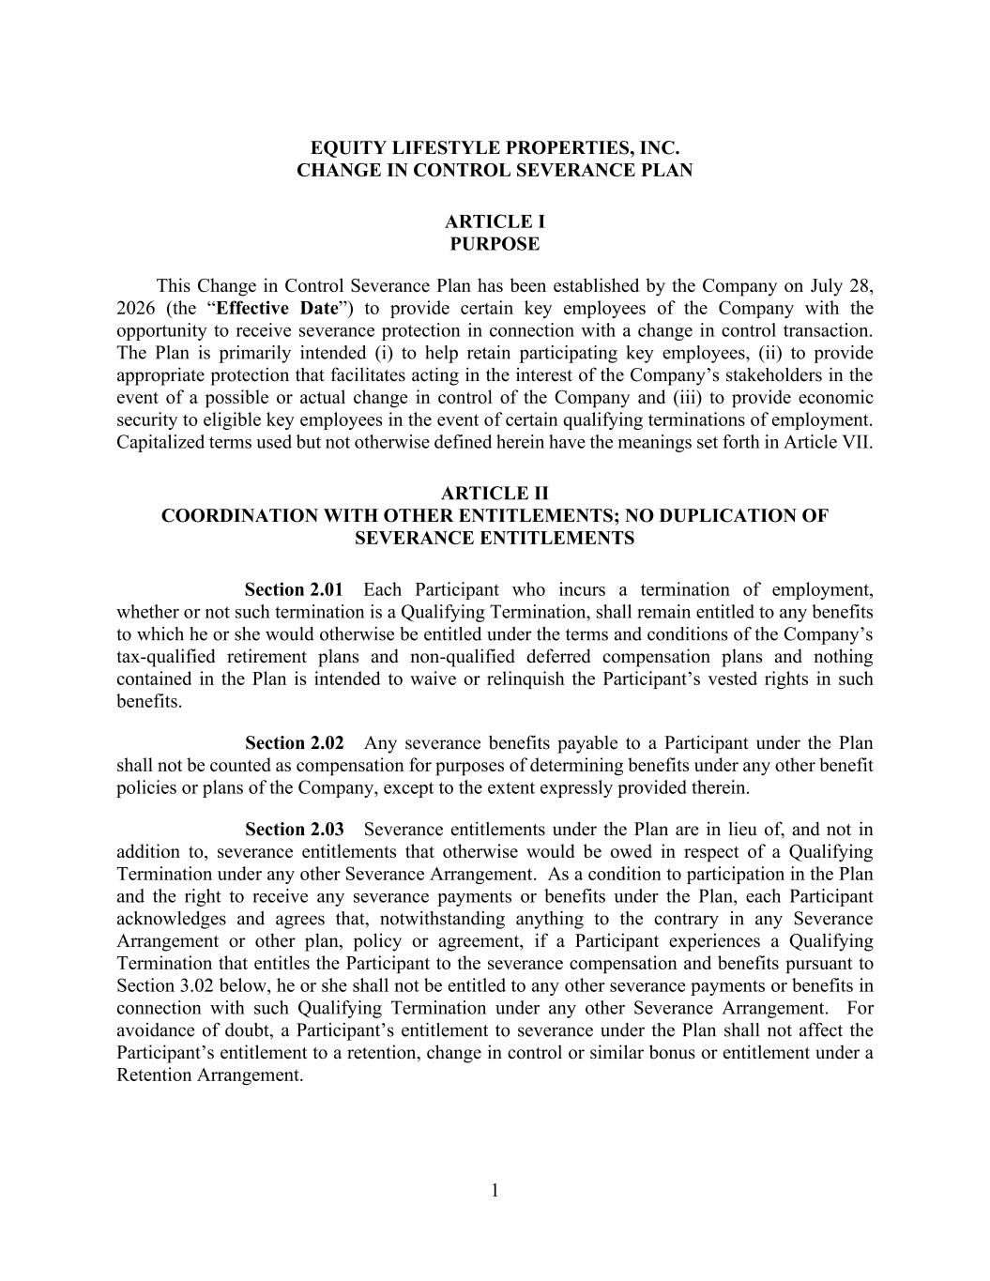
40
1 EQUITY LIFESTYLE PROPERTIES, INC. CHANGE IN CONTROL SEVERANCE PLAN ARTICLE I PURPOSE This Change in Control Severance Plan has been established by the Company on July 28, 2026 (the “Effective Date”) to provide certain key employees of the Company with the opportunity to receive severance protection in connection with a change in control transaction. The Plan is primarily intended (i) to help retain participating key employees, (ii) to provide appropriate protection that facilitates acting in the interest of the Company’s stakeholders in the event of a possible or actual change in control of the Company and (iii) to provide economic security to eligible key employees in the event of certain qualifying terminations of employment. Capitalized terms used but not otherwise defined herein have the meanings set forth in Article VII. ARTICLE II COORDINATION WITH OTHER ENTITLEMENTS; NO DUPLICATION OF SEVERANCE ENTITLEMENTS Section 2.01 Each Participant who incurs a termination of employment, whether or not such termination is a Qualifying Termination, shall remain entitled to any benefits to which he or she would otherwise be entitled under the terms and conditions of the Company’s tax-qualified retirement plans and non-qualified deferred compensation plans and nothing contained in the Plan is intended to waive or relinquish the Participant’s vested rights in such benefits. Section 2.02 Any severance benefits payable to a Participant under the Plan shall not be counted as compensation for purposes of determining benefits under any other benefit policies or plans of the Company, except to the extent expressly provided therein. Section 2.03 Severance entitlements under the Plan are in lieu of, and not in addition to, severance entitlements that otherwise would be owed in respect of a Qualifying Termination under any other Severance Arrangement. As a condition to participation in the Plan and the right to receive any severance payments or benefits under the Plan, each Participant acknowledges and agrees that, notwithstanding anything to the contrary in any Severance Arrangement or other plan, policy or agreement, if a Participant experiences a Qualifying Termination that entitles the Participant to the severance compensation and benefits pursuant to Section 3.02 below, he or she shall not be entitled to any other severance payments or benefits in connection with such Qualifying Termination under any other Severance Arrangement. For avoidance of doubt, a Participant’s entitlement to severance under the Plan shall not affect the Participant’s entitlement to a retention, change in control or similar bonus or entitlement under a Retention Arrangement.

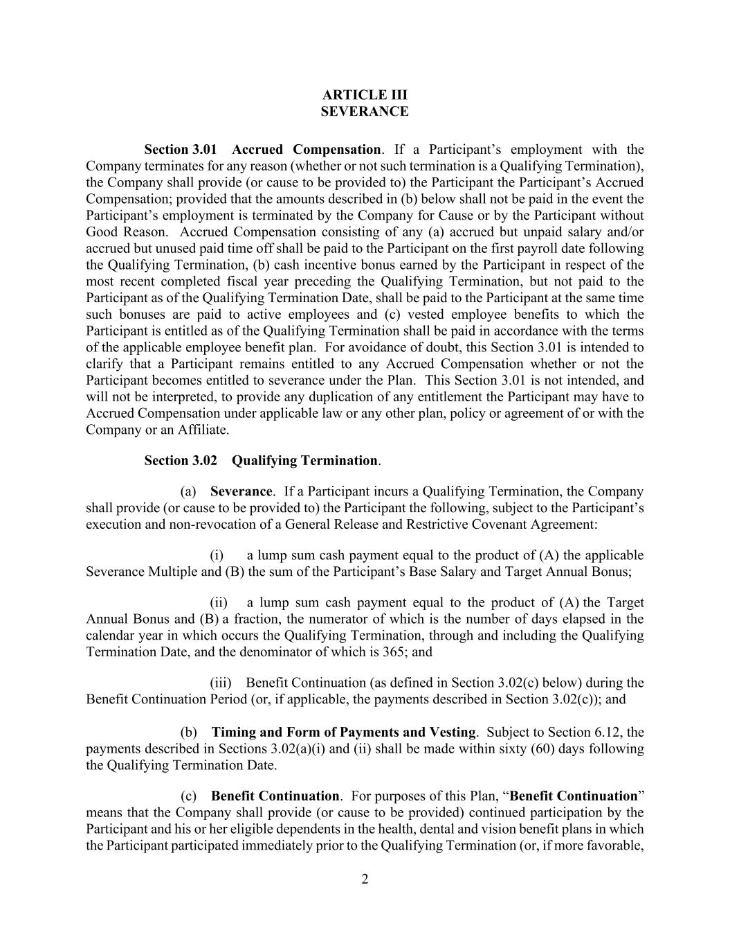
2 ARTICLE III SEVERANCE Section 3.01 Accrued Compensation. If a Participant’s employment with the Company terminates for any reason (whether or not such termination is a Qualifying Termination), the Company shall provide (or cause to be provided to) the Participant the Participant’s Accrued Compensation; provided that the amounts described in (b) below shall not be paid in the event the Participant’s employment is terminated by the Company for Cause or by the Participant without Good Reason. Accrued Compensation consisting of any (a) accrued but unpaid salary and/or accrued but unused paid time off shall be paid to the Participant on the first payroll date following the Qualifying Termination, (b) cash incentive bonus earned by the Participant in respect of the most recent completed fiscal year preceding the Qualifying Termination, but not paid to the Participant as of the Qualifying Termination Date, shall be paid to the Participant at the same time such bonuses are paid to active employees and (c) vested employee benefits to which the Participant is entitled as of the Qualifying Termination shall be paid in accordance with the terms of the applicable employee benefit plan. For avoidance of doubt, this Section 3.01 is intended to clarify that a Participant remains entitled to any Accrued Compensation whether or not the Participant becomes entitled to severance under the Plan. This Section 3.01 is not intended, and will not be interpreted, to provide any duplication of any entitlement the Participant may have to Accrued Compensation under applicable law or any other plan, policy or agreement of or with the Company or an Affiliate. Section 3.02 Qualifying Termination. (a) Severance. If a Participant incurs a Qualifying Termination, the Company shall provide (or cause to be provided to) the Participant the following, subject to the Participant’s execution and non-revocation of a General Release and Restrictive Covenant Agreement: (i) a lump sum cash payment equal to the product of (A) the applicable Severance Multiple and (B) the sum of the Participant’s Base Salary and Target Annual Bonus; (ii) a lump sum cash payment equal to the product of (A) the Target Annual Bonus and (B) a fraction, the numerator of which is the number of days elapsed in the calendar year in which occurs the Qualifying Termination, through and including the Qualifying Termination Date, and the denominator of which is 365; and (iii) Benefit Continuation (as defined in Section 3.02(c) below) during the Benefit Continuation Period (or, if applicable, the payments described in Section 3.02(c)); and (b) Timing and Form of Payments and Vesting. Subject to Section 6.12, the payments described in Sections 3.02(a)(i) and (ii) shall be made within sixty (60) days following the Qualifying Termination Date. (c) Benefit Continuation. For purposes of this Plan, “Benefit Continuation” means that the Company shall provide (or cause to be provided) continued participation by the Participant and his or her eligible dependents in the health, dental and vision benefit plans in which the Participant participated immediately prior to the Qualifying Termination (or, if more favorable,

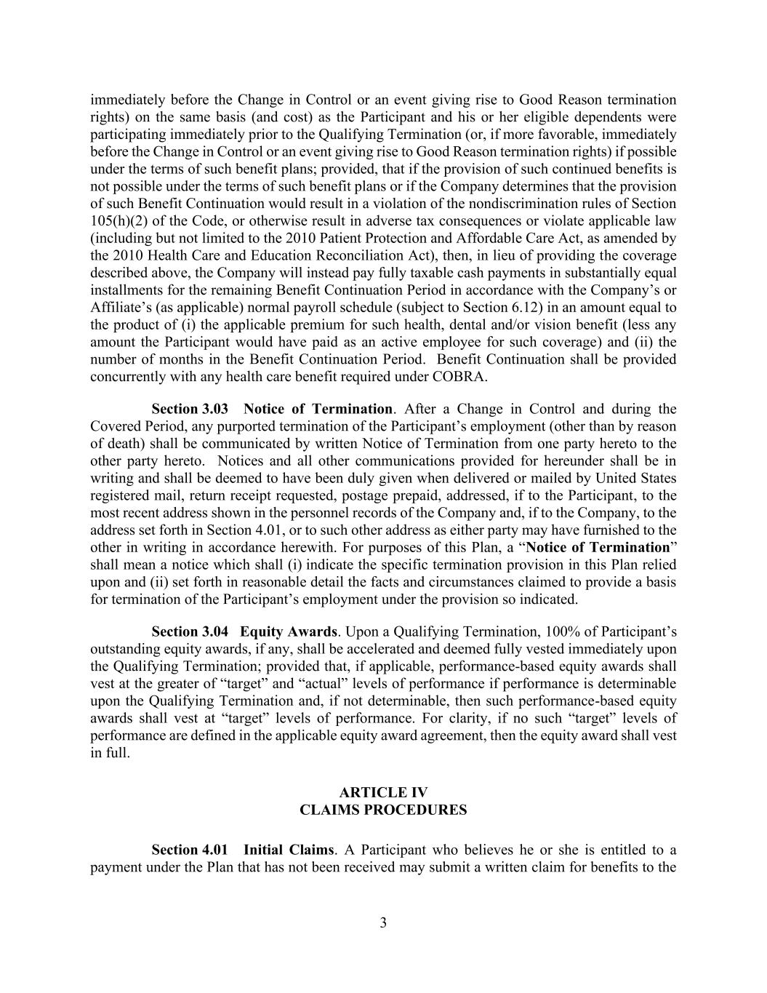
3 immediately before the Change in Control or an event giving rise to Good Reason termination rights) on the same basis (and cost) as the Participant and his or her eligible dependents were participating immediately prior to the Qualifying Termination (or, if more favorable, immediately before the Change in Control or an event giving rise to Good Reason termination rights) if possible under the terms of such benefit plans; provided, that if the provision of such continued benefits is not possible under the terms of such benefit plans or if the Company determines that the provision of such Benefit Continuation would result in a violation of the nondiscrimination rules of Section 105(h)(2) of the Code, or otherwise result in adverse tax consequences or violate applicable law (including but not limited to the 2010 Patient Protection and Affordable Care Act, as amended by the 2010 Health Care and Education Reconciliation Act), then, in lieu of providing the coverage described above, the Company will instead pay fully taxable cash payments in substantially equal installments for the remaining Benefit Continuation Period in accordance with the Company’s or Affiliate’s (as applicable) normal payroll schedule (subject to Section 6.12) in an amount equal to the product of (i) the applicable premium for such health, dental and/or vision benefit (less any amount the Participant would have paid as an active employee for such coverage) and (ii) the number of months in the Benefit Continuation Period. Benefit Continuation shall be provided concurrently with any health care benefit required under COBRA. Section 3.03 Notice of Termination. After a Change in Control and during the Covered Period, any purported termination of the Participant’s employment (other than by reason of death) shall be communicated by written Notice of Termination from one party hereto to the other party hereto. Notices and all other communications provided for hereunder shall be in writing and shall be deemed to have been duly given when delivered or mailed by United States registered mail, return receipt requested, postage prepaid, addressed, if to the Participant, to the most recent address shown in the personnel records of the Company and, if to the Company, to the address set forth in Section 4.01, or to such other address as either party may have furnished to the other in writing in accordance herewith. For purposes of this Plan, a “Notice of Termination” shall mean a notice which shall (i) indicate the specific termination provision in this Plan relied upon and (ii) set forth in reasonable detail the facts and circumstances claimed to provide a basis for termination of the Participant’s employment under the provision so indicated. Section 3.04 Equity Awards. Upon a Qualifying Termination, 100% of Participant’s outstanding equity awards, if any, shall be accelerated and deemed fully vested immediately upon the Qualifying Termination; provided that, if applicable, performance-based equity awards shall vest at the greater of “target” and “actual” levels of performance if performance is determinable upon the Qualifying Termination and, if not determinable, then such performance-based equity awards shall vest at “target” levels of performance. For clarity, if no such “target” levels of performance are defined in the applicable equity award agreement, then the equity award shall vest in full. ARTICLE IV CLAIMS PROCEDURES Section 4.01 Initial Claims. A Participant who believes he or she is entitled to a payment under the Plan that has not been received may submit a written claim for benefits to the

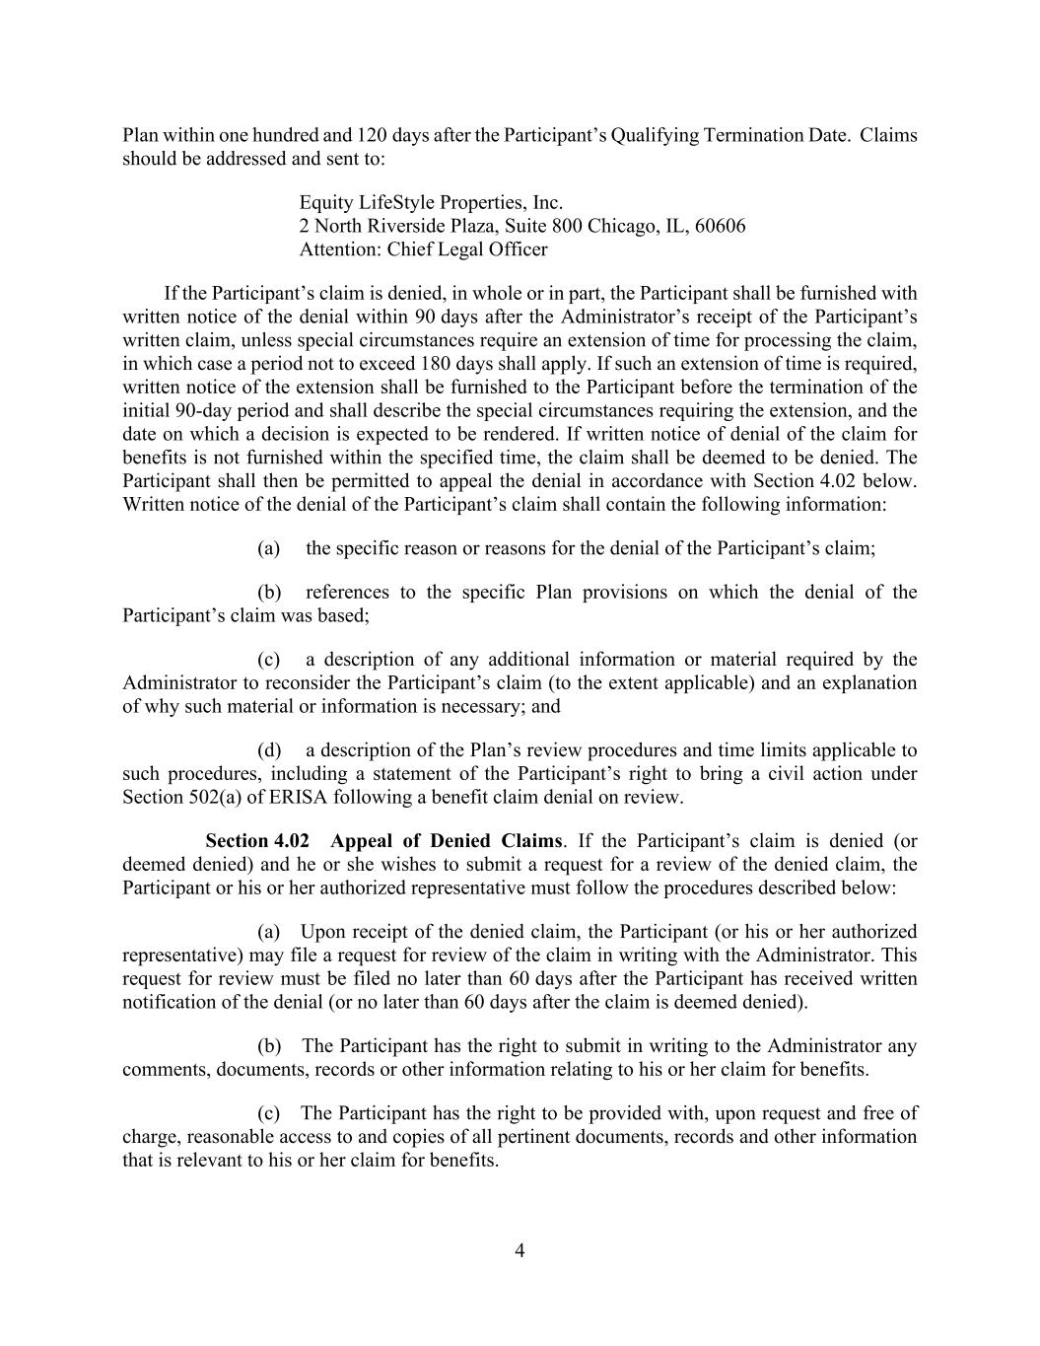
4 Plan within one hundred and 120 days after the Participant’s Qualifying Termination Date. Claims should be addressed and sent to: Equity LifeStyle Properties, Inc. 2 North Riverside Plaza, Suite 800 Chicago, IL, 60606 Attention: Chief Legal Officer If the Participant’s claim is denied, in whole or in part, the Participant shall be furnished with written notice of the denial within 90 days after the Administrator’s receipt of the Participant’s written claim, unless special circumstances require an extension of time for processing the claim, in which case a period not to exceed 180 days shall apply. If such an extension of time is required, written notice of the extension shall be furnished to the Participant before the termination of the initial 90-day period and shall describe the special circumstances requiring the extension, and the date on which a decision is expected to be rendered. If written notice of denial of the claim for benefits is not furnished within the specified time, the claim shall be deemed to be denied. The Participant shall then be permitted to appeal the denial in accordance with Section 4.02 below. Written notice of the denial of the Participant’s claim shall contain the following information: (a) the specific reason or reasons for the denial of the Participant’s claim; (b) references to the specific Plan provisions on which the denial of the Participant’s claim was based; (c) a description of any additional information or material required by the Administrator to reconsider the Participant’s claim (to the extent applicable) and an explanation of why such material or information is necessary; and (d) a description of the Plan’s review procedures and time limits applicable to such procedures, including a statement of the Participant’s right to bring a civil action under Section 502(a) of ERISA following a benefit claim denial on review. Section 4.02 Appeal of Denied Claims. If the Participant’s claim is denied (or deemed denied) and he or she wishes to submit a request for a review of the denied claim, the Participant or his or her authorized representative must follow the procedures described below: (a) Upon receipt of the denied claim, the Participant (or his or her authorized representative) may file a request for review of the claim in writing with the Administrator. This request for review must be filed no later than 60 days after the Participant has received written notification of the denial (or no later than 60 days after the claim is deemed denied). (b) The Participant has the right to submit in writing to the Administrator any comments, documents, records or other information relating to his or her claim for benefits. (c) The Participant has the right to be provided with, upon request and free of charge, reasonable access to and copies of all pertinent documents, records and other information that is relevant to his or her claim for benefits.

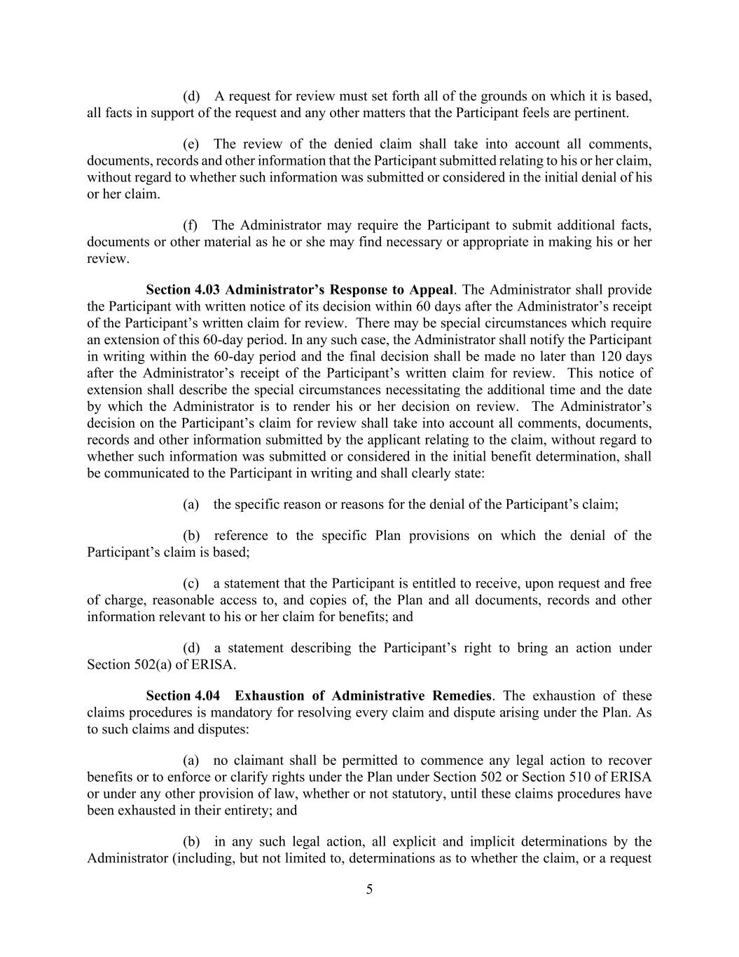
5 (d) A request for review must set forth all of the grounds on which it is based, all facts in support of the request and any other matters that the Participant feels are pertinent. (e) The review of the denied claim shall take into account all comments, documents, records and other information that the Participant submitted relating to his or her claim, without regard to whether such information was submitted or considered in the initial denial of his or her claim. (f) The Administrator may require the Participant to submit additional facts, documents or other material as he or she may find necessary or appropriate in making his or her review. Section 4.03 Administrator’s Response to Appeal. The Administrator shall provide the Participant with written notice of its decision within 60 days after the Administrator’s receipt of the Participant’s written claim for review. There may be special circumstances which require an extension of this 60-day period. In any such case, the Administrator shall notify the Participant in writing within the 60-day period and the final decision shall be made no later than 120 days after the Administrator’s receipt of the Participant’s written claim for review. This notice of extension shall describe the special circumstances necessitating the additional time and the date by which the Administrator is to render his or her decision on review. The Administrator’s decision on the Participant’s claim for review shall take into account all comments, documents, records and other information submitted by the applicant relating to the claim, without regard to whether such information was submitted or considered in the initial benefit determination, shall be communicated to the Participant in writing and shall clearly state: (a) the specific reason or reasons for the denial of the Participant’s claim; (b) reference to the specific Plan provisions on which the denial of the Participant’s claim is based; (c) a statement that the Participant is entitled to receive, upon request and free of charge, reasonable access to, and copies of, the Plan and all documents, records and other information relevant to his or her claim for benefits; and (d) a statement describing the Participant’s right to bring an action under Section 502(a) of ERISA. Section 4.04 Exhaustion of Administrative Remedies. The exhaustion of these claims procedures is mandatory for resolving every claim and dispute arising under the Plan. As to such claims and disputes: (a) no claimant shall be permitted to commence any legal action to recover benefits or to enforce or clarify rights under the Plan under Section 502 or Section 510 of ERISA or under any other provision of law, whether or not statutory, until these claims procedures have been exhausted in their entirety; and (b) in any such legal action, all explicit and implicit determinations by the Administrator (including, but not limited to, determinations as to whether the claim, or a request

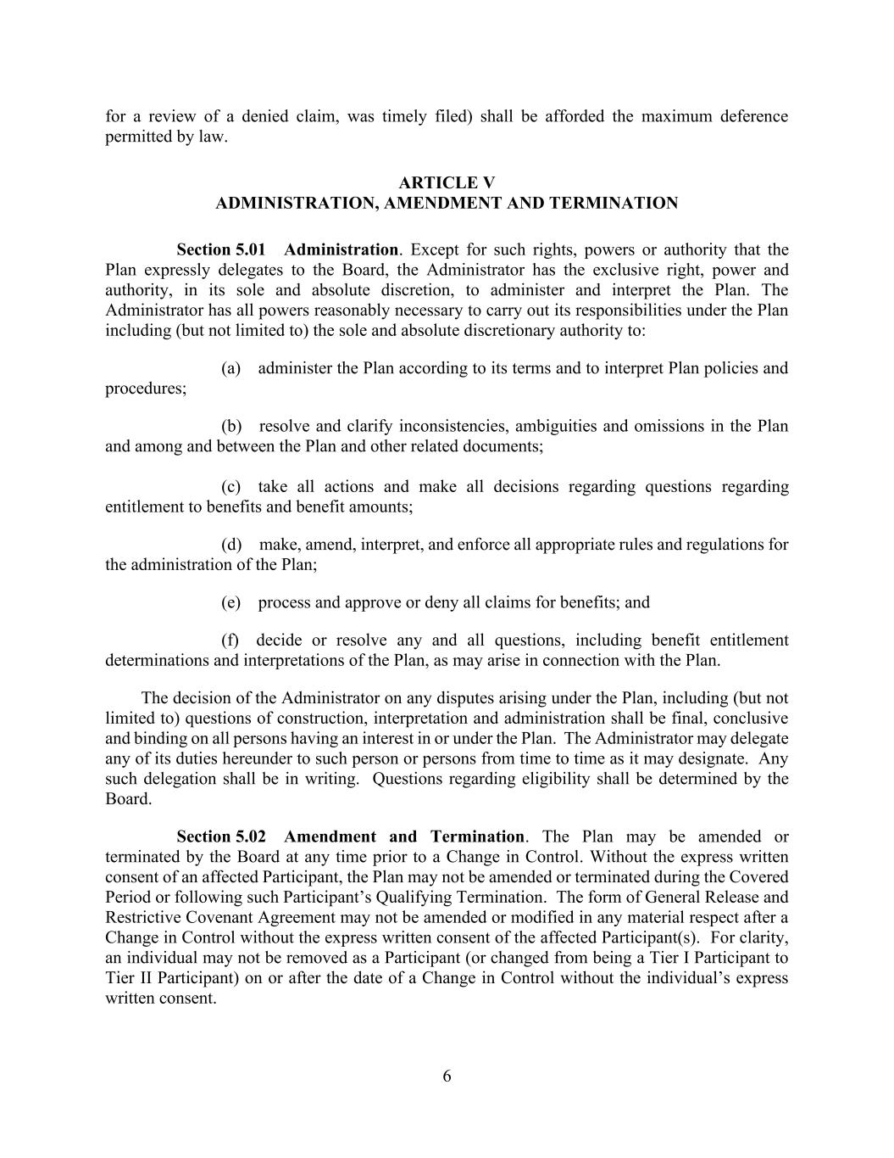
6 for a review of a denied claim, was timely filed) shall be afforded the maximum deference permitted by law. ARTICLE V ADMINISTRATION, AMENDMENT AND TERMINATION Section 5.01 Administration. Except for such rights, powers or authority that the Plan expressly delegates to the Board, the Administrator has the exclusive right, power and authority, in its sole and absolute discretion, to administer and interpret the Plan. The Administrator has all powers reasonably necessary to carry out its responsibilities under the Plan including (but not limited to) the sole and absolute discretionary authority to: (a) administer the Plan according to its terms and to interpret Plan policies and procedures; (b) resolve and clarify inconsistencies, ambiguities and omissions in the Plan and among and between the Plan and other related documents; (c) take all actions and make all decisions regarding questions regarding entitlement to benefits and benefit amounts; (d) make, amend, interpret, and enforce all appropriate rules and regulations for the administration of the Plan; (e) process and approve or deny all claims for benefits; and (f) decide or resolve any and all questions, including benefit entitlement determinations and interpretations of the Plan, as may arise in connection with the Plan. The decision of the Administrator on any disputes arising under the Plan, including (but not limited to) questions of construction, interpretation and administration shall be final, conclusive and binding on all persons having an interest in or under the Plan. The Administrator may delegate any of its duties hereunder to such person or persons from time to time as it may designate. Any such delegation shall be in writing. Questions regarding eligibility shall be determined by the Board. Section 5.02 Amendment and Termination. The Plan may be amended or terminated by the Board at any time prior to a Change in Control. Without the express written consent of an affected Participant, the Plan may not be amended or terminated during the Covered Period or following such Participant’s Qualifying Termination. The form of General Release and Restrictive Covenant Agreement may not be amended or modified in any material respect after a Change in Control without the express written consent of the affected Participant(s). For clarity, an individual may not be removed as a Participant (or changed from being a Tier I Participant to Tier II Participant) on or after the date of a Change in Control without the individual’s express written consent.

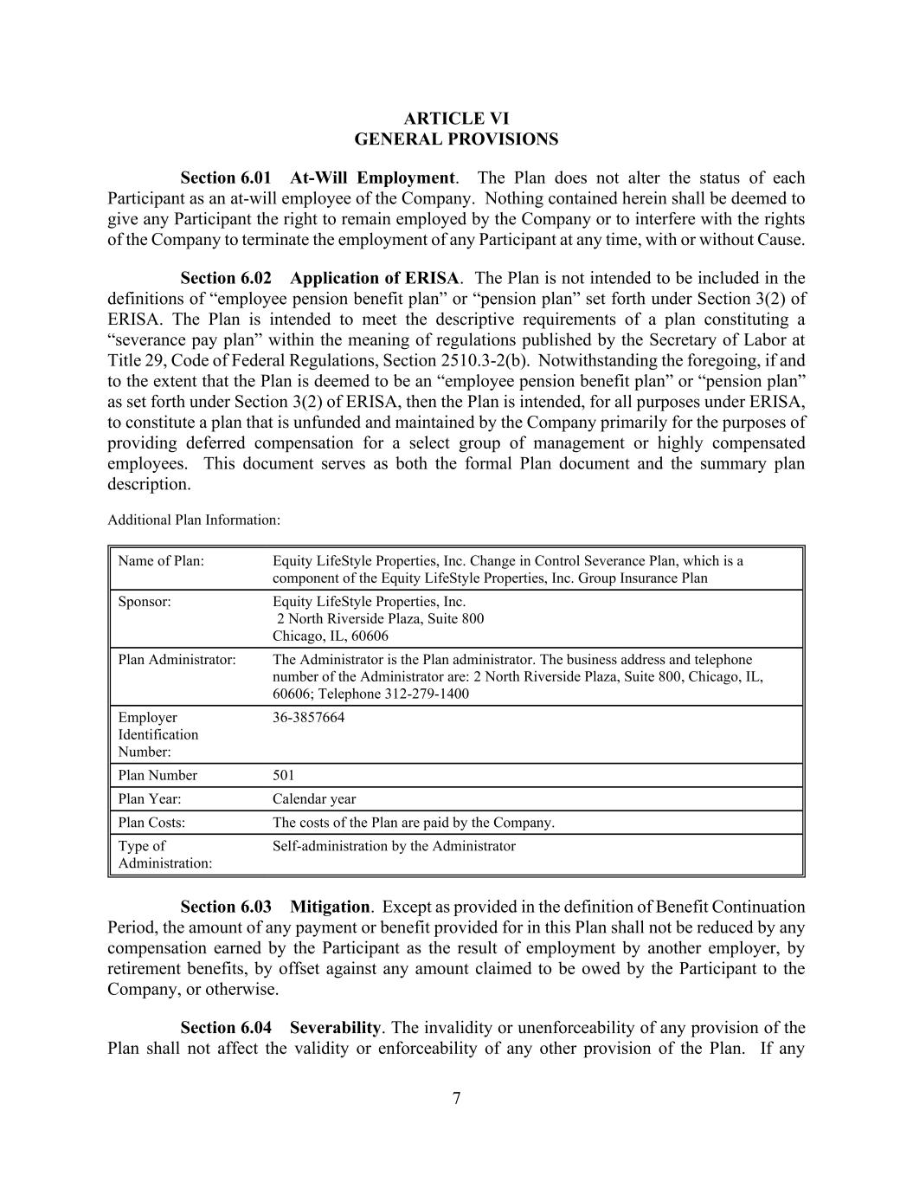
7 ARTICLE VI GENERAL PROVISIONS Section 6.01 At-Will Employment. The Plan does not alter the status of each Participant as an at-will employee of the Company. Nothing contained herein shall be deemed to give any Participant the right to remain employed by the Company or to interfere with the rights of the Company to terminate the employment of any Participant at any time, with or without Cause. Section 6.02 Application of ERISA. The Plan is not intended to be included in the definitions of “employee pension benefit plan” or “pension plan” set forth under Section 3(2) of ERISA. The Plan is intended to meet the descriptive requirements of a plan constituting a “severance pay plan” within the meaning of regulations published by the Secretary of Labor at Title 29, Code of Federal Regulations, Section 2510.3-2(b). Notwithstanding the foregoing, if and to the extent that the Plan is deemed to be an “employee pension benefit plan” or “pension plan” as set forth under Section 3(2) of ERISA, then the Plan is intended, for all purposes under ERISA, to constitute a plan that is unfunded and maintained by the Company primarily for the purposes of providing deferred compensation for a select group of management or highly compensated employees. This document serves as both the formal Plan document and the summary plan description. Additional Plan Information: Name of Plan: Equity LifeStyle Properties, Inc. Change in Control Severance Plan, which is a component of the Equity LifeStyle Properties, Inc. Group Insurance Plan Sponsor: Equity LifeStyle Properties, Inc. 2 North Riverside Plaza, Suite 800 Chicago, IL, 60606 Plan Administrator: The Administrator is the Plan administrator. The business address and telephone number of the Administrator are: 2 North Riverside Plaza, Suite 800, Chicago, IL, 60606; Telephone 312-279-1400 Employer Identification Number: 36-3857664 Plan Number 501 Plan Year: Calendar year Plan Costs: The costs of the Plan are paid by the Company. Type of Administration: Self-administration by the Administrator Section 6.03 Mitigation. Except as provided in the definition of Benefit Continuation Period, the amount of any payment or benefit provided for in this Plan shall not be reduced by any compensation earned by the Participant as the result of employment by another employer, by retirement benefits, by offset against any amount claimed to be owed by the Participant to the Company, or otherwise. Section 6.04 Severability. The invalidity or unenforceability of any provision of the Plan shall not affect the validity or enforceability of any other provision of the Plan. If any

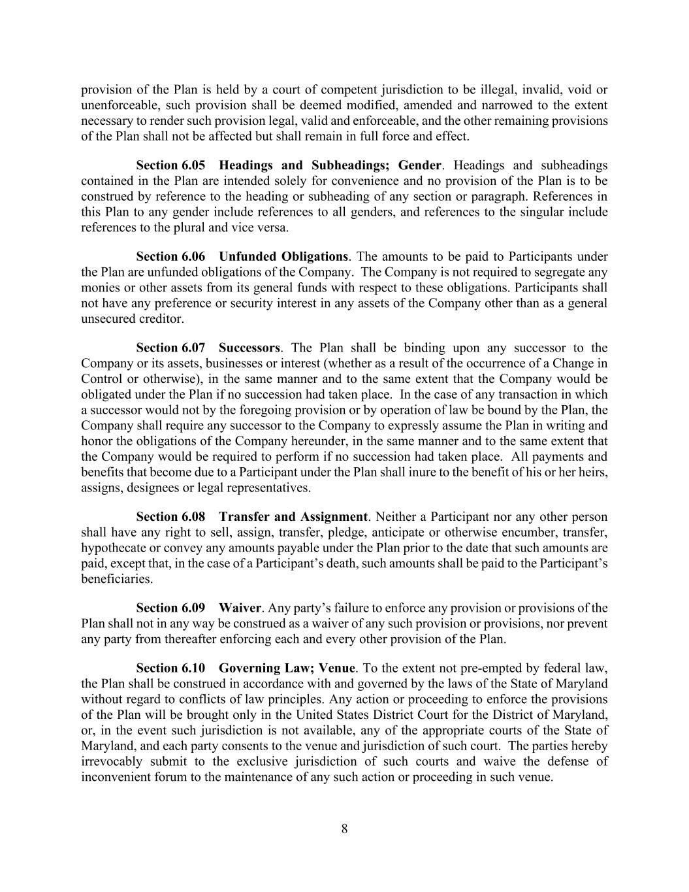
8 provision of the Plan is held by a court of competent jurisdiction to be illegal, invalid, void or unenforceable, such provision shall be deemed modified, amended and narrowed to the extent necessary to render such provision legal, valid and enforceable, and the other remaining provisions of the Plan shall not be affected but shall remain in full force and effect. Section 6.05 Headings and Subheadings; Gender. Headings and subheadings contained in the Plan are intended solely for convenience and no provision of the Plan is to be construed by reference to the heading or subheading of any section or paragraph. References in this Plan to any gender include references to all genders, and references to the singular include references to the plural and vice versa. Section 6.06 Unfunded Obligations. The amounts to be paid to Participants under the Plan are unfunded obligations of the Company. The Company is not required to segregate any monies or other assets from its general funds with respect to these obligations. Participants shall not have any preference or security interest in any assets of the Company other than as a general unsecured creditor. Section 6.07 Successors. The Plan shall be binding upon any successor to the Company or its assets, businesses or interest (whether as a result of the occurrence of a Change in Control or otherwise), in the same manner and to the same extent that the Company would be obligated under the Plan if no succession had taken place. In the case of any transaction in which a successor would not by the foregoing provision or by operation of law be bound by the Plan, the Company shall require any successor to the Company to expressly assume the Plan in writing and honor the obligations of the Company hereunder, in the same manner and to the same extent that the Company would be required to perform if no succession had taken place. All payments and benefits that become due to a Participant under the Plan shall inure to the benefit of his or her heirs, assigns, designees or legal representatives. Section 6.08 Transfer and Assignment. Neither a Participant nor any other person shall have any right to sell, assign, transfer, pledge, anticipate or otherwise encumber, transfer, hypothecate or convey any amounts payable under the Plan prior to the date that such amounts are paid, except that, in the case of a Participant’s death, such amounts shall be paid to the Participant’s beneficiaries. Section 6.09 Waiver. Any party’s failure to enforce any provision or provisions of the Plan shall not in any way be construed as a waiver of any such provision or provisions, nor prevent any party from thereafter enforcing each and every other provision of the Plan. Section 6.10 Governing Law; Venue. To the extent not pre-empted by federal law, the Plan shall be construed in accordance with and governed by the laws of the State of Maryland without regard to conflicts of law principles. Any action or proceeding to enforce the provisions of the Plan will be brought only in the United States District Court for the District of Maryland, or, in the event such jurisdiction is not available, any of the appropriate courts of the State of Maryland, and each party consents to the venue and jurisdiction of such court. The parties hereby irrevocably submit to the exclusive jurisdiction of such courts and waive the defense of inconvenient forum to the maintenance of any such action or proceeding in such venue.

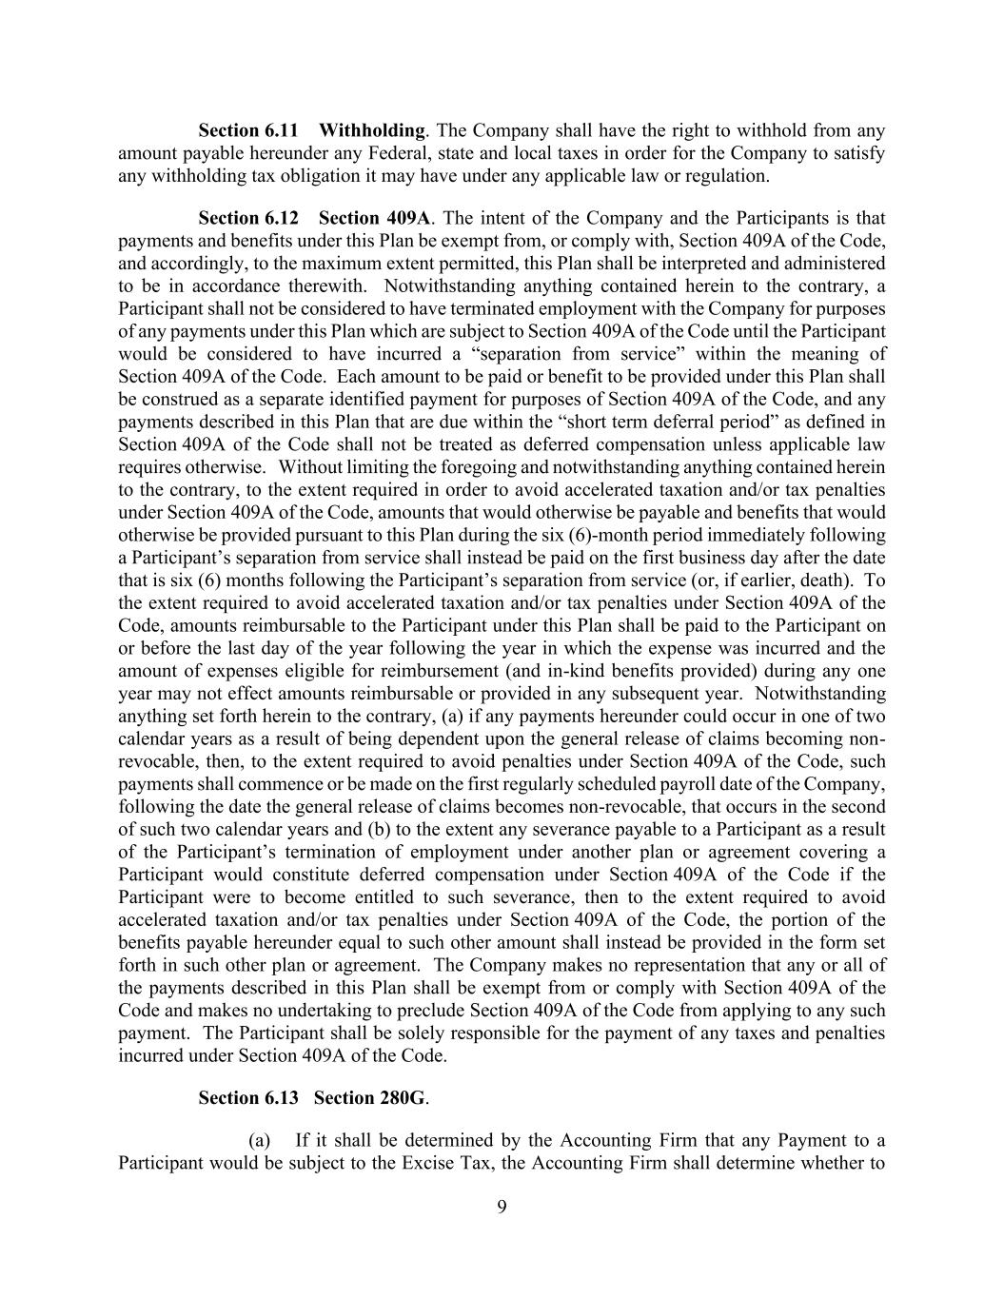
9 Section 6.11 Withholding. The Company shall have the right to withhold from any amount payable hereunder any Federal, state and local taxes in order for the Company to satisfy any withholding tax obligation it may have under any applicable law or regulation. Section 6.12 Section 409A. The intent of the Company and the Participants is that payments and benefits under this Plan be exempt from, or comply with, Section 409A of the Code, and accordingly, to the maximum extent permitted, this Plan shall be interpreted and administered to be in accordance therewith. Notwithstanding anything contained herein to the contrary, a Participant shall not be considered to have terminated employment with the Company for purposes of any payments under this Plan which are subject to Section 409A of the Code until the Participant would be considered to have incurred a “separation from service” within the meaning of Section 409A of the Code. Each amount to be paid or benefit to be provided under this Plan shall be construed as a separate identified payment for purposes of Section 409A of the Code, and any payments described in this Plan that are due within the “short term deferral period” as defined in Section 409A of the Code shall not be treated as deferred compensation unless applicable law requires otherwise. Without limiting the foregoing and notwithstanding anything contained herein to the contrary, to the extent required in order to avoid accelerated taxation and/or tax penalties under Section 409A of the Code, amounts that would otherwise be payable and benefits that would otherwise be provided pursuant to this Plan during the six (6)-month period immediately following a Participant’s separation from service shall instead be paid on the first business day after the date that is six (6) months following the Participant’s separation from service (or, if earlier, death). To the extent required to avoid accelerated taxation and/or tax penalties under Section 409A of the Code, amounts reimbursable to the Participant under this Plan shall be paid to the Participant on or before the last day of the year following the year in which the expense was incurred and the amount of expenses eligible for reimbursement (and in-kind benefits provided) during any one year may not effect amounts reimbursable or provided in any subsequent year. Notwithstanding anything set forth herein to the contrary, (a) if any payments hereunder could occur in one of two calendar years as a result of being dependent upon the general release of claims becoming non- revocable, then, to the extent required to avoid penalties under Section 409A of the Code, such payments shall commence or be made on the first regularly scheduled payroll date of the Company, following the date the general release of claims becomes non-revocable, that occurs in the second of such two calendar years and (b) to the extent any severance payable to a Participant as a result of the Participant’s termination of employment under another plan or agreement covering a Participant would constitute deferred compensation under Section 409A of the Code if the Participant were to become entitled to such severance, then to the extent required to avoid accelerated taxation and/or tax penalties under Section 409A of the Code, the portion of the benefits payable hereunder equal to such other amount shall instead be provided in the form set forth in such other plan or agreement. The Company makes no representation that any or all of the payments described in this Plan shall be exempt from or comply with Section 409A of the Code and makes no undertaking to preclude Section 409A of the Code from applying to any such payment. The Participant shall be solely responsible for the payment of any taxes and penalties incurred under Section 409A of the Code. Section 6.13 Section 280G. (a) If it shall be determined by the Accounting Firm that any Payment to a Participant would be subject to the Excise Tax, the Accounting Firm shall determine whether to

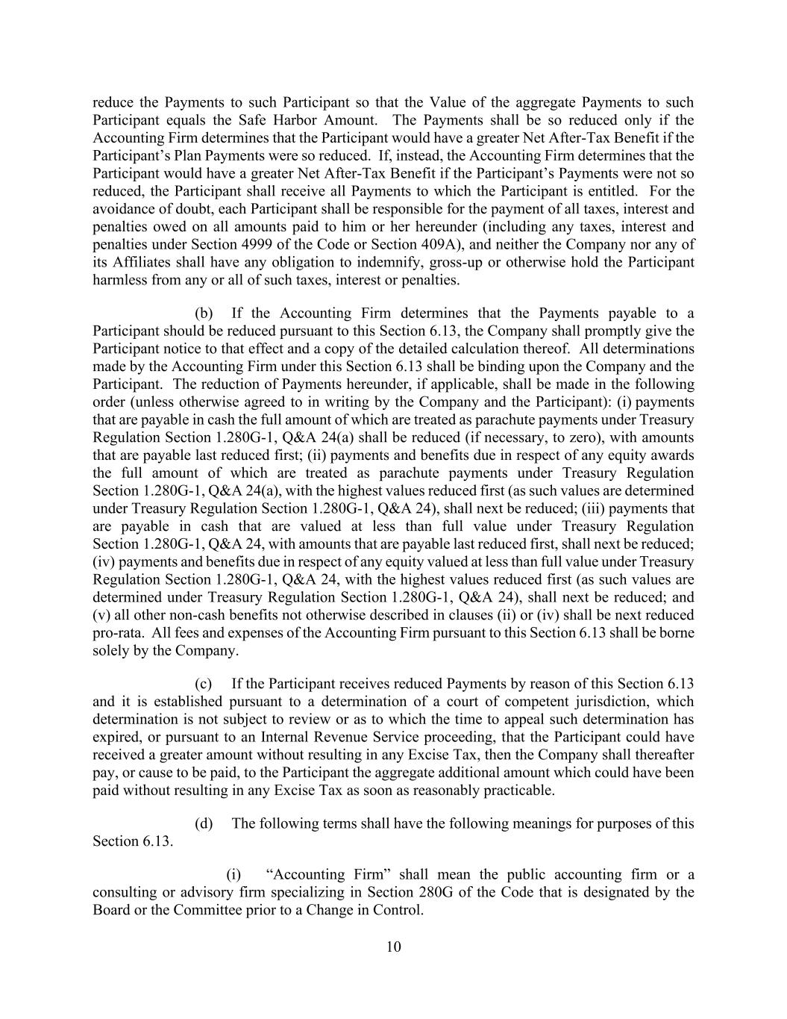
10 reduce the Payments to such Participant so that the Value of the aggregate Payments to such Participant equals the Safe Harbor Amount. The Payments shall be so reduced only if the Accounting Firm determines that the Participant would have a greater Net After-Tax Benefit if the Participant’s Plan Payments were so reduced. If, instead, the Accounting Firm determines that the Participant would have a greater Net After-Tax Benefit if the Participant’s Payments were not so reduced, the Participant shall receive all Payments to which the Participant is entitled. For the avoidance of doubt, each Participant shall be responsible for the payment of all taxes, interest and penalties owed on all amounts paid to him or her hereunder (including any taxes, interest and penalties under Section 4999 of the Code or Section 409A), and neither the Company nor any of its Affiliates shall have any obligation to indemnify, gross-up or otherwise hold the Participant harmless from any or all of such taxes, interest or penalties. (b) If the Accounting Firm determines that the Payments payable to a Participant should be reduced pursuant to this Section 6.13, the Company shall promptly give the Participant notice to that effect and a copy of the detailed calculation thereof. All determinations made by the Accounting Firm under this Section 6.13 shall be binding upon the Company and the Participant. The reduction of Payments hereunder, if applicable, shall be made in the following order (unless otherwise agreed to in writing by the Company and the Participant): (i) payments that are payable in cash the full amount of which are treated as parachute payments under Treasury Regulation Section 1.280G-1, Q&A 24(a) shall be reduced (if necessary, to zero), with amounts that are payable last reduced first; (ii) payments and benefits due in respect of any equity awards the full amount of which are treated as parachute payments under Treasury Regulation Section 1.280G-1, Q&A 24(a), with the highest values reduced first (as such values are determined under Treasury Regulation Section 1.280G-1, Q&A 24), shall next be reduced; (iii) payments that are payable in cash that are valued at less than full value under Treasury Regulation Section 1.280G-1, Q&A 24, with amounts that are payable last reduced first, shall next be reduced; (iv) payments and benefits due in respect of any equity valued at less than full value under Treasury Regulation Section 1.280G-1, Q&A 24, with the highest values reduced first (as such values are determined under Treasury Regulation Section 1.280G-1, Q&A 24), shall next be reduced; and (v) all other non-cash benefits not otherwise described in clauses (ii) or (iv) shall be next reduced pro-rata. All fees and expenses of the Accounting Firm pursuant to this Section 6.13 shall be borne solely by the Company. (c) If the Participant receives reduced Payments by reason of this Section 6.13 and it is established pursuant to a determination of a court of competent jurisdiction, which determination is not subject to review or as to which the time to appeal such determination has expired, or pursuant to an Internal Revenue Service proceeding, that the Participant could have received a greater amount without resulting in any Excise Tax, then the Company shall thereafter pay, or cause to be paid, to the Participant the aggregate additional amount which could have been paid without resulting in any Excise Tax as soon as reasonably practicable. (d) The following terms shall have the following meanings for purposes of this Section 6.13. (i) “Accounting Firm” shall mean the public accounting firm or a consulting or advisory firm specializing in Section 280G of the Code that is designated by the Board or the Committee prior to a Change in Control.

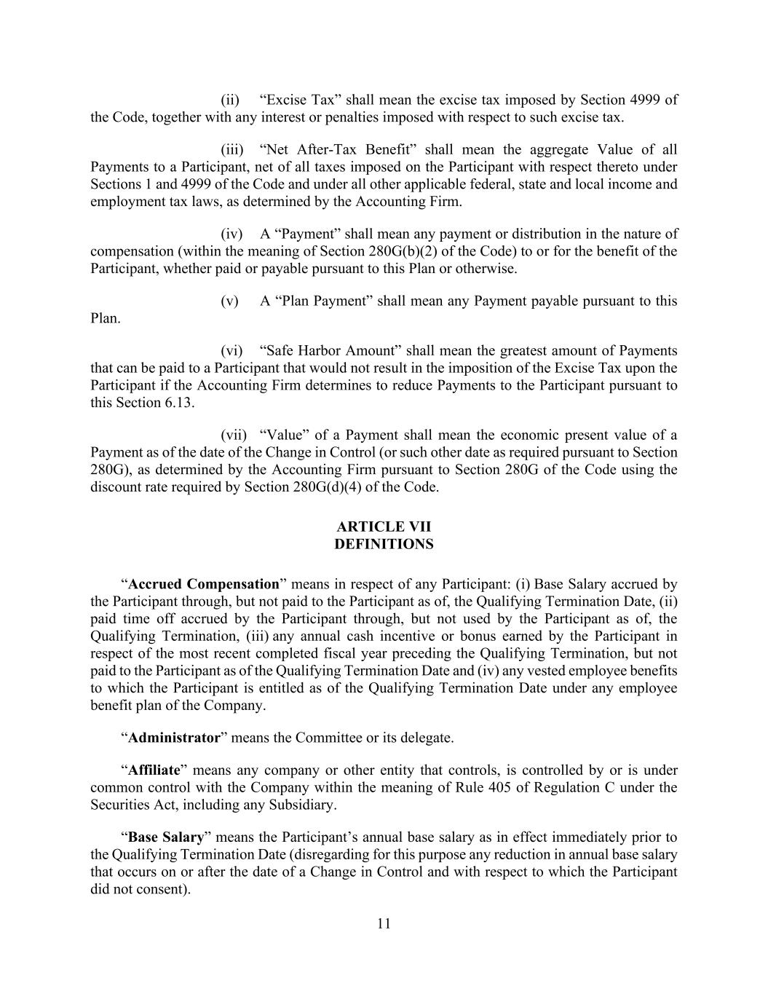
11 (ii) “Excise Tax” shall mean the excise tax imposed by Section 4999 of the Code, together with any interest or penalties imposed with respect to such excise tax. (iii) “Net After-Tax Benefit” shall mean the aggregate Value of all Payments to a Participant, net of all taxes imposed on the Participant with respect thereto under Sections 1 and 4999 of the Code and under all other applicable federal, state and local income and employment tax laws, as determined by the Accounting Firm. (iv) A “Payment” shall mean any payment or distribution in the nature of compensation (within the meaning of Section 280G(b)(2) of the Code) to or for the benefit of the Participant, whether paid or payable pursuant to this Plan or otherwise. (v) A “Plan Payment” shall mean any Payment payable pursuant to this Plan. (vi) “Safe Harbor Amount” shall mean the greatest amount of Payments that can be paid to a Participant that would not result in the imposition of the Excise Tax upon the Participant if the Accounting Firm determines to reduce Payments to the Participant pursuant to this Section 6.13. (vii) “Value” of a Payment shall mean the economic present value of a Payment as of the date of the Change in Control (or such other date as required pursuant to Section 280G), as determined by the Accounting Firm pursuant to Section 280G of the Code using the discount rate required by Section 280G(d)(4) of the Code. ARTICLE VII DEFINITIONS “Accrued Compensation” means in respect of any Participant: (i) Base Salary accrued by the Participant through, but not paid to the Participant as of, the Qualifying Termination Date, (ii) paid time off accrued by the Participant through, but not used by the Participant as of, the Qualifying Termination, (iii) any annual cash incentive or bonus earned by the Participant in respect of the most recent completed fiscal year preceding the Qualifying Termination, but not paid to the Participant as of the Qualifying Termination Date and (iv) any vested employee benefits to which the Participant is entitled as of the Qualifying Termination Date under any employee benefit plan of the Company. “Administrator” means the Committee or its delegate. “Affiliate” means any company or other entity that controls, is controlled by or is under common control with the Company within the meaning of Rule 405 of Regulation C under the Securities Act, including any Subsidiary. “Base Salary” means the Participant’s annual base salary as in effect immediately prior to the Qualifying Termination Date (disregarding for this purpose any reduction in annual base salary that occurs on or after the date of a Change in Control and with respect to which the Participant did not consent).

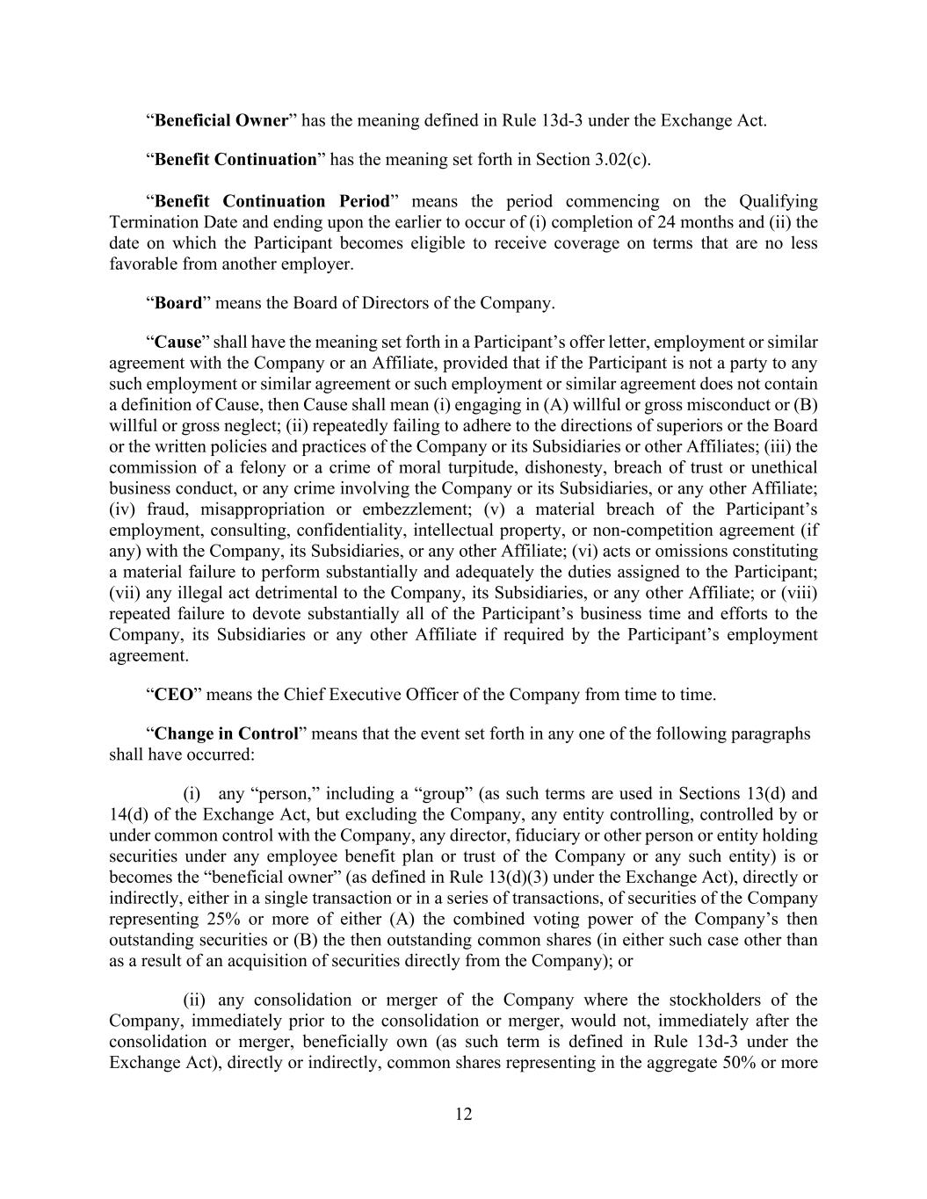
12 “Beneficial Owner” has the meaning defined in Rule 13d-3 under the Exchange Act. “Benefit Continuation” has the meaning set forth in Section 3.02(c). “Benefit Continuation Period” means the period commencing on the Qualifying Termination Date and ending upon the earlier to occur of (i) completion of 24 months and (ii) the date on which the Participant becomes eligible to receive coverage on terms that are no less favorable from another employer. “Board” means the Board of Directors of the Company. “Cause” shall have the meaning set forth in a Participant’s offer letter, employment or similar agreement with the Company or an Affiliate, provided that if the Participant is not a party to any such employment or similar agreement or such employment or similar agreement does not contain a definition of Cause, then Cause shall mean (i) engaging in (A) willful or gross misconduct or (B) willful or gross neglect; (ii) repeatedly failing to adhere to the directions of superiors or the Board or the written policies and practices of the Company or its Subsidiaries or other Affiliates; (iii) the commission of a felony or a crime of moral turpitude, dishonesty, breach of trust or unethical business conduct, or any crime involving the Company or its Subsidiaries, or any other Affiliate; (iv) fraud, misappropriation or embezzlement; (v) a material breach of the Participant’s employment, consulting, confidentiality, intellectual property, or non-competition agreement (if any) with the Company, its Subsidiaries, or any other Affiliate; (vi) acts or omissions constituting a material failure to perform substantially and adequately the duties assigned to the Participant; (vii) any illegal act detrimental to the Company, its Subsidiaries, or any other Affiliate; or (viii) repeated failure to devote substantially all of the Participant’s business time and efforts to the Company, its Subsidiaries or any other Affiliate if required by the Participant’s employment agreement. “CEO” means the Chief Executive Officer of the Company from time to time. “Change in Control” means that the event set forth in any one of the following paragraphs shall have occurred: (i) any “person,” including a “group” (as such terms are used in Sections 13(d) and 14(d) of the Exchange Act, but excluding the Company, any entity controlling, controlled by or under common control with the Company, any director, fiduciary or other person or entity holding securities under any employee benefit plan or trust of the Company or any such entity) is or becomes the “beneficial owner” (as defined in Rule 13(d)(3) under the Exchange Act), directly or indirectly, either in a single transaction or in a series of transactions, of securities of the Company representing 25% or more of either (A) the combined voting power of the Company’s then outstanding securities or (B) the then outstanding common shares (in either such case other than as a result of an acquisition of securities directly from the Company); or (ii) any consolidation or merger of the Company where the stockholders of the Company, immediately prior to the consolidation or merger, would not, immediately after the consolidation or merger, beneficially own (as such term is defined in Rule 13d-3 under the Exchange Act), directly or indirectly, common shares representing in the aggregate 50% or more

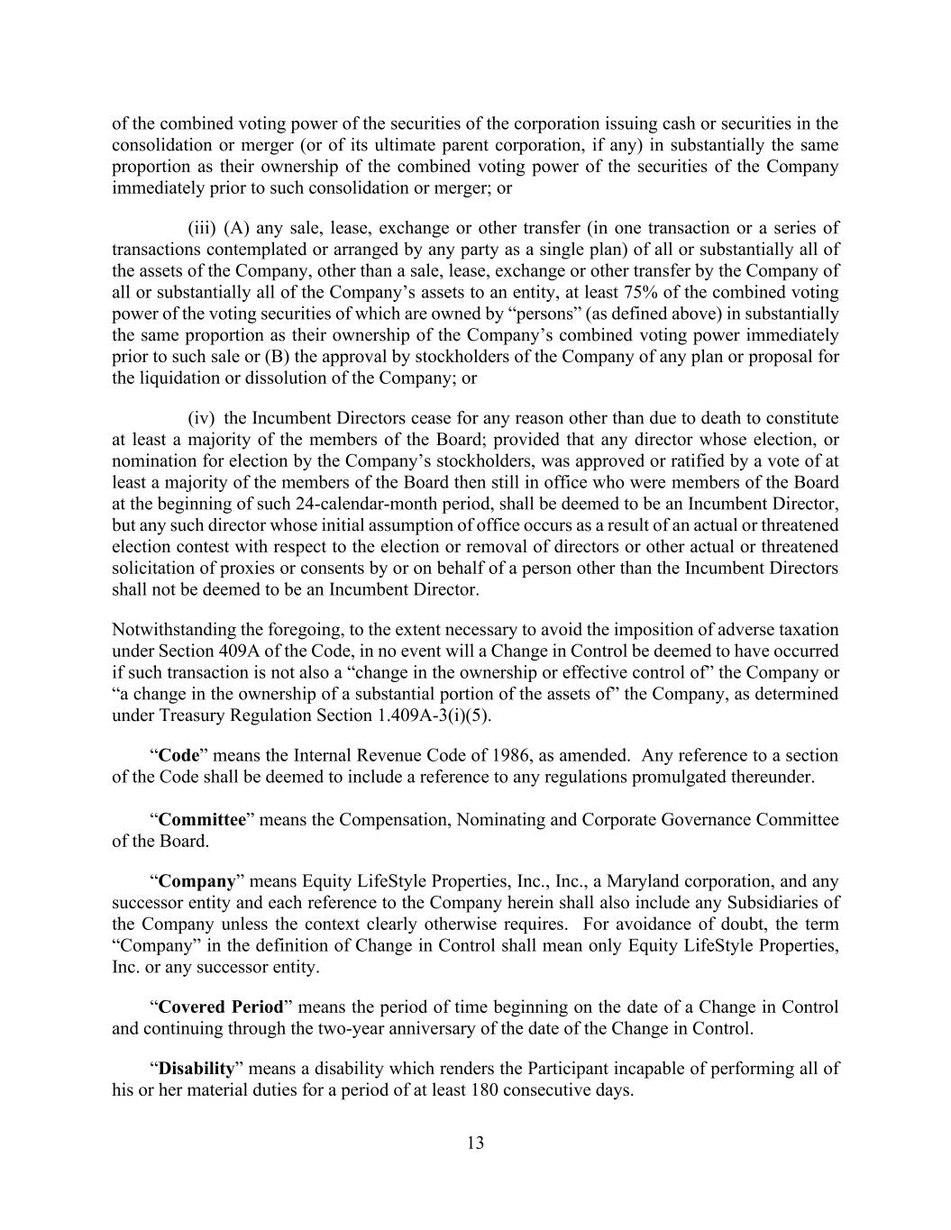
13 of the combined voting power of the securities of the corporation issuing cash or securities in the consolidation or merger (or of its ultimate parent corporation, if any) in substantially the same proportion as their ownership of the combined voting power of the securities of the Company immediately prior to such consolidation or merger; or (iii) (A) any sale, lease, exchange or other transfer (in one transaction or a series of transactions contemplated or arranged by any party as a single plan) of all or substantially all of the assets of the Company, other than a sale, lease, exchange or other transfer by the Company of all or substantially all of the Company’s assets to an entity, at least 75% of the combined voting power of the voting securities of which are owned by “persons” (as defined above) in substantially the same proportion as their ownership of the Company’s combined voting power immediately prior to such sale or (B) the approval by stockholders of the Company of any plan or proposal for the liquidation or dissolution of the Company; or (iv) the Incumbent Directors cease for any reason other than due to death to constitute at least a majority of the members of the Board; provided that any director whose election, or nomination for election by the Company’s stockholders, was approved or ratified by a vote of at least a majority of the members of the Board then still in office who were members of the Board at the beginning of such 24-calendar-month period, shall be deemed to be an Incumbent Director, but any such director whose initial assumption of office occurs as a result of an actual or threatened election contest with respect to the election or removal of directors or other actual or threatened solicitation of proxies or consents by or on behalf of a person other than the Incumbent Directors shall not be deemed to be an Incumbent Director. Notwithstanding the foregoing, to the extent necessary to avoid the imposition of adverse taxation under Section 409A of the Code, in no event will a Change in Control be deemed to have occurred if such transaction is not also a “change in the ownership or effective control of” the Company or “a change in the ownership of a substantial portion of the assets of” the Company, as determined under Treasury Regulation Section 1.409A-3(i)(5). “Code” means the Internal Revenue Code of 1986, as amended. Any reference to a section of the Code shall be deemed to include a reference to any regulations promulgated thereunder. “Committee” means the Compensation, Nominating and Corporate Governance Committee of the Board. “Company” means Equity LifeStyle Properties, Inc., Inc., a Maryland corporation, and any successor entity and each reference to the Company herein shall also include any Subsidiaries of the Company unless the context clearly otherwise requires. For avoidance of doubt, the term “Company” in the definition of Change in Control shall mean only Equity LifeStyle Properties, Inc. or any successor entity. “Covered Period” means the period of time beginning on the date of a Change in Control and continuing through the two-year anniversary of the date of the Change in Control. “Disability” means a disability which renders the Participant incapable of performing all of his or her material duties for a period of at least 180 consecutive days.

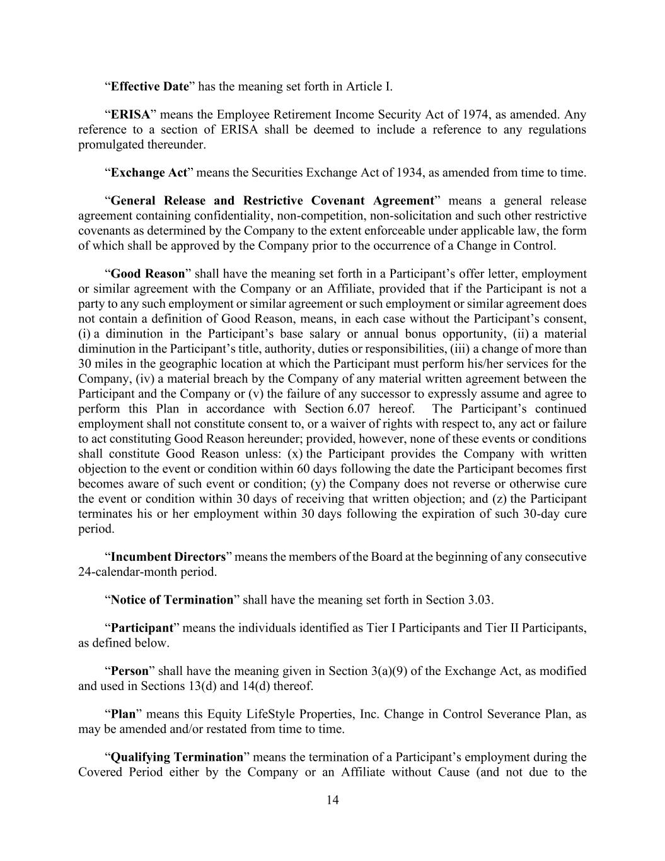
14 “Effective Date” has the meaning set forth in Article I. “ERISA” means the Employee Retirement Income Security Act of 1974, as amended. Any reference to a section of ERISA shall be deemed to include a reference to any regulations promulgated thereunder. “Exchange Act” means the Securities Exchange Act of 1934, as amended from time to time. “General Release and Restrictive Covenant Agreement” means a general release agreement containing confidentiality, non-competition, non-solicitation and such other restrictive covenants as determined by the Company to the extent enforceable under applicable law, the form of which shall be approved by the Company prior to the occurrence of a Change in Control. “Good Reason” shall have the meaning set forth in a Participant’s offer letter, employment or similar agreement with the Company or an Affiliate, provided that if the Participant is not a party to any such employment or similar agreement or such employment or similar agreement does not contain a definition of Good Reason, means, in each case without the Participant’s consent, (i) a diminution in the Participant’s base salary or annual bonus opportunity, (ii) a material diminution in the Participant’s title, authority, duties or responsibilities, (iii) a change of more than 30 miles in the geographic location at which the Participant must perform his/her services for the Company, (iv) a material breach by the Company of any material written agreement between the Participant and the Company or (v) the failure of any successor to expressly assume and agree to perform this Plan in accordance with Section 6.07 hereof. The Participant’s continued employment shall not constitute consent to, or a waiver of rights with respect to, any act or failure to act constituting Good Reason hereunder; provided, however, none of these events or conditions shall constitute Good Reason unless: (x) the Participant provides the Company with written objection to the event or condition within 60 days following the date the Participant becomes first becomes aware of such event or condition; (y) the Company does not reverse or otherwise cure the event or condition within 30 days of receiving that written objection; and (z) the Participant terminates his or her employment within 30 days following the expiration of such 30-day cure period. “Incumbent Directors” means the members of the Board at the beginning of any consecutive 24-calendar-month period. “Notice of Termination” shall have the meaning set forth in Section 3.03. “Participant” means the individuals identified as Tier I Participants and Tier II Participants, as defined below. “Person” shall have the meaning given in Section 3(a)(9) of the Exchange Act, as modified and used in Sections 13(d) and 14(d) thereof. “Plan” means this Equity LifeStyle Properties, Inc. Change in Control Severance Plan, as may be amended and/or restated from time to time. “Qualifying Termination” means the termination of a Participant’s employment during the Covered Period either by the Company or an Affiliate without Cause (and not due to the

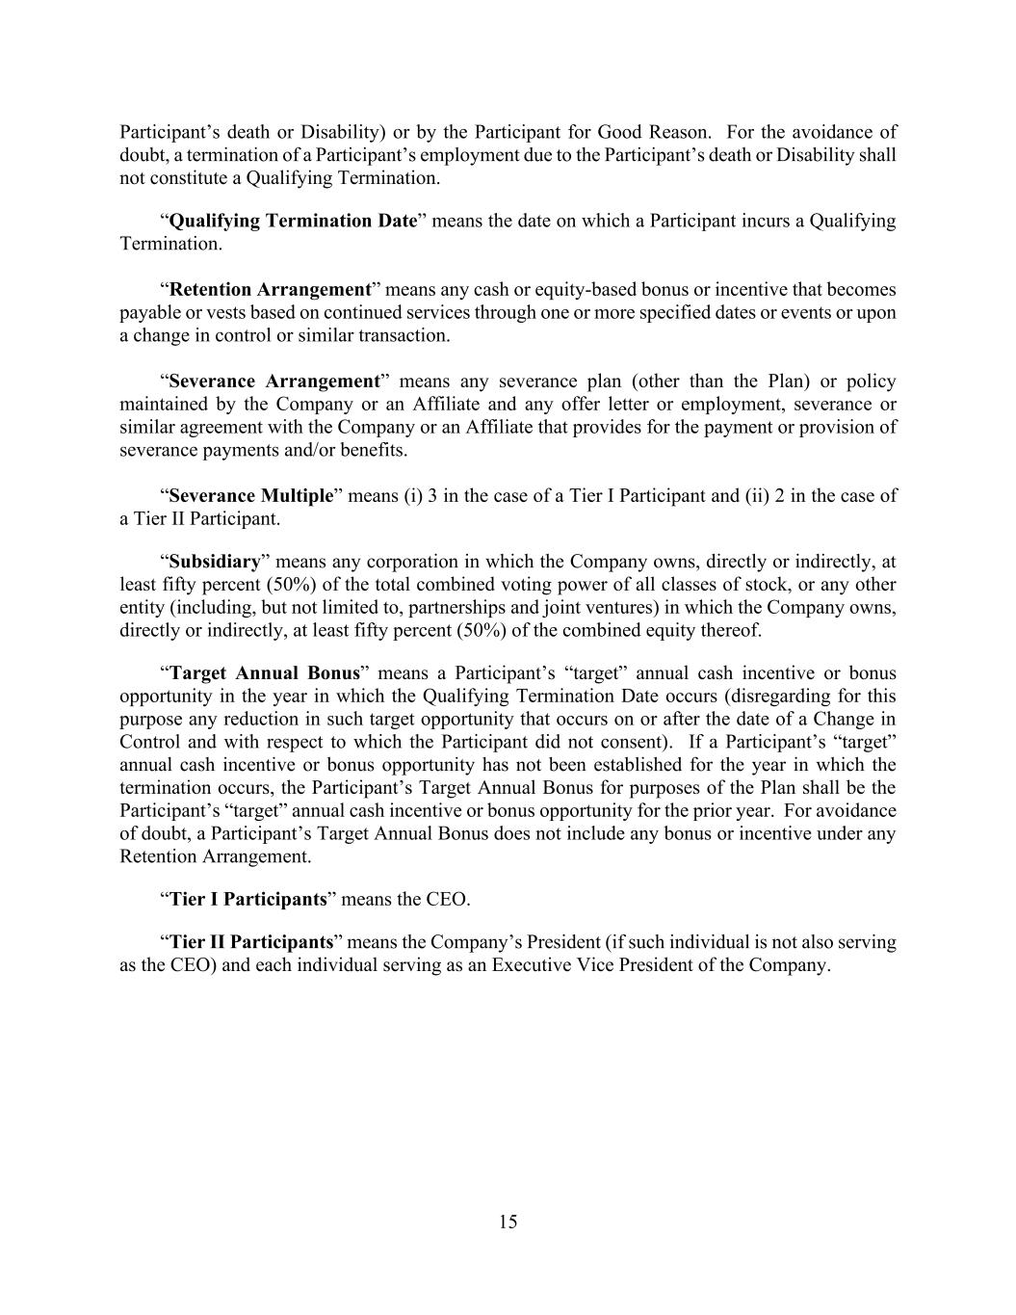
15 Participant’s death or Disability) or by the Participant for Good Reason. For the avoidance of doubt, a termination of a Participant’s employment due to the Participant’s death or Disability shall not constitute a Qualifying Termination. “Qualifying Termination Date” means the date on which a Participant incurs a Qualifying Termination. “Retention Arrangement” means any cash or equity-based bonus or incentive that becomes payable or vests based on continued services through one or more specified dates or events or upon a change in control or similar transaction. “Severance Arrangement” means any severance plan (other than the Plan) or policy maintained by the Company or an Affiliate and any offer letter or employment, severance or similar agreement with the Company or an Affiliate that provides for the payment or provision of severance payments and/or benefits. “Severance Multiple” means (i) 3 in the case of a Tier I Participant and (ii) 2 in the case of a Tier II Participant. “Subsidiary” means any corporation in which the Company owns, directly or indirectly, at least fifty percent (50%) of the total combined voting power of all classes of stock, or any other entity (including, but not limited to, partnerships and joint ventures) in which the Company owns, directly or indirectly, at least fifty percent (50%) of the combined equity thereof. “Target Annual Bonus” means a Participant’s “target” annual cash incentive or bonus opportunity in the year in which the Qualifying Termination Date occurs (disregarding for this purpose any reduction in such target opportunity that occurs on or after the date of a Change in Control and with respect to which the Participant did not consent). If a Participant’s “target” annual cash incentive or bonus opportunity has not been established for the year in which the termination occurs, the Participant’s Target Annual Bonus for purposes of the Plan shall be the Participant’s “target” annual cash incentive or bonus opportunity for the prior year. For avoidance of doubt, a Participant’s Target Annual Bonus does not include any bonus or incentive under any Retention Arrangement. “Tier I Participants” means the CEO. “Tier II Participants” means the Company’s President (if such individual is not also serving as the CEO) and each individual serving as an Executive Vice President of the Company.

Exhibit 31.1
CERTIFICATION OF CHIEF FINANCIAL OFFICER PURSUANT TO SECTION 302 OF
THE SARBANES-OXLEY ACT OF 2002

I, Paul Seavey, certify that:
1. I have reviewed this quarterly report on Form 10-Q of Equity LifeStyle Properties, Inc.;
2. Based on my knowledge, this report does not contain any untrue statement of a material fact or omit to state a material fact necessary to make the statements made, in light of the circumstances under which such statements were made, not misleading with respect to the period covered by this report;
3. Based on my knowledge, the financial statements, and other financial information included in this report, fairly present in all material respects the financial condition, results of operations and cash flows of the registrant as of, and for, the periods presented in this report;
4. The registrant's other certifying officer and I are responsible for establishing and maintaining disclosure controls and procedures (as defined in Exchange Act Rules 13a-15(e) and 15d-15(e)) and internal control over financial reporting (as defined in Exchange Act Rules 13a-15(f) and 15d-15(f)) for the registrant and have:
a) Designed such disclosure controls and procedures, or caused such disclosure controls and procedures to be designed under our supervision, to ensure that material information relating to the registrant, including its consolidated subsidiaries, is made known to us by others within those entities, particularly during the period in which this report is being prepared;
b) Designed such internal control over financial reporting, or caused such internal control over financial reporting to be designed under our supervision, to provide reasonable assurance regarding the reliability of financial reporting and the preparation of financial statements for external purposes in accordance with generally accepted accounting principles;
c) Evaluated the effectiveness of the registrant's disclosure controls and procedures and presented in this report our conclusions about the effectiveness of the disclosure controls and procedures, as of the end of the period covered by this report based on such evaluation; and
d) Disclosed in this report any change in the registrant's internal control over financial reporting that occurred during the registrant's most recent fiscal quarter (the registrant's fourth fiscal quarter in the case of an annual report) that has materially affected, or is reasonably likely to materially affect, the registrant's internal control over financial reporting; and
5. The registrant's other certifying officer and I have disclosed, based on our most recent evaluation of internal control over financial reporting, to the registrant's auditors and the audit committee of the registrant's board of directors (or persons performing the equivalent functions):
a) All significant deficiencies and material weaknesses in the design or operation of internal control over financial reporting which are reasonably likely to adversely affect the registrant's ability to record, process, summarize and report financial information; and
b) Any fraud, whether or not material, that involves management or other employees who have a significant role in the registrant's internal control over financial reporting.
Date: July 28, 2026 |  |  | By: |  |  | /s/ Paul Seavey
 |  |  |  |  |  | Paul Seavey
 |  |  |  |  |  | Executive Vice President and Chief Financial Officer

Exhibit 31.2

CERTIFICATION OF CHIEF EXECUTIVE OFFICER PURSUANT TO SECTION 302 OF
THE SARBANES-OXLEY ACT OF 2002

I, Marguerite Nader, certify that:
1. I have reviewed this quarterly report on Form 10-Q of Equity LifeStyle Properties, Inc.;
2. Based on my knowledge, this report does not contain any untrue statement of a material fact or omit to state a material fact necessary to make the statements made, in light of the circumstances under which such statements were made, not misleading with respect to the period covered by this report;
3. Based on my knowledge, the financial statements, and other financial information included in this report, fairly present in all material respects the financial condition, results of operations and cash flows of the registrant as of, and for, the periods presented in this report;
4. The registrant's other certifying officer and I are responsible for establishing and maintaining disclosure controls and procedures (as defined in Exchange Act Rules 13a-15(e) and 15d-15(e)) and internal control over financial reporting (as defined in Exchange Act Rules 13a-15(f) and 15d-15(f)) for the registrant and have:
a) Designed such disclosure controls and procedures, or caused such disclosure controls and procedures to be designed under our supervision, to ensure that material information relating to the registrant, including its consolidated subsidiaries, is made known to us by others within those entities, particularly during the period in which this report is being prepared;
b) Designed such internal control over financial reporting, or caused such internal control over financial reporting to be designed under our supervision, to provide reasonable assurance regarding the reliability of financial reporting and the preparation of financial statements for external purposes in accordance with generally accepted accounting principles;
c) Evaluated the effectiveness of the registrant's disclosure controls and procedures and presented in this report our conclusions about the effectiveness of the disclosure controls and procedures, as of the end of the period covered by this report based on such evaluation; and
d) Disclosed in this report any change in the registrant's internal control over financial reporting that occurred during the registrant's most recent fiscal quarter (the registrant's fourth fiscal quarter in the case of an annual report) that has materially affected, or is reasonably likely to materially affect, the registrant's internal control over financial reporting; and
5. The registrant's other certifying officer and I have disclosed, based on our most recent evaluation of internal control over financial reporting, to the registrant's auditors and the audit committee of the registrant's board of directors (or persons performing the equivalent functions):
a) All significant deficiencies and material weaknesses in the design or operation of internal control over financial reporting which are reasonably likely to adversely affect the registrant's ability to record, process, summarize and report financial information; and
b) Any fraud, whether or not material, that involves management or other employees who have a significant role in the registrant's internal control over financial reporting.
Date: July 28, 2026 |  |  | By: |  |  | /s/ Marguerite Nader
 |  |  |  |  |  | Marguerite Nader
 |  |  |  |  |  | Vice Chairman and Chief Executive Officer

Exhibit 32.1

CERTIFICATION OF CHIEF FINANCIAL OFFICER
PURSUANT TO 18 U.S.C. SECTION 1350

In connection with the accompanying Quarterly Report on Form 10-Q of Equity LifeStyle Properties, Inc. for the quarter ended June 30, 2026 (the “Form 10-Q”), I, Paul Seavey, Executive Vice President and Chief Financial Officer of Equity LifeStyle Properties, Inc., hereby certify pursuant to 18 U.S.C. Section 1350, as adopted by Section 906 of the Sarbanes-Oxley Act of 2002, that to the best of my knowledge:
1. the Form 10-Q fully complies with the requirements of section 13(a) or 15(d) of the Securities Exchange Act of 1934, as amended; and
2. the information contained in the Form 10-Q fairly presents, in all material respects, the financial condition and results of operations of Equity LifeStyle Properties, Inc.
Date: July 28, 2026 |  |  | By: |  |  | /s/ Paul Seavey
 |  |  |  |  |  | Paul Seavey
 |  |  |  |  |  | Executive Vice President and Chief Financial Officer

A signed original of this written statement required by Section 906 has been provided to
Equity LifeStyle Properties, Inc. and will be retained by Equity LifeStyle Properties, Inc. and furnished to the Securities and Exchange Commission or its staff
upon request.

Exhibit 32.2

CERTIFICATION OF CHIEF EXECUTIVE OFFICER
PURSUANT TO 18 U.S.C. SECTION 1350

In connection with the accompanying Quarterly Report on Form 10-Q of Equity LifeStyle Properties, Inc. for the quarter ended June 30, 2026 (the “Form 10-Q”), I, Marguerite Nader, Vice Chairman and Chief Executive Officer of Equity LifeStyle Properties, Inc., hereby certify pursuant to 18 U.S.C. Section 1350, as adopted by Section 906 of the Sarbanes-Oxley Act of 2002, that to the best of my knowledge:
1. the Form 10-Q fully complies with the requirements of section 13(a) or 15(d) of the Securities Exchange Act of 1934, as amended; and
2. the information contained in the Form 10-Q fairly presents, in all material respects, the financial condition and results of operations of Equity LifeStyle Properties, Inc.
Date: July 28, 2026 |  |  | By: |  |  | /s/ Marguerite Nader
 |  |  |  |  |  | Marguerite Nader
 |  |  |  |  |  | Vice Chairman and Chief Executive Officer

A signed original of this written statement required by Section 906 has been provided to
Equity LifeStyle Properties, Inc. and will be retained by Equity LifeStyle Properties, Inc. and furnished to the Securities and Exchange Commission or its staff
upon request.

